Contact Visit Record Manager 2
Contact Visit List 2
Visit List Filters 3
Toolbar Buttons 4
Context Menu 4
Calendar Dialog 6
Visit Filter Detail Dialog 6
Form Controls 7
Context Menu 7
Contact Visit Detail Dialog 8
Form Controls 8
Context Menu 9
Contact Person List 10
Contact List Filters 11
Toolbar Buttons 11
Context Menu 11
Contact Person Detail Dialog 13
Form Controls 13
Context Menu 14
Facility List 15
Context Menu 15
Facility Detail Dialog 17
Form Controls 17
Context Menu 18

Contact Visit Record Manager
The Contact Visit Record Manager tracks contact visits to a facility. This data can be used for contact tracing and reporting.

Contact Visit List
The Contact Visit List contains the visits for the selected filters. Visits can be added, edited and deleted from this list.
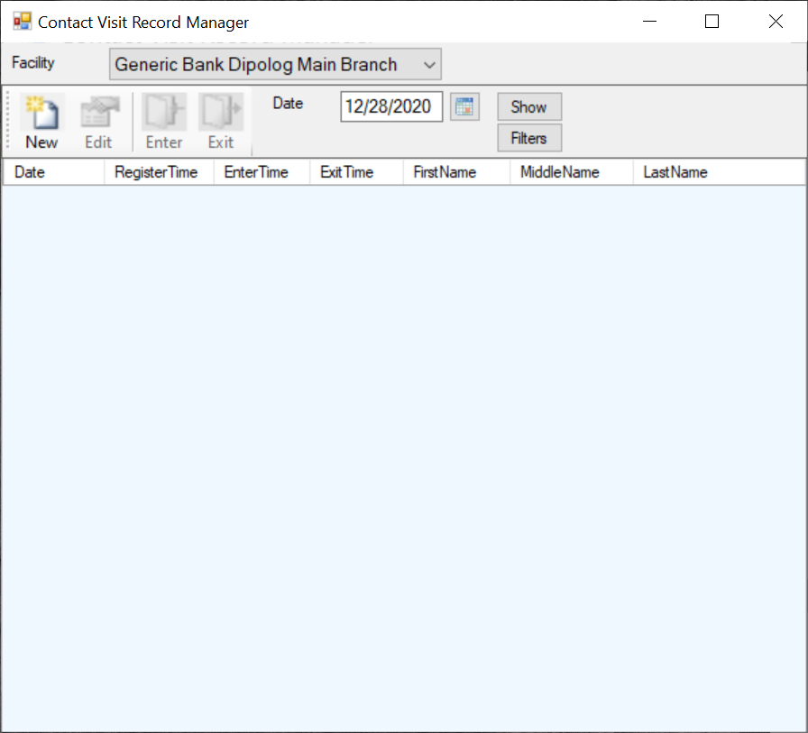

Visit List Filters
The Visit List Filter controls are located to the right of the Toolbar Buttons.
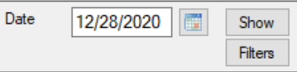

The list filters determine which records will appear in the list.
Date Filter
When the Visit List form is first displayed, the Date Filter contains today’s date and the Visit List is filled with the visits using the Date Filter as the Register Date.
If the Date Filter is manually changed or changed from the Calendar Dialog, then the "Show" button must be selected before the list is refreshed using the Date Filter value.
Calendar Button
The Calendar Button displays the Calendar Dialog. The Calendar Dialog is used to select a date for the Date Filter. The date is copied back to the Date Filter when the user selects a date.
Show Button
The Show Button applies the Date Filter and other filters selected from the Visit Filter Detail Dialog.
The Show Button retrieves the visits that match the filter values. If the filter values are empty, then all visits are retrieved.
Filters Button
The Filters Button displays the Visit Filter Detail Dialog. The Visit Filter Detail Dialog allows the user to add additional filter values.
Clear Filters Button
The Clear Filters Button clears all the filters from the Visit Filter Detail Dialog.

Toolbar Buttons
The Contact Visit List has a toolbar above it which provides one touch access to the most common list actions.
New
The 'New' toolbar button displays the Contact Visit Detail dialog to allow for the creation of a new visit entry.
Edit
The 'Edit' toolbar button displays the Contact Visit Detail dialog to allow for editing the selected list item.
Enter
The 'Enter' toolbar button sets the Visit Enter Date and Time to the current date and time. This is the time the Contact actually entered the facility.
Exit
The 'Exit' toolbar button sets the Visit Exit Date and Time to the current date and time. This is the time the Contact actually exited the facility.

Context Menu
The Context Menu can be displayed by clicking the right mouse button on the desired list item. The list item is selected and the menu items apply to the selected item or list.
If you are using a Tablet or a laptop in Tablet Mode, touch the desired list item and leave your finger on the item for a short while until a box is displayed. This shows that the touch is considered a right mouse click. Remove your finger and the context menu will be displayed.
New
The 'New' menu item displays the Contact Visit Detail dialog to allow for the creation of a new visit entry.
Edit
The 'Edit' menu item displays the Contact Visit Detail dialog to allow for editing the selected list item.

Enter
The 'Enter' menu item sets the Visit Enter Date and Time to the current date and time. This is the time the Contact actually entered the facility.
Exit
The 'Exit' menu item sets the Visit Exit Date and Time to the current date and time. This is the time the Contact actually exited the facility.
Delete
The 'Delete' menu item deletes the selected list item.
Refresh
The 'Refresh' menu item reloads the list items from the database.
Export Text
The 'Export Text' menu item creates a tab delimited text file with the file name 'ExportFiles\CVVisit.doc'. It attempts to display the data with the application that is associated with the '.doc' extension.
Export CSV
The 'Export CSV' menu item creates a comma delimited text file with the file name 'ExportFiles\CVVisit.csv'. It attempts to display the data with the application that is associated with the '.csv' extension.
Close
The 'Close' menu item closes the window and exits the application.
Facility
The 'Facility' menu item displays the Facility List to allow for maintaining the Facility data.
Help
The 'Help' menu item displays the help page for the current list.

Calendar Dialog
The Calendar Dialog is used to select a date. The date is returned to the parent form when the user selects a date.
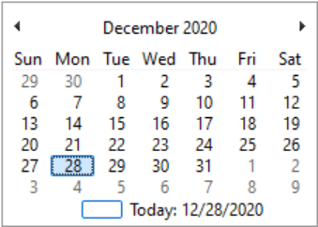

A date is selected from the Calendar Dialog by double clicking on a date value or selecting a date value and pressing the ENTER key.

Visit Filter Detail Dialog
The Visit Filter Detail dialog allows the user to enter values that are used to filter the Contact Visit List.
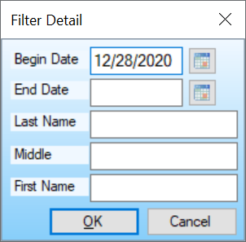

To “Filter” a list means to limit the list to items that match user selected values.
The Filter values are applied with "AND" logic. This means that the items that appear in the list must match each value "and" the other entered values. So, if you put in a "Last Name" and a "First Name" the list will include only those items that match both the "Last Name" and "First Name".
The text filters match those items that begin with the entered filter letters. The matching is not case sensitive. So, if the "Last Name" filter value is "C", then it will match with any entry where the Last Name starts with a "C" or "c".

Form Controls
Begin Date
The Begin Date filter value will limit the Contact Visit List to those visits that were registered on the Begin Date.
Begin Date Button
The Begin Date Button displays the Calendar Dialog for selecting the Begin Date.
End Date
The End Date filter value will limit the Contact Visit List to those visits that were registered between the Begin date and End Date. The Begin Date and End Date are included with all the register dates between.
End Date Button
The End Date Button displays the Calendar Dialog for selecting the End Date.
Last Name
The "Last Name" filter value.
Middle Name
The "Middle Name" filter value.
First Name
The "First Name" filter value.

Context Menu
The Context Menu can be displayed by clicking the right mouse button on an empty space on the form.
If you are using a Tablet or a laptop in Tablet Mode, touch the desired list item and leave your finger on the item for a short while until a box is displayed. This shows that the touch is considered a right mouse click. Remove your finger and the context menu will be displayed.
Help
The 'Help' menu item displays the help page for the current dialog.

Contact Visit Detail Dialog
The Contact Visit Detail dialog allows the user to create and edit contact visit entries.
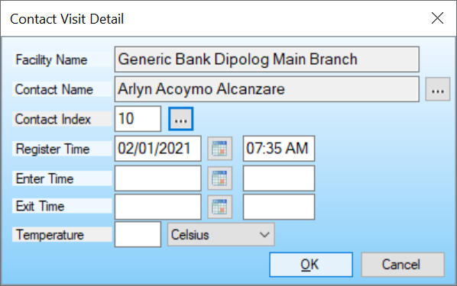

Form Controls
Contact Name Button
The Contact Name Button displays the Contact Person List to allow for the selection of the Contact data.
Contact Index
The Contact Index is the unique index for this Contact.
Contact Recall Button
The Contact Recall Button recalls the existing Customer information for the entered Contact Index.
Register Time
The Register Time values are the Register Date and Register Time.
If this is a new Visit Record, the Register Date is automatically populated with the current date and the Register Time is automatically populated with the current time.
Register Date Button
The Register Date Button displays the Calendar Dialog for selecting the Register Date and Time.
Enter Time
The Enter Time values are the Enter Date and Enter Time.

Enter Date Button
The Enter Date Button displays the Calendar Dialog for selecting the Enter Date and Time.
Exit Time
The Exit Time values are the Exit Date and Exit Time.
Exit Date Button
The Exit Date Button displays the Calendar Dialog for selecting the Exit Date and Time.
OK Button
Saves the entered data and exits the dialog.
Cancel Button
Exits the dialog without saving the entered data.

Context Menu
The Context Menu can be displayed by clicking the right mouse button on an empty space on the form.
If you are using a Tablet or a laptop in Tablet Mode, touch the desired list item and leave your finger on the item for a short while until a box is displayed. This shows that the touch is considered a right mouse click. Remove your finger and the context menu will be displayed.
Help
The 'Help' menu item displays the help page for the current dialog.

Contact Person List
The Contact Person List contains the defined contacts for the selected filters. Contacts can be added, edited and deleted from this list.
A Contact can also be selected from this list.
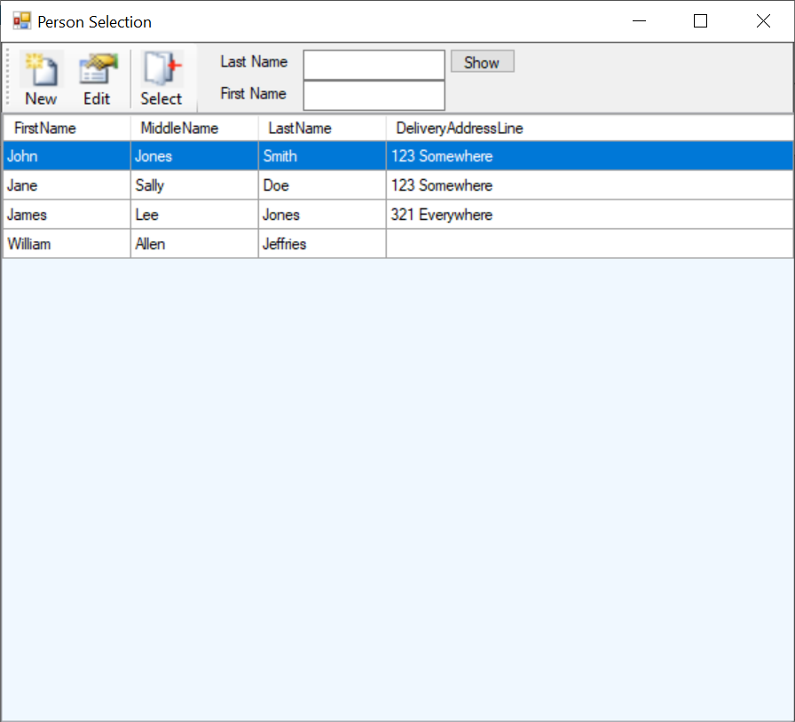

Contact List Filters
The Contact List Filter controls are located to the right of the Toolbar Buttons.
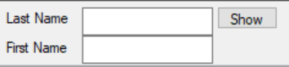

The list filters determine which records will appear in the list.
The list filters are "Last Name" and "First Name". These filters are used to find the record values that start with the filter values.
Show Button
The Show Button retrieves the contacts that match the filter values. If the filter values are empty, then all contacts are retrieved.

Toolbar Buttons
The list has a toolbar above it which provides one touch access to the most common list actions.
New
The 'New' toolbar button displays the Contact Person Detail dialog to allow for the creation of a new contact entry.
Edit
The 'Edit' toolbar button displays the Contact Person Detail dialog to allow for editing the selected list item.
Select
The 'Select' toolbar button returns the selected item from the list to the parent form.

Context Menu
The Context Menu can be displayed by clicking the right mouse button on the desired list item. The list item is selected and the menu items apply to the selected item or list.
If you are using a Tablet or a laptop in Tablet Mode, touch the desired list item and leave your finger on the item for a short while until a box is displayed. This shows that the touch is considered a right mouse click. Remove your finger and the context menu will be displayed.
New
The 'New' menu item displays the Contact Person Detail dialog to allow for the creation of a new visit entry.
Edit
The 'Edit' menu item displays the Contact Person Detail dialog to allow for editing the selected list item.
Delete
The 'Delete' menu item deletes the selected list item.
Refresh
The 'Refresh' menu item reloads the list items from the database.
Export Text
The 'Export Text' menu item creates a tab delimited text file with the file name 'ExportFiles\CVPerson.doc'. It attempts to display the data with the application that is associated with the '.doc' extension.
Export CSV
The 'Export CSV' menu item creates a comma delimited text file with the file name 'ExportFiles\CVPerson.csv'. It attempts to display the data with the application that is associated with the '.csv' extension.
Select
The 'Select' menu item returns the selected item from the list to the parent form.
Close
The 'Close' menu item closes the window and returns to the parent window.
Help
The 'Help' menu item displays the help page for the current list.

Contact Person Detail Dialog
The Contact Person Detail dialog allows the user to create and edit contact person entries.
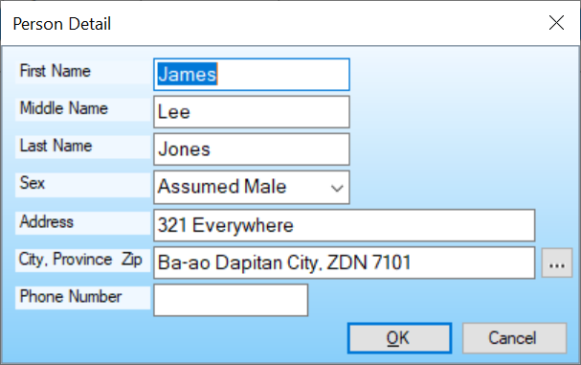

Form Controls
First Name
The First name.
Middle Name
The Middle name.
Last Name
The Last name.
Sex
The Sex selection.
Address
The street Address value.
City, Province Zip
The City, Province and Zip value.
Region Button
The Region Data selection button displays the Region Manager window for selecting the Region, Province, City and CitySection.

Phone Number
The Phone number.
OK Button
Saves the entered data and exits the dialog.
Cancel Button
Exits the dialog without saving the entered data.

Context Menu
The Context Menu can be displayed by clicking the right mouse button on an empty space on the form.
If you are using a Tablet or a laptop in Tablet Mode, touch the desired list item and leave your finger on the item for a short while until a box is displayed. This shows that the touch is considered a right mouse click. Remove your finger and the context menu will be displayed.
Help
The 'Help' menu item displays the help page for the current dialog.

Facility List
The Facility List contains the defined Facilities. Facilities can be added, edited and deleted from this list.
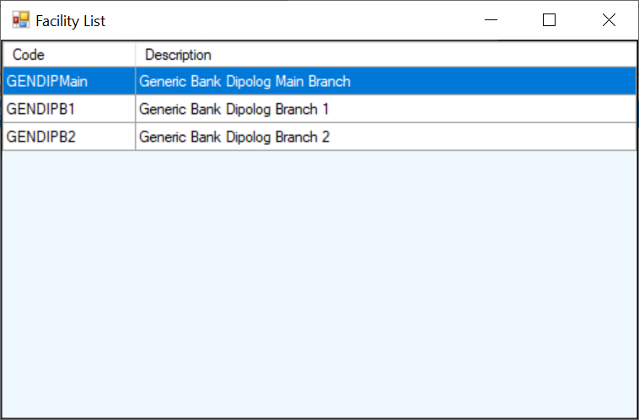

Context Menu
The Context Menu can be displayed by clicking the right mouse button on the desired list item. The list item is selected and the menu items apply to the selected item or list.
If you are using a Tablet or a laptop in Tablet Mode, touch the desired list item and leave your finger on the item for a short while until a box is displayed. This shows that the touch is considered a right mouse click. Remove your finger and the context menu will be displayed.
New
The 'New' menu item displays the Facility Detail dialog to allow for the creation of a new facility entry.
Edit
The 'Edit' menu item displays the Facility Detail dialog to allow for editing the selected list item.
Delete
The 'Delete' menu item deletes the selected list item.
Refresh
The 'Refresh' menu item reloads the list items from the database.
Export Text
The 'Export Text' menu item creates a tab delimited text file with the file name 'ExportFiles\Facility.doc'. It attempts to display the data with the application that is associated with the '.doc' extension.
Export CSV
The 'Export CSV' menu item creates a comma delimited text file with the file name 'ExportFiles\Facility.csv'. It attempts to display the data with the application that is associated with the '.csv' extension.
Close
The 'Close' menu item closes the window and returns to the parent window.
Help
The 'Help' menu item displays the help page for the current list.

Facility Detail Dialog
The Facility Detail dialog allows the user to create and edit facility entries.
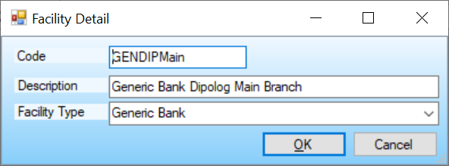

Form Controls
Code
This is the user-defined code for this facility. A code is an abbreviation that is easier to use than the long item description.
So if you define a facility code type for School facilities with the code FACSCH and you have a main school and two branches, you might give the schools the codes: SCHMAIN, SCHBR1 and SCHBR2. For these schools you would select the Facility Type of FACSCH.
If you have branches in multiple cities, you might include the city abbreviation in the codes. E.G. SCHCTYMAIN, SCHCTYBR1 and SCHCTYBR2.
Description
This is the facility description.
Facility Type
This is the facility type selection.
Only code types that belong to the Facility code type class will appear in this list.
OK Button
Saves the entered data and exits the dialog.
Cancel Button
Exits the dialog without saving the entered data.

Context Menu
The Context Menu can be displayed by clicking the right mouse button on an empty place on the form.
If you are using a Tablet or a laptop in Tablet Mode, touch the desired list item and leave your finger on the item for a short while until a box is displayed. This shows that the touch is considered a right mouse click. Remove your finger and the context menu will be displayed.
Help
The 'Help' menu item displays the help page for the current dialog.

