Region Manager 2
Province List 2
Toolbar Buttons 3
Context Menu 3
Province Detail Dialog 5
Form Controls 5
Context Menu 5
City List 6
Toolbar Buttons 7
Context Menu 7
City Detail Dialog 9
Form Controls 9
Context Menu 9
City Section List 10
Toolbar Buttons 10
Context Menu 11
City Section Detail Dialog 12
Form Controls 12
Context Menu 13
Context Menu 13

Region Manager
The Region Manager contains Region, Province, City and City Section data. In the Philippines, City Sections are known as Barangays.

Province List
The Region List Form contains the Province List Grid. The Province List contains the defined provinces for the selected region. Provinces can be added, edited and deleted from this list.
Province data can also be selected from this list.
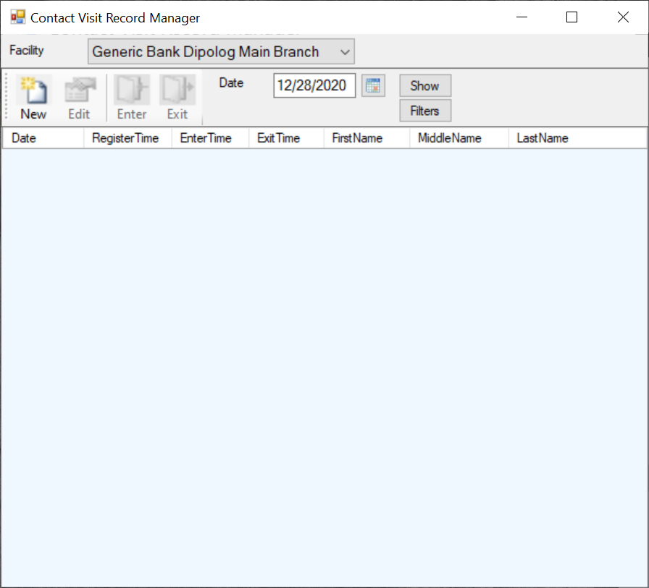

Toolbar Buttons
The list has a toolbar above it which provides one touch access to the most common list actions.
New
The 'New' toolbar button displays the Province Detail dialog to allow for the creation of a new province entry.
Edit
The 'Edit' toolbar button displays the Province Detail dialog to allow for editing the selected list item.
Delete
The 'Delete' toolbar button deletes the selected list item.
Select
The 'Select' toolbar button returns the selected item from the list to the calling form. It also returns the selected Region.

Context Menu
The Context Menu can be displayed by clicking the right mouse button on the desired list item. The list item is selected and the menu items apply to the selected item or list.
If you are using a Tablet or a laptop in Tablet Mode, touch the desired list item and leave your finger on the item for a short while until a box is displayed. This shows that the touch is considered a right mouse click. Remove your finger and the context menu will be displayed.
New
The 'New' menu item displays the Province Detail dialog to allow for the creation of a new province entry.
Edit
The 'Edit' menu item displays the Province Detail dialog to allow for editing the selected list item.
Delete
The 'Delete' menu item deletes the selected list item.

Refresh
The 'Refresh' menu item reloads the list items from the database.
Export Text
The 'Export Text' menu item creates a tab delimited text file with the file name 'ExportFiles\Province.doc'. It attempts to display the data with the application that is associated with the '.doc' extension.
Export CSV
The 'Export CSV' menu item creates a comma delimited text file with the file name 'ExportFiles\Province.csv'. It attempts to display the data with the application that is associated with the '.csv' extension.
Select
The 'Select' menu item returns the selected item from the list to the calling form. It also returns the selected Region.
Close
The 'Close' menu item closes the window and exits the application.
Help
The 'Help' menu item displays the help page for the current list.

Province Detail Dialog
The Province Detail dialog allows the user to create and edit contact province entries.
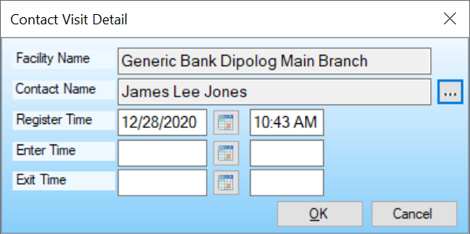

Form Controls
Region
The read-only control that shows the parent region description.
Abbreviation
The abbreviation text.
Name
The unique name text.
Description
The description text.
OK Button
Saves the entered data and exits the dialog.
Cancel Button
Exits the dialog without saving the entered data.

Context Menu
The Context Menu can be displayed by clicking the right mouse button on an empty space on the form.
If you are using a Tablet or a laptop in Tablet Mode, touch the desired list item and leave your finger on the item for a short while until a box is displayed. This shows that the touch is considered a right mouse click. Remove your finger and the context menu will be displayed.
Help
The 'Help' menu item displays the help page for the current dialog.

City List
The Region List Form contains the City List Grid. The City List contains the defined cities for the selected province. Cities can be added, edited and deleted from this list.
City data can also be selected from this list.
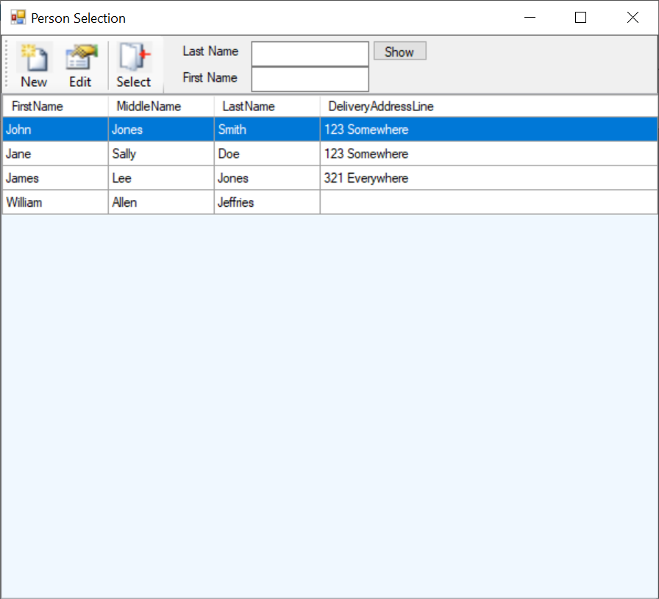

Toolbar Buttons
The list has a toolbar above it which provides one touch access to the most common list actions.
New
The 'New' toolbar button displays the City Detail dialog to allow for the creation of a new city entry.
Edit
The 'Edit' toolbar button displays the City Detail dialog to allow for editing the selected list item.
Delete
The 'Delete' toolbar button deletes the selected list item.
Select
The 'Select' toolbar button returns the selected item from the list to the calling form. It also returns the selected Region and Province.

Context Menu
The Context Menu can be displayed by clicking the right mouse button on the desired list item. The list item is selected and the menu items apply to the selected item or list.
If you are using a Tablet or a laptop in Tablet Mode, touch the desired list item and leave your finger on the item for a short while until a box is displayed. This shows that the touch is considered a right mouse click. Remove your finger and the context menu will be displayed.
New
The 'New' menu item displays the City Detail dialog to allow for the creation of a new city entry.
Edit
The 'Edit' menu item displays the City Detail dialog to allow for editing the selected list item.
Delete
The 'Delete' menu item deletes the selected list item.

Refresh
The 'Refresh' menu item reloads the list items from the database.
Export Text
The 'Export Text' menu item creates a tab delimited text file with the file name 'ExportFiles\City.doc'. It attempts to display the data with the application that is associated with the '.doc' extension.
Export CSV
The 'Export CSV' menu item creates a comma delimited text file with the file name 'ExportFiles\City.csv'. It attempts to display the data with the application that is associated with the '.csv' extension.
Select
The 'Select' menu item returns the selected item from the list to the calling form. It also returns the selected Region and Province.
Close
The 'Close' menu item closes the window and returns to the parent window.
Help
The 'Help' menu item displays the help page for the current list.

City Detail Dialog
The City Detail dialog allows the user to create and edit city entries.
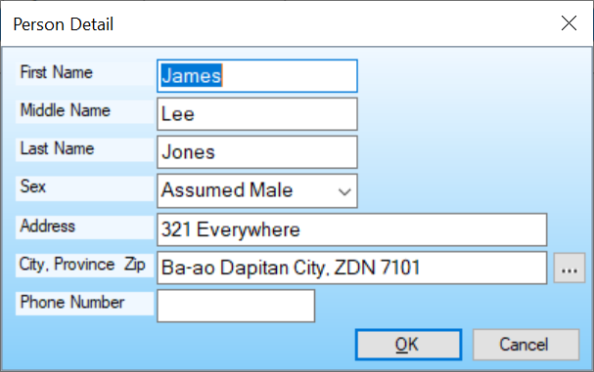

Form Controls
Province
The read-only control that shows the parent province description.
Name
The unique name text.
Description
The description text.
City
The CheckBox that indicates this is a city.
OK Button
Saves the entered data and exits the dialog.
Cancel Button
Exits the dialog without saving the entered data.

Context Menu
The Context Menu can be displayed by clicking the right mouse button on an empty space on the form.
If you are using a Tablet or a laptop in Tablet Mode, touch the desired list item and leave your finger on the item for a short while until a box is displayed. This shows that the touch is considered a right mouse click. Remove your finger and the context menu will be displayed.
Help
The 'Help' menu item displays the help page for the current dialog.

City Section List
The Region List Form contains the City Section List Grid. The City Section List contains the defined City Sections for the selected city. City Sections can be added, edited and deleted from this list.
City Section data can also be selected from this list.
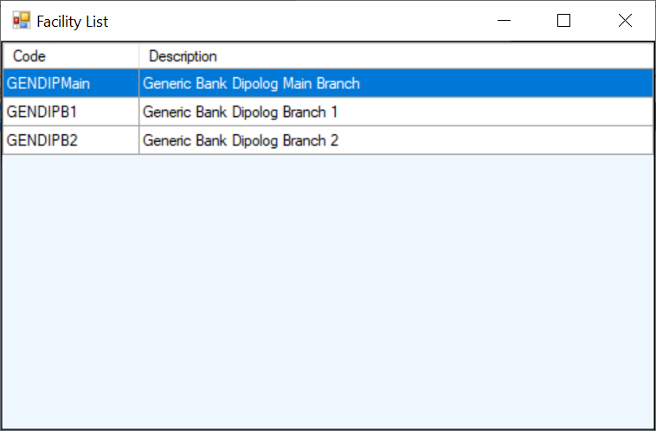

Toolbar Buttons
The list has a toolbar above it which provides one click access to the most common list actions.
New
The 'New' toolbar button displays the City Section Detail dialog to allow for the creation of a new city section entry.

Edit
The 'Edit' toolbar button displays the City Section Detail dialog to allow for editing the selected list item.
Delete
The 'Delete' toolbar button deletes the selected list item.
Select
The 'Select' toolbar button returns the selected item from the list to the calling form. It also returns the selected Region, Province and City.

Context Menu
The Context Menu can be displayed by clicking the right mouse button on the desired list item. The list item is selected and the menu items apply to the selected item or list.
If you are using a Tablet or a laptop in Tablet Mode, touch the desired list item and leave your finger on the item for a short while until a box is displayed. This shows that the touch is considered a right mouse click. Remove your finger and the context menu will be displayed.
New
The 'New' menu item displays the City Section Detail dialog to allow for the creation of a new city section entry.
Edit
The 'Edit' menu item displays the City Section Detail dialog to allow for editing the selected list item.
Delete
The 'Delete' menu item deletes the selected list item.
Refresh
The 'Refresh' menu item reloads the list items from the database.
Export Text
The 'Export Text' menu item creates a tab delimited text file with the file name 'ExportFiles\CitySection.doc'. It attempts to display the data with the application that is associated with the '.doc' extension.

Export CSV
The 'Export CSV' menu item creates a comma delimited text file with the file name 'ExportFiles\CitySection.csv'. It attempts to display the data with the application that is associated with the '.csv' extension.
Close
The 'Close' menu item closes the window and exits the application.
Help
The 'Help' menu item displays the help page for the current list.

City Section Detail Dialog
The City Section Detail dialog allows the user to create and edit city section entries.
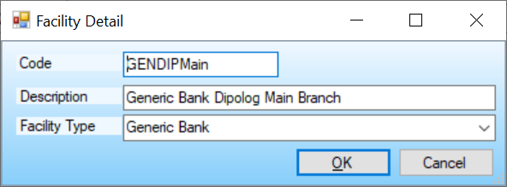

Form Controls
City
The read-only control that shows the parent city description.
Name
The unique name text.
Description
The description text.
Zone Type
The zone type text.
Contact
The contact name.
OK Button
Saves the entered data and exits the dialog.
Cancel Button
Exits the dialog without saving the entered data.

Context Menu
The Context Menu can be displayed by clicking the right mouse button on an empty space on the form.
If you are using a Tablet or a laptop in Tablet Mode, touch the desired list item and leave your finger on the item for a short while until a box is displayed. This shows that the touch is considered a right mouse click. Remove your finger and the context menu will be displayed.
Help
The 'Help' menu item displays the help page for the current dialog.

Context Menu
The Context Menu can be displayed by clicking the right mouse button on an empty place on the form.
If you are using a Tablet or a laptop in Tablet Mode, touch the desired list item and leave your finger on the item for a short while until a box is displayed. This shows that the touch is considered a right mouse click. Remove your finger and the context menu will be displayed.
Help
The 'Help' menu item displays the help page for the current dialog.

