# EXERCISE 6

1. **data and graphical**
2. **Study the data:**

As shown on the Table 1, we compute the mean and standard deviation of running time (lemo and energy drink). Specifically, the “lemo_difference” = “running time before (lemo)” – “running time after (lemo)”.

We can find two basic results:

1. Energy drink group seems run faster after drinking the energy drink, because the time of “energy_after” is shorter than the time of “energy_before. Similarly, softdrink group seems run slower after drinking the softdrink, because the time of “lemo_after” is longer than the time of “lemo_before.
2. From the standard deviation, we can find that energy drink group has lower standard deviation than softdrink group. Therefore, the energy drink group’s data tend to be close to the mean of the set.

**Table 1 The mean and Standard Deviation of lemo and energy**

|  |  |  |
| --- | --- | --- |
|  | **mean** | **standard deviation** |
| **lemo_before** | 7.554 | 0.5471157 |
| **lemo_after** | 7.699 | 0.8339551 |
| **lemo_difference** | -0.145 | 0.6232248 |
| **energy_before** | 7.733 | 0.2971417 |
| **energy_after** | 7.578 | 0.4585319 |
| **energy_difference** | 0.154 | 0.3229258 |

1. **Graphical representations:**

As shown on the figure29 and figure30, we can see the distribution of energy drink group is more concentrated.

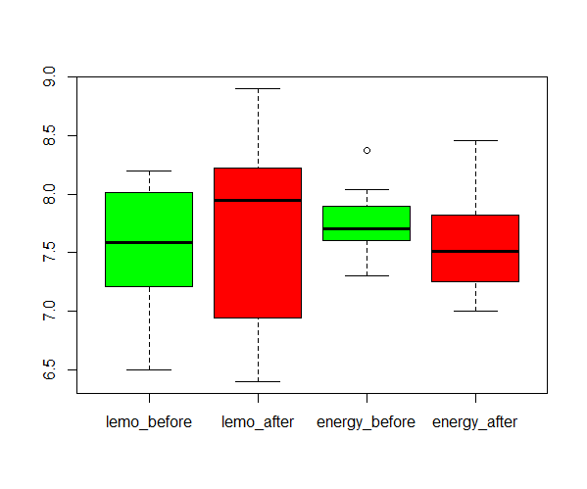

**Figure29: boxplots of soft drink and energy drink (before and after)**

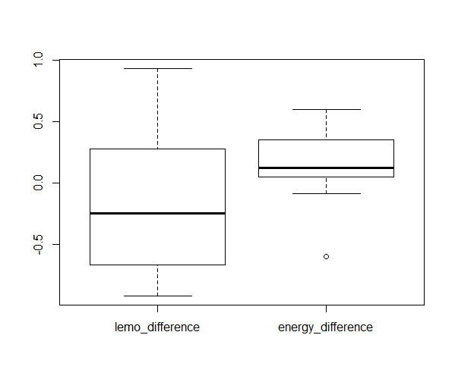

**Figure30: boxplots of soft drink and energy drink (difference)**

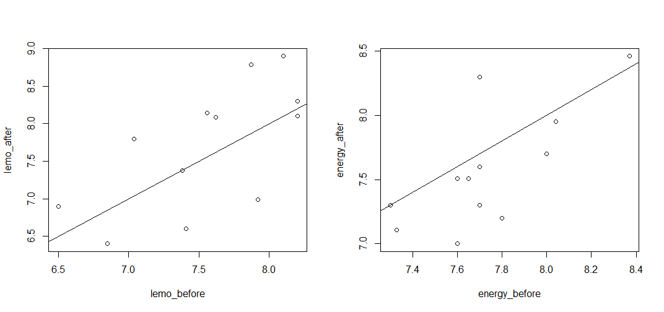

**Figure31 plot of before and after**

**code of (1):**

alldata = read.table("run.txt")

lemo_before = alldata[which(alldata$drink=="lemo"),"before"]

lemo_after = alldata[which(alldata$drink=="lemo"),"after"]

lemo_difference = lemo_before - lemo_after

energy_before = alldata[which(alldata$drink=="energy"),"before"]

energy_after = alldata[which(alldata$drink=="energy"),"after"]

energy_difference = energy_before - energy_after

mydiff = c(lemo_difference,energy_difference)

alldata$difference = mydiff

mean(lemo_before)

mean(lemo_after)

mean(lemo_difference)

mean(energy_before)

mean(energy_after)

mean(energy_difference)

sd(lemo_before)

sd(lemo_after)

sd(lemo_difference)

sd(energy_before)

sd(energy_after)

sd(energy_difference)

par(mfrow=c(1,2))

plot(lemo_before,lemo_after); abline(0,1)

plot(energy_before,energy_after); abline(0,1)

boxplot(lemo_before,lemo_after,energy_before,energy_after, names=c("lemo_before","lemo_after","energy_before","energy_after"),col=c('green','red',"green","red"))

boxplot(lemo_difference,energy_difference,names=c("lemo_difference","energy_difference"))

1. **Test separately**

We can use paired t-test, because each group contains two numerical outcomes per experimental unit and our interest is in a possible difference between the two outcomes.

H0 = there is not a significant difference in speed in the two running tasks.

For softdrink group, the p-value = 0.4373 > 0.05. Therefore, we cannot reject H0, which means there is not a significant difference in speed in the two running tasks after drinking softdrink.

**result of paired t-test on softdrink:**

> t.test(lemo_before,lemo_after,paired = TRUE)

Paired t-test

data: lemo_before and lemo_after

t = -0.80596, df = 11, p-value = 0.4373

alternative hypothesis: true difference in means is not equal to 0

95 percent confidence interval:

-0.5409781 0.2509781

sample estimates:

mean of the differences

-0.145

For energy drink group, the p-value = 0.1246 > 0.05. Therefore, we cannot reject H0, which means there is not significant a difference in speed in the two running tasks after drinking energy drink.

**result of paired t-test on energy drink:**

> t.test(energy_before,energy_after, paired=TRUE)

Paired t-test

data: energy_before and energy_after

t = 1.6538, df = 11, p-value = 0.1264

alternative hypothesis: true difference in means is not equal to 0

95 percent confidence interval:

-0.05101059 0.35934392

sample estimates:

mean of the differences

0.1541667

Finally, we check the normality assumption on the differences.

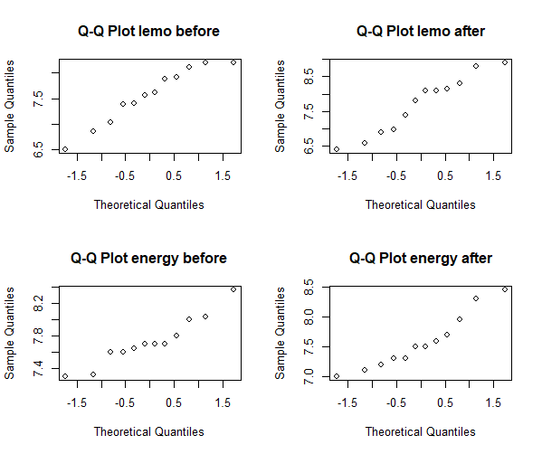

**Figure 32, Q-Q plots of energy drink and softdrink group**

After Shapiro-Wilk normality test, there is no reason to suspect that the running time sample are not taken from a normal population.

**result of Shapiro-Wilk normality test on soft drink:**

> shapiro.test(lemo_before)

Shapiro-Wilk normality test

data: lemo_before

W = 0.93899, p-value = 0.485

> shapiro.test(lemo_after)

Shapiro-Wilk normality test

data: lemo_after

W = 0.94117, p-value = 0.5133

> shapiro.test(energy_before)

Shapiro-Wilk normality test

data: energy_before

W = 0.93334, p-value = 0.4169

> shapiro.test(energy_after)

Shapiro-Wilk normality test

data: energy_after

W = 0.92444, p-value = 0.3249

**code of (2)**

t.test(lemo_before,lemo_after,paired = TRUE)

t.test(energy_before,energy_after, paired=TRUE)

par(mfrow=c(2,2))

qqnorm(lemo_before,main="Q-Q Plot lemo before")

qqnorm(lemo_after,main="Q-Q Plot lemo after")

qqnorm(energy_before,main="Q-Q Plot energy before")

qqnorm(energy_after,main="Q-Q Plot energy after")

shapiro.test(lemo_before)

shapiro.test(lemo_after)

shapiro.test(energy_before)

shapiro.test(energy_after)

1. **Test whether these time differences**

As the table 2 shows, we can find the time difference of soft drink and energy drink.

**Table 2. The time difference of soft drink and energy drink**

|  |  |
| --- | --- |
| **time difference of soft drink** | **time difference of energy drink** |
| 0.93 | 0.22 |
| -0.58 | -0.60 |
| -0.47 | -0.09 |
| 0.45 | 0.10 |
| -0.92 | 0.60 |
| 0.81 | 0.09 |
| 0.00 | 0.40 |
| -0.76 | 0.60 |
| -0.80 | 0.30 |
| -0.40 | 0.14 |
| 0.10 | 0.09 |
| -0.10 | 0.00 |

Because there are two groups of student, one drinking softdrink and anther one drinking energy drink respectively, they are two independent samples. We use two samples t-test.

**results of t-test of time difference:**

> t.test(lemo_difference,energy_difference)

Welch Two Sample t-test

data: lemo_difference and energy_difference

t = -1.4764, df = 16.509, p-value = 0.1586

alternative hypothesis: true difference in means is not equal to 0

95 percent confidence interval:

-0.7276409 0.1293076

sample estimates:

mean of x mean of y

-0.1450000 0.1541667

The p-value=0.1586 > 0.05. Therefore, we cannot reject H0, which means there is not a time difference between soft drink and energy drink.

Finally, we check the normality assumption. Figure 33 shows the Q-Q plot of soft drink and energy drink time difference.

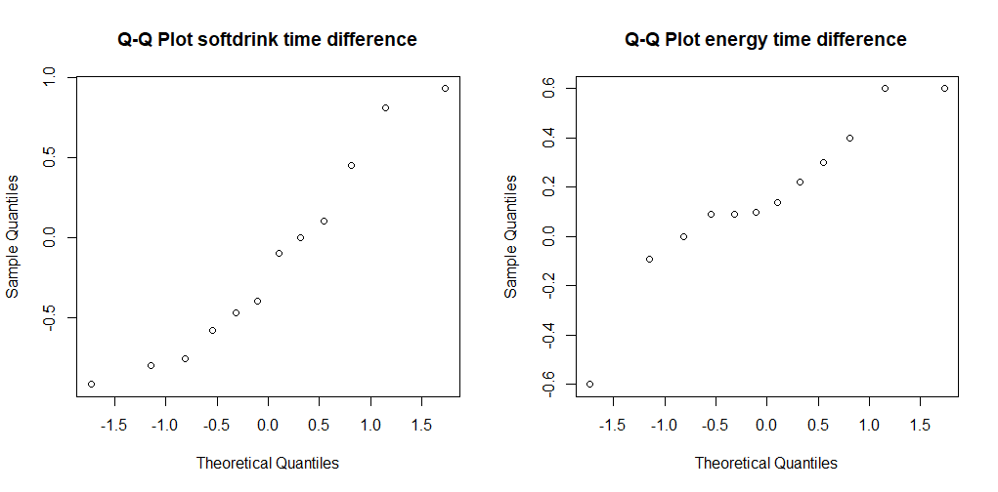

**Figure33. Q-Q plot of soft drink and energy drink time difference**

After Shapiro-Wilk normality test, there is no reason to suspect that the differences are not taken from a normal population. The reason is that p-value of soft drink = 0.3723 > 0.05, and the p-value of energy drink = 0.2788 > 0.05.

**result of** **Shapiro-Wilk normality test on soft drink:**

> shapiro.test(lemo_before-lemo_after)

Shapiro-Wilk normality test

data: lemo_before - lemo_after

W = 0.92927, p-value = 0.3725

**result of Shapiro-Wilk normality test on energy drink:**

> shapiro.test(energy_before-energy_after)

Shapiro-Wilk normality test

data: energy_before - energy_after

W = 0.91913, p-value = 0.2788

**Figure 33, Q-Q plots of energy drink and softdrink group**

**code of (3):**

lemo_before = alldata[which(alldata$drink=="lemo"),"before"]

lemo_after = alldata[which(alldata$drink=="lemo"),"after"]

lemo_difference = lemo_before - lemo_after

energy_before = alldata[which(alldata$drink=="energy"),"before"]

energy_after = alldata[which(alldata$drink=="energy"),"after"]

energy_difference = energy_before - energy_after

t.test(lemo_difference,energy_difference)

shapiro.test(lemo_difference-energy_difference)

qqnorm(lemo_difference,main="Q-Q Plot softdrink time difference")

qqnorm(energy_difference,main="Q-Q Plot energy time difference")

shapiro.test(lemo_before-lemo_after)

shapiro.test(energy_before-energy_after)

1. **plausible objection**

The original design is testing on two different group of students, which is 12 pupils for each. However, we think different student may influence the results. Also, the 60 meters is too short to find the time difference.

We suggest the new design of the experiment:

1. test on the same pupils, randomized and double-blind for drinking softdirnk and energy drink.
2. running on 500 meters
3. **Yes**

The t-test result of 3) also cannot reject H0. The running distance is too short to compute a significant difference between energy drink and soft drink.

1. **normal distribution assumption** on these differences is needed for the analysis in 3).

The vector into 24 residuals to investigate this assumption in QQ-plot is shown on the figure 34.

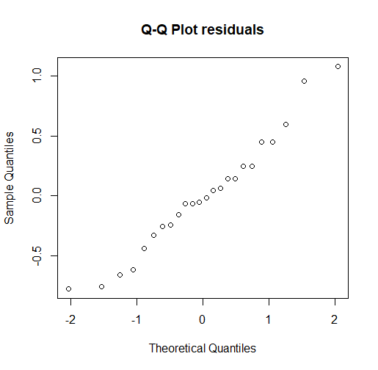

**Figure 34. Q-Q Plot residuals**

**code of (6):**

diff = data.frame(lemo_diff=lemo_difference,energy_diff=energy_difference)

diff_frame= data.frame(yield=as.vector(as.matrix(diff)),variety=factor(rep(1:2,each=12)))

diff_frame[1:12,]

timeonaov= lm(yield~variety,data=diff_frame)

anova(timeonaov)

par(mfrow=c(1,1)); qqnorm(residuals(timeonaov),main="Q-Q Plot residuals")

# EXERCISE 7

1. As the figure 35 shows, the boxplots of 3 samples.

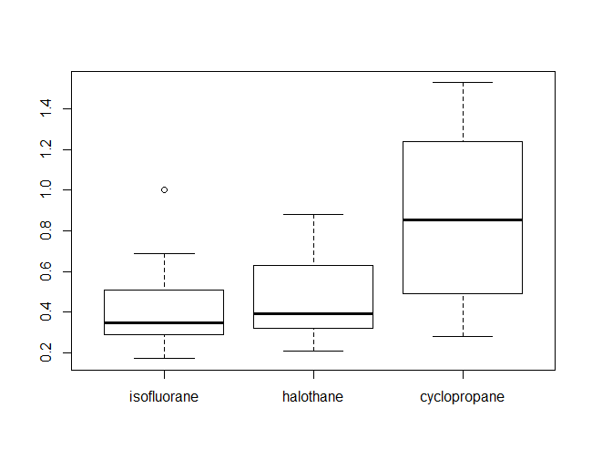

**Figure 35. Boxplots of 3 samples**

As the figure shows, the Q-Q plots of 3 samples. There is no reason to suspect that the two samples are not taken from a normal population.

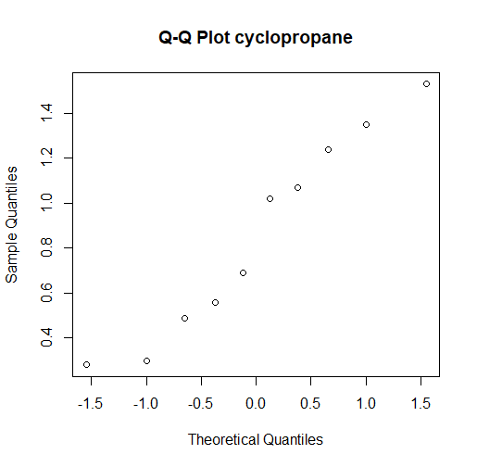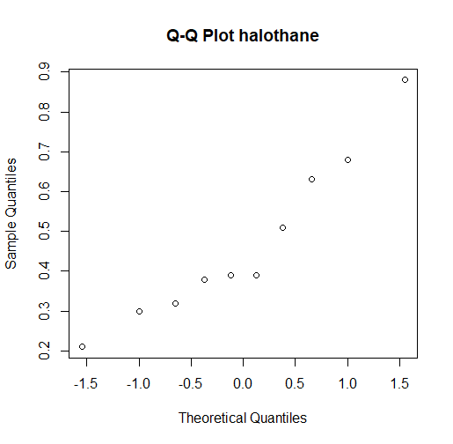

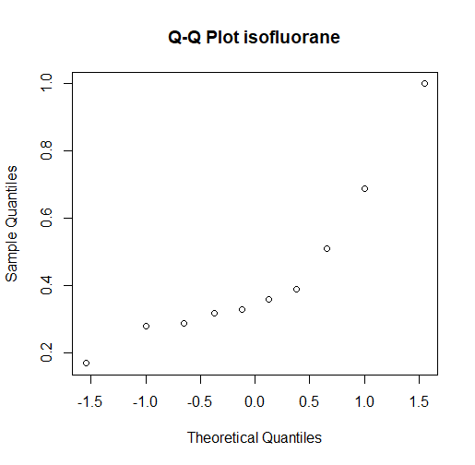

**Figure 36. Q-Q plots of 3 samples**

**code of (1):**

dogs = read.table("dogs.txt", header=TRUE)

isofl = dogs$isofluorane

haloe = dogs$halothane

cyclo = dogs$cyclopropane

boxplot(dogs)

qqnorm(isofl,main="Q-Q Plot isofluorane")

qqnorm(haloe,main="Q-Q Plot halothane")

qqnorm(cyclo,main="Q-Q Plot cyclopropane")

1. **We use one-way ANOVA to test.**

The p-value=0.011< 0.05, so we reject H0. 1-way ANOVA yield significant differences among the three drugs.

**result of ANOVA:**

> anova(dogsonaov)

Analysis of Variance Table

Response: yield

Df Sum Sq Mean Sq F value Pr(>F)

variety 2 1.0808 0.54040 5.355 0.011 *

Residuals 27 2.7247 0.10092

---

Signif. codes: 0 ‘***’ 0.001 ‘**’ 0.01 ‘*’ 0.05 ‘.’ 0.1 ‘ ’ 1

We takes “isofluorane” as a base level and compares the other levels to it. The estimates:

µ ˆ1 =0.4340; µ ˆ2 − µ ˆ1 = 0.0350; µ ˆ3 − µ ˆ1 = 0.4190;

Therefor, estimate of “isofluorane” is 0.4340; estimate of “halothane” is 0.4690; estimate of “cyclopropane” is 0.8530.

**result of summary:**

> summary(dogsonaov)

Call:

lm(formula = yield ~ variety, data = dogs_frame)

Residuals:

Min 1Q Median 3Q Max

-0.5730 -0.1608 -0.0790 0.2000 0.6770

Coefficients:

Estimate Std. Error t value Pr(>|t|)

(Intercept) 0.4340 0.1005 4.320 0.000189 ***

variety2 0.0350 0.1421 0.246 0.807266

variety3 0.4190 0.1421 2.949 0.006504 **

---

Signif. codes: 0 ‘***’ 0.001 ‘**’ 0.01 ‘*’ 0.05 ‘.’ 0.1 ‘ ’ 1

Residual standard error: 0.3177 on 27 degrees of freedom

Multiple R-squared: 0.284, Adjusted R-squared: 0.231

F-statistic: 5.355 on 2 and 27 DF, p-value: 0.011

**Diagnostics:**

The Q-Q plot is shown on the figure 37.

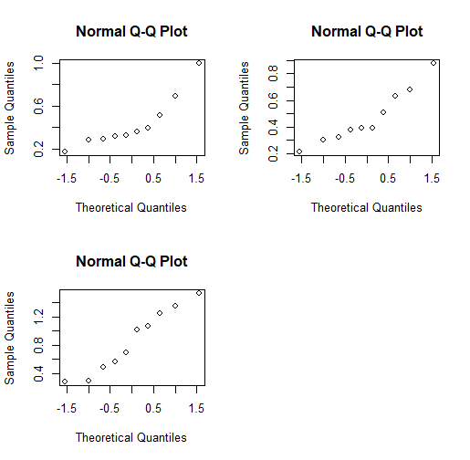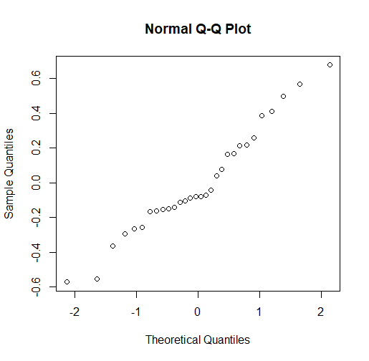

**Figure 37. Q-Q plots of three drugs**

Because the 3 samples are small, separate QQ-plots are not so useful. The second plot, using residuals, uses all 30 points, but corrected for being sampled from different populations. The residuals don’t seem to deviate significantly from normal.

**code of (2):**

dogs_frame = data.frame(yield=as.vector(as.matrix(dogs)),variety=factor(rep(1:3,each=10)))

dogsonaov=lm(yield~variety,data=dogs_frame)

anova(dogsonaov)

summary(dogsonaov)

confint(dogsonaov)

par(mfrow=c(2,2)); for (i in 1:3) qqnorm(dogs[,i])

par(mfrow=c(1,1)); qqnorm(residuals(dogsonaov))

1. **Kruskal-Wallis test**

As the Kruskal-Wallis test shows, the p-value=0.05948>0.05, we cannot reject H0. There is not a significant difference among the three drugs.

> kruskal.test(worms,group)

Kruskal-Wallis rank sum test

data: worms and group

Kruskal-Wallis chi-squared = 5.6442, df = 2, p-value =

0.05948

The reason why there is a difference between the two test is that ANOVA is value-based, but Kruskal-Wallis is rank based. ANOVA can analyze normal distribution, but Kruskal-Wallis is suitable for non-normal distribution.

From Shapiro-Wilk normality test, "halothane" and "cyclopropane" samples are normal distribution. However, "isofluorane" is non-normal distribution.

> shapiro.test(isofl)

Shapiro-Wilk normality test

data: isofl

W = 0.83093, p-value = 0.03434

> shapiro.test(haloe)

Shapiro-Wilk normality test

data: haloe

W = 0.9234, p-value = 0.3862

> shapiro.test(cyclo)

Shapiro-Wilk normality test

data: cyclo

W = 0.93334, p-value = 0.4815

**code of (3):**

dogframe=data.frame(worms=as.vector(as.matrix(dogs)),group=as.factor(rep(1:3,each=10)))

attach(dogframe)

kruskal.test(worms,group)

shapiro.test(isofl)

shapiro.test(haloe)

shapiro.test(cyclo)