**EXERCISE 3**

We use incomplete block design by formula ‘acidity ~ starter + batch + position’, because we do not interest about the batch and position.

First, we study the boxplot of “acidity~batch”, “acidity~position”, “acidity~starter”. We can find starter 4 has a larger acidity than others.

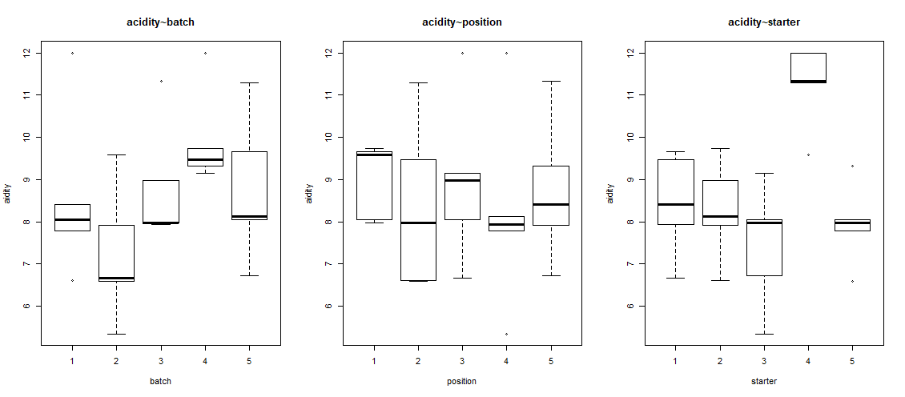

**Fig. boxplot of “acidity~batch”, “acidity~position”, “acidity~starter”**

Then, we show the interaction plot between starter~position and starter~batch.

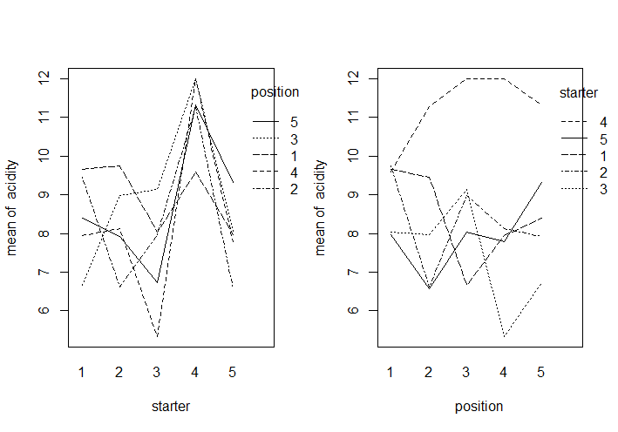

**Fig. interaction plot between starter~position**

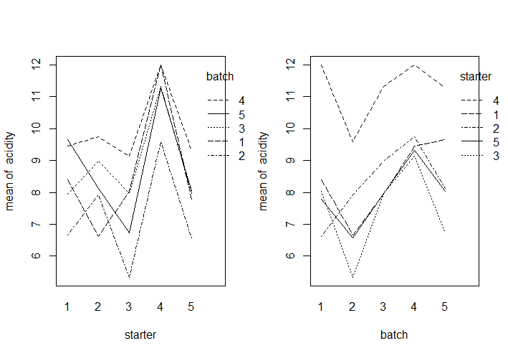

**Fig. interaction plot between starter~batch**

Next, we do the Anova. The starter effects are significantly different from 0 (significant influence on acidity) (p<0.05, reject H0). The batch are also significantly different from 0 (significant influence on acidity) (p<0.05, reject H0), but this was not the research question. The position effects are not significantly different from 0 (p>0.05, cannot reject H0).

**Result of Anova:**

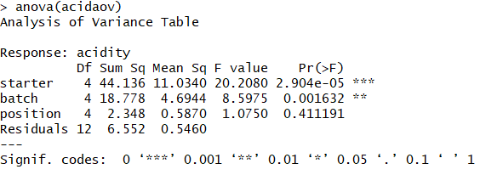

Finally, we get the summary. The acidity of starter4 is 2.8 higher than starter1. Also, the p-value of starter2 is much less than 0.05 (we cannot reject H0).

Starter4 has significant difference between starter1 on the acidity. Batch2 and batch4 also have significant difference between batch1 on the acidity, but we do not interest about the batch and position.

**Result of summary:**

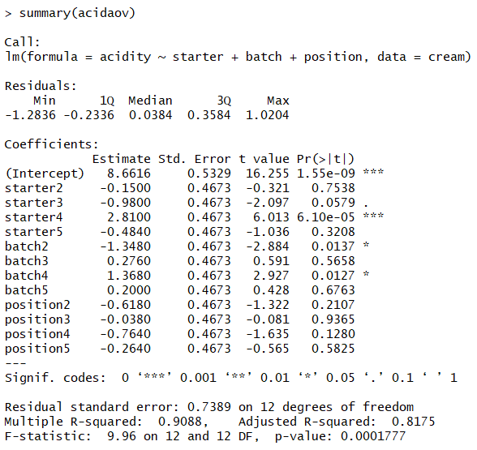Code of 3.1:

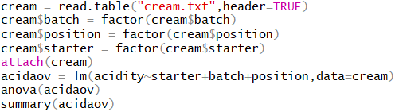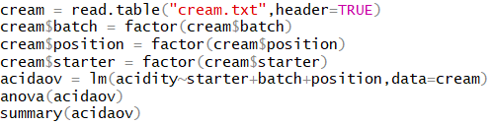

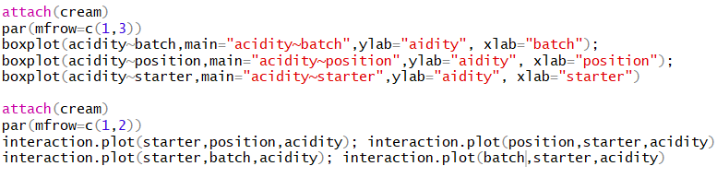

We use multiple testing and comparisons to get the table of p-value. We can find that starter4 leads to significantly different acidity, because the p-values of “4-1”, “4-2”, “4-3”, “5-4” all less than level 5%. We reject the H0, so starter4 is significantly different from all other starters. Starter4 leads to significantly different acidity.

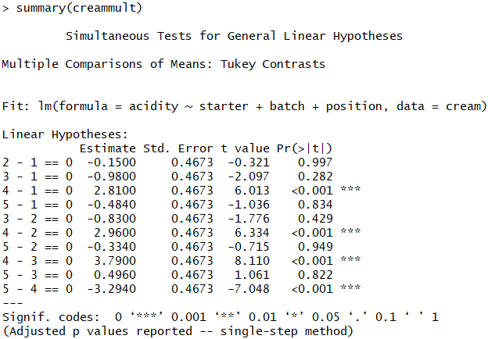

Code of 3.2:



It means there is no significant difference between p-value (p-value=0.997) of “2-1” in question (2) and p-value (p-value=0.754) of starter2 in question (1). We can find p-value of ‘2-1’ is smaller than the simultaneous p-value (0.997), and it is not a coincidence. The reason is that simultaneous confidence intervals have confidence level of 95%.

**3.4**

From the table of confidence intervals, we can find the intervals of [1.3204, 4.2996], [1.4704 , 4.4496], [2.3004 , 5.2796], [-4.7836 ,-1.8044] (4-1, 4-2, 4-3, 5-4) are not contain the number 0. Therefore, the starter4 lead to significantly different between other starters.

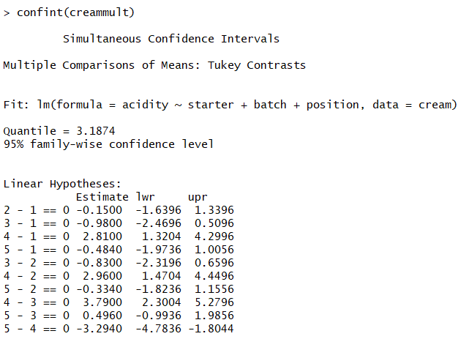

Code of 3.4:



**EXERCISE 4**

**4.1**

Fixed Effects: There is not a significant treatment (feeding stuff) effect, because the treatment p-value=0.75>0.05. There is no significant influences milk production by the type of feeding stuffs.

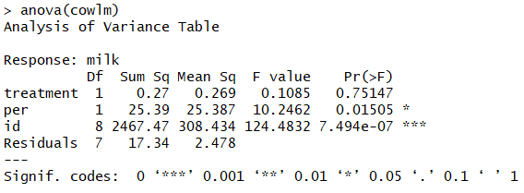

Code of 4.1:

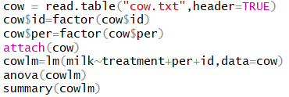

**4.2**

As the results shown on 4.1, There is no statistically significant feeding stuff effect on milk. The feeding stuff B gives 0.51 less than feeding stuff A. Also, the p-value of treatment is 0.51>0.05 (cannot reject H0). There is a statistically significant period effect. Period 2 gives 2.39 less than period 1. There is also a statistically significant cow(=id) effect. For example, id2-cow gives 23 more than id1-cow, but we do not interest on the id effects.

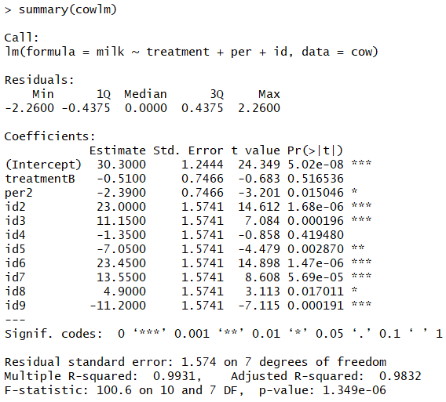

Code of 4.2:



**4.3 crossover design with random effects**

The number 133.14 under Random effects is the estimated variance of the normal population of the “individual effects” (bn).

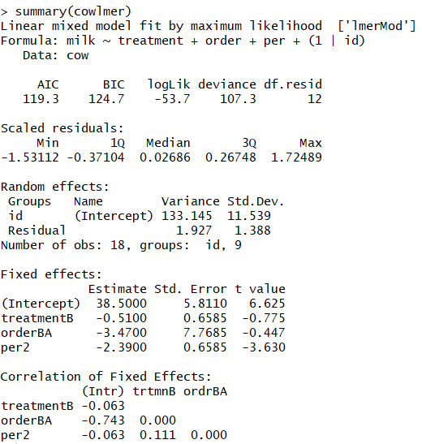

By applying anova with 2 arguments, we found that there is no significant effects by treatment (feeding stuff).

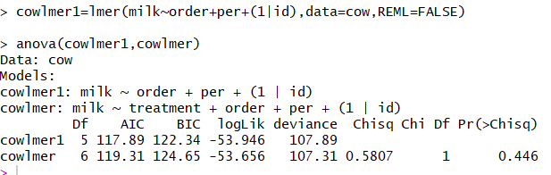

The estimated treatment and period effects under Fixed effects are identical to those in the result of 4.1. The difference between the “fixed effects” and “mixed effects” is minor. Also, we got the similar result: There is no significant influences milk production by the type of feeding stuffs.

Code of 4.3:

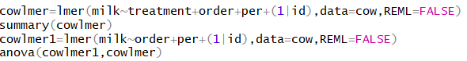

**4.4**

From paired t-test, we can find the p-value=0.82>0.05, so we cannot reject H0 which means feeding stuff A and B do not have significant influence on the milk production. It is not a valid test for a difference in milk production, because this test cannot consider the period effects. When we delete the period effects on 4.1, we can get a similar p-value with the paired t-test. It has the similar result with 4.1.

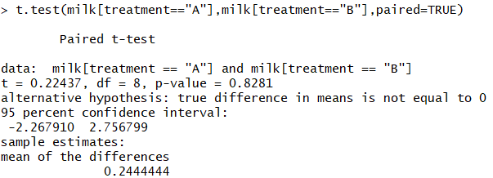

Code of 4.4:



**EXERCISE 5**

**5.1**

We a nausea vector which 0 means incidence of no nausea and 1 means incidence of nausea. We also build a medicin vector. Finally, we build a data.frame by combine the two vectors.

Code of 5.1:

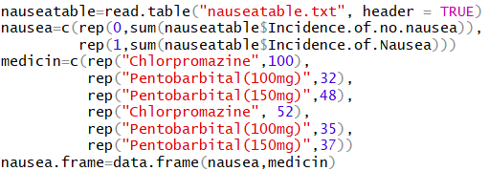

**5.2**

We can find the xtabs has the same result with the original file, which the rows show the 3 different medicins and 2 columns show the nausea.

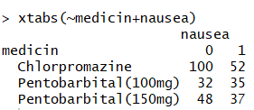

Code of 5.2:



**5.3**

Permutation test results show that the pr=0.041<0.05 (reject H0), and the pl=0.959>0.05 (cannot reject H0). Therefore, different medicins do not work equally well against nausea.

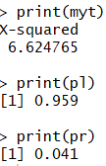

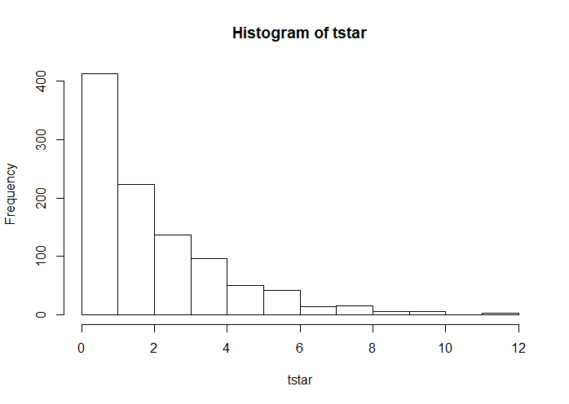

**Fig. Histogram of tstar**

Code of 5.3:

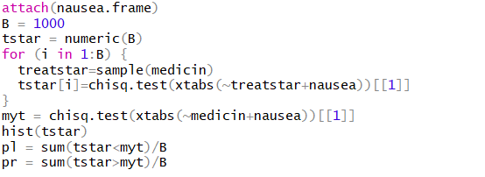

**5.4**

There is a difference between the p-value found by the permutation test with the p-value

found from the chisquare test for contingency tables. For small sample, permutation test is more accuracy.

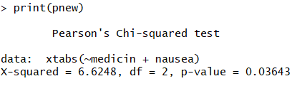

Code of 5.4:

