**EXERCISE 3**

**3.1**

Firstly, we change the n. The number of times an event occurs in an interval increase with the n increasing.

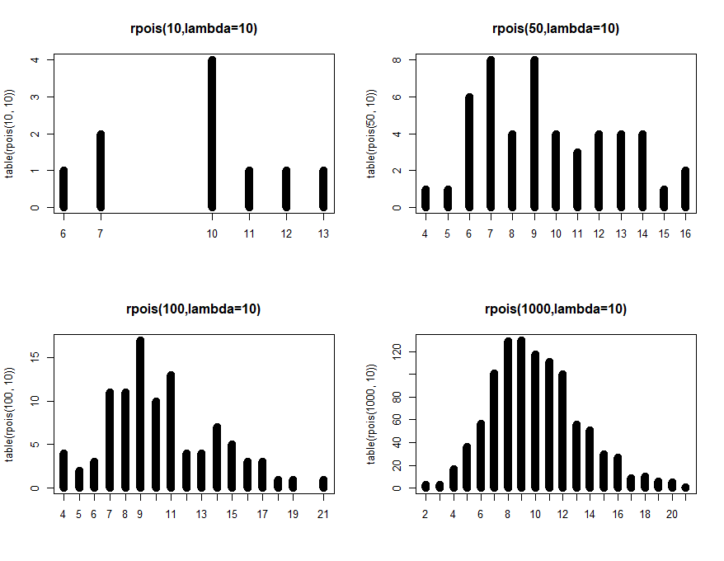

**Fig. change the n 10, 50,100, 1000**

Secondly, we change the lambda from 2 to 20.

we can find that with the lambda increasing, the distribution is more like normal distribution, which means for very large λ the Poisson(λ)-distribution is approximately equal to a normal distribution with mean µ = λ and variance σ2 = λ.

Then, the mean of distribution increase with the larger λ value. The mean and variance of the Poisson-distribution both equal λ. Hence, the larger the parameter, the larger the values of Y on average and the larger the spread in the values of Y. 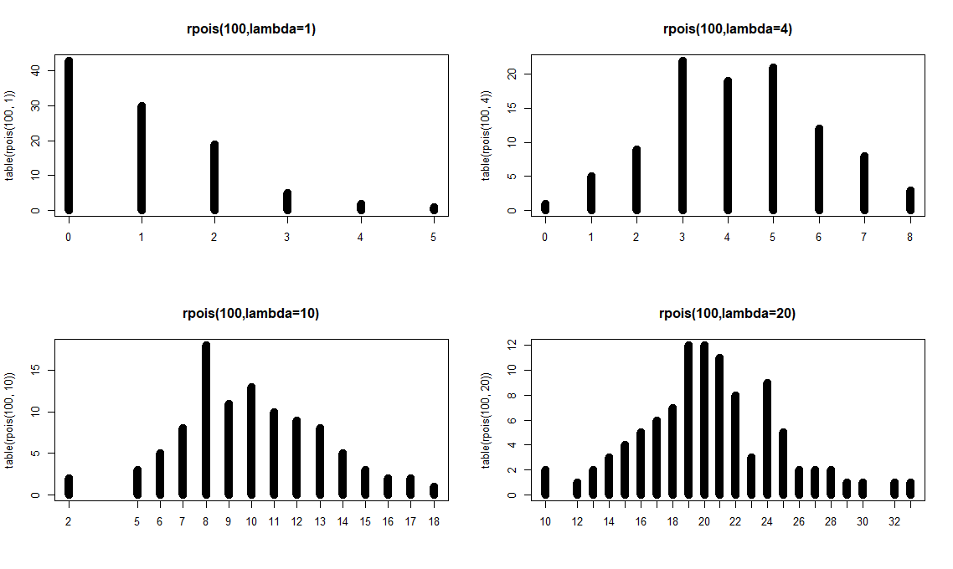

**Fig. change the lambda 2, 4,10, 20**

Code of 3.1:

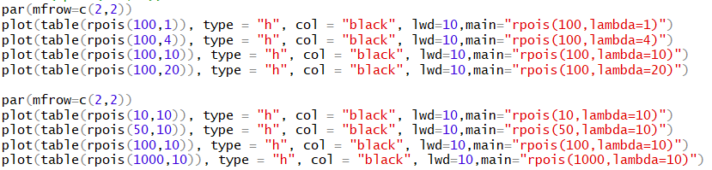

**3.2**

The random variable X and distribution function of Y = a + b X also belongs to the location scale family. In Poisson-regression, the parameter λ is modelled as: log λ = β0 + β1X1 + . . . βpXp. where the expression on the right indicates the combination of explanatory variables.

For each observation Y the parameter λ is modelled differently, since the corresponding values of X1, . . . , Xp will differ in general. Hence, the variances in different observations are different as well. This means that residuals Yn − Y ˆn do not come from one fixed distribution. Therefore, a normal QQ-plot of these response residuals is not useful!)

Instead, the deviance residuals are useful for diagnostic plots. Deviance is a measure of the discrepancy between the full model and the model under consideration. Deviance residuals are response residuals scaled by the deviance of that observation.

**3.3**

First, we study the collinearity. We can see some collinearity between the miltcoup and other explanatory variables.

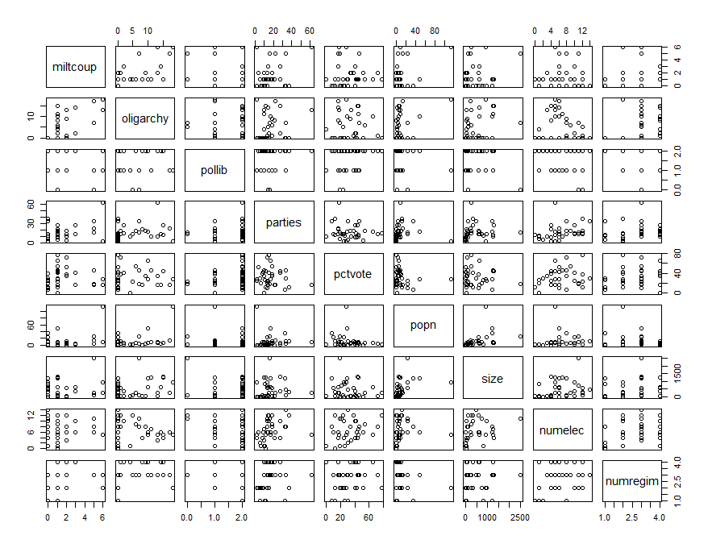

**Fig. collinearity of Africa**

Then, from summary we can find that oligarchy, pollib, parties have significant effet on number years country ruled by military oligarchy (p-value <0.05, reject H0). The positive signs of the parameter (oligarchy, parties) estimates mean that higher values of these variables give higher numbers of muiltcoup. Oppositely, negative signs of the parameter (pollib) estimates mean that lower values of these variables give lower numbers of muiltcoup.

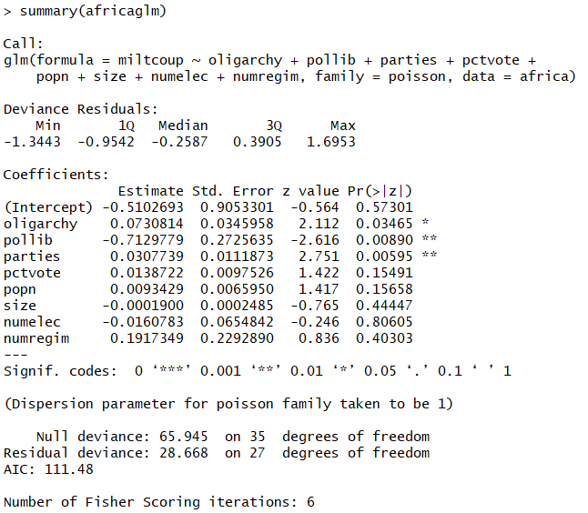

The output shows 95 % confidence intervals.

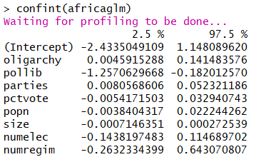

The coefficients table shows that oligarchy, parties and numregim have positive relevant with number years country ruled by military oligarchy. Pollib has negative relevant with number years country ruled by military oligarchy.

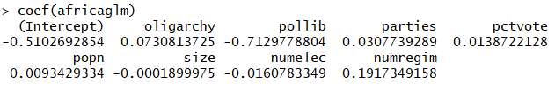

Code of 3.3:

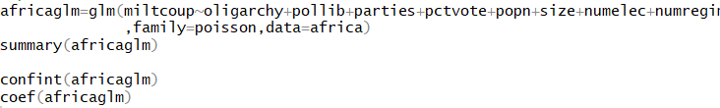

**3.4**

We use step down approach to reduce the step-down approach. Finally, all explanatory variables (oligarchy, pollib, parties) in the model are significant.

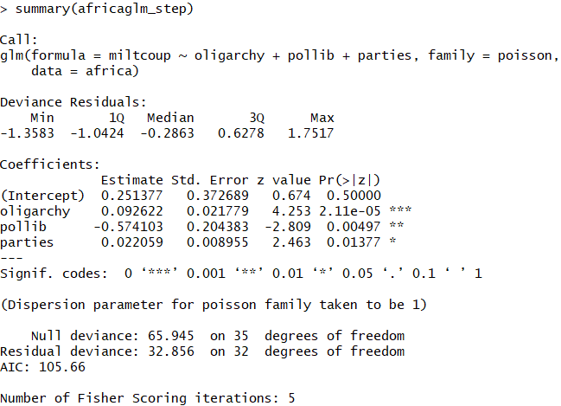

Code of 3.4:



**3.5**

We do some diagnostics on the model in part (4).

First, we use default the residuals of a glm object are the so-called deviance residuals, which should have equal variance.

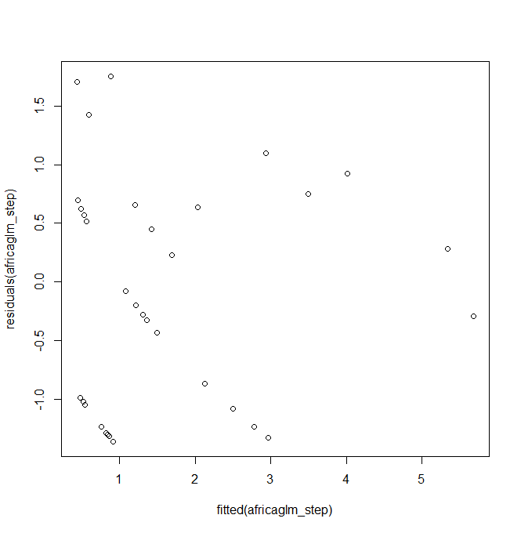

**Fig. fitted(africaglm_step) and residuals(africaglm_step)**

Then, we fitted the x-values by a linear function in the plot. This plot does not have not specific structure.

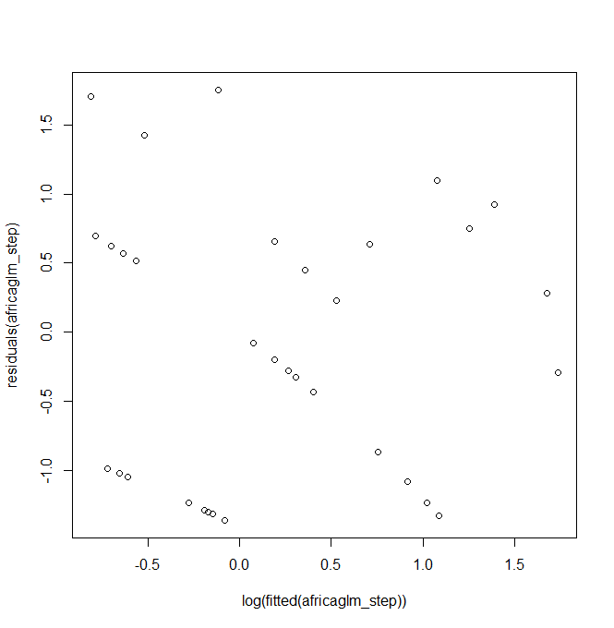

**Fig. log(fitted(africaglm_step)) and residuals(africaglm_step)**

Next, the response residuals also do not have not specific structure.

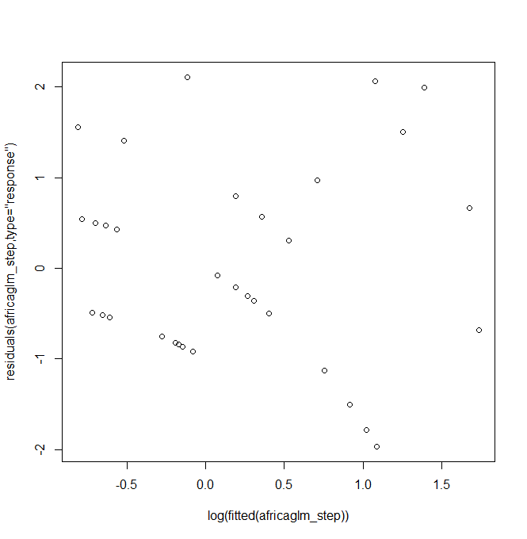

**Fig. log(fitted(africaglm_step)) and residuals(africaglm_step,type="response")**

Finally, we check the full model, but we find the similar result. Therefore, it is not due to deleting too many variables

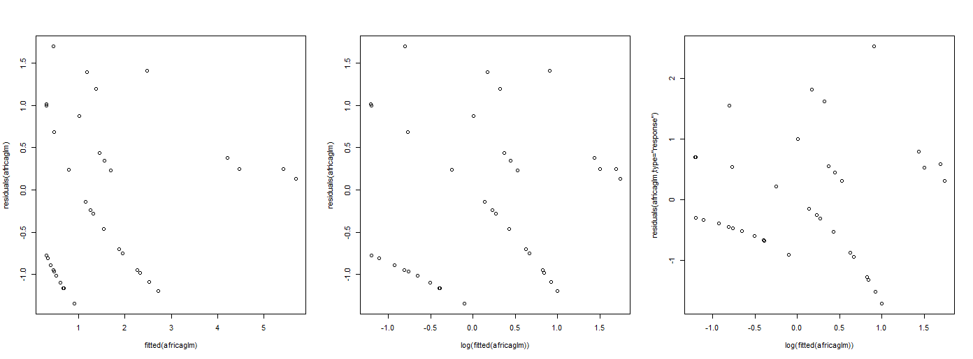

**Fig. Full Model**

Code of 3.5:

