**Task 8**

Because all values of cook distance are smaller than 1, there is no influence point.

The result of cook distance:

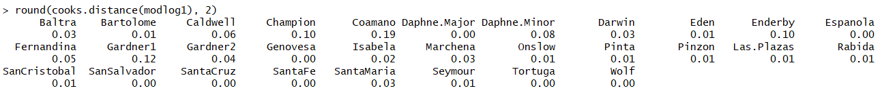

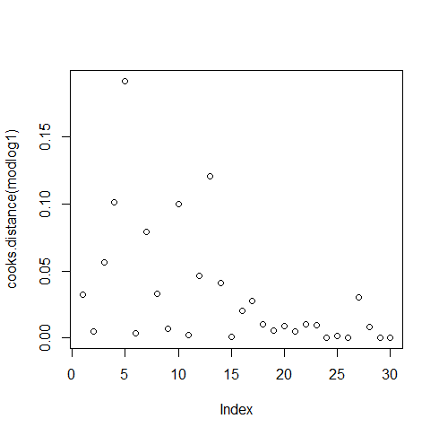

Figure values of cook distance

As the Q-Q plot shown, the distribution of residuals is normal distribution.

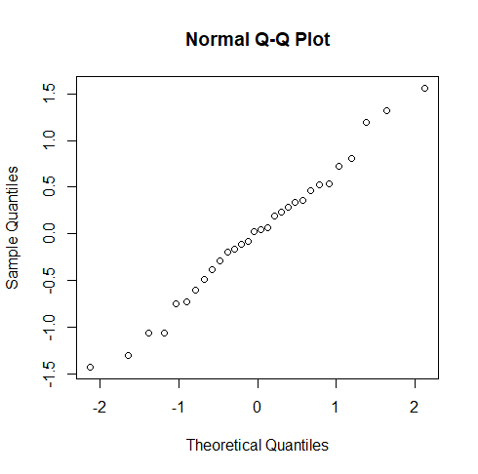

Firgure qqnorm plot of the residuals

From the plot of residuals versus fitted values, we can see there is scattered and no obvious structure, so there is no significant relation between the residuals and fitted values.

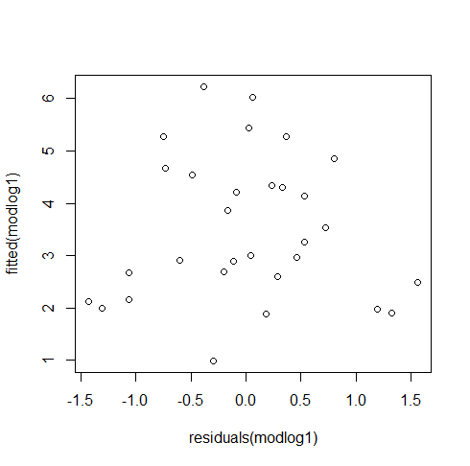

Figure Residuals versus fitted values

Code of 8:

