population_stability = {Normalized[min:0,max:1]:people working/population)*100(} + {Normalized[min:0,max:1]:(people moving to/people moving away)*100}

safety = safety_index

living condition score = (a*population stability)+(b*safety)

**10th March**: finish all sub graph basic

finish map basic

**15th March:** add all dynamic (change by year and district)/ beautiful

combine all sub graph(sub-graph should be small and on the bottom)

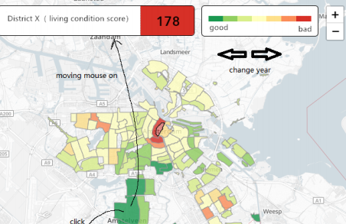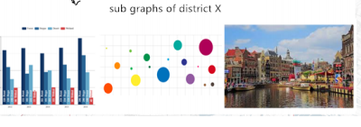

(For subgraph: add year button and districts buttons)

**17th March: c**ombine map+subgraph

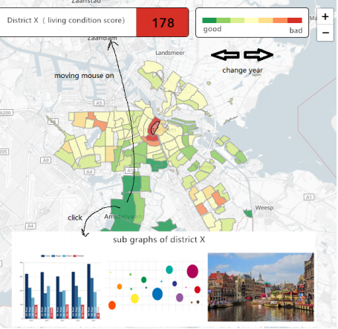

**30th March:** finish report