**ELCT222 HW1 P-SPICE Exercise**

1. Go to Example 10.6 in the textbook. For your convenience, the schematic is reproduced here.

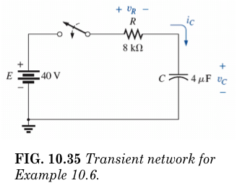

In P-SPICE, simulate the transient response of this circuit. (60%)

a) Plot the capacitor voltage as a function of time (20%)

b) Plot the capacitor current as a function of time. (20%)

Please attach your circuit schematic and plots. Please annotate things by hand the best you can, so that we know what’s what, and don’t have to dig through your papers. The burden of proof is on YOU to show us that you’ve answered the questions.