ELCT222 HW 2: Pulses and Compensation for O-scope.

Today, we will simulate a capacitor compensation for an oscilloscope. It’s a simple circuit, with two series banks of parallel RC combinations. This is depicted in Figure 24.42.

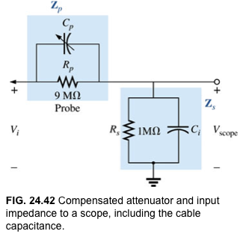

If Ci=30pF, make a 10us pulse for Vi. Rise times can be ns (see textbook). Plot the transient response to this pulse for Cp=1pF. Modify Cp until you can make the shapes of the input and output the same. What do you notice about this value of Cp? Show the results for 3 values of Cp to show how this compensation affects the circuit.