**ELCT222 HW4**

**RLC Circuit and Resonance (Total 200)**

1. Consider the following series RLC circuit.

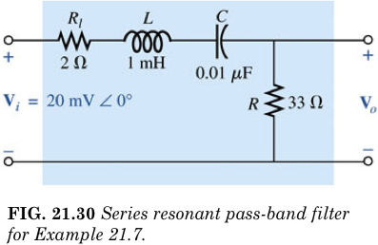

1. Using MATLAB, plot the magnitude of Vo as a function of frequency. You can choose f or ω. Just make sure you get the units right. Now change R=33Ω to 100Ω. Plot V0 now on the same axes. Change R to 1kΩ and replot on the same axes. Describe qualitatively what happens to the resonance. In MATLAB, you can hold the plots by using the ***hold on*** call in your code. (30)
2. What is the bandwidth for each of the cases in a)? Remember the cutoffs are determined as 0.707 of the PEAK, not 0.707 of the input. What is the Q factor for each of the cases? Remember **Q=resonance frequency/bandwidth.** Qualitatively describe in 1 sentence what Q factor represents. Use the cursor function in MATLAB to do this. (20)
3. Come back to R=13Ω. Using MATLAB, plot the phase of the gain Vo/Vi as a function of frequency. On the same axes, plot the phase of Vo. What is the difference? (20)
4. Do the plots in a) and c) using 5SPICE. Compare the results with the MATLAB ones. Comment on any differences. (30)

For the following problems, I recommend you use MATLAB to help you with your calculations. However, I want to see the plots etc. in your problem write-up, not attached separately.

1. Boylestad Chapter 21 Problem 22 (20)
2. Boylestad Chapter 21 Problem 25 (20)
3. Boylestad Chapter 21 Problem 29 (20)
4. Boylestad Chapter 21 Problem 30 (20)
5. Describe in a paragraph the physical process responsible for creating resonance in an RLC circuit. Basically, I want to see a summary of what I talked about in class. Write this in complete sentences. Simply stating an equation is not acceptable. (20).