1. The value for an for ll n is zero
2. 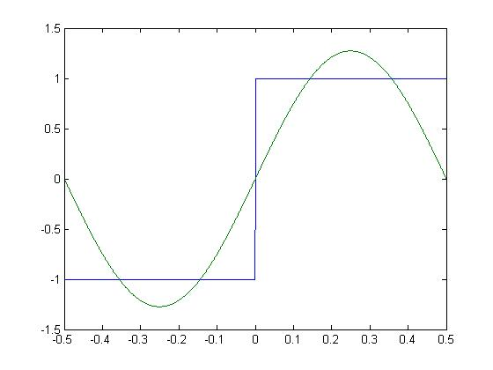With n =1
3. With n = 3

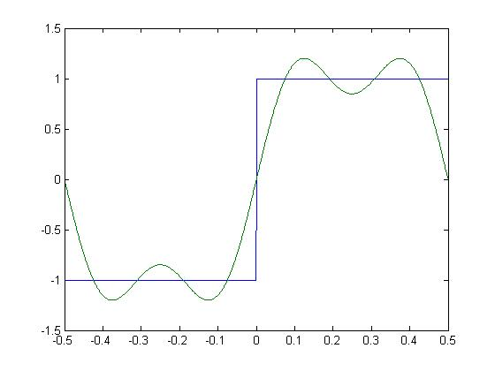

1. 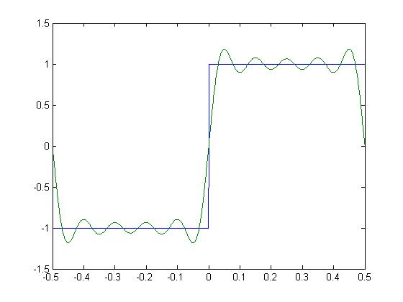With n = 10
2. With n equaling 10, this seems to be an accurate enough measurement of the square wave. The voltage fluctuates about 0.2 volts. We can create an error margin with this number by using the absolute value of what the voltage is supposed to be which is one in this case, and use the error percentage equation to get 80%. This needs to be subtracted by 100% in order to get the error percentage which is 20%.