**Laboratory Grade**

Lab demonstration grade: _______ of 100

Lab report grade: _______ of 100

Student comments:

Grader comments:

**Class B and Class AB Audio Amplifier Operating Open-Loop and Closed-Loop**

1. Introduction

This lab studies the class B and class AB audio amplifiers. Amplifiers are used to increase the power of a signal [1]. The power coming from a typical audio player is low and needs to be amplified in order to drive large speaker systems that can be thousands of watts in power [2]. In this lab, class B open and closed loop as well as the class AB closed loop amplifiers will be studied. Each circuit will be built then the total harmonic distortion of each audio amplifier circuit will be calculated. The total harmonic distortion or THD is a measurement that describes the distortion in a signal when it has been amplified [3].

1. Theory

The human ear can hear in a frequency range of 20 Hz to about 20 kHz and hears in a logarithmic scale measured in decibels [4]. The decibel or dB is expressed in equation 1 where is the output voltage of a circuit and is the input voltage of the same circuit:

|  |  |
| --- | --- |
|  | (1) |

Measuring human hearing in decibels allows for easy measurement because humans can detect change in sound intensity in one decibel increments [5]. In an audio amplifier, the job of amplifying a signal is split into two parts; the voltage amplification and the current amplification [6]. An operational amplifier is used for the voltage gain stage. The operational amplifier is configured as a non-inverting configuration and the gain is given by equation 2:

|  |  |
| --- | --- |
|  | (3) |

The current amplification stage of an audio amplifier is created by NPN and PNP transistors in a Darlington configuration. A Darlington configuration is when two bipolar transistors of the same type are stacked on each other with the emitter output of one transistor connected to the base of another transistor. This allows the current amplified by the first transistor to be further amplified by the second transistor [6]. In a class A amplifier, the transistors bias the input signal just enough for the peak to peak voltage of the signal to be in the positive region at all times [7]. This allows for one transistor to be able to amplify the entire signal and removes the chance of distortion. Unfortunately, one transistor used to amplify an entire signal causes an immense amount of heat. The efficiency of a standard class A amplifier is as low as 25 percent [8]. A class B amplifier on the other hand, uses two transistors to split up the work [9]. The signal is split up where the positive voltage of the input signal goes to one transistor and the negative part goes to another transistor. This split of the work to amplify the signal leaves the class B amplifier with an efficiency of up to 78 percent [10]. The problem occurs when the input signal crosses the zero volt threshold to switch transistors [11]. Transistors only react when the input voltage to the base reaches about 0.7V [12]. This causes a dead zone of no signal output from about -0.7V to 0.7V. This is a large area where there is no amplification and causes a large distortion. A class AB amplifier uses both class A and class B characteristics. As in the class A amplifier, the signal is biased just enough for the entire signal to be in the positive region. The all positive voltage signal is then split up from the bias point to be amplifier by two transistors just as in the class B amplifier [13].

Both the class B and the class A amplifiers still have the problem of the transistor turn on voltage of 0.7V. To get rid of this, diodes and bias resistors are used [14]. Another way to help with the efficiency and THD of an amplifier is to change the gain loop. The 25 times gain from the op amp in the first stage of an audio amplifier is fed back from the output of the op amp. Changing the feedback from the output of the op amp to the output of the transistors allows for the voltage amplification to be based after the biasing of the transistors. This closed-loop configuration reduces distortion and therefore increases efficiency [15]. In order to calculate the THD, equation 4 will be used:

|  |  |
| --- | --- |
|  | (4) |

1. Experimental

The first amplifier that was built was the class B open-loop amplifier. The schematic for the setup is given in Figure 1:

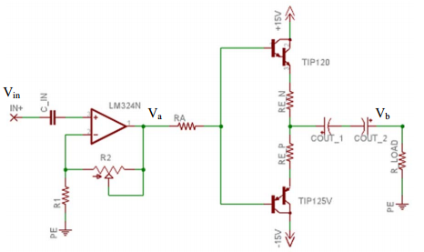

Fig. 1 The schematic for a class B open-loop audio amplifier.

A few components’ values were given already. The capacitor is to create a high pass filter to keep DC signals from reaching the speaker and damaging it. It was given a value of 0.1 µF. The resistor was given with a resistance of 510 Ω. A gain of 25 was needed for the op amp and values of 1 kΩ and 24 kΩ were given to resistors and respectively. and were both given the value of 2.7 Ω. Finally, two coupling capacitors were installed at the output of the transistors to also filter out DC signals. They were both given a value of 470 µF. With this configuration setup, the input and output voltage signals of the op amp were recorded through the oscilloscope. The TIP 120 and TIP 125 voltages were also recorded to show the split of the voltage signal to the two transistor pairs. Lastly, the output voltage signal was recorded.

The next amplifier configuration built was the class B closed-loop. All component values are the same but the feedback of the op amp is changed to the output of the transistors. This can be seen in Figure 2. The input and output voltage of the op amp as well as the voltages of the transistors were recorded in an oscilloscope. The output voltage signal of the amplifier configuration was then recorded.

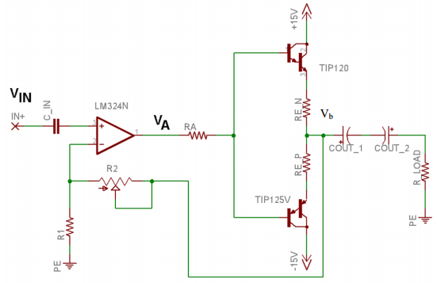

Fig. 2 The schematic for the class B closed-loop audio amplifier.

Lastly, the class AB closed-loop audio amplifier was built. The biasing diodes used were the 1N4148. The and resistors to bias the 0.7V were given a value of 40 and 1400 Ω respectively. A schematic of the class AB closed-loop audio amplifier is seen in Figure 3. The input and output voltage of the class AB configuration of the op amp was recorded along with the magnitude of the first ten harmonics.

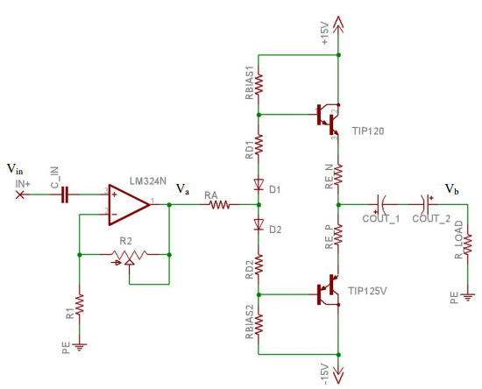

Fig. 3 The schematic for a closed-loop class AB audio amplifier.

1. Results

Simulations of each amplifier type were made in PSpice. The class B closed-loop amplifier simulations are seen in Figure 4 and Figure 5. In Figure 4, The lowest graph is the input signal and is recorded as 400 mV peak-to-peak with a frequency of 1 kHz. The middle graph in Figure 4 is the output of the op amp with a gain of 25. Finally, the top graph is the output of the class B closed-loop amplifier.

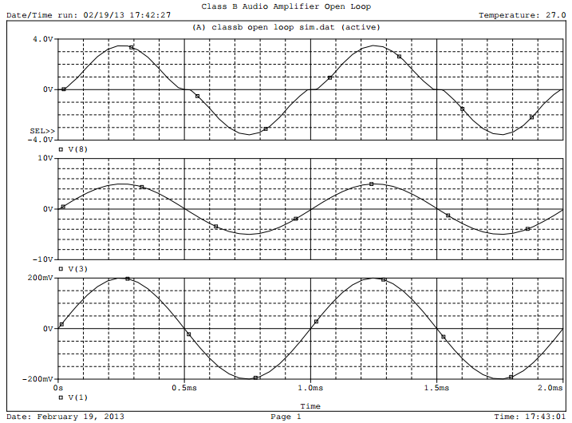

Fig. 4 The input/output voltage of the op amp and output of the class B closed-loop circuit

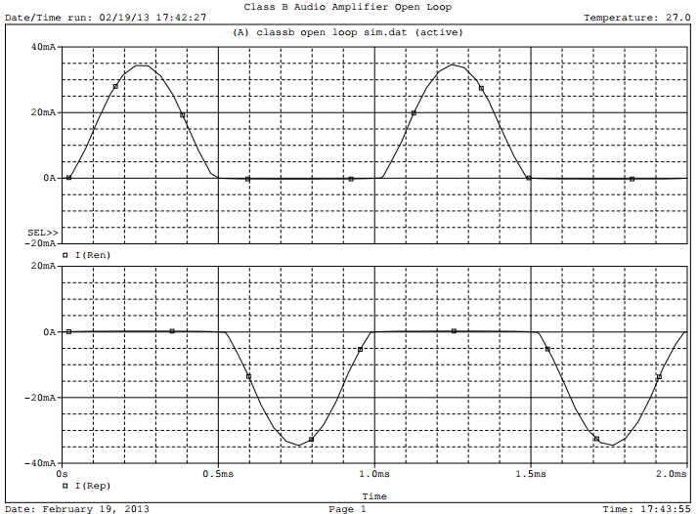

Fig. 5 The output of each transistor of the class B closed-loop amplifier.

In Figure 5, the lower graph is the output current of the PNP Darlington configuration. This portion of the circuit handles the negative part of the input signal. In the upper graph in Figure 5, the output current of the NPN Darlington configuration is printed. This part of the circuit handles the positive portion of the input signal.

For the class B open-loop amplifier, the simulations are in Figure 6 and Figure 7. In Figure 6, the lower graph represents the input signal also at 400 mV peak-to-peak. The middle graph is the output signal of the op amp with a gain of 25. The top graph in Figure 6 is the final output signal of the circuit. In Figure 7, the lower graph is the output current of the PNP Darlington configuration. This portion of the circuit handles the negative part of the input signal. In the upper graph in Figure 7, the output current of the NPN Darlington configuration is printed.

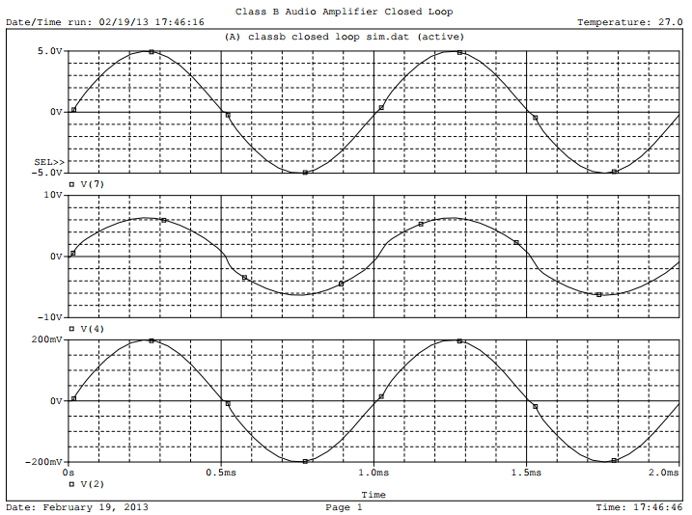

Fig. 6 The input/output voltage of the op amp and output of the class B open-loop amplifier.

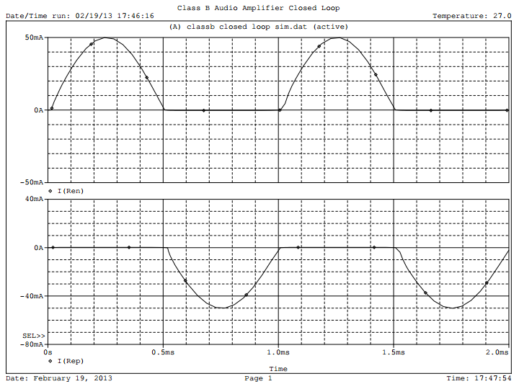

Fig.7 The output current of each transistor set in the class B open-loop amplifier.

The final simulations made were for the class AB amplifier configuration. These simulations are seen in Figure 8 and Figure 9. In Figure 8, the lower graph is the input signal. The middle graph is the output signal of the op amp. The top graph is Figure 8 is the output signal of the entire circuit. In Figure 9, the lower graph is the output current of the PNP Darlington configuration. In the upper graph in Figure 9, the output current of the NPN Darlington configuration is printed.

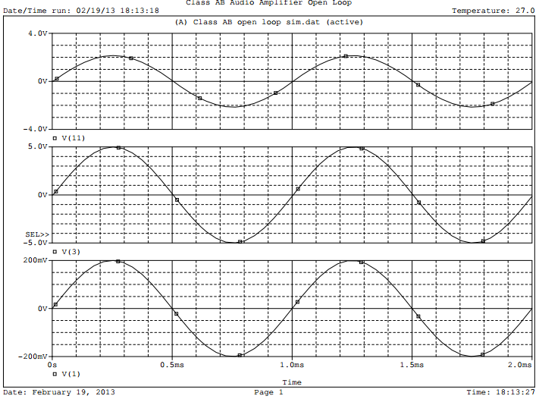

Fig. 8 The input/output of the op amp and the output of the class AB open-loop circuit.

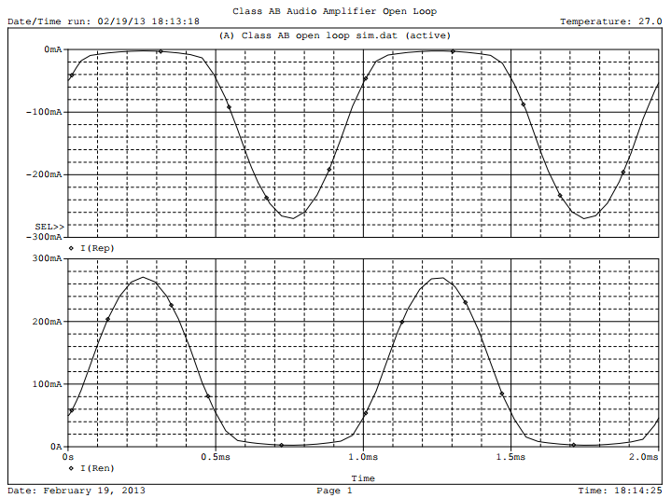

Fig. 9 The output current of each transistor set in the class AB open-loop amplifier.

The class B closed-loop amplifier input and output signals from the op amp are seen in Figure 10. The lower signal is the input signal and the upper signal is the output signal of the op amp.

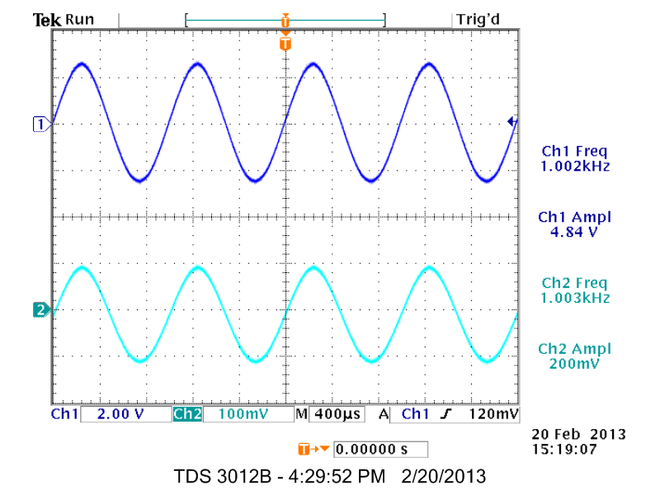

Fig. 10 The input and output voltages of the op amp in a class B closed-loop amplifier.

For Figure 11, the input signal is shown at the top and the overall output signal is shown at the bottom. A large distortion in the output signal can easily be seen in this graph. Finally, in Figure 12, the fast Fourier transform is seen with the first ten harmonics at 1 kHz.

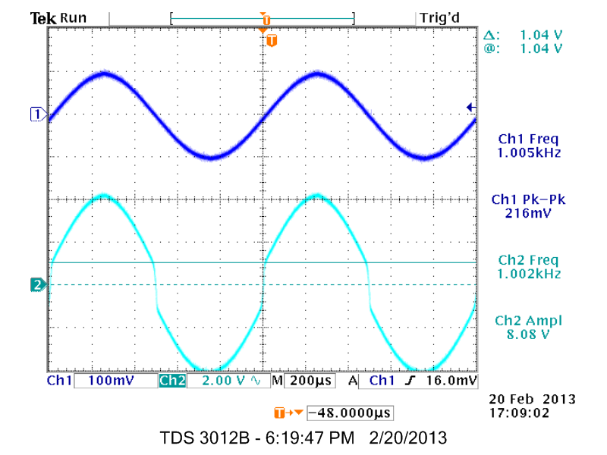

Fig. 11 The input and output signal of the class B closed-loop amplifier.

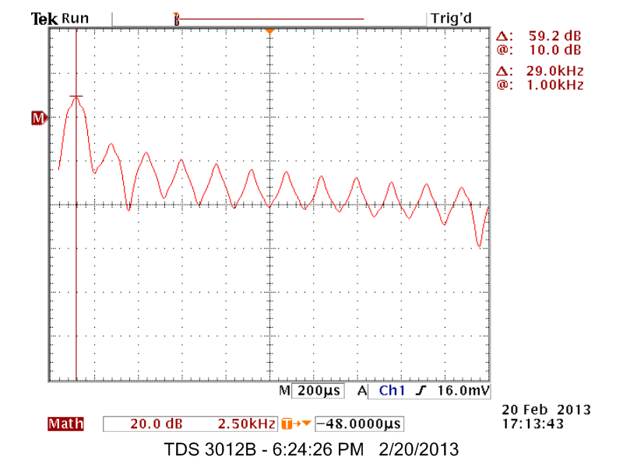

Fig. 12 The fast Fourier transform of the class B closed-loop amplifier

Next, the class B open-loop amplifier was built. The input and output signal of the op amp is seen in Figure 13. The lower signal is the input at 400mV peak-to-peak and the top signal is the output of the op amp at a gain of 25. In Figure 14, the output of the op amp signal is seen at the top while the output of the circuit is at the bottom of Figure 14. A smaller but still rather large distortion is still in the output of the class B open-loop circuit.



Fig. 13 The input and output of the op amp in a class B open-loop amplifier.

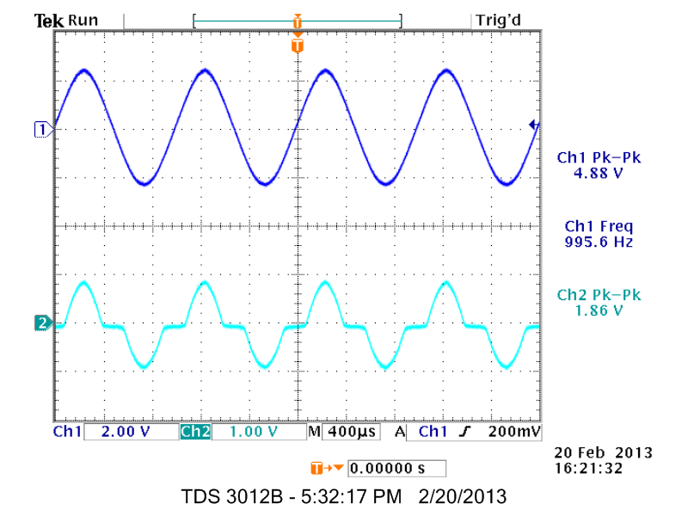

Fig. 14 The output of the op amp and the output of the class B open-loop amplifier.

In Figure 15, the fast Fourier transform was recored for the first ten harmonics at 1 kHz.

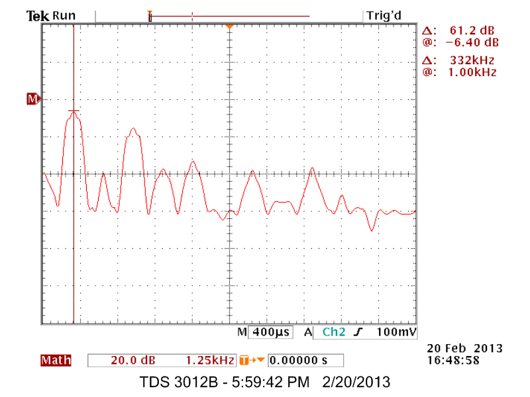

Fig. 15 The fast Fourier transform of a class B open-loop amplifier.

Lastly, the class AB open-loop amplifier was built. In Figure 16, the input signal is seen at the top and the bottom signal is the output of the op amp. In Figure 17, the output of the class AB open-loop amplifier is seen. Finally, in Figure 18, the fast Fourier transform of the class AB amplifier was recorded. The first ten harmonics at 1 kHz are displayed.

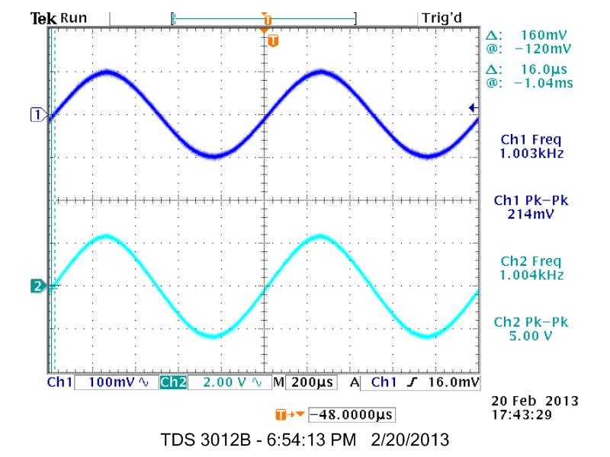

Fig. 16 The input and output signal of the op amp in a class AB open-loop circuit.

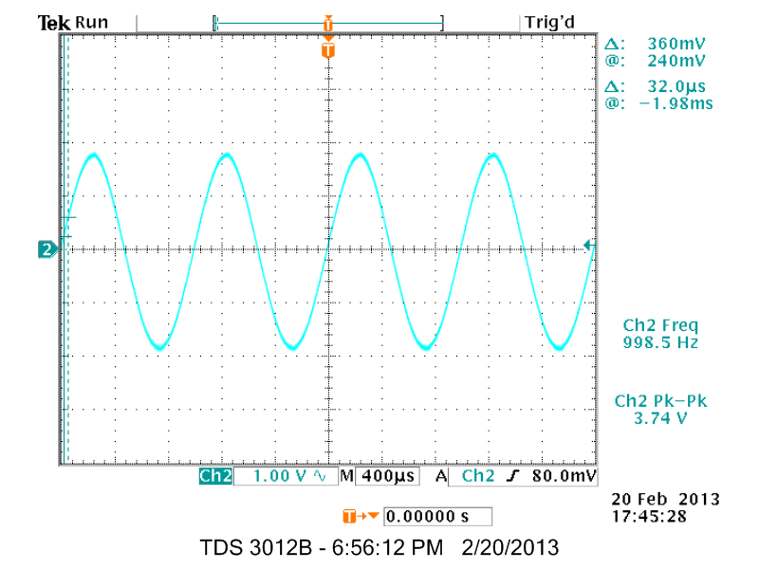

Fig. 17 The output of the class AB open-loop amplifier.

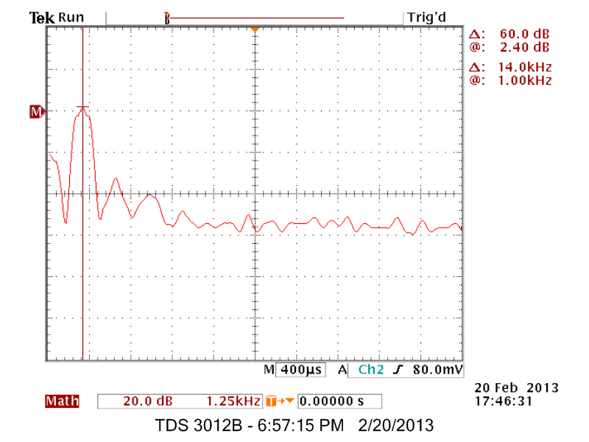

Fig. 18 The fast Fourier transform of the class AB open-loop amplifier.

The first ten harmonics of each type of amplifier was recorded and can be seen in Table 1. Calculating the THD for each amplifier, the class B closed-loop THD is 51.08 percent, the class B open-loop THD is 23.92 percent, and the THD of the class AB open-loop is 4.13 percent.

Table 1 The magnitude of first ten harmonics of the three amplifier types in dB

|  |  |  |
| --- | --- | --- |
| Class B closed-loop | Class B open-loop | Class AB open-loop |
| -6.4 | 10 | 2.4 |
| -39.2 | -24.8 | -31.2 |
| -15.6 | -11.2 | -40 |
| -37.2 | -41.2 | -50.6 |
| -33.2 | -15.2 | -53.1 |
| -63 | -36 | -50.6 |
| -37.6 | -18.8 | -57.1 |
| -58 | -39.2 | -50.8 |
| -36.8 | -20.8 | -50.2 |
| -52.8 | -41.2 | -57.6 |

1. Conclusions

In this lab, we explored three types of audio amplifiers – the class B closed-loop, the class B open-loop, and the class AB open-loop. Each amplifier configuration has its own THD rating which is a percentage that explains the amount of distortion in the amplified signal. The error margin of the THD for the class B closed-loop amplifier is 75.30 percent. The error margin of the class B open-loop amplifier is 93.98 percent. Finally, the class AB open-loop THD error margin is 97.60 percent. The reason for the large error margins are because the resistors used to bias the transistors had to be standard values. Instead of using 40 Ω, we used 39 Ω and instead of 1400 Ω, we used 1200 Ω. Other heat and errors in measurement have added to this large error margin.

Appendix

|  |  |  |
| --- | --- | --- |
| Class B closed-loop code | Class B open-loop code | Class AB open-loop code |
| Class B Audio Amplifier Closed Loop  .lib eval.lib  Vin 1 0 sin(0 0.2V 1k)  Vcc 5 0 DC 15V  Vee 9 0 DC -15V  R1 2 0 500  R2 2 7 12k  Ra 3 4 510  X0 1 2 5 9 3 LM324  X1 5 4 6 Q2N6059  X3 9 4 8 Q2N6052  Ren 6 7 2.7  Rep 8 7 2.7  Rl 7 0 100  .TRAN 1us 2ms  .FOUR 1k 10 V(7)  .PROBE  .END | Class B Audio Amplifier Open Loop  .lib eval.lib  Vin 1 0 sin(0 0.2V 1k)  Vcc 5 0 DC 15V  Vee 9 0 DC -15V  R1 2 0 500  R2 2 3 12k  Ra 3 4 510  X0 1 2 5 9 3 LM324  X1 5 4 6 Q2N6059  X3 9 4 8 Q2N6052  Ren 6 7 2.7  Rep 8 7 2.7  Rl 7 0 100  .TRAN 1us 2ms  .FOUR 1k 10 V(7)  .PROBE  .END | Class AB Audio Amplifier Open Loop  .lib eval.lib  Vin 1 0 sin(0 0.2V 1k)  Vcc 9 0 DC 15V  Vee 13 0 DC -15V  R1 2 0 500  R2 2 3 12k  Ra 3 4 510  X0 1 2 9 13 3 LM324  X1 9 6 10 Q2N6059  X3 13 8 12 Q2N6052  Ren 10 11 2.7  Rep 12 11 2.7  Rl 11 0 8  Rd1 6 5 40  Rd2 8 7 40  Rb1 9 6 1400  Rb2 13 8 1400  D1 5 4 D1N914  D2 4 7 D1N914  .TRAN 1us 2ms  .FOUR 1k 10 V(7)  .PROBE  .END |

References

[1] Boylestad, Robert. Eectronic Devices and Circuit Theory 7th Edition. New York: Prentice Hall College Division

1996. Print.

[2] Cherry, Mark. Maxim Engineering Journal, volume 62. *Amplifier Considerations in Ceramic Speaker Applications.* Chicago: McGraw Hill. 2012. Print.

[3] Sedra, Adel, Smith, Kenneth. Microelectronic Circuits. New York: Oxford. 2010. Print.

[4] Malvino, A.P.. Electronic Principles 2nd Edition. Chicago: McGraw Hill. 1989. Print.

[5] Lee, Thomas. The Deisgn of CMOS Radio-Frequency Integrated Circuits. New York, NY: Cambridge

University Press. 2004. Print.

[6] Bohn, Dennis. Practical Line-Driving Current Requirements. New York: Focal Express. 2004. Print.

[7] Otala, Matti. Circuit Deisng Modifications for Minimizing Transient Intermodulation Distortion in Audio

Amplifiers. Journal of Audio Engineering Society. Vol 20. June 1972.

[8] Baxandel, Peter. “Audio Power Amplifier Design,” Wireless Word Magazine. February 1979.

[9] Randy, Stone. G. The Audiophie’s Project Sourcebook. Ney York: McGraw-Hil. 2001. Print.

[10] Smith, Steven. The Scientist and Engineer’s Guide to Digita Signa Processing. March 5, 2013.

<http://www.dspguide.com/ch22/1.htm>

[11] Horowitz, Paul, Winfied, Hill The Art of Electronics. Cambridge: Cambrige University Press. 1989. Print.

[12] Audio and Hi-Fi Handbook, Third Edition. New York: McGraw-Hill. 1998. Print.

[13] Everett, John. Vsats: Very Small Aperture Terminals. New York: Focal Express. 2001. Print.

[14] Sokal, N.O., Sokal, A.D.. Class B – A New Class of High Efficiency Tuned Single-Ended Switching Power

Amplifiers. IEEE Journal of Solid-State Circuits, vol SC-10. June 1975.

[15] Symons, Robert. Tubes: Stil Vital After All These Years. IEEE Spectrum. Vol 25. Issue 4. April 1998.