ELCT 301

Laboratory Report #1

**Op-Amp Characteristics**

February 13, 2013

I hereby certify that I have

complied with the Spirit and the Letter

of the Carolinian Creed in preparing this report

_________________________

Leonardo Merza

Department of Electrical Engineering

University of South Carolina

Columbia, SC 29208

**Laboratory Grade**

Lab demonstration grade: _______ of 100

Lab report grade: _______ of 100

Student comments:

Grader comments:

**Experimental Design to Measure**

**Characteristics and Limitations of Op-Amps**

1. Introduction

This lab experiment will examine the operational amplifier and its limiting characteristics, the slew rate limit and the gain-bandwidth product. The slew-rate limit is the maximum rate of change in the output voltage over time, or rise/fall time, and can affect large-signal applications. When a frequency of an input signal of an op-amp and its amplitude are very high, the output to input ratio begins to become non-linear and causes distortion in the output signal. The slew-rate limit is an effect of the internal compensation capacitor. This capacitor has a finite current that can charge and discharge it. The input of an op-amp can have a fast rise time but the internal capacitor’s limitation causes the output of the overall output of the op-amp to be effected. An overall slew-rate comes in the manufacture’s datasheet but a real world slew-rate still needs to be found. In order to find this slew-rate, an input pulse signal will be applied to the op-amp. The output then can be recorded and measured to find the real world slew-rate of this particular op-amp.

The gain-bandwidth product is the maximum input frequency that can be obtained with a certain gain set on the op-amp. The internal capacitor is used to create a dominate pole in the transfer function of an open-loop op-amp. The dominate pole increases stability by causing the phase shift of an op-amp to be below 180 degrees until the op-amp has reached unity gain. This dominate pole causes the magnitude of the gain to drop about 20dB per decade and in return the op-amp reaches its gain-bandwidth product when the gain drops to unity. In order for the gain-bandwidth product to be found in the circuit, a gain of 10 will be set on the op-amp and the input frequency will be risen until the op-amp gain reads zero. This frequency when the gain is lowered to zero is the gain-bandwidth product.

1. Theory

The slew-rate is the rate of change in voltage over time. If an output voltage of an amplifier is $Vo=Vsin⁡(2πft)$ then the slew rate is defined as $\frac{dV_{o}}{dt}=V2πfcos(2πft)$. As can be seen, the maximum frequency that can be applied to an op-amp without distortion is proportional to the input voltage as well. Since cosine is maximum at one, then the slew-rate limit is defined as $\frac{dV_{o}}{dt}max=V2πf$. In order to record the slew rate limit on an oscilloscope, the voltage must be set high enough in order to set a frequency in range of the oscilloscope. This setup also ensures the gain-bandwidth product does not interfere with the slew-rate results. The slew rate will only be seen when the input is over the slew-rate limit of the op-amp. For this reason a pulse signal is used because the near zero change in time for a low and high voltage will trigger the slew-rate limit of the op-amp. Once an input voltage and a frequency is selected, the input and output voltages are read through an oscilloscope and the time delay of the pulse in the output signal will be the slew rate of the op-amp.

The gain-bandwidth product is the maximum frequency that an op-amp can linearly output a signal while retaining its gain. It is the product of the frequency and the open-loop voltage gain. Op-amps are designed with an internal capacitor that causes a dominate pole in the open loop transfer function. This transfer function can be modeled by $A\left(s\right)=\frac{A_{0}}{1+\frac{s}{w_{0}}}$ where $A_{0}$ is the dc open-loop voltage gain. The variable $w_{0}$ is the break frequency and is the fall in gain by 3dB. This dominate pole created causes the phase of the op-amp to be below 180 degree until unity. The internal capacitor ensures that once the gain-bandwidth product is reached at what is called the break frequency, a linear fall of the gain of approximately -20dB per decade happens. Unfortunately, this drop in gain does not happen linearly when it begins to drop off. At the break frequency, the fall in gain is at 3dB. A gain must be set that will ensure reliable recording of the gain-bandwidth product because of this nonlinearity at the break frequency. The input signal should be set to a frequency and voltage that does not interfere with the slew-rate. The lowest voltage will be set in order to get a high enough frequency bandwidth available to record the high gain-bandwidth product. Once the gain and input signal are set, the input and output of the op-amp is read through an oscilloscope and the frequency in which the gain falls -3dB is the break frequency at that particular gain.

In order to set the gain of an op-amp, a configuration of the circuit must be made. This particular configuration will be the inverting op-amp configuration. The gain is set by two resistors and is given by $G\left(s\right)= -\frac{R_{2}}{R_{1}}$.

1. Procedure

The circuit was first built with a LM741 op-amp with the gain set to-10. Resistor R2 is selected to be 10k-ohms and therefore making resistor R1 equal to 1k-ohm. This gain of negative ten is selected in order to get an accurate reading. The input signal for this experiment is a four volt pulse signal. With this, the output signal can be seen as to have a delay in the low and high voltages of the pulse signal as seen in figure A. The time it takes for the output voltage to change from high to low was recorded with cursors on the oscilloscope and was found to be 7.84 microseconds. In between this period of time the voltage changed 3.64 volts. Dividing the change in voltage by the change in time has found the slew-rate of this particular op-amp to be 0.4648 volts per microsecond.

The gain-bandwidth product was found by lowering the voltage to the minimum allowed on the oscilloscope which is particular case was 180 millivolts. The gain was still set to negative ten and the input frequency was then turned up until the gain of the op-amp is equal to negative unity as seen in figure B. This unity frequency was recorded and found to be 628kHz. Reading the datasheet of the LM347 found the theoretical gain-bandwidth product at unity gain to be 1Mhz. This is a large difference of 372kHz.

1. Results

Looking at the datasheet of a LM347 op-amp, the typical slew-rate at 25 degrees Celsius is 0.5 volts per microsecond. This is a close approximation and is only off by 35.2 millivolts. Such a small difference can be attributed to measurement error. The PSpice simulation was made for the gain-bandwidth product and the bode plots can be seen in figure C. V1 is the input voltage and is at one volt AC. With the gain set at ten, the output voltage is at ten volts and starts to drop around 10kHz. At unity gain, the frequency is at 1MHz. This is the simulated gain-bandwidth product. During circuit testing, the gain-bandwidth product was found to be 628kHz. Seeing that in output voltage at unity gain is 180mV and the frequency is at 628kHz, the current slew-rate is at 0.12 volts per microsecond. This is well in range of the tested slew-rate limit and does not interfere with the gain-bandwidth product being tested.

1. Conclusions

The purpose of this lab was to explore the op-amp limitations, specifically, the slew-rate limit and the gain-bandwidth product. The slew rate limit is the maximum change in voltage from input to output over time. The gain-bandwidth product is a product of the gain set by the amplifier configuration and the input frequency. These two limitations must be taken into account when dealing with higher frequency and voltage signals. The found slew-rate of this particular op-amp was 0.4648 volts per microsecond. This is an error of 7.04 percent. The gain-bandwidth product of the circuit was found to be 628kHz and is a percent error of 37.2 percent.

Appendix

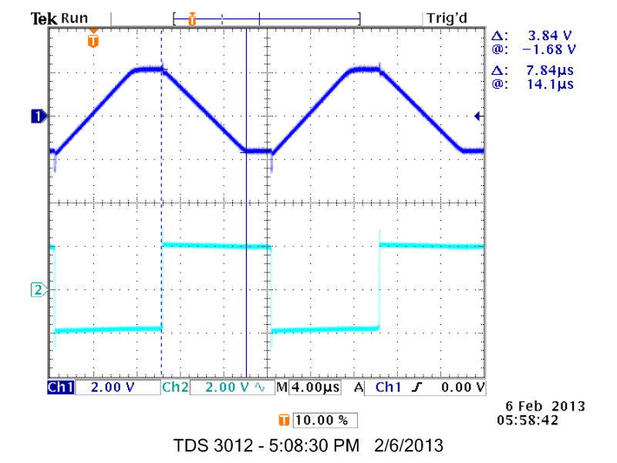

Figure A

(Channel 1 – output of op-amp)

(Channel 2 – input of op-amp)

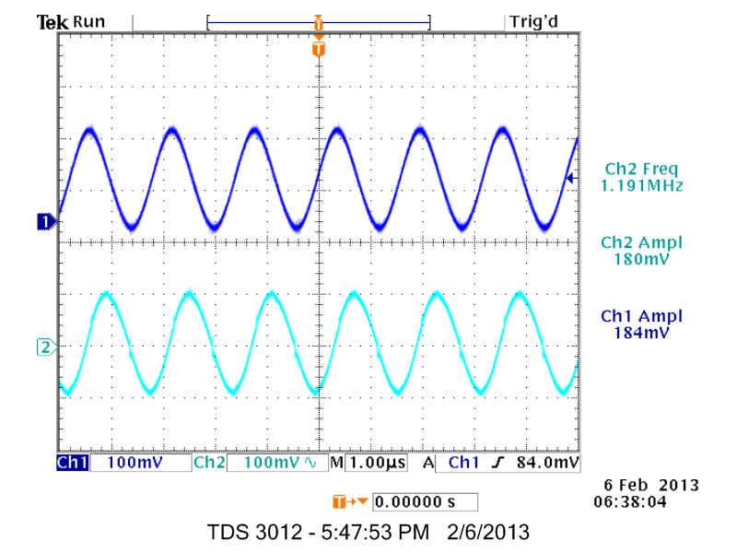

Figure B

(Channel 1 – output of op-amp) (Channel 2 – input of op-amp)

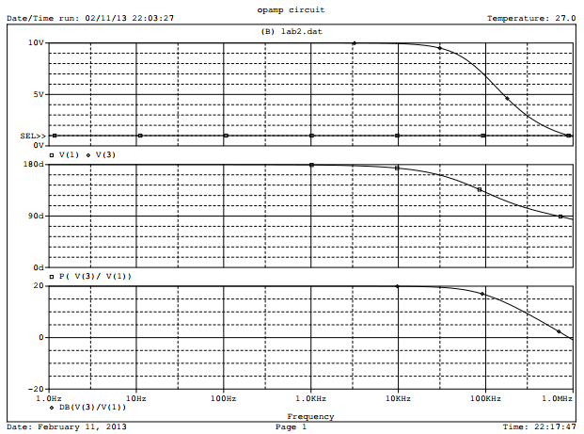

Figure C