**Laboratory Grade**

Lab demonstration grade: _______ of 100

Lab report grade: _______ of 100

Student comments:

Grader comments:

**Boost Converter**

1. Introduction

In this lab, the DC-to-DC boost converter circuit will be studied and created. A boost converter is a power converter that converts a low DC voltage to a high DC voltage [1]. It does this by changing the input current with a MOSFET and an inductor made in the previous lab. The key item that makes a boost converter work is the inductor’s tendency to resist changes in current [2]. The boost converter built in this lab will convert a DC signal of 12V at 2A to 48V at 0.5A. The switching frequency of the MOSFET will be 100kHz.

1. Theory

Boost converters are used in many applications such as battery powered devices [3]. They allow batteries that are unable to easily carry high voltages to be used in high voltage circuits. A MOSFET controls the output voltage by turning on and off [4]. This on and off switch is controlled by a pulse-width-modulated input square wave signal. The on time of the MOSFET can be found by equation 1 with D being the duty cycle of the input signal to the MOSFET and $T_{s}$ being the time period of the input signal.

|  |  |
| --- | --- |
| $$Time On=DT_{s}$$ | (1) |

If $V_{g}$ is the input voltage of the input signal, then the average voltage or the DC component of the input signal is given by equation 2:

|  |  |
| --- | --- |
| $$V_{avg}=DV_{g}$$ | (2) |

The properties of the boost converter create a small current ripple in the output signal. This current ripple can be found by equation 3, were V is the input voltage of the boost converter and L is the inductance of the inductor.

|  |  |
| --- | --- |
| $$Δi_{L}=\frac{V_{g}-V}{2L}DT_{s}$$ | (3) |

The duty cycle of the boost converter is dependent on the input and output voltage and is given by equation 4:

|  |  |
| --- | --- |
| $$D=\frac{V-V_{g}}{V}$$ | (4) |

An input and output capacitor are needed in order to smooth out the output voltage ripple [5]. The equations to calculate the input and output capacitor values are given in equation 5 and 6 respectively.

|  |  |
| --- | --- |
| $$C_{in}=\frac{∆i_{L}T_{s}}{4∆V_{G}}$$ | (5) |
| $$C_{out}=\frac{VDT_{s}}{2∆vR}$$ | (6) |
|  |  |

1. Experimental

The schematic for the boost convert that was built in lab is given in Figure 1:

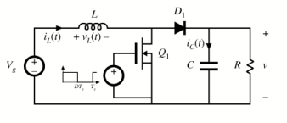

Fig. 1 The schematic for the DC to DC boost converter.

The MOSFET used for this circuit was an IRF540. Input and output capacitor values were calculated to be 22µF and 33µF. The inductor value recorded for the previous lab was 123.015µH. The diode used was a MBR1060 Schottky diode. A gate drive was used for the input of the MOSFET and it was a TC4428. Finally, the load resistor was an 100 Ω 25W resistor. Once the circuit was built, the gate-source and drain-source voltages were recorded on the oscilloscope for the MOSFET. The input and output voltage ripple was recorded next. Finally, the inductor and diode current were recorded.

1. Results

The simulation for the boost converter was made with PSpice. The first graph in Figure 2 is the input voltage $V_{g}$ on the bottom graph and the input voltage of the MOSFET on the bottom graph.

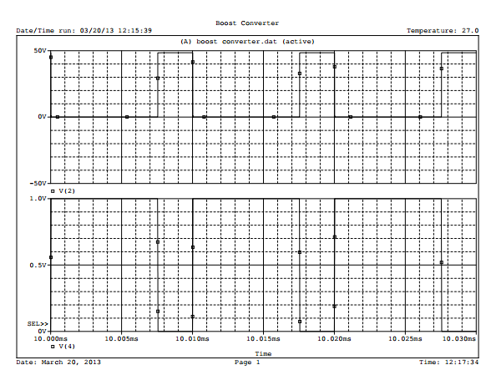

Fig. 2 The input voltage of the MOSFET and the input voltage $V_{g}$.

The next simulation graph in Figure 3 represents the output voltage of the boost converter at the bottom and the input voltage $V_{g}$ at the top.

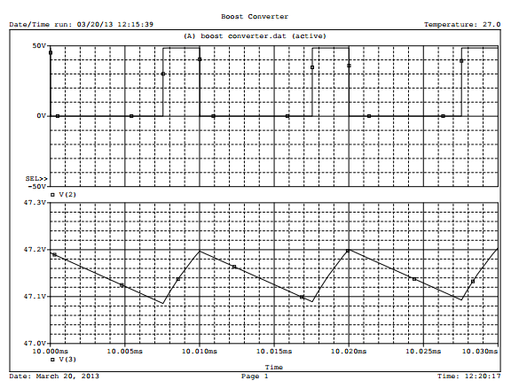

Fig. 3 The input voltage and output voltage of the boost converter.

The next graph in Figure 4 is the input voltage $V_{g}$ at the top and the input voltage from the power supply on the bottom:

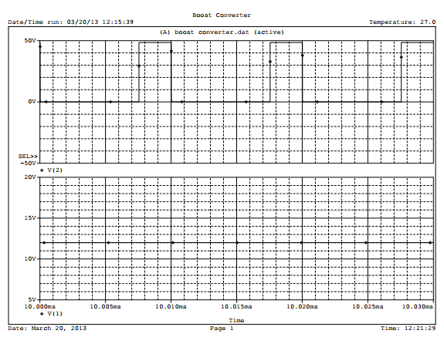

Fig. 4 The input and output voltage of the circuit.

Figure 5 graphs the input voltage $V_{g}$ on the top and the current through the inductor at the bottom:

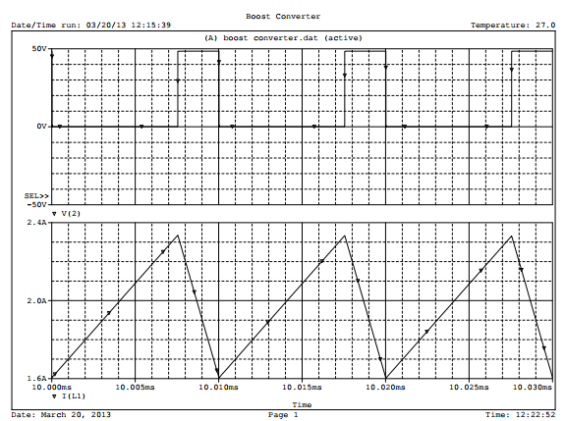

Fig. 5 The output voltage of the circuit and the current through the inductor

For Figure 6, the top graph is the input voltage $V_{g}$ and the bottom graph is the current across the diode:

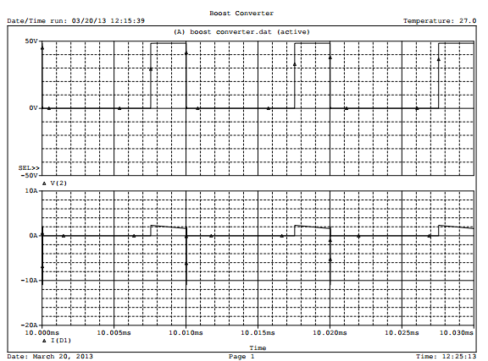

Fig. 6 The output voltage of the circuit and the current across the diode.

Once the simulations were made, the circuit was built and pictures through the oscilloscope were taken at certain points in the circuit. The first oscilloscope picture taken in Figure 7 was of the gate-source at channel one and the drain-source voltage at channel two for the MOSFET.

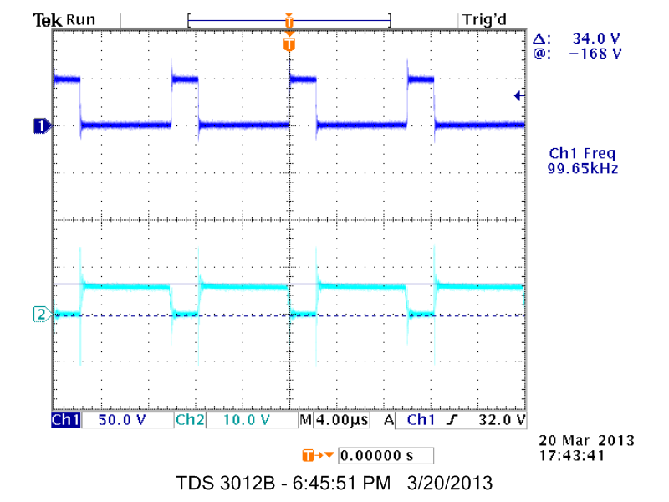

Fig. 7 The gate-source and drain-source voltage of the MOSFET.

Next, the drain-source voltage of the MOSFET on channel one and the output voltage ripple of the circuit on channel two were taken and are seen in Figure 8:

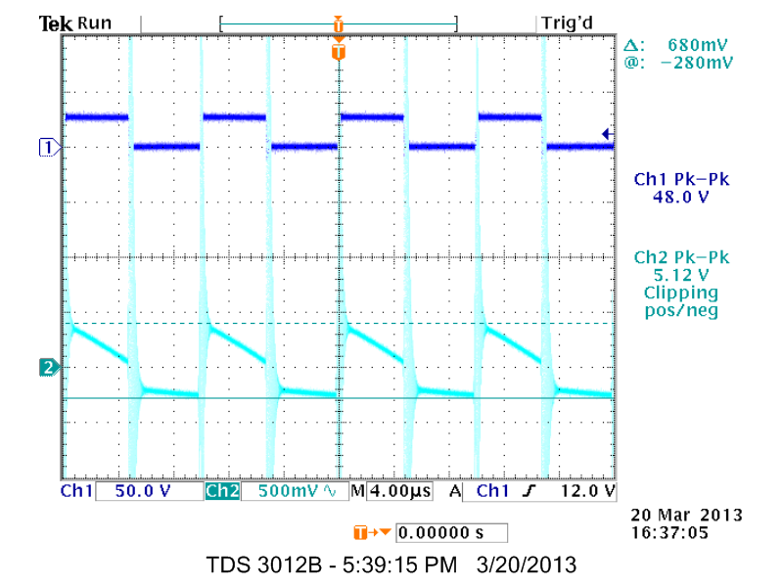

Figure 8 The drain-source voltage of the MOSFET and the output voltage ripple.

In Figure 9, the drain-source voltage of the MOSFET on channel one and the input voltage ripple on channel two was recorded:

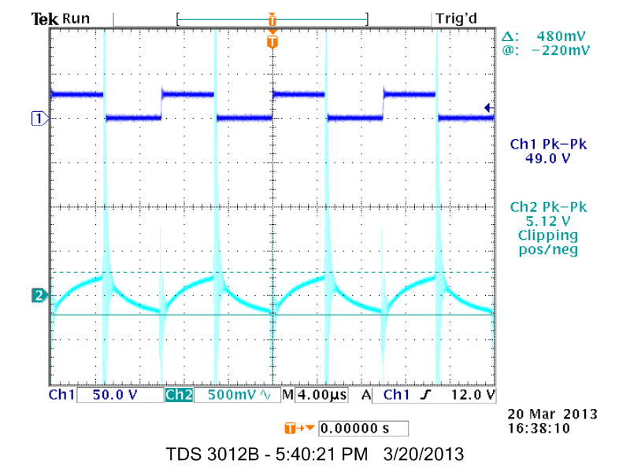

Fig. 9 The drain-source voltage of the MOSFET and input voltage ripple.

A current probe was connected to channel two of the oscilloscope and was used to measure the inductor and diode current. In Figure 10, the drain-source voltage of the MOSFET in channel one and the inductor current on channel two are recorded.

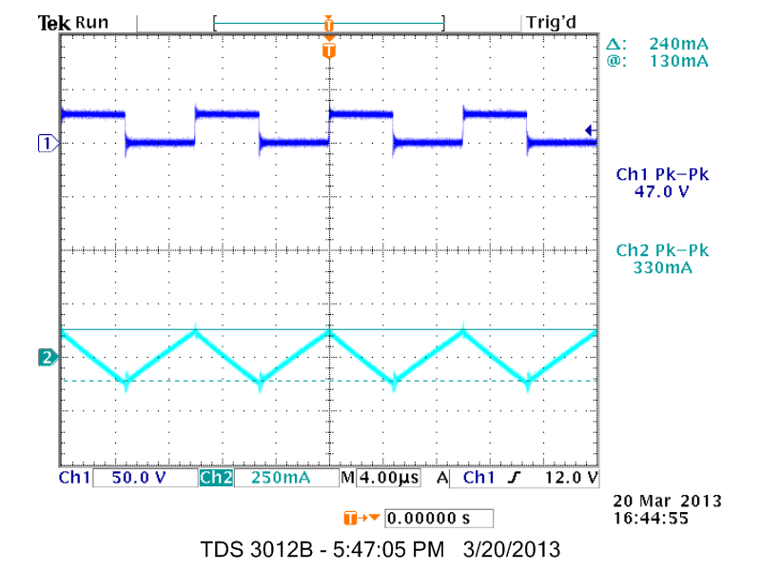

Fig. 10 The drain-source voltage of the MOSFET and the inductor current.

Finally, the drain-source voltage for the MOSFET on channel one and the diode current on channel two is seen in Figure 11.

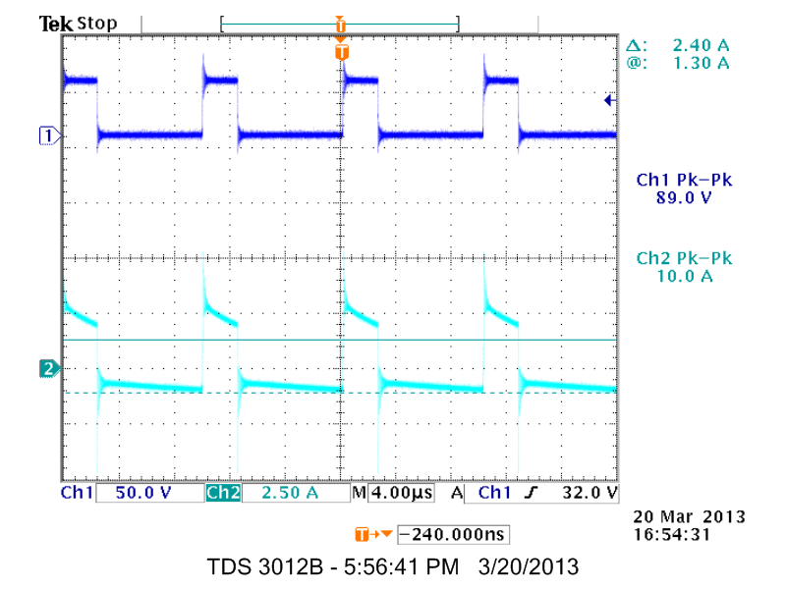

Fig. 11 The drain-source voltage of the MOSFET and the current through the diode.

The duty cycle for the input of the MOSFET was calculated to be 75%. The inductor current ripple was found to be 0.3658A.

1. Conclusions

In this lab, we explored the boost converter. This circuit allows a low voltage DC signal to be changed to a higher voltage DC signal by changing the current. This allows the overall power of the converter to be conserved. Specifically in this circuit, a 12V at 2A signal is converted to a 48V at 0.5A output signal. In reality, the power efficiency of a boost converter can be around 95%.

Appendix

PSpice code for boost converter:

Boost Converter

.lib eval.lib

Vg 1 0 12V

Cin 1 0 22u

L1 1 2 123.015uH

SFET 2 0 4 0 SMOD

.MODEL SMOD VSWITCH(RON=0.044 ROFF=10E+10 VON=0.7 VOFF=0.0)

Vgate 4 0 PULSE(0 1 0 35n 35n 7.5u 10u)

D1 2 3 D1N914

Cout 3 0 33uF

Rl 3 0 100

.TRAN 1ns 10000u 10m

.PROBE

.END

References

[1] Daycounter, Inc. Boost switching Converter Design Equations. March 24, 2013.

http://www.daycounter.com/LabBook/BoostConverter/Boost-Converter-Equations.phtml

[2] Bramble, Simon. Boost Converter Design. March 24, 2013.

http://www.simonbramble.co.uk/dc_dc_converter_design/boost_converter/boost_convert

er_design.htm

[3] Martin, K.R.. DC Boost Converter. March 24, 2013. http://www.instructables.com/id/DC-Boost-Converter/?ALLSTEPS

[4] LadyAda. DC/DC Boost Calc. March 24, 2013. http://www.ladyada.net/library/diyboostcalc.html

[5] Marasco. Ken. How to apply DC-to-DC Step-up (Boost) Regulators Successfully. March 24, 2013.

http://www.analog.com/library/analogDialogue/archives/45-09/boost.html