**Laboratory Grade**

Lab demonstration grade: _______ of 100

Lab report grade: _______ of 100

Student comments:

Grader comments:

**Signal Generator**

1. Introduction

This lab studies the signal generator circuit. This particular signal generator will generate the square, sine, and triangle wave. A frequency range of 10 Hz to 2500 Hz is also required. In order to achieve this, three sub circuits are created. A Schmitt trigger circuit will be used to create a square wave. The square wave will then be used as the input for the integrator circuit that will create a triangle wave. The triangle wave will be looped back into the input of the Schmitt trigger to create the original square wave. The triangle wave will also be used as the input of the sine wave circuit which will consist of a diode wave shaper. The THD of the sine wave will then be recorded at 10 and 2500 Hz.

1. Theory

The first sub circuit of the signal generator is the Schmitt trigger. The schematic of this sub circuit is seen in Figure 1:

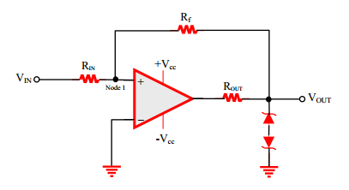

Fig. 1 The Schmitt trigger sub circuit of the signal generator circuit.

Designing the sub circuit will require an operational amplifier used as a comparator. A comparator compares the voltages at both inputs and outputs a high or a low depending on which input has the highest voltage [1]. A problem that can occur on this type of circuit is when both voltages are close to each other and enough noise in the circuit causes the output to jump high and low [2]. Positive feedback is used to resolve this problem [3]. In order to limit the output voltage to about 5V, two zener diodes connected by the cathode. This configuration is connected to ground. This allows only one zener diode to be the forward bias region with an AC signal therefore only allowing 5V output of the Schmitt trigger. The value of $R_{out}$ is not very important and is used to limit the output current of the op amp [4]. The positive feedback configuration of the op amp will need to have a gain of one and is calculated by equation one:

|  |  |
| --- | --- |
| $$Gain=\frac{-R_{f}}{R_{IN}}$$ | (1) |

The next sub circuit is the integrator which uses a similar feedback circuit with an op amp to integrate the square wave into a triangle wave. The circuit for this integrator is in Figure 2:

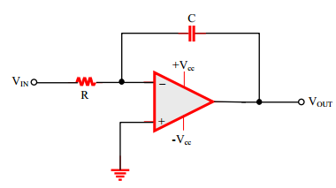

Fig. 2 The integrator sub circuit of the signal generator circuit.

In order to change the frequency, the resistor R in the integrator circuit will be a variable resistor. The frequency of the signal can be calculated by equation 2:

|  |  |
| --- | --- |
| $$f_{0}=\frac{1}{4RC}$$ | (2) |

The frequency and the output voltage are dependent on the values of R and C of the integrator [5]. The output voltage calculation is seen in equation 3:

|  |  |
| --- | --- |
| $$V_{out}\left(t\right)=\frac{-1}{RC}\int_{0}^{t}{V_{in}\left(x\right)dx}+V_{out}(0)$$ | (3) |

The last sub circuit of the signal generator is the diode wave shaper. The schematic for this sub circuit is seen in Figure 3:

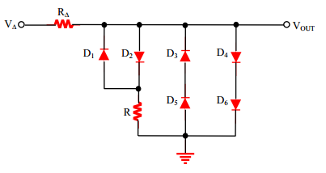

Fig 3 The diode wave shaper schematic sub circuit of the signal generator.

This diode wave shaper works by changing the slope of the output sine wave every voltage drop across a diode or 0.6V. When the circuit is from 0V to 0.6V, the voltage at $V_{out}$ is the voltage of the input signal and is a slope of one. Once the voltage reaches 0.6V, $D_{2}$ starts to conduct and the voltage slope of the input to output voltage turns to equation 4:

|  |  |
| --- | --- |
| $$m=\frac{R}{R+R_{∆}}$$ | (4) |

When the input voltage reaches 1.2V, $D_{4}$ and $D_{6}$ start to conduct and the voltage at the output stays at 1.2V. This piece-wise sine function also works for negative voltages. The graphical representation of this piece-wise sine wave is shown in Figure 4:

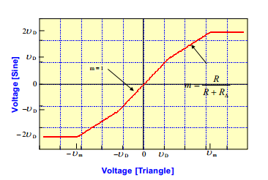

Fig. 4 The input voltage (triangle wave) versus the output voltage (sine wave).

1. Experimental

The full circuit for the signal generator is given in Figure 5:

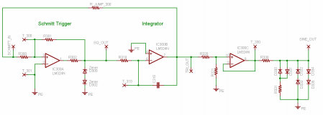

Fig. 5 The schematic for the signal generator circuit.

Once the circuit was built, the three different signals were captured through an oscilloscope at the maximum and minimum frequency. Once this was completed, the THD of the sine wave a maximum and minimum frequencies were recorded with the first ten harmonics.

1. Results

The simulation for the signal generator was made with PSpice. Two simulations were made with the frequency at 10 Hz and 2500 Hz. Both simulation graphs show the three signal outputs of the circuit. In Figure 6, the 10 Hz simulation voltage output is shown. The square and triangle wave have a peak to peak voltage of about 10V. The sine wave on the other hand has a peak to peak voltage of about 2V. This is because the voltage of the sine wave depends on the voltage across multiple diodes.

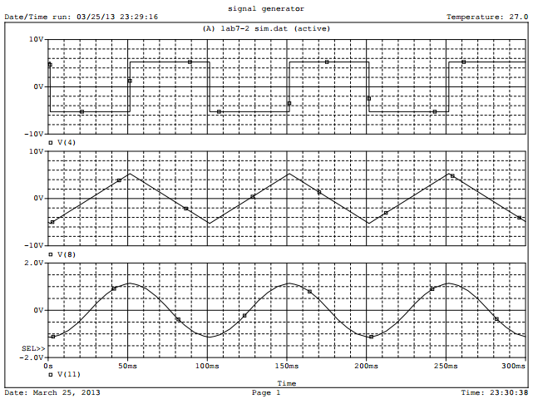

Fig. 6 The signal outputs of the circuit at 10 Hz.

Figure 7 shows the signal outputs of the signal generator circuit with the frequency set at 2500 Hz. The peak to peak voltage of the triangle and square wave change to about 4.5V while the peak to peak voltage of the sine wave stay the same. The THD of the sine wave was recorded through the simulation at 10 Hz and 2500 Hz and was found to be 0.838 and 26.496 percent respectively.

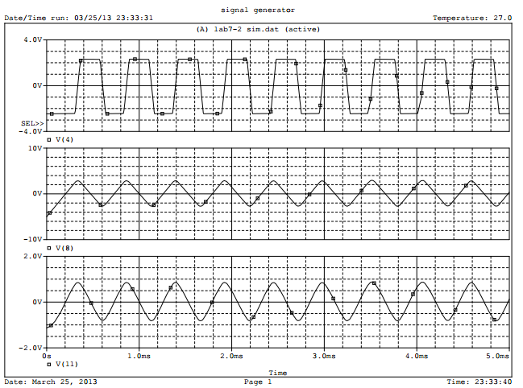

Fig 7 The output signals of the signal generator at 2500 Hz.

Once the simulations were ran, the circuit was built and the output signals were recorded. In Figure 8, 9, and 10, the square, triangle, and sine wave were recorded respectively at the lowest frequency at about 3.6 Hz.

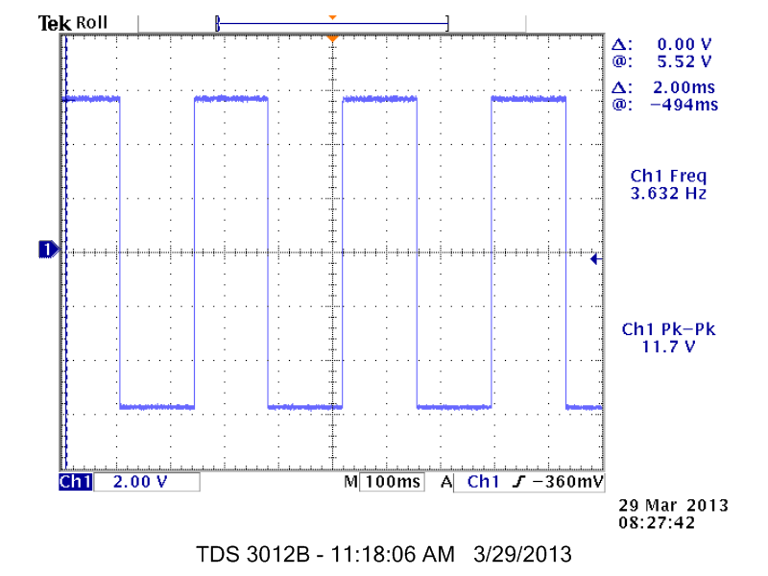

Fig. 8 The square wave output at 3.6 Hz.

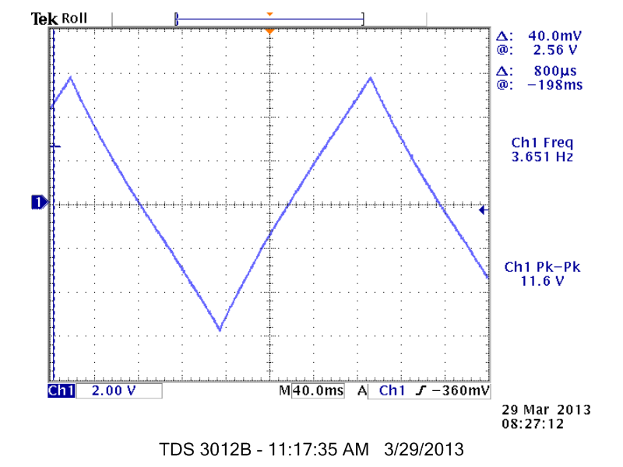

Fig. 9 The triangle wave output at 3.6 Hz.

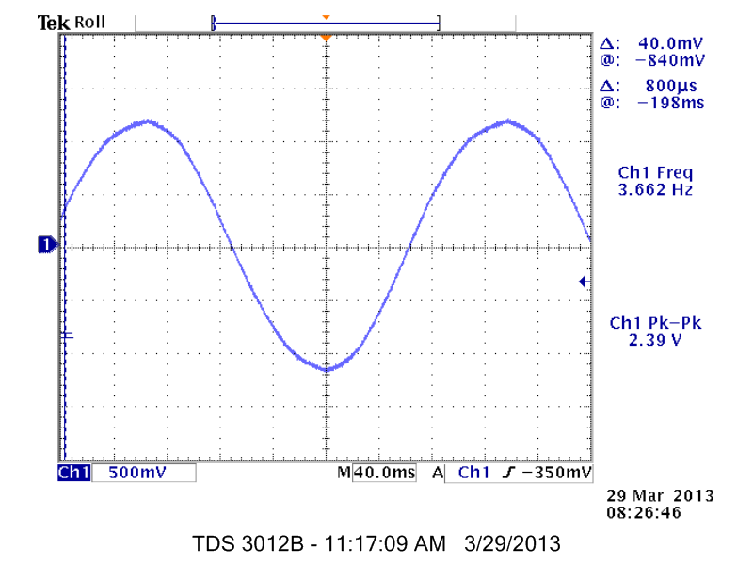

Fig. 10 The sine wave output at 3.6 Hz.

Next, the square, triangle, and sine wave of the signal generator circuit were recorded at about 2.5 kHz and are shown in Figure 11, 12, and 13 respectively.

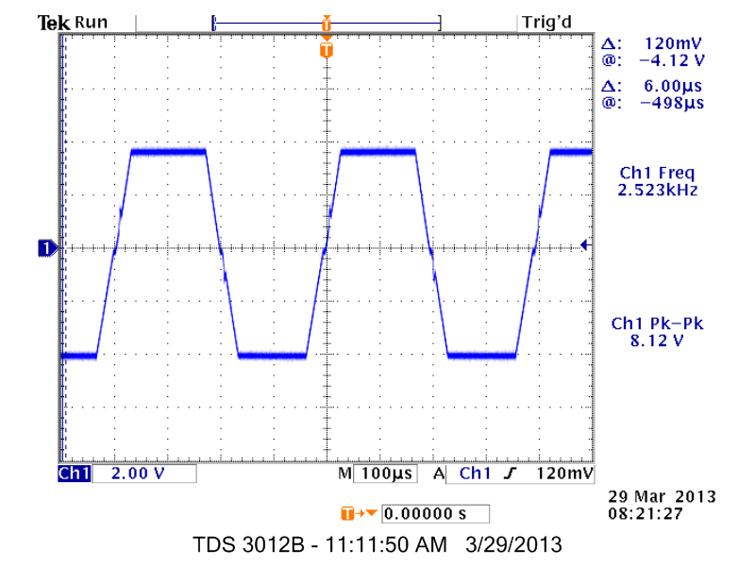

Fig. 11 The square wave output at 2.5 kHz.

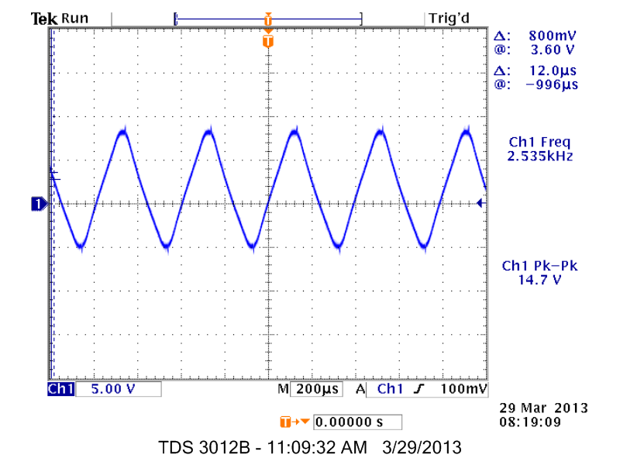

Fig. 12 The triangle wave output at 2.5 kHz.

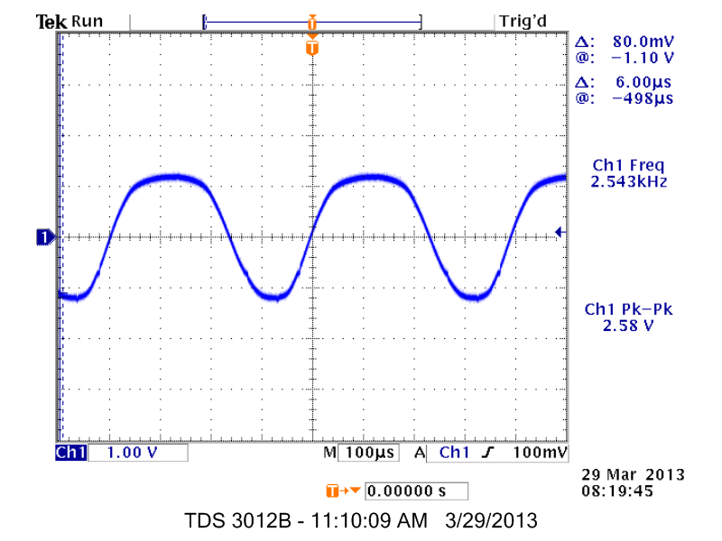

Fig. 13 The sine wave output at 2.5 kHz.

The square and triangle wave at the lowest frequency are recorded to have at peak to peak voltage of about 11.6V. The sine wave on the other hand has a peak to peak voltage of about 2.6V. When the frequency is turned up to 2.5 kHz, both the square and triangle wave peak to peak voltages change to about 8V and 14V respectively while the sine wave voltage stays the same. The reason behind this is because the resistor that changes the frequency is in the integrator circuit and the output voltage of the integrator is related by the $\frac{1}{RC}$ value in equation 3.

Lastly, the THD of the sine wave at 10 Hz and 2500 Hz were recorded. The THD of the sine wave at 10 Hz was found to be 2.884 percent and at 2500 Hz the THD was found to be 48.688 percent. The THD for the 10 Hz sine wave is about small enough to reach the goal of less than 2 percent THD but the THD for the 2.5 kHz sine wave is high and is largely contributed by the piecewise linear function of the diode wave shaper. Although the diodes have a small non-linear characteristic in the voltage, the large change at about 0.6V and 1.2V from the didoes becoming conductive cause a large distortion in the signal. The square wave can be seen to have a slight distortion when changing from the low voltage to high voltage and is caused by the slew rate limitation of the op amps used for this circuit.

1. Conclusions

In this lab, we explored the signal generator. Specifically, the square, triangle, and sine wave were created using three sub circuits. A feedback loop system was used for the square and triangle wave to produce each other while the sine wave was created by a diode wave shaper. More diodes could be used to create a large sine wave signal. The square and triangle wave are limited by the slew rate and the gain bandwidth product of the op amps used.

Appendix

|  |  |
| --- | --- |
| signal generator for 2500Hz  .LIB eval.lib  VCC 15 0 15V  VEE 16 0 -15V  R300 1 2 100k  R301 2 4 100k  X1 2 0 15 16 3 LM324  R302 3 4 5.1k  D300 5 4 D1N750  D302 5 0 D1N750  R310 4 7 1k  X2 0 7 15 16 8 LM324  C310 7 8 100n IC=5V  R320 8 9 3.3k  R321 9 0 1.8k  RJUMP300 1 8 .01  X3 9 10 15 16 10 LM324  R330 10 11 1k  D330 12 11 D1N4148  D331 11 12 D1N4148  R331 12 0 2.7k  D332 13 11 D1N4148  D333 0 13 D1N4148  D334 11 14 D1N4148  D335 14 0 D1N4148  .TRAN 5ns .005s  .FOUR 2500Hz V(11)  .PROBE  .END | signal generator for 10Hz  .LIB eval.lib  VCC 15 0 15V  VEE 16 0 -15V  R300 1 2 100k  R301 2 4 100k  X1 2 0 15 16 3 LM324  R302 3 4 5.1k  D300 5 4 D1N750  D302 5 0 D1N750  R310 4 6 1k  RFREQ 6 7 249k  X2 0 7 15 16 8 LM324  C310 7 8 100n IC=5V  R320 8 9 3.3k  R321 9 0 1.8k  RJUMP300 1 8 .01  X3 9 10 15 16 10 LM324  R330 10 11 1k  D330 12 11 D1N4148  D331 11 12 D1N4148  R331 12 0 2.7k  D332 13 11 D1N4148  D333 0 13 D1N4148  D334 11 14 D1N4148  D335 14 0 D1N4148  .TRAN 5ns .2s  .FOUR 10Hz V(11)  .PROBE  .END |

References

[1] Technology Student. Op-amps as Comparators. April 4, 2013.

<http://www.technologystudent.com/elec1/opamp3.htm>

[2] EDN Network. Designing with Comparators. April 4, 2013.

<http://www.edn.com/design/analog/4353925/Designing-with-comparators>

[3] Maxim Integrated. Selecting the Right Comparator. April 4, 2013.

<http://www.maximintegrated.com/app-notes/index.mvp/id/886>

[4] Schottky Diode. Advantages to Schottky Diodes. April 4, 2013. <http://www.schottkydiode.net/>