**Laboratory Grade**

Lab demonstration grade: _______ of 100

Lab report grade: _______ of 100

Student comments:

Grader comments:

**Butterworth Filter Design**

1. Introduction

This lab studies the butterworth filter. A forth order high pass and low pass filter will be studied. Once the component values of the each filter are calculated, the -3dB gain of the circuit will be measured. From there, ten equal frequencies for the gain from $\frac{1}{10}$ the frequency of the -3dB point to the -3dB point will be measured. Lastly, ten more equal points from the -3dB gain frequency to 10 times the frequency of the -3dB point will be measured. These 21 points for the low pass and high pass filters are then used to construct bode plots to compare with the simulations.

1. Theory

Filters can be designed with basic RCL circuits but are passive and the gain of the circuit cannot be over 0dB [1]. Since inductors are large and hard to make accurately, RC circuits are most commonly used [2]. A high pass filter works by lowering the gain of the circuit when lower frequencies are passed through it while allowing the higher frequencies to pass through [3]. A low pass filter on the other hand allows lower frequencies to pass through while high frequencies are suppressed [4]. The schematics for the high pass and low pass filters are seen in Figure 1 below.

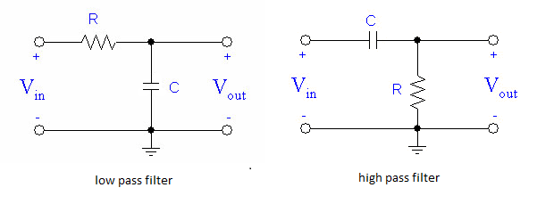

Fig.1 Schematics for the low pass and high pass filter.

The transfer function for the low pass filter is shown in equation 1 while the transfer function for the high pass filter is shown in equation 2:

|  |  |
| --- | --- |
| $$G\left(s\right)=\frac{1}{RCs+1}$$ | (1) |
| $$G\left(s\right)=\frac{RCs}{RCs+1}$$ | (2) |

In this lab, active linear filters are designed. Active filters allow the gain to be larger than 0dB by using op-amps [5]. One type of active filter is the Sallen-Key filter. The schematic for a low pass and high pass Sallen-Key filter is seen in Figure 2 below.

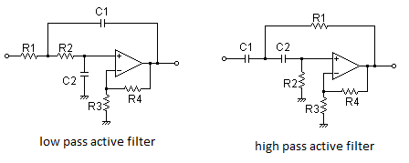

Fig. 2 Schematics for the Sallen-Key active linear filters.

Sallen-Key active filters can be cascaded together in order to cause a larger drop in gain as the input signal passes the break frequency [6]. The break frequency is the frequency when the gain is at -3dB [7]. The specific filters shown in Figure 2 are second order filters and when two are cascaded together, they create a 4th order filter [8]. A nth order filter will cause a drop in gain after the break frequency at a n*-20dB drop, and therefore the higher the order of the filter, the faster the drop in gain to filter out higher or lower frequencies depending on the filter configuration [9]. The transfer function for a low pass Sallen-Key filter is given in equation 3:

|  |  |
| --- | --- |
| $$G\left(s\right)=\frac{\frac{1}{R_{1}C_{1}R_{2}C_{2}}}{s^{2}+s\left(\frac{1}{R_{1}C_{1}}+\frac{1}{R_{2}C_{2}}\right)+\frac{1}{R_{1}C_{1}R_{2}C_{2}}}$$ | (3) |

The transfer function for a high pass Sallen-Key filter is given in equation 4:

|  |  |
| --- | --- |
| $$G\left(s\right)=\frac{s^{2}}{s^{2}+s\left(\frac{1}{R_{1}C_{1}}+\frac{1}{R_{2}C_{2}}\right)+\frac{1}{R_{1}C_{1}R_{2}C_{2}}}$$ | (4) |

In order to get the transfer function of even higher order filters, the transfer function is multiplied by itself [10]. For example, a 4th order filter transfer function will be ${G\left(s\right)}^{2}$. In order to calculate the values of the resistors and capacitors, equation 5 will be used where $f_{b}$ is the break frequency. All resistor values are the same and all capacitor values are the same.

|  |  |
| --- | --- |
| $$f_{b}=\frac{1}{2πRC}$$ | (5) |

1. Experimental

The full circuit for the active filter is seen in Figure 3 below:

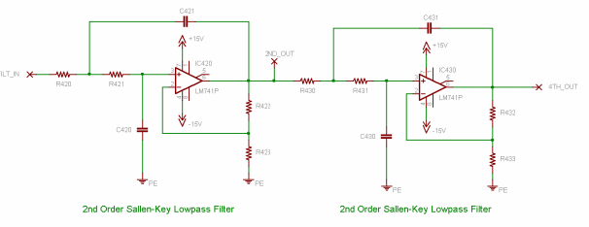

Fig. 3 The schematic for a 4th order low pass Sallen-Key filter.

For the low pass filter, a break frequency value was given at 700Hz. After setting all capacitor values to 0.01µF, the resistor value calculated was 22.7 kΩ. For the high pass filter, a break frequency of 9 kHz was given and the resistor value calculated was 1.77 kΩ. Once each filter was built, the -3dB gain point was recorded. Next, 20 points from $\frac{1}{10}f_{b}$ to $10f_{b}$ were recorded and plotted in bode plots to compare with the simulation bode plots.

1. Results

The simulations for the active filters were made through PSpice. The low pass simulation is shown in Figure 4. At 700 Hz, the gain is at -3dB and at 10 kHz, the gain is at about -80dB.

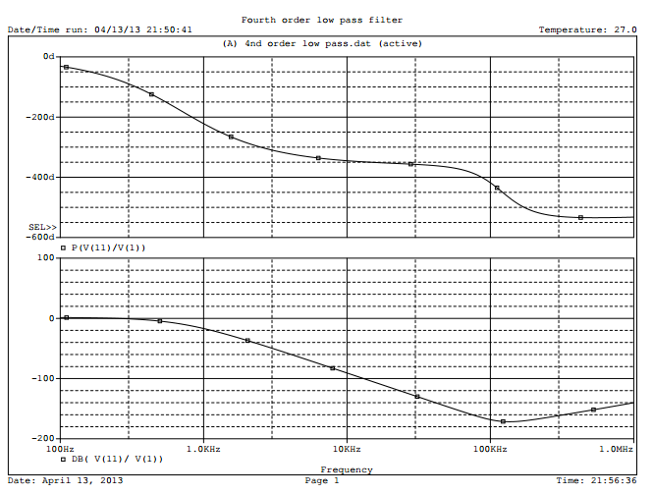

Fig. 4 Bode plot for the 4th order Sallen-Key filter simulation.

The high pass filter simulation bode plot is shown in Figure 5. The -3dB gain frequency is at 9 kHz and at 1 kHz, the gain is shown to be about -80dB.

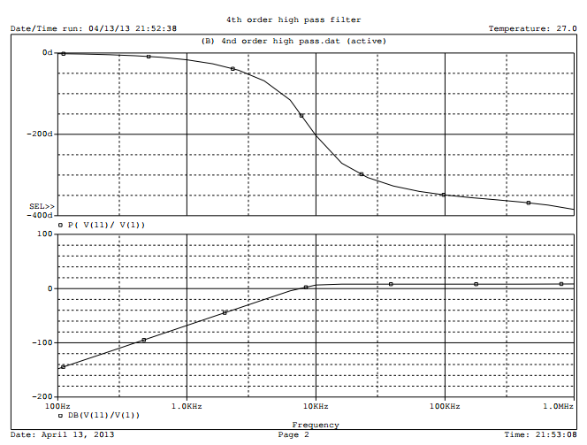

Fig. 5 Simulation bode plot for the 4th order Sallen-Key high pass filter.

Once the simulations were completed, the real circuit was built. First, the low pass filter was constructed. After testing out a few resistor values, the best value was determined to be 12 kΩ. In Figure 6, the -3dB frequency was recorded with an oscilloscope. The break frequency in this configuration was shown to be 740 Hz with the phase at -116 degrees.

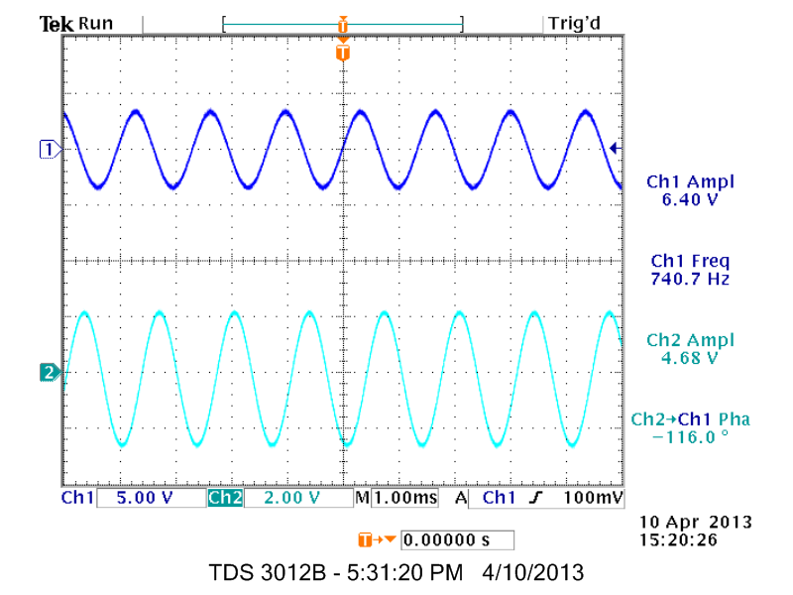

Fig. 6 The -3dB gain frequency of the 4th order Hallen-Key low pass filter.

Next, 20 gains and phases at different frequencies were record. The values were recorded into Matlab and a bode plot was generated and can be seen in Figure 7 below. The -3dB point lies at 740 Hz and dips down to about -60dB at 10 kHz. The phase at -3dB is about -140 degrees and at 10 kHz the phase is about 60 degrees.

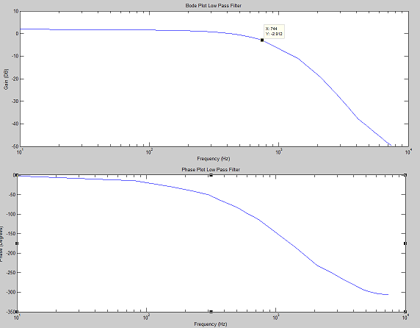

Fig. 7 The bode plot generated by Matlab from the low pass filter circuit.

The high pass filter was built next. After a few different resistor values were experimented with, a resistor value of 2.2 kΩ was used. The -3dB was recorded by the oscilloscope and is shown in Figure 8 below. The break frequency was shown to be 9.239 kHz and the phase at 74.9 degrees.

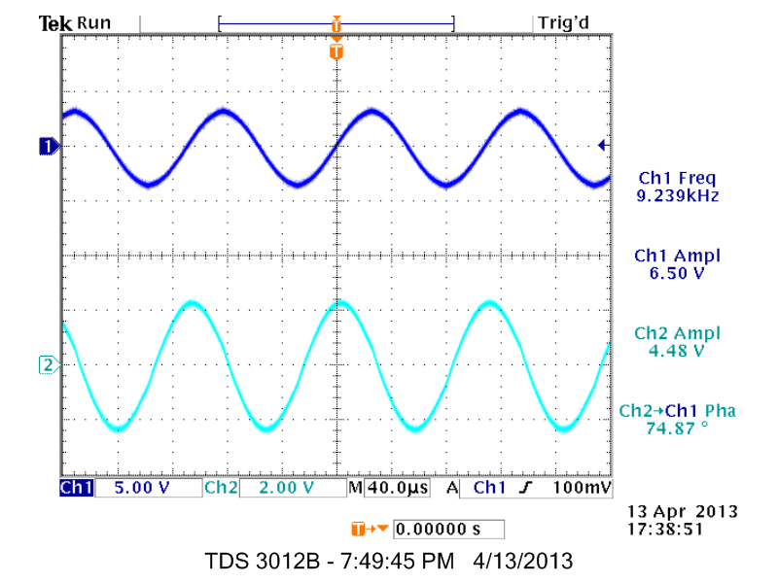

Fig. 8 The -3dB frequency of the 4th order Sallen-Key high pass filter circuit.

After 20 frequencies and there respective gain and phase were recorded, these values were also put into Matlab and a bode plot was generated. Figure 9 shows the bode plot generated. At about 9.2 kHz, the gain is about -3dB and at 1 kHz, the gain is about -35dB.

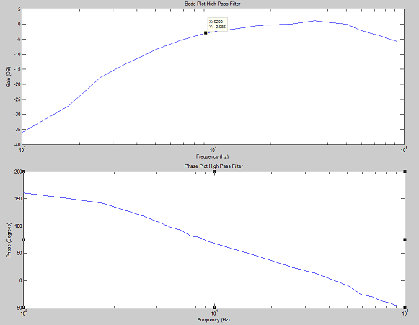

Fig. 9 The bode plot generated by Matlab for the high pass filter circuit.

1. Conclusions

In this lab, the 4th order Sallen-Key low pass and high pass filters were studied and constructed. The higher the order of the filter causes a faster drop in gain after the filter has reached the -3dB point. This feature was successfully shown in the simulations and actual circuit design in this lab report.

Appendix

|  |  |
| --- | --- |
| 4th order low pass filter code | 4th order high pass filter code |
| Fourth order low pass filter  .LIB eval.lib  Vin 1 0 AC 1  R1 1 2 22.7k  R2 2 3 22.7k  X 3 4 5 6 7 LF411  VCC 5 0 15V  VEE 6 0 -15V  C1 2 7 .01uF  C2 3 0 .01uF  C3 9 0 .01uF  C4 8 11 .01uF  RFk 4 7 1k  Rf 4 0 10k  R5 7 8 22.7k  R6 8 9 22.7k  X2 9 10 5 6 11 LF411  RFk2 10 11 1k  Rf2 10 0 10k  .AC dec 1000 100 1000k  .probe  .end | 4th order high pass filter  .LIB eval.lib  Vin 1 0 AC 1  C1 1 2 .01uF  C2 2 3 .01uF  X 3 4 5 6 7 LF411  VCC 5 0 15V  VEE 6 0 -15V  R2 2 7 1.77k  R1 3 0 1.77k  R3 7 4 1.52k  R4 4 0 10k  C3 7 8 .01uF  C4 8 9 .01uF  X2 9 10 5 6 11 LF411  R5 8 11 1.77k  R6 9 0 1.77k  R7 11 10 12.35k  R8 10 0 10k  RL 11 0 1k  .AC dec 5 100 1000k  .probe  .end |

References

[1] BryanDom. RCL Filters. April 15, 2013. <http://rlcelectronics.com/products/8-filters>

[2] University of Sydney. Physclips. April 15, 2013. <http://www.animations.physics.unsw.edu.au/jw/RCfilters.html>

[3] Hyper Physics. RC High Pass Filter. April 15, 2013.

<http://hyperphysics.phy-astr.gsu.edu/hbase/electric/filcap.html>

[4] Electronic Tutorials. Passive Low Pass Filter. April 13, 2013.

<http://www.electronics-tutorials.ws/filter/filter_2.html>

[5] EDN. Designing RC Active Filter with Standard Component Values. April 13, 2013.

<http://www.electronics-tutorials.ws/filter/filter_2.html>

[6] Filter-Solutions. Active Filter Solutions. April 15, 2013. <http://www.filter-solutions.com/active.html>

[7] Learning About Electronics. Cutoff Frequency Calculator. April 13, 2013.

<http://www.learningaboutelectronics.com/Articles/Cut-off-frequency-calculator.php>

[8] Daycounter, Inc. Sallen-Key Low Pass Filter. April 14, 2013.

<http://www.daycounter.com/Filters/Sallen-Key-LP-Calculator.phtml>

[9] Mathworks. Fourth-Order Sallen-Key Lowpass Filter. April 14, 2013.

http://www.mathworks.com/help/physmod/elec/examples/fourth-order-sallen-key-lowpass-filter.html