**Laboratory Grade**

Lab demonstration grade: _______ of 100

Lab report grade: _______ of 100

Student comments:

Grader comments:

**Current Sources for Integrated Circuits**

1. Introduction

This lab will be studying the design of current sources. A current source is independent of the voltage across it and will deliver or absorb a constant current through it [1]. Three different types of current sources will be studied using 2N2222 transistors. These three types are single transistor, diode-transistor, and Willard transistor configurations. Different resistor loads will be used to record the stability of the current source while different resistor loads are added. A heat gun is also used to simulate a heated environment and the effects on the circuit are recorded.

1. Theory

Independent current sources have current going through them that are independent of any other component in the circuit [2]. Bipolar Transistors are used to create current sources and can be mathematically modeled by the Ebers-Moll model for large signals [3]. The Ebers-Moll model for a NPN transistor can be seen in Figure 1:

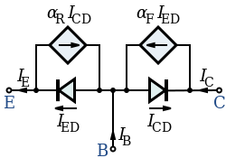

Fig. 1 Ebers-Moll Model for bipolar transistors.

The current through the emitter through the Ebers-Moll circuit is mathematically expressed by equation 1, where $I_{ES}$ is the reverse saturation current of the diode across the base and emitter.

|  |  |
| --- | --- |
| $$I_{E}=I_{ES}(e^{\frac{V_{BE}}{V_{T}}}-1)$$ | (1) |

Currents going through the transistor model can vary by temperature [4]. A mathematical relationship of the transistor and temperature is shown in equation 2:

|  |  |
| --- | --- |
| $$β_{F}\left(T\right)=β_{F}\left(25℃\right)[1+0.007\left(T-25\right)]$$ | (2) |

Three types of current sources are studied. The first is the simple single transistor circuit. This is one transistor used to keep a certain current and is not very efficient compared to other circuits. The diode-based current source uses two transistors in order to stabilize the load current and is a better representation of an ideal current source. Finally, the Willard configuration also uses two transistors but with an emitter resistor to further stabilize the current through the load resistor.

1. Experimental

The circuit for the single transistor circuit is seen in Figure 2 below. A 2.2M Ω resistor was used as $R_{1}$. Voltages and currents were recorded with a load resistance of 10k Ω. A heat gun was then used to measure the change in the load current given the same load resistance.

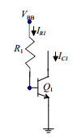

Fig. 2 Single transistor circuit for a current source model.

The next circuit tested was the diode-based transistor circuit. This circuit is seen in Figure 3. The resistor $R_{1}$ was given a value of 18k Ω while the load resistance was again given a value of 10k Ω. The load current was also recorded after using a heat gun to heat the transistors. Lastly, six different load resistances, 1k, 4.7k, 10k, 18k, 47k, and 100k Ω where used and their load currents recorded in order to judge the stability of the current source circuit.

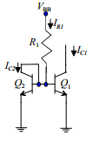

Fig. 3 Diode-based transistor circuit for a current source model.

The last circuit tested was the Willard transistor circuit and is shown in Figure 4. The resistor $R_{1}$ was given a value of 15k Ω. The added emitter resistor was given a value of 560 Ω. Voltages and currents with a 10k Ω load were recorded along with the load current with varying temperature. Six different resistances were also used to record the stability of the circuit.

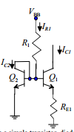

Fig. 4 Willard transistor circuit for a current source model.

1. Results

Simulations for each circuit were created using PSpice. Figure 5 shows the simulation output voltages and current for a one transistor current source circuit.

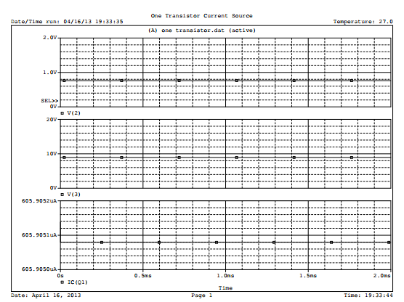

Fig. 5 PSpice simulation for a single transistor circuit.

Figure 6 shows the simulation output voltages and current for the diode-based current source circuit.

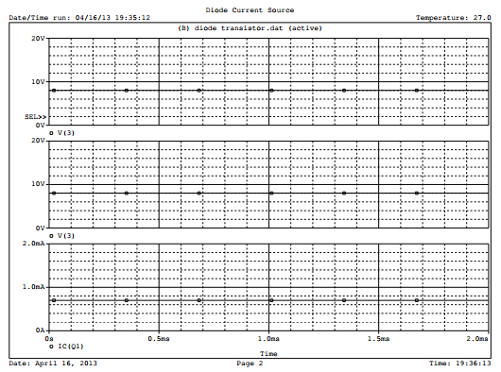

Fig. 6 PSpice circuit simulation for a diode-based transistor circuit.

The last simulation was for the Willard transistor circuit and is shown in Figure 7 below:

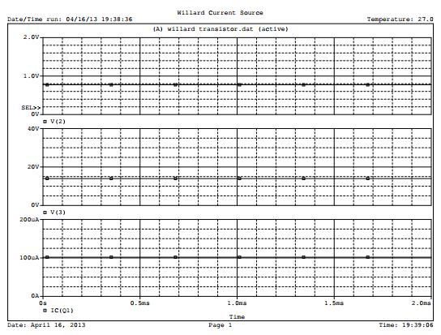

Fig. 7 PSpice Willard transistor circuit simulation.

Once the simulations were complete, the circuits were built in the lab. Table 1 shows the values recorded for each circuit:

Table 1 Voltages and current values recorded for each circuit.

|  |  |  |  |
| --- | --- | --- | --- |
|  | Single Transistor | Diode-based Transistor | Willard Transistor |
| $$I_{RL}$$ | 1.30mA | 0.795mA | 0.948mA |
| $$V_{be}$$ | 0.631V | 0.618V | 0.57V |
| $$V_{ce}$$ | 2.087V | 6.67V | 13.59V |
| $$I_{R1}$$ | 6.6µA | 0.793mA | 0.1057mA |
| $I_{RL}$ with heat gun | 1.45mA | 1.47mA | N/A |

Six different resistance loads were used and recorded for the diode-based transistor and Willard transistor circuits. Table 2 shows the different resistor values used for the circuit load and their respective variables for the diode-based transistor circuit. Analyzing Table 2, a 72mA change in load current is shown when changing the resistor load.

Table 2 Current and Voltages recorded for different load resistances

|  |  |  |  |
| --- | --- | --- | --- |
|  | $$I_{RL}$$ | $V_{ce1}$ (transistor 1) | $V_{ce2}$ (transistor 2) |
| 1k Ω | 0.87mA | 0.616V | 13.8V |
| 4.7k Ω | 0.86mA | 0.616V | 10.7V |
| 10k Ω | 0.83mA | 0.614V | 6.51V |
| 18k Ω | 0.79mA | 0.613V | 2.4V |
| 47k Ω | 0.31mA | 0.610V | 35.4mV |
| 100k Ω | 0.15mA | 0.602V | 22.3mV |

For the Willard transistor circuit, the same recordings using six different load resistances were taken and are shown in Table 3. The load resistance current of this circuit has small changes of about 0.002mA.

Table 3 Current and Voltages recorded for different load resistances

|  |  |  |  |
| --- | --- | --- | --- |
|  | $$I_{RL}$$ | $V_{ce1}$ (transistor 1) | $V_{ce2}$ (transistor 2) |
| 1k Ω | 0.106mA | 0.620V | 14.6V |
| 4.7k Ω | 0.106mA | 0.620V | 14.3V |
| 10k Ω | 0.105mA | 0.620V | 13.7V |
| 18k Ω | 0.105mA | 0.619V | 13.0V |
| 47k Ω | 0.105mA | 0.617V | 10V |
| 100k Ω | 0.104mA | 0.613V | 4.6V |

1. Conclusions

In this lab, three different circuits used as current sources for integrated circuits were tested. These three circuits were the single transistor, diode-based transistor, and the Willard transistor configurations. The load currents and voltages were recorded for each configuration for room temperature and with heat applied from a heat gun. Finally, the load currents for the diode-based and Willard transistor circuits were recorded at six different load resistances.

Appendix

|  |  |  |
| --- | --- | --- |
| One Transistor Current Source  .lib eval.lib  VCC 1 0 15V  RL 1 3 10k  R1 1 2 2.35Meg  Q1 3 2 0 Q2N2222  .MODEL Q2N2222 NPN(BF=300)  .TRAN 10us 2ms  .PROBE  .END | Diode Current Source  .lib eval.lib  VCC 1 0 15V  R1 1 2 20k  RL 1 3 10k  Q1 3 2 0 Q2N2222  Q2 2 2 0 Q2N2222  .MODEL Q2N2222 NPN(BF=300)  .TRAN 10us 2ms  .PROBE  .END | Willard Current Source  .LIB eval.lib  VCC 1 0 15V  R1 1 2 14.9k  RL 1 3 10k  RE1 4 0 560  Q1 3 2 4 Q2N2222  Q2 2 2 0 Q2N2222  .MODEL Q2N2222 NPN(BF=300)  .TRAN 10us 2ms  .PROBE  .END |

References

[1] Linear Technology. Current Source. April 21, 2013. http://www.linear.com/products/current_sources

[2] Radio-Electronics. Active Transistor Constant Current Source. April 21, 2013.

<http://www.radio-electronics.com/info/circuits/transistor/active-constant-current-source.php>

[3] Colorado University. Bipolar Junction Transistors. April 21, 2013.

<http://ecee.colorado.edu/~bart/book/book/chapter5/ch5_3.htm>

[4] StackExchange. Voltage Controlled Current Source. April 21, 2013.

<http://electronics.stackexchange.com/questions/19877/voltage-controlled-current-source-integrated-circuit-exists>