EGR 281 - Project 7 due Tuesday, October 12 by 6:00 PM
Write a program to mirror a children’s board game named Chutes and Ladders®.
You will need a separate classes for each object (Die, Player), as well as a separate game program (main method). To be clear, you will submit a total of three classes.
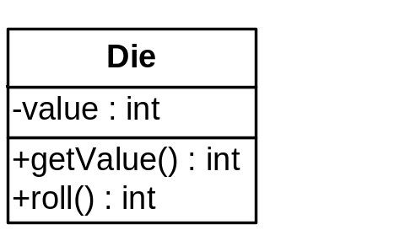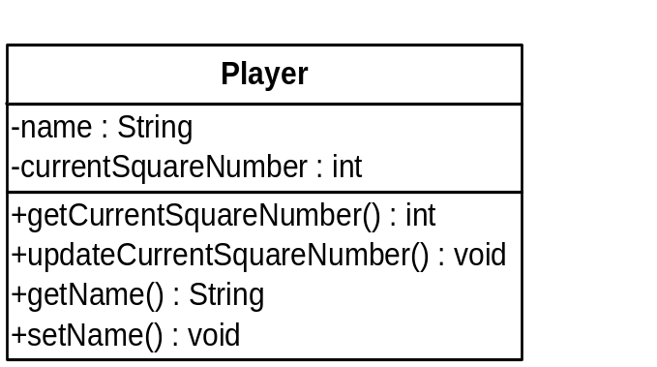
Game Algorithm:
1) Create a Die object, and 2 Player objects. 2) Ask for and store the names of the two players. 3) Loop until a player’s wins (Winning - a player’s current square number is equal to or greater than 100). 3a) Roll, then update the first player’s current square number. 3b) Roll, then update the second player’s current square number. 3c) Check if either player was won.
Please have appropriate prompts and game information.
Remember, this is Chutes and Ladders, so if the current square number is divisible by 10 then “ladder” up an additional dice roll; if the current square number is divisible by 11 then “chute” down an additional dice roll.
As always, don’t forget to include your name, the date, and a description of the program as javadoc comments at the top of your program file. Also be sure to use good variable names. Please send your .class file as an attachment to simsw@midlandstech.edu. Also turn in a printed copy of your program.

