EGR 281 - Project 9 due Tuesday, October 26 by 6:00 PM
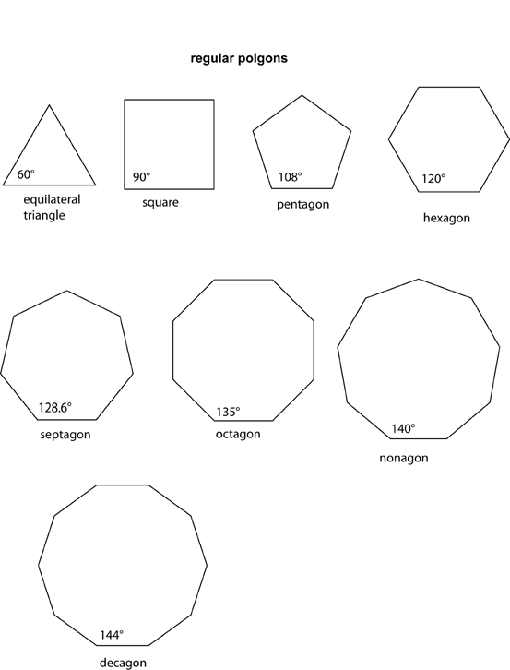
Write an applet that inscribes a red equilateral triangle, inside of a pink circle, inside of an orange regular square, inside of a yellow regular pentagon, inside of a green regular hexagon, inside of a blue regular septagon, inside of a indigo regular octagon, inside of a regular violet nonagon, inside of a black regular decagon.
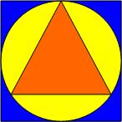
A shape is considered a regular shape if and only if all of its sides are the same length and all of its angles are the same size. (See the figures to the right for the correct angle sizes.)
To the left is a sample that inscribed an orange equilateral triangle, inside of a yellow circle, inside of a blue square.

As always, don’t forget to include your name, the date, and a description of the program as javadoc comments at the top of your program file. Also be sure to use good variable names. Please send your .class file(s) as an attachment to simsw@midlandstech.edu. Also turn in a printed copy of your code.

