Team Member Name, PSID, Cougarnet Email

1. Andrew Carranza, 1636927, aecarra2@Cougarnet.uh.edu

2. Joshua Kanagasabai, 1596314, jkanagas@CougarNet.UH.EDU

3. Dylan Cao, 1844775, dhcao4@cougarnet.uh.edu

4. Lizandro Jesus Meza, 1772231, ljmeza@uh.edu

**CT reconstruction: The Radon Transform Research Project:**

**Introduction:**

CT reconstruction is the mathematical process to generate tomographic images. The goal for this project was to implement a transformation using both the phantoms that we created in class and the sheppard logan phantom.

The Radon transformation is a mathematical operation that is used to convert the data collected by an X-ray detector in a CT scan into a 3D image of the inside of the body. This is done by taking a series of 2D images of the body from different angles, and then using the Radon transformation to combine these images into a single 3D image. This allows doctors to more easily diagnose conditions and diseases by examining the images produced by the CT scan.

The Radon transformation works by projecting the data collected by the X-ray detector onto a series of lines, known as "projection lines," that are perpendicular to the plane of the 2D image. This results in a series of 1D projections, which are then used to reconstruct the original 3D image using a mathematical technique called the inverse Radon transformation. This allows the 3D image to be reconstructed with high accuracy, providing doctors with a detailed view of the inside of the body.

The Radon transformation can be performed using two main methods: the filtered back projection technique and the algebraic reconstruction method.

The filtered back projection technique is a simple and efficient way to perform the Radon transformation. In this method, the 1D projections produced by the Radon transformation are passed through a low-pass filter to remove any high-frequency noise. The filtered projections are then "backprojected" onto the plane of the 2D image to reconstruct the original 3D image.

The algebraic reconstruction method method is a more computationally intensive way to perform the Radon transformation. In this method, an initial estimate of the 3D image is generated using the FBP method, and then this estimate is refined iteratively through the application of a series of mathematical operations.

**Motivation:**

Our motivation for this project came from the things we learned in class. Along with the techniques we learned from reconstructing phantom images using Signal intensity, in our previous assignments. Thus we wanted to further experiment and implement a different method in which we use sinograms to alter images and learn more about the different uses that image reconstruction has in the Medical field.

**Implementation:**

**Phantoms:**

The phantoms we decided to implement took the shapes of a rectangle and ellipse for our first phantom image we used digital image processing to recreate these. In Addition, with the shepp_logan_phantom in the second image that we imported from a library to have as a second image to replicate the experiment.

**Sinograms:**

Inorder to use this technique we used skimage to import radon, iradon. The library radon allowed us to create a sinogram for each of our phantoms.

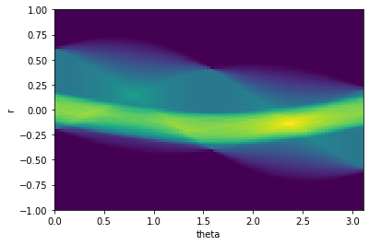

Figure 1: Rectangle and Ellipse phantom Singoram.

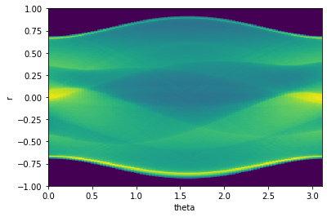

Figure 2: Sheppard logan phantom Sinogram.

The sinogram in (Fig. 1, 2) projects the sine wave of both phantoms; the radon function calculates the given image when the projection angle is specified.

This process can be compared to how the direction of x-rays are scanned. Since they start at the bottom of the θ axis in an angle of zero indicating x-rays are incident on the image from the bottom, the middle of the θ axis is x-rays incident from the left, and the top of the θ axis is x-rays incident from the top. Similarly, to the angles methods described we were able to achieve the same effect in the θ axis. When our ranges were from 0 to 180 in the projection angle.

**Filtered back projection Technique:**

Inorder to implement the back projection technique. The process involves the use of Sinogram. The Sinogram contains in it the phantom image along with the theta, being the set of angle rotations which we declared up to 180 degrees in our code. We included an option to choose a degree to display your desired output. Next, the process includes creating a Reconstruction error image that is calculated by subtracting the previous reconstructed image using the radon function from the phantom image. This error displays the computational errors of the filtered back projections for its respective phantom.

**Algebraic Reconstruction Technique:**

This technique's implementation is similar to the filtered back projection. Being that it also uses the sinogram and requires degrees in order to construct the images. However, for this we used the iradon_sart library which allows us to create a sart construction. Sart stands for (Simultaneous Algebraic Reconstruction Technique). This will be critical in our implementation. From the fact that it is used in projecting previous images into a loop that will pass the previous sart image into a new sart. This will impact the image into a more sharp , higher frequency along with reducing the Square error at the expense of being at a higher frequency.

**Results and Findings:**

**Sinogram Analysis:**

In our analysis of our Sinograms we found that the difference in the projections between the two different phantom images (Fig. 1, 2) was caused by the shape of our phantom images. Showing that the transformation for the Ellipse in (fig. 1) had a strip-like, long and narrow bright visualization. While in the background the Rectangle image has a more faint visualization with the sine wave having two contrasting sine waves intersecting each other. Thus it is easier to spot and make comparisons of the sine waves in (Fig. 1) in contrast to the many different jumbled together sine waves displayed in the Sheppard logan phantom in (Fig. 2). Given that the Sheppard logan phantom is made of multiple different shapes inside the phantom further complicating the waves in the transformation.

**Filtered back projection Technique Analysis:**

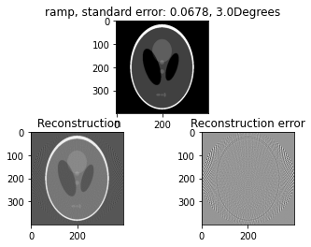

Figure. 3 Sheppard_logan_phatnom Reconstruction

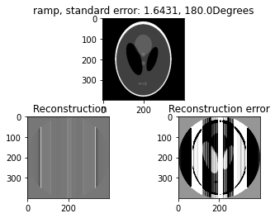

Fig 4 Sheppard_logan_phatnom Reconstruction Higher Degree

Take a look at (fig. 3) this image displays the ramp filter and reconstructs the phantom using a lower degree limitation set at 3 degrees. The image labeled Reconstruction is the processed image after applying the technique and displays the filtered image after applying the transformation. Furthermore, the image is tunable by using different filters that come from the fourier transform library.

For (fig. 4) the degree was increased to the maximum 180 degrees in our angle rotation, the standard error increasing to 1.6431 and the reconstruction error has taken a higher frequency. This gives the image a distorted filtered look. This in comparison to (fig 3) which has a lower standard error which was at 0.0678 seems to suggest that a lower degree leads to less error for these phantoms.

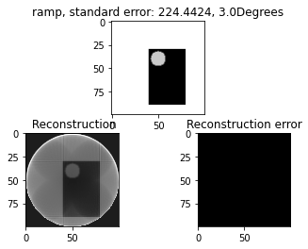

Figure . 5 Rectangle and Ellipse Reconstruction

In analyzing (fig. 5) we found that the standard error did not change in accordance to the degree as shown in the phantom image. This could be due to a multitude of factors. Since the reconstruction image is filtering the image with the radon transform. However, it is likely that sine waves are less distinct given the simplicity of the ellipse and rectangle images. The utility of this method could be better used with our results from (fig. 5). Since this method is intended to be used in analyzing bone and tissue and creating contrast between the different shapes of an image. It could be that our rectangle and ellipse phantom do not have enough definition to properly display a more varied standard error. Thus the shepard_logan_phantom in (fig . 4) has a better utility given the increased amount and variation between the different ellipses inside of it.

**Algebraic Reconstruction Technique Analysis:**

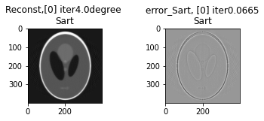

Figure 6

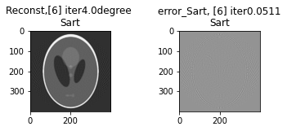

Figure 7

Next, we will analyze the algebraic reconstruction images in (fig. 6, 7) these images are the result of iterating the previous reconstruction images over until the 6th iteration. The degree was set to a low set angle rotation of 4 degrees. The results were expected, in that as the reconstruction of images continued the error would get smaller in correspondence to the iteration. Moreover, a point of interest would be that after 6 iterations the 7th iteration error result did not change from the 6th onward. This could be an indication of the limits in the amount of times a reconstructed image can be filtered through using this Algebraic process.

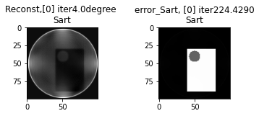

Figure 8

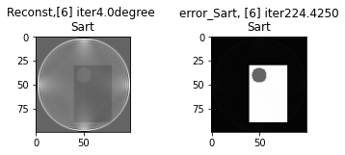

Figure 9

The reconsted images of our Rectangle and ellipse phantom set in (fig. 8,9) proved to be working in its reconstructions with the images displaying different frequencies in noise between the first iteration and the sixth. The Squared error however still remained very high with very little change between the two having a total difference of 0.0040. The explanation for this I believe would be the same as what I described in the analysis of figure 5. With it being due to the limited amount of shapes along with the variation of our phantom. I further speculate that the squared error shows white because the rectangle is below the ellipse making the image to perceive that the rectangle as the tissue with a higher intensity and the ellipse a bone thus a stronger intensity with the image being contrasted heavily. Further suggesting the useful utility this has when x-rays are used on patients when given better more realistic phantoms like the shepard_logan_phantom in (fig. 6,7) that better represents a human's contrasting intensities and frequencies.

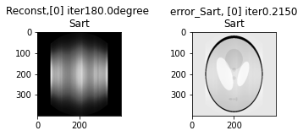

Figure 10

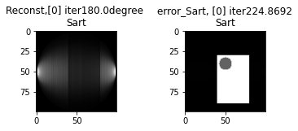

Figure 11

Lastly for (fig. 10,11) the images presented had an predicted effect when the degree was increased to 180 degrees.WIth the image showing the high frequency in noise that occurs. As opposed to those in (fig. 8,9) the increase was most noticeable in the filtered reconstruction image where the sinogram intensity was greater than what was displayed in (fig. 8) of th sheppard_logan_phant.In addition the Square error of the sart for (fig. 10) was slightly higher showing that it performed better when it had less degrees.

**Conclusion:**

In conclusion, we experimented and learned more about sinograms. Along with filtering reconstructed images using two different methods. The results and analysis gave us a stronger intuition of how to approach and think about the correct ways to use topography when utilizing these technologies and tools. And has thus shaped and increased our interests in image processing when applied to the medical field.

Works Cited:

1.Radon transform filter projections:

<https://howradiologyworks.com/filtered-backprojection-fbp-illustrated-guide-for-radiologic-technologists/#what-is-a-ramp-filter>

2.Radon transform info: <https://en.wikipedia.org/wiki/Radon_transform#Relationship_with_the_Fourier_transform>

3.Radon transform guide:

<https://scikit-image.org/docs/stable/auto_examples/transform/plot_radon_transform.html>

4.Research on computational errors:

<https://www.researchgate.net/figure/Computational-errors-of-the-filtered-back-projection-for-the-log-polar-based-method-with_fig6_277603803>