

CSE 1325 Project Documentation

ENTER THE DUNGEON

Students names, surnames, IDs:

1. Levi Johanon, 1002187310

2. Nischal Parakoti, 1002234942

3. Hayden Nguyen, 1002226722

4. Christian Nguyen, 1002128156

Mentor: Marika Apostolova

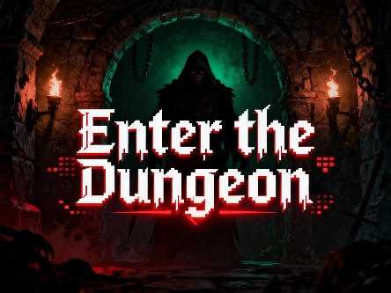

Object oriented programming CSE 1325
Student declaration:

We declare that:
- We understand what is meant by plagiarism
- The implication of plagiarism has been explained to me by our professor
- This assignment is all team own work and we have acknowledged any use of the published and unpublished works of other people.
1 Student Levi Johanon, 1002187310 Signature: ……………………......
2 Student Nischal Parakoti, 1002234942 Signature: ……………………......
3 Student Hayden Nguyen, 1002226722 Signature: ……………………......
4 Student Christian Nguyen, 1002128156 Signature: ……………………......

Date:……..............................................

 | Total number of pages including this cover page | 10
Class Code / Group | CSE 1325
Lecturer’s Name | MARIKA APOSTOLOVA

Table of Contents

1. Project Introduction 1
2. Project Description 1
3.Project Architecture 1
4.UML Class Diagram 2
5. OOP Concepts Used 2
6. Code Description 2
7.System Testing 5
8.Group Members 6
8. Conclusions 6

- Project Introduction
Enter the Dungeon is a dungeon-crawler game focusing on improving typing speed in a fun way. The player explores through the dungeon, meeting and talking to NPCs, and if that meeting results in a fight, they must type as fast as possible in order to win.

- Project Description
When designing this game, we decided we wanted to focus on a way to make typing fun again. Therefore, we decided that we wanted to make the fighting mechanics of our game something related to typing, specifically typing different characters as fast as possible. So, in order to design a program to emphasize this feature, we chose to go with a simple dungeon-crawler game. The player would go around and talk to different NPCs, and after going through a dialogue with them, could potentially fight them. To achieve this, we chose to try and really make something that would draw the user in. Also, in order to provide some motivation and a challenge for the users, we made it so that the user would take damage every second in a fight, as well as different difficulty settings for the user. This provides a challenge for everybody from beginner typists to even experienced ones such as our group. We can’t even beat the hard difficulty. Overall, we really tried to make this game one that would make improving typing fun and interesting.

- Project Architecture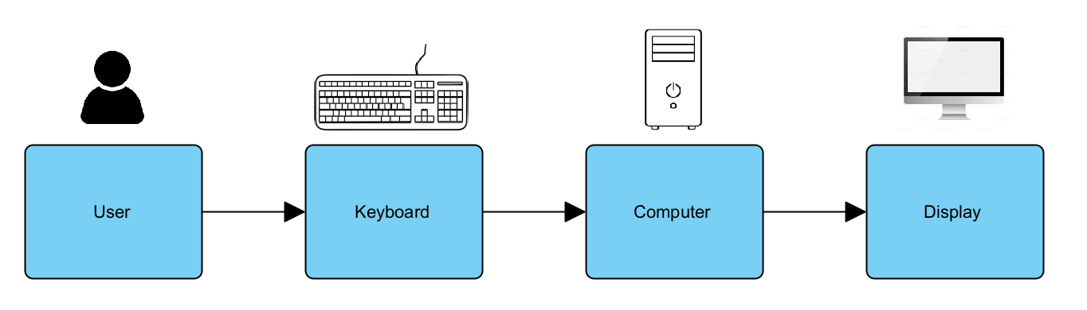
Figure 1 System architecture
The user types on the keyboard and the data is transmitted through two ways: Scanner and KeyListener through Swing. Because Scanner requires you to hit enter afterwards, KeyListener was used for most of the inputs to avoid this. The display is updated after every input.

- UML Class Diagram
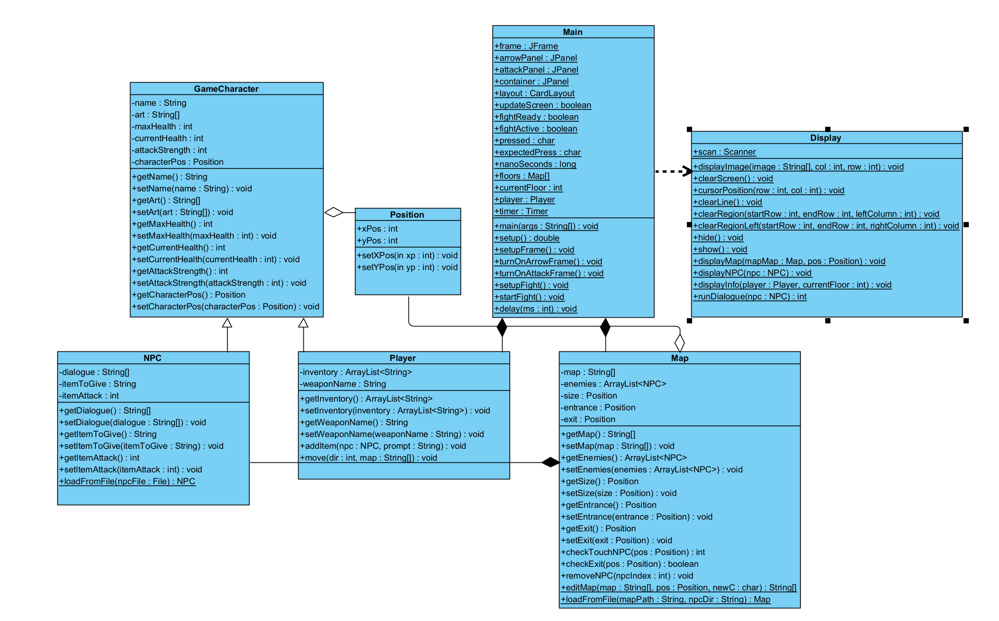
Figure 2 UML class diagram
- OOP Concepts Used
For this project, we used inheritance, encapsulation, and focused on reusability to connect all the parts. Both the Player class and the NPC class inherit from the class GameCharacter, which holds things like the artwork, name, health, attack, and position fo the character. Player then added a weaponName and an inventory, while the NPC added a dialogue as well as an item to give. After noticing that two ints were used to control where everything was on the Map, we made a Position class which wrapped this all up into one and controlled everything. Also, used some elements of abstraction by hiding all of the display related code in a Display class which we called repeatedly.

- Code Description
The four most important parts of this code is the file-loading system, the dialogue, the state machine, and the fighting mechanics.
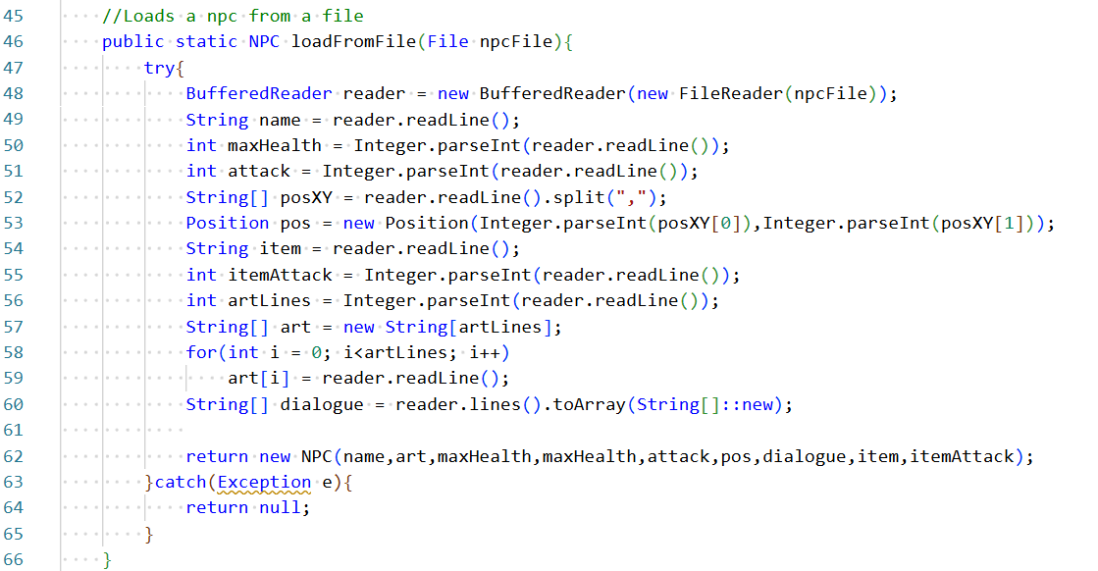
The above code is the method we wrote to load an NPC from a file through BufferedReader. As you can see, inside of a try-catch block, we go through each and every line of the .txt file that holds the NPC’s data, potentially parse them, assign them to variables, and return an NPC created from those variables. When combined with another function that goes through a folder and automatically loads all the maps and npcs located within, it can be used to easily change or set a story for this game. This helped us while testing and crafting the story because it made it so we didn’t have to recompile every time we changed the story or dialogue.
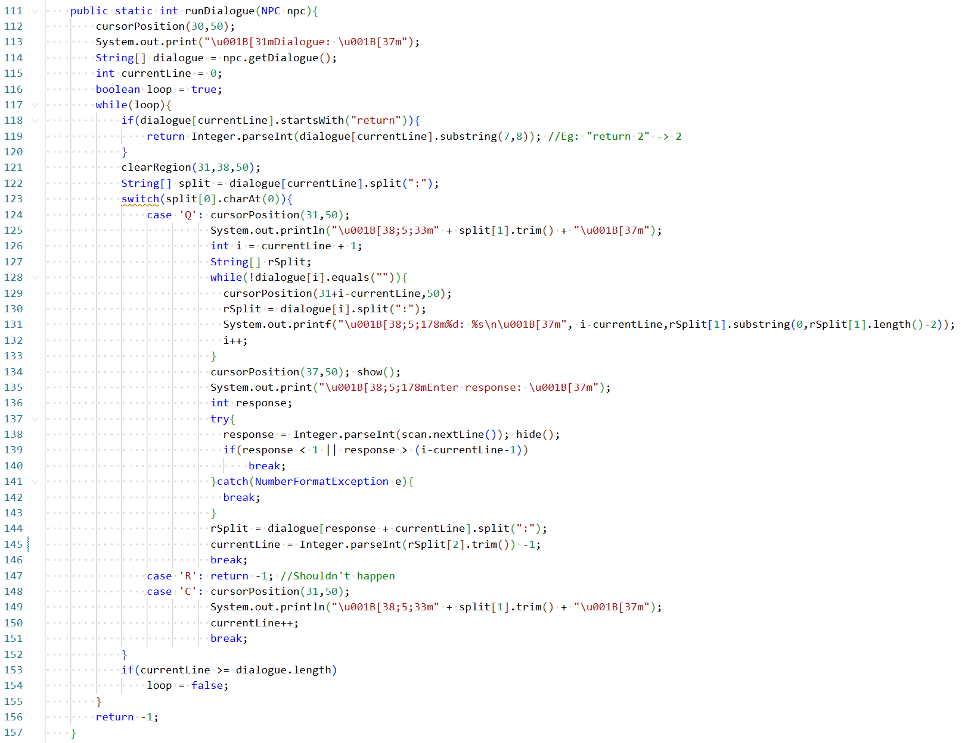
The above code is a part of our dialogue system. We first created a dialogue format and design to control how we would write the dialogue while trying to include multiple responses and branching paths. This involved a String array in which each line was a question, response, comment, return value, or blank line. Then by iterating through this as well as certain goto statements within the code, we could control the dialogue. First, we start by checking if a line is a return value and returning that number if it is. Then, we check what kind of line it is, such as a question, then based on that we have a switch case controlling the behavior. When the line is a question, we know that every line between that line and the next empty line is a possible response to the question. So, we print them all and use Scanner to get the response. Another interesting thing is the error-handling regarding parsing the user’s responses. If the response isn’t a number or is out-of-bounds, we simply break out of the switch block. Because we break before the line in which the currentLine variable is updated, the code simply erases the bad answer and redisplays the question. This dialogue portion of the code is what we feel most draws the user into our game.
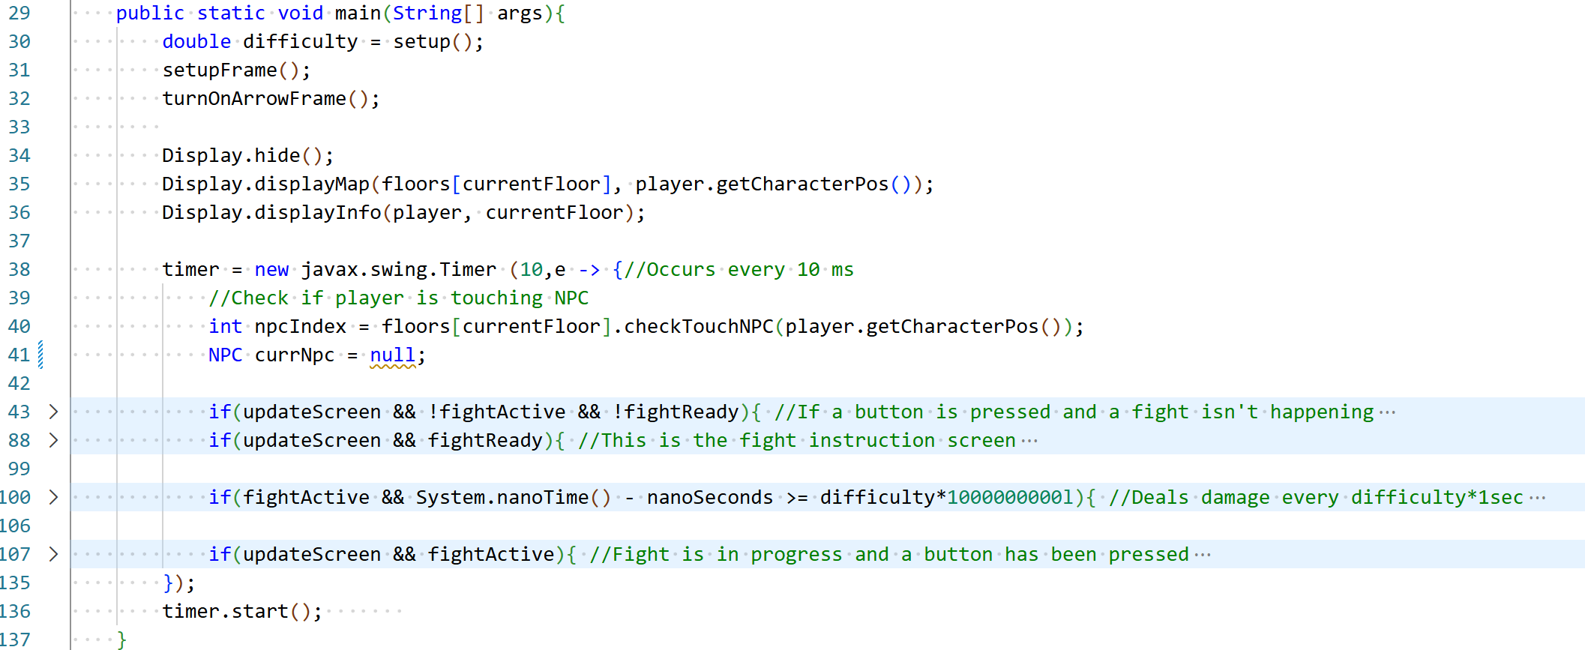
As mentioned earlier, a KeyListener was used for inputs such as the arrow keys and keyboard, so the user doesn’t have to press enter each time. Because a while loop would block the thread that this runs on, we used a timer in a similar manner to a while loop. Every time a key was pressed (that we care about), we set updateScreen to be true. Also, we used some boolean variables in a manner like a state machine so the code could remember what stage of the game it was in. When combining both together, we get some code that every 10ms, checks if the player is next to an NPC or if a key has been pressed, then proccesses that and redisplays the screen if necessary. Unfortunately, due to the limitations of variables in lambdas which require all outside variables to be final, effectively final, or static, most of the variables had to be static in order to use them. This included the Player, Map array, the state machine variables, the JFrame controlling the KeyListener, and a few others.
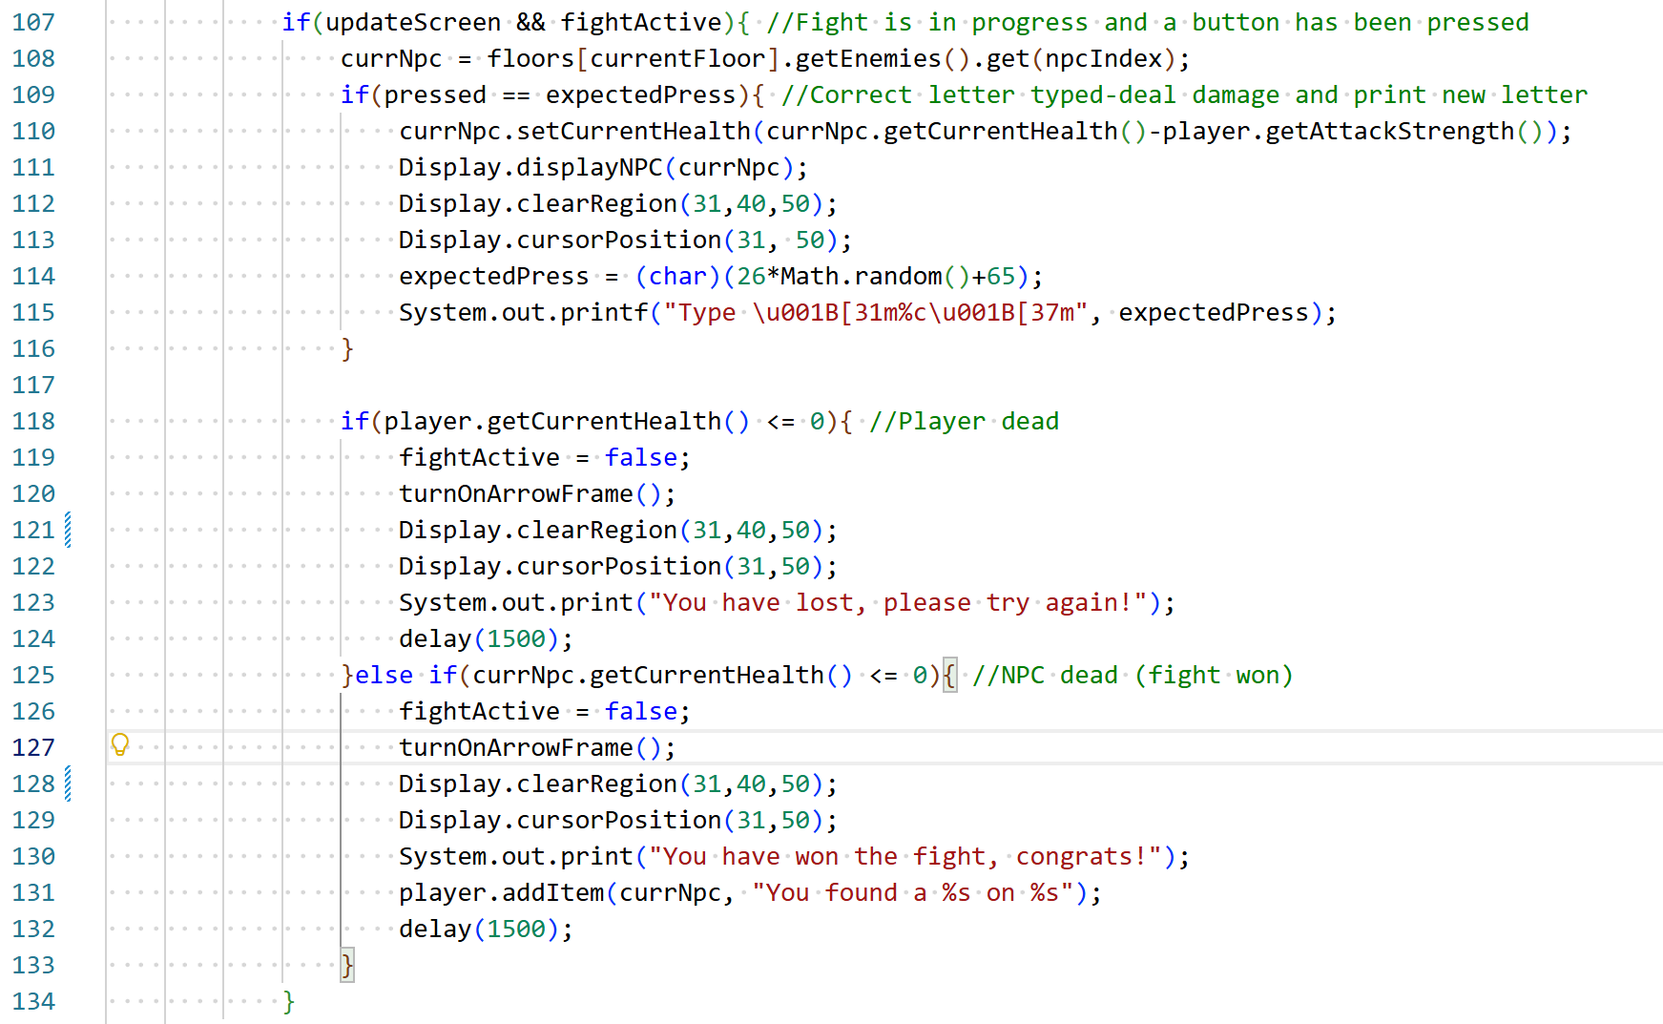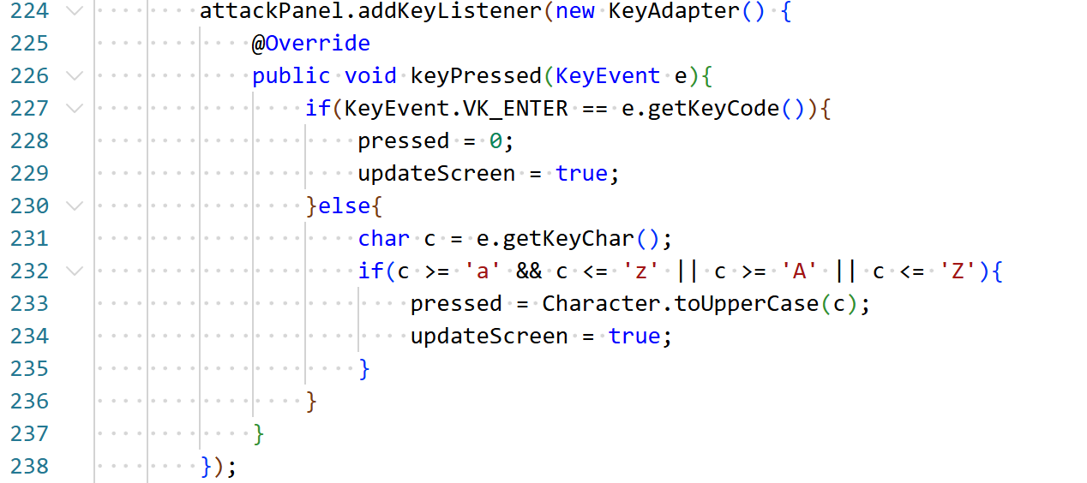
Finally, the main code which controls the fighting mechanic is shown above. First of all, when the attackPanel is the focused panel on the frame, which is set earlier, the code detects when a letter key or enter, which is used to start the fight, is pressed by the user. It places the keyPressed in a variable and sets updateScreen to true. When the timer’s next cycle starts, it sees this, checks if the right button has been pressed, and if so, decreases the health of the NPC, redisplays everything, and asks for a new random character to be pressed. Then, if either the Player or NPC is dead, it displays the result, has a small delay, and then kicks you out of the fight. Because the Player takes damage every second, the user must type the random characters fast enough to avoid losing the fight.
- System Testing
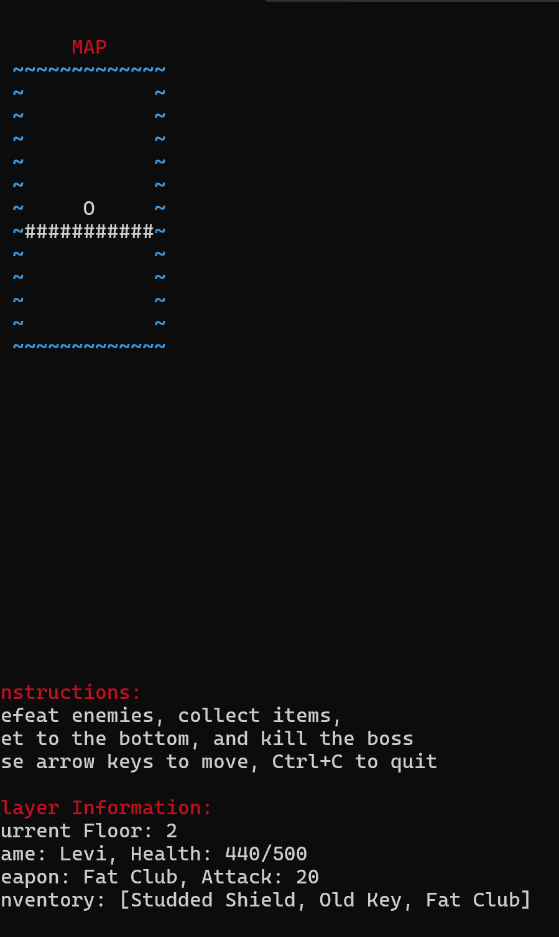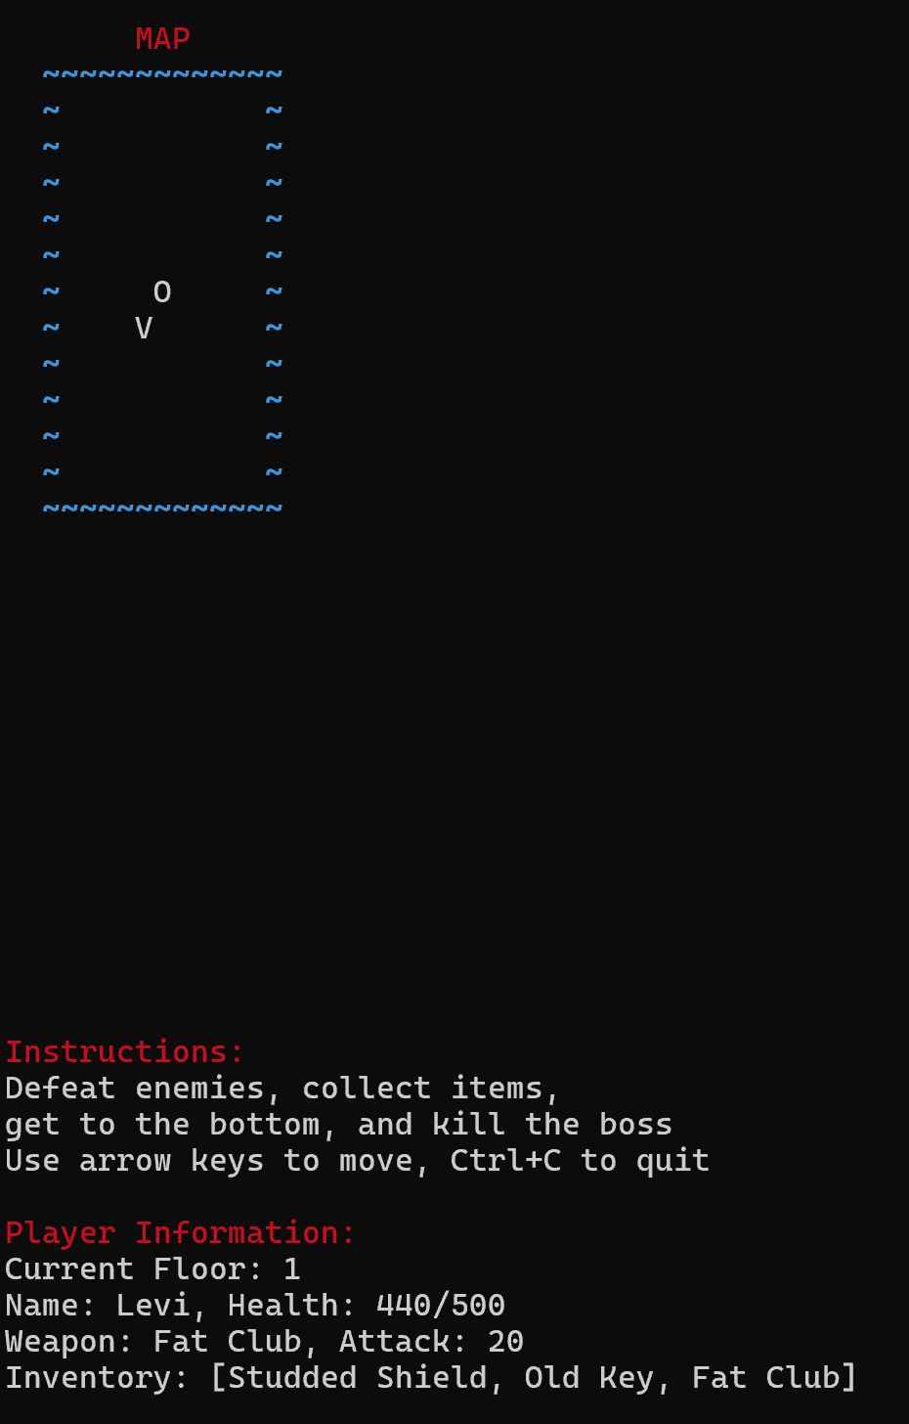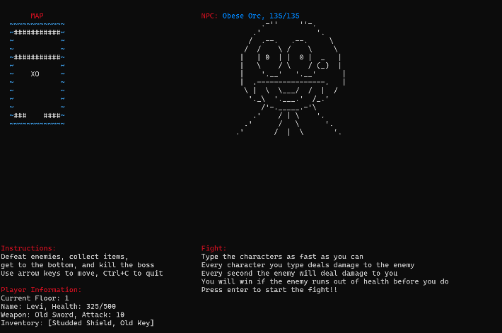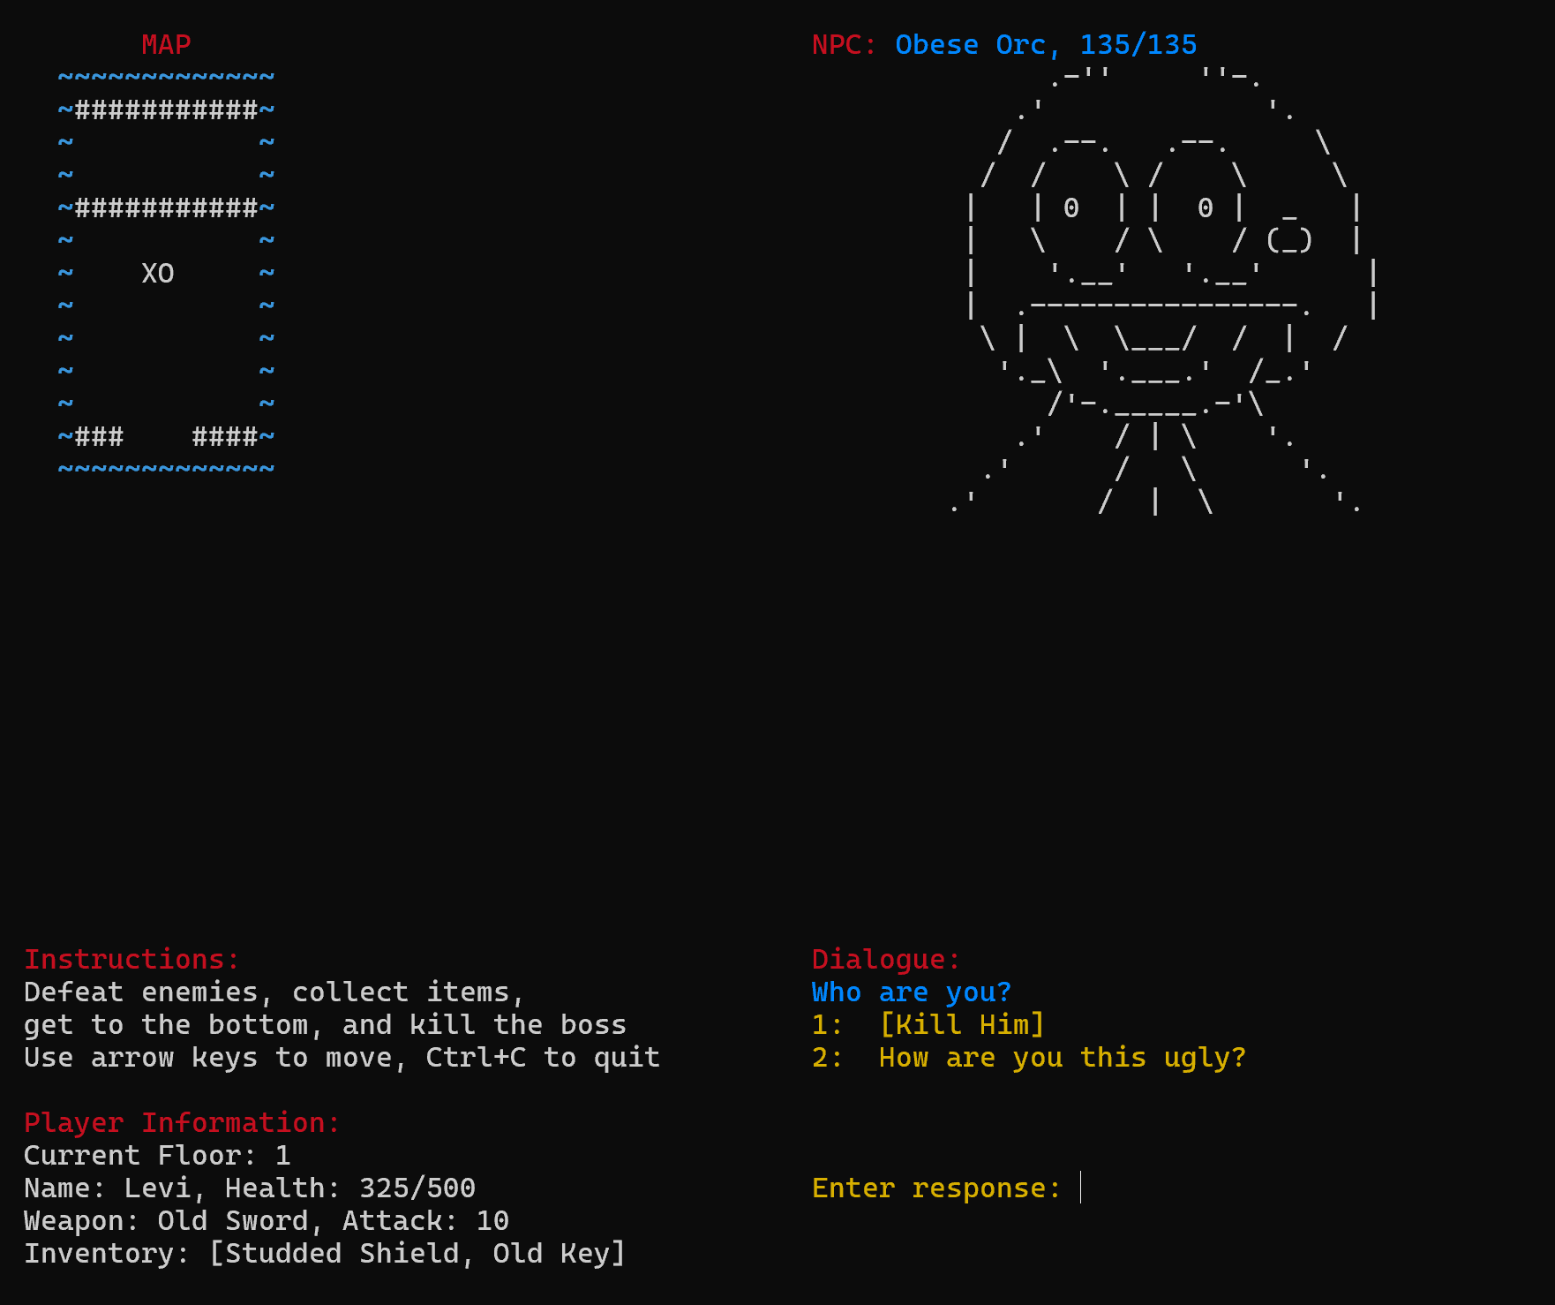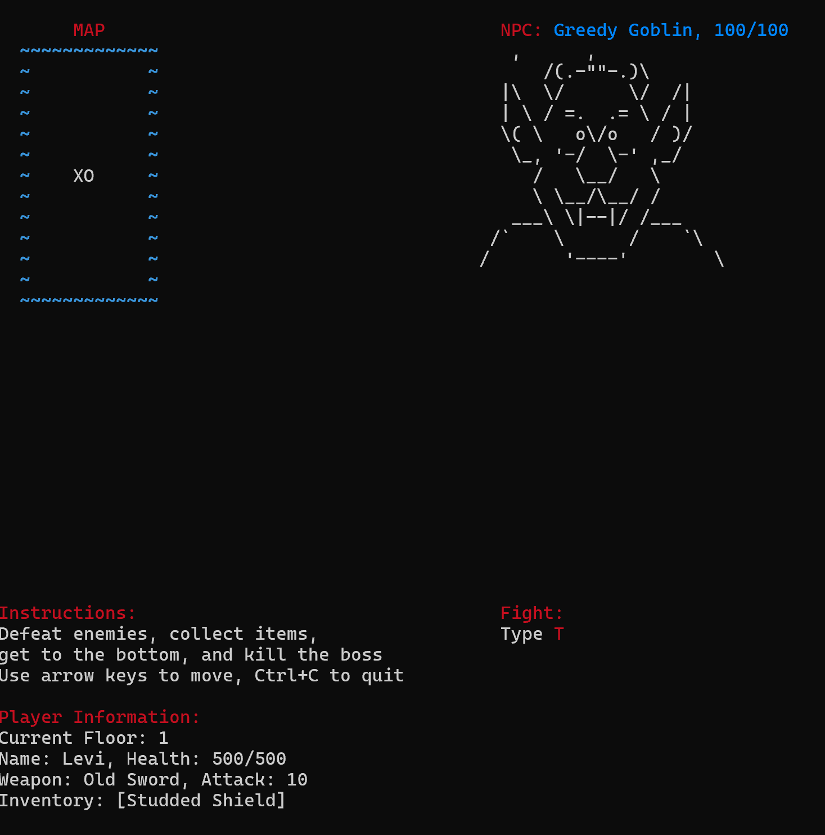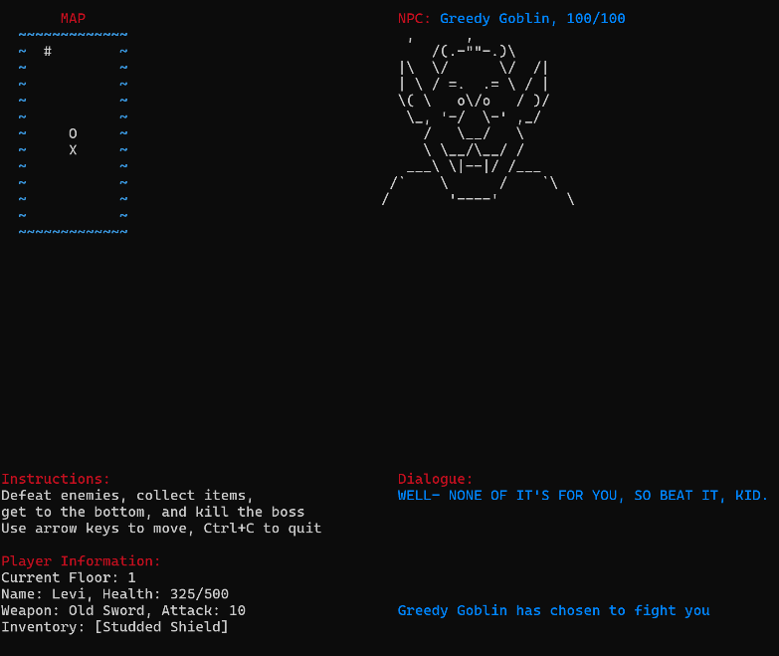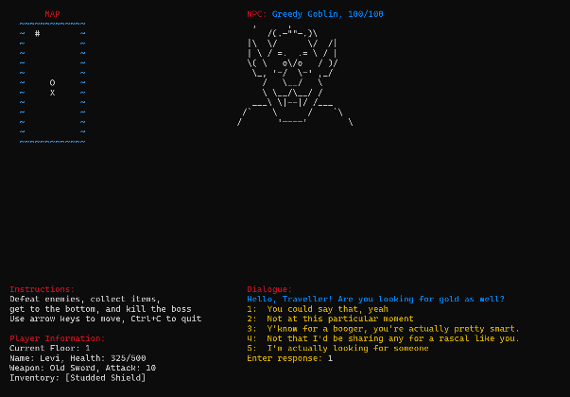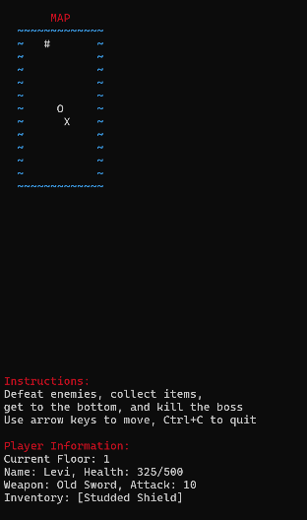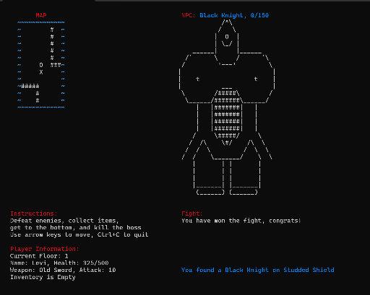


- Group members
Levi Johanon: Helped brainstorm, main coder, created UML diagram, wrote report.
Nischal Parakoti: Helped brainstorm, created maps, helped debug, helped with report.
Christian Nguyen: Helped brainstorm and made planning document, helped with code structure, worked on story and characters, helped debug.
Hayden Nguyen: Helped brainstorm, main story developer, made characters, helped debug.
- Conclusion and future works
Exploring through this project really allowed us to internalize some of the things that are required to create programs with users. We learned how to create something that looked bright and attentive and how to control the user’s input. Throughout this project, we created classes and used inheritance, used file handling, input parsing, and error handling, learned how to create UML diagrams, explored github and working on a shared repository, and learned how to manage a large Java project with multiple files and classes. We also brushed against the basics of GUI and concurrancy, as well as terminal display using ANSI. Overall, this project really helped us learn Java better through using it in a practical program and seeing what we could do when we put our minds to it.
In the future, there are a few things that we would want to do to improve this project in the future. First of all, the GUI code is quite messy simply because we don’t fully understand how it works. In the future, if we take the time to learn how Swing, GUI, threads, and concurrancy works in Java, we could recode that system and take the time to fully clean up the code. Secondly, we can do some more with the map and the character images. We can add colors, other blocks, things like treasure chests, and other stuff that really helps to further immerse the user int the game. Third, we can add a item checking system to the game, while you can currently only move to the new floor after getting past all of the NPCs, it would be interesting to have NPCs only give you items or change their dialogue based on what you have in your inventory. Fourth, we can add more story to the game. A bigger story is better in our opinion. Fifth, we can add numbers and punctuation to the game, something that we personally struggle typing compared to basic letters. Finally, we can just work on cleaning up the code. Any code that is written in the process of learning is obviously not the best. If we were to code this after taking the entire class the code would be better, but unfortunately that’s not an option due to the timing of the class. Overall though, we’re proud of what we have produced here in the game.

