SFBC Jan 01-Mar 31, 2026 Budget Report
San Francisco Bay Chapter
Generated: April 13, 2026

Summary
Metric | Amount
Membership Income | $1,089.00
Donations | $0.00
Total Income | $1,089.00
Expenses | $59.97
PayPal Fees | $30.29
Total Outflows | $90.26
NET INCOME | $998.74

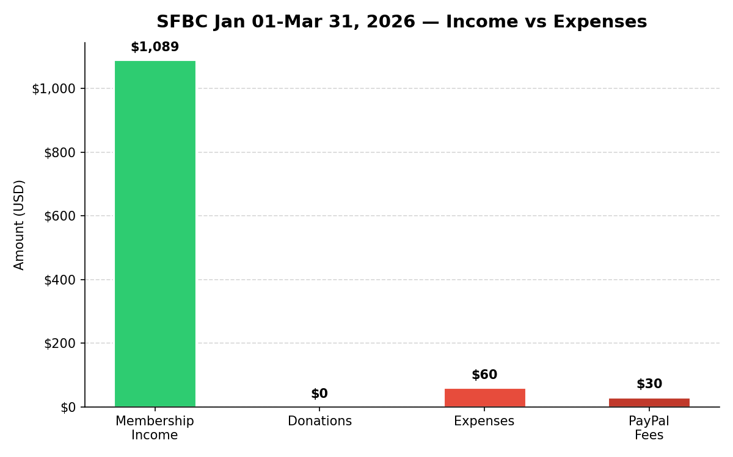
Figure 1 - Income vs Expenses

Income Breakdown

Monthly Income
Month | Membership | Donations | Total
January | $849.00 | $0.00 | $849.00
February | $120.00 | $0.00 | $120.00
March | $120.00 | $0.00 | $120.00
TOTAL | $1,089.00 | $0.00 | $1,089.00

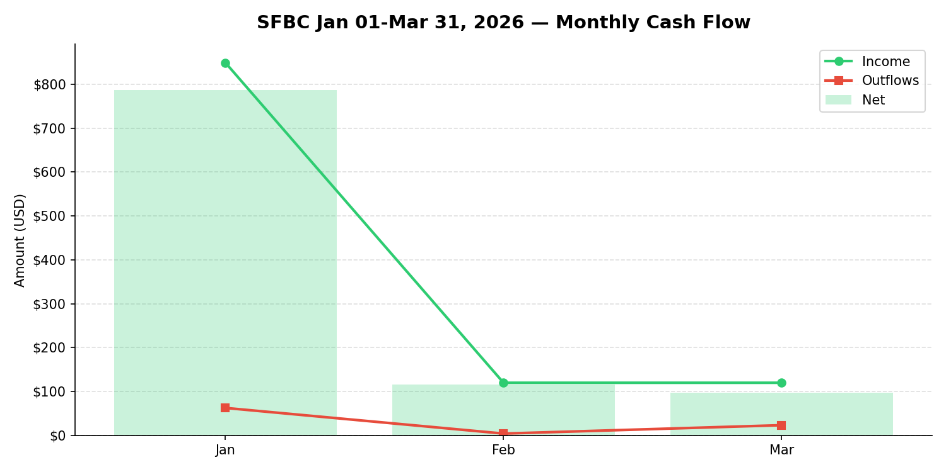
Figure 2 - Monthly Cash Flow

Expense Breakdown

Monthly Expenses
Month | Expenses
January | $39.99
March | $19.98
TOTAL | $59.97

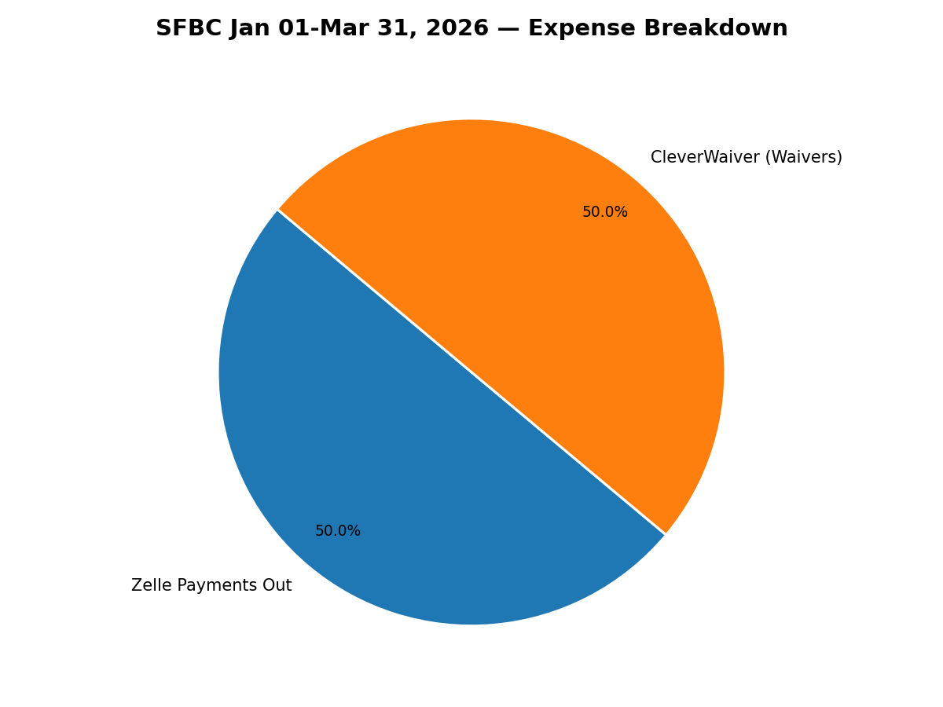
Figure 3 - Expense Breakdown by Category

Major Expenses (>$50) with Notes
No major expenses found.

Zelle Payments Out
Date | Description | Amount | Note
2026-01-21 | Zelle payment to V*** JPM99c2rhw8l | $30.00

All Itemized Expenses
Date | Description | Amount
2026-01-21 | Zelle payment to V*** JPM99c2rhw8l | $30.00
2026-01-28 | CLEVERWAIVER CLEVERWAIVER. WA 01/28 | $9.99
2026-03-02 | CLEVERWAIVER CLEVERWAIVER. WA 02/28 | $9.99
2026-03-30 | CLEVERWAIVER CLEVERWAIVER. WA 03/28 | $9.99

PayPal Summary
Item | Amount
Gross Received | $706.00
Fees | $30.29
Net | $675.71

Fidelity Investments
Account: Z40319360
Current Portfolio Value: $14,674.76

Current Holdings
Symbol | Description | Price | Value | G/L $ | G/L % | Alloc
SPAXX** | HELD IN MONEY MARKET | - | $1.53 | +$0.00 | +0.00% | 0.01%
FSKAX | FIDELITY TOTAL MARKET INDEX FUND | $187.12 | $6,724.71 | +$2,589.06 | +62.60% | 45.83%
FTIHX | FIDELITY TOTAL INTL INDEX FUND | $18.64 | $3,461.61 | +$1,148.50 | +49.65% | 23.59%
FXNAX | FIDELITY U.S. BOND INDEX FUND | $10.49 | $4,486.91 | -$102.38 | -2.24% | 30.58%

Notes
- Internal transfers excluded: PayPal <-> Chase ACH transfers are detected and excluded from all totals to avoid double-counting.
- Date range: posting dates from 2026-01-01 through 2026-03-31 (inclusive).
- PayPal fees: Tracked separately and excluded from income.
- Donations: credits whose description matches donation-related keywords; other income is membership.
- Major expenses: Expenses >= $50 are annotated in the Major Expenses section.
- Name redaction: Personal names in transaction descriptions have been anonymized.
- Fidelity: Portfolio positions are as of the CSV export date; not mixed into operating figures.

