Project/ Pre-final: C++ Visual Novel - Dispatch Decision Engine

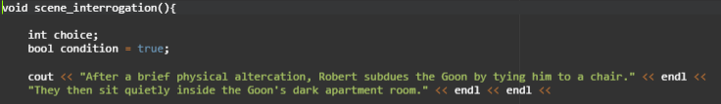
void scene_interrogation()
- First scene called by main()
int choice;
- integer variable declared.
- to store the user input.
bool condition = true;
- boolean variable declared.
- used in the while loop condition to create an infinite loop.
cout << “After a....”
- prints narration, character dialogues and choices.

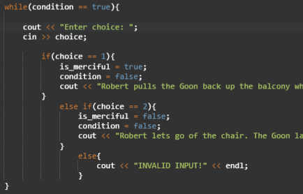
while(condition == true)
- uses an infinite loop to allow multiple user input in case of invalid inputs.
- using condition = false for each correct input to break the infinite loop.

cout << “Enter choice: “;
cin >> choice;
- using cout to print something to gather user input.
- using cin to save user input to variable choice.

if(choice == 1){
is_merciful = true;
condition = false;
cout << "Robert pulls the Goon back up the balcony which calms him down." << endl;
}
else if(choice == 2){
is_merciful = false;
condition = false;
cout << "Robert lets go of the chair. The Goon lands on a conveniently placed mattress, saving his life." << endl;
}
else{
cout << "INVALID INPUT!" << endl;
}
- using an if else statement, if the user’s input is 1 then set variable is_merciful to true, variable condition to false and print outcome message.
- same process for user input 2.
- else statement if the user input is invalid.

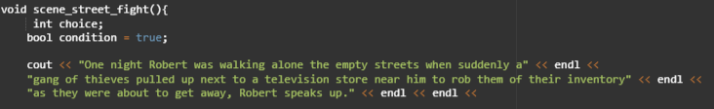
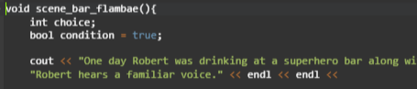
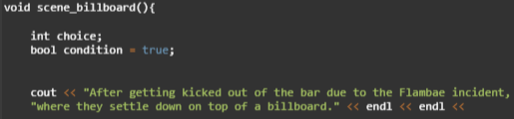
- these three scene functions follows the same process as the aforementioned function (scene_interrogation()).

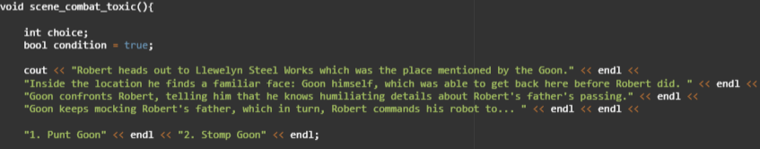

- This function uses two variables to determine the scene’s result/output.
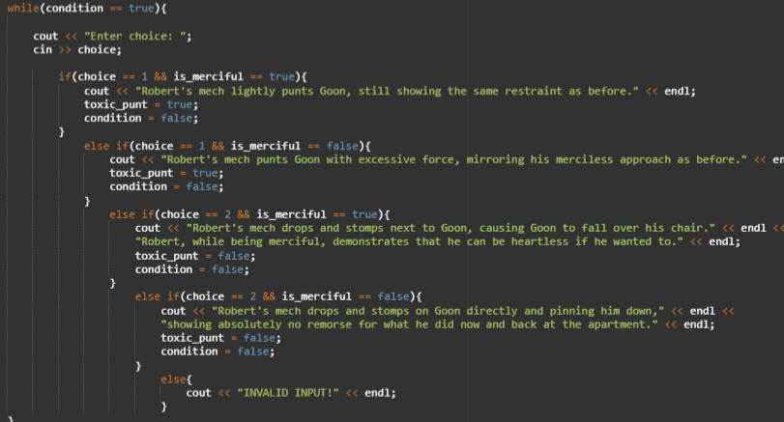
- uses same process as the other functions for the while loop and user input.

if(choice == 1 && is_merciful == true){
cout << "Robert's mech lightly punts Goon, still showing the same restraint as before." << endl;
toxic_punt = true;
condition = false;
- if user input is equal to one AND if is_merciful is equal to true, then print output message, set toxic_punt to true, set condition to false.
- All other else if statements follow the same process.
- Else prints if the user input is invalid.

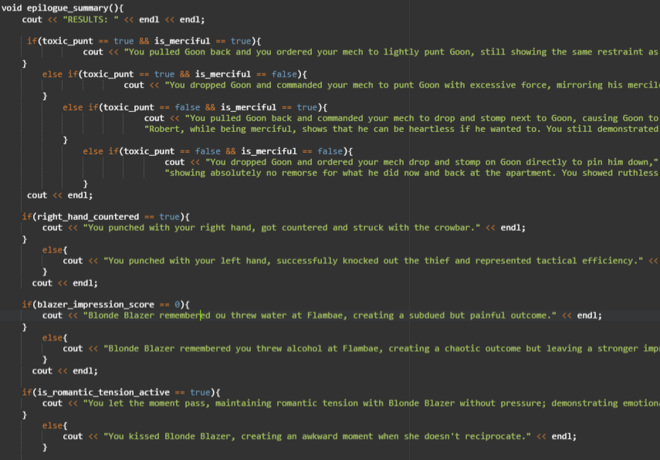
- this function prints the summarized choices of the user from all the scenes.
- all possible choices of the user have a corresponding output that shows the consequences derived from their chosen decisions.

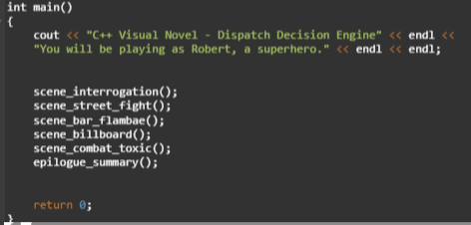
- the main() function serves to print the description of the program.
- all the scene functions are called in the correct sequence.
- return 0 to end the program.

