**Introduction**

Native plant communities across the western United States have experienced serious degradation, invasion, and population decline [(Pyke 2011)](https://www.zotero.org/google-docs/?qohon3). To restore these native plant communities, efforts often involve bolstering existing populations, or creating new populations with wild-collected or farm-grown progeny of wild-collected seeds. Seed mass is an important characteristic for restoration because it can be predictive of plant performance including dormancy, recruitment, and establishment [(Rees 1996; Moles and Westoby 2002)](https://www.zotero.org/google-docs/?zkrSVy). While interspecific seed size has long been studied, less is known about intraspecific seed size. My research aims to describe patterns of inter and intraspecific seed size variation in seed mass, shape, and embryo fill across space and time.

There are many seed characteristics that comprise a seed’s ‘size’ which are understudied and may be more predictive of plant performance than mass alone. For example, seed shape (height and shape variance) and embryo to seed size (E:S) ratio can be better predictors of germination rates than seed mass alone in certain species [(Barak et al. 2018)](https://www.zotero.org/google-docs/?Kl5Khq). Similarly, the variation in seed mass distribution within an individual seed may influence early seedling traits. For example, seeds may have equal weights but vary in embryo and endosperm shape and size, which can affect early plant growth. However, how embryo and seed coat shape and ratios influence early traits, including germination and growth, is even less understood than seed mass in western species. By better understanding species level seed traits including seed shape and embryo size, we can improve seed lot testing, seed collection planning, and ultimately restoration practices.

For the past 2 field seasons and this coming field season I have been collecting seeds from the same individual maternal plants from 4 different communities of 4 native plant species (*Balsamorhiza sagittata, Hesperostipa comata, Elymus elymoides, and Achnatherum hymenoides*). Individual seeds are weighed and then prepared for x-ray imaging. So far, I have taken 360 X-ray images of 1,800 individual seeds from 4 different species (Figure 1). Each image contains 5 seeds from the same maternal plant.

**Methods**

From the x-ray images, I plan to identify presence or absence of embryos within seeds, measure embryo to seed ratio, total seed height and width as well as height to width ratio, distribution of internal morphology (embryo and endosperm) and proportion of empty space within each seed following modified protocols [(Gomes-Júnior et al. 2013; Rocha et al. 2014)](https://www.zotero.org/google-docs/?acEPzb). I intend to use machine learning techniques to take these measurements. X-ray images will be analyzed in either Python, imageJ software, or comparable software [(Schneider et al. 2012)](https://www.zotero.org/google-docs/?TdtIsK). I will also push results to GitHub for backup purposes and to track image progress. Eventually, I will use GGPlot to show results with consideration to maternal plant identity, home site, seed mass, germination success, and seedling growth rate.

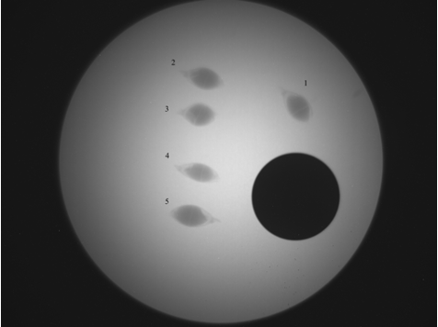

*Figure 1. Standard x-ray layout for each set of 5 seeds. Image is of Achnatherum hymenoides. BB pellet included for standard size and color in each image.*

**Results:**

This data lends itself well to a relational database. I would have at least 3 databases, one for individual seeds and weights, one for greenhouse results, and one for field data each year for each maternal plant.

* **Seed Weight Table**
  + Seed Unique ID (full data)
  + Maternal Plant ID – foreign key
  + Site – foreign key
  + Year
  + Species
* **Greenhouse Table**
  + Seed Unique ID (subset of data)
  + X-ray (Y/N)
  + Emergence date
  + Flowering data
* **Field Data**
  + Maternal Plant ID
  + Date collected
  + Status (vegetative year, lost, completely herbivorized)

In my greenhouse experiment, not all seeds germinated. Of the 900 *Elymus elymoides* seeds planted, 353 seedlings emerged (Figure 1). Of the 900 Hesperostipa comata seeds planted, 134 seedlings emerged in 2022 (Figure 2). Additional seeds are continuing to emerge in 2023 but are not plotted due to low samples skewing the graph.

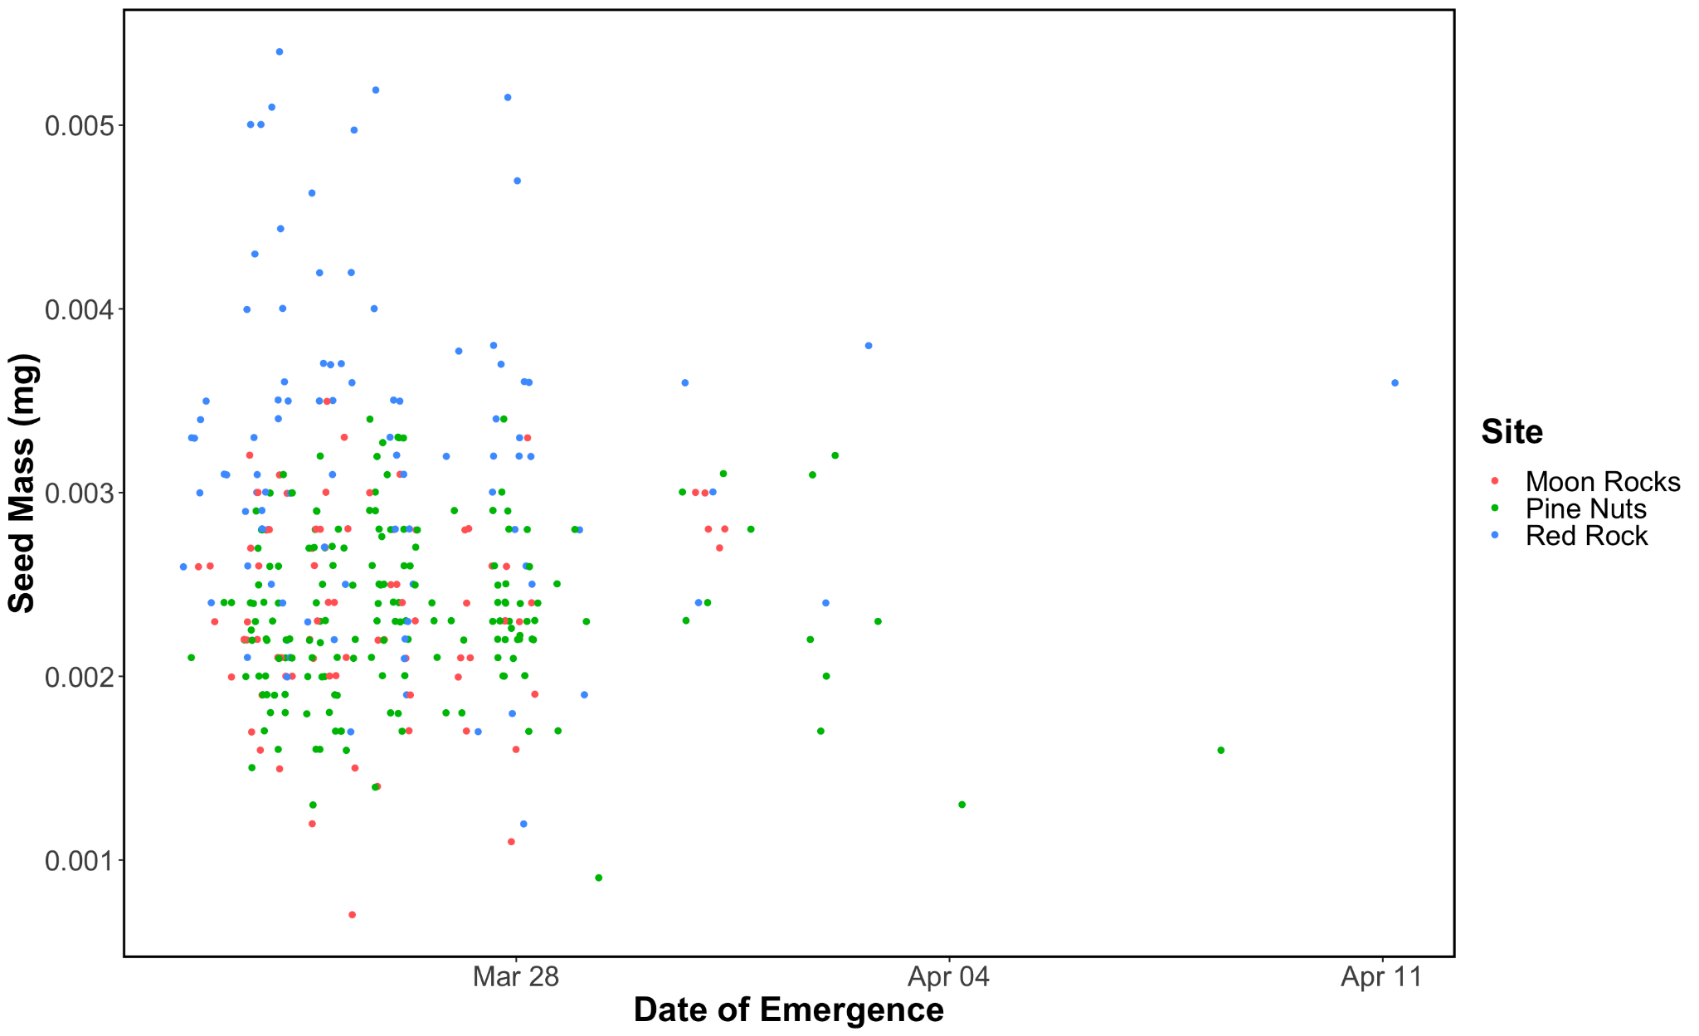

**Figure 1.** Emergence timing of *Elymus elymoides* seeds. Points are plotted by seed mass to allow for more spacing and colored by site.

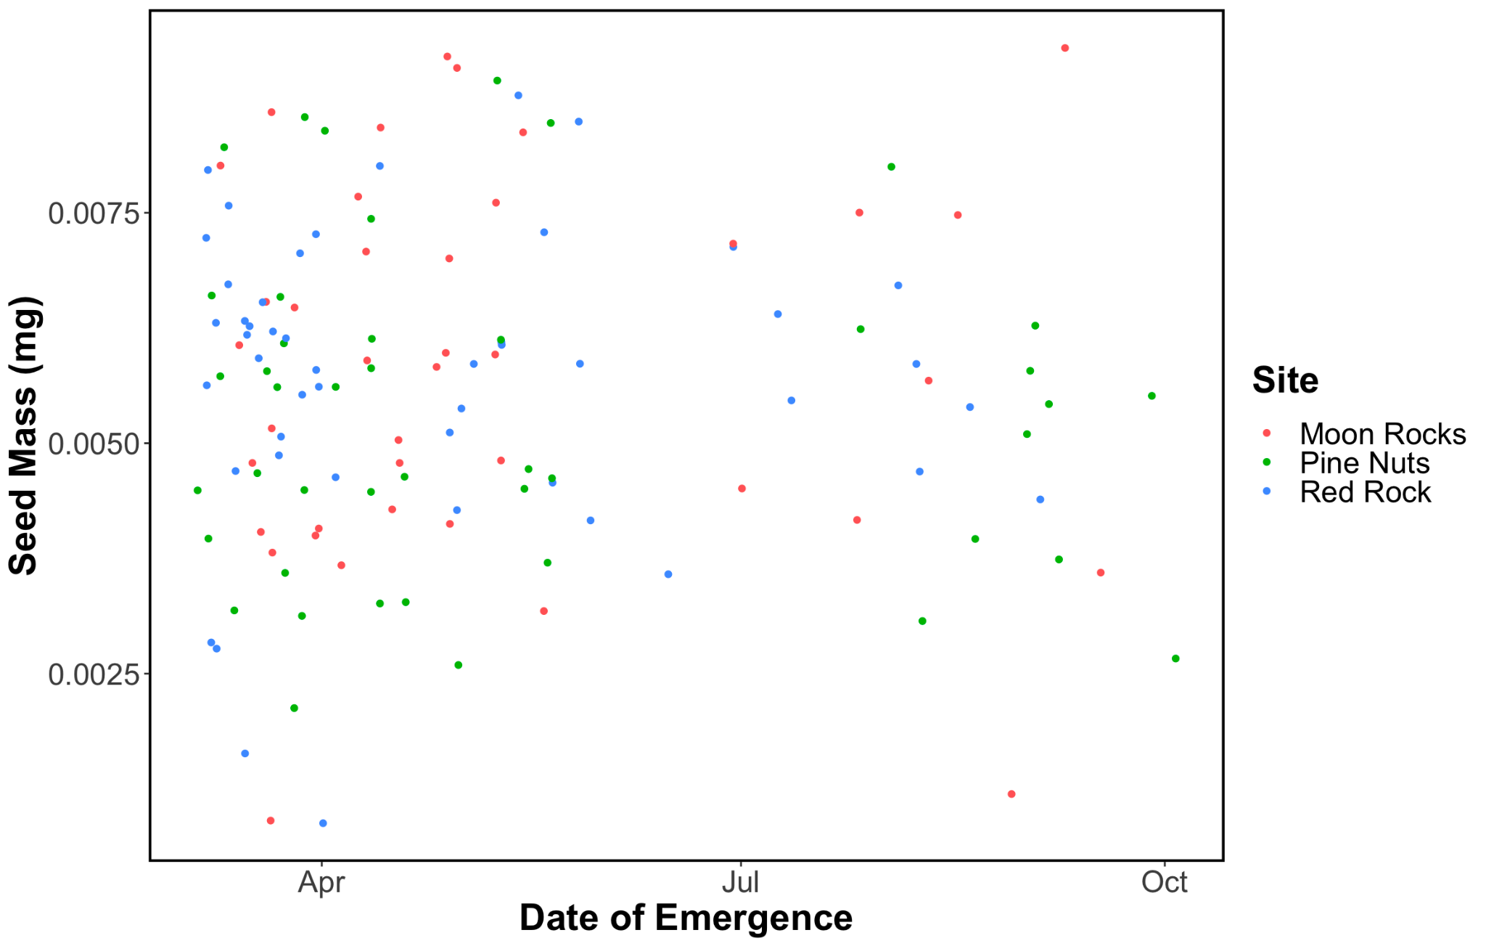

**Figure 2.** Emergence timing of *Hesperostipa comata* seeds. Points are plotted by seed mass to allow for more spacing and colored by site.

**Discussion:**

Although larger seeds appear to emerge more often overall, there are still small seeds emerging in both species. This suggests that there are other factors outside of seed weight that may influence germination and emergence. These traits may be uncovered through analysis of the x-ray images of each seed. It may be that seeds with more certain characteristics like narrowness may be more likely to germinate. On the other hand, there may be a strong genetic basis and maternal line may best predict germination in the first year. Future work will identify seed characteristics that predict germination through machine learning. This work will aid future seed collection protocols, screening and testing, and ultimately restoration.

**Literature Cited**

[Barak RS, Lichtenberger TM, Wellman‐Houde A, Kramer AT, Larkin DJ. 2018. Cracking the case: Seed traits and phylogeny predict time to germination in prairie restoration species. Ecol Evol. 8(11):5551–5562. doi:10.1002/ece3.4083.](https://www.zotero.org/google-docs/?WndWOr)

[Gomes-Júnior FG, Chiquito AA, Marcos-Filho J. 2013. Semi-automated assessment of the embryonic area of cucumber seeds and its relationship to germination and seedling length. doi:10.1590/S2317-15372013000200007.](https://www.zotero.org/google-docs/?WndWOr)

[Moles AT, Westoby M. 2002. Seed addition experiments are more likely to increase recruitment in larger-seeded species. Oikos. 99(2):241–248. doi:10.1034/j.1600-0706.2002.990204.x.](https://www.zotero.org/google-docs/?WndWOr)

[Pyke DA. 2011. Restoring and rehabilitating sagebrush habitats. :531–548.](https://www.zotero.org/google-docs/?WndWOr)

[Rees M. 1996. Evolutionary Ecology of Seed Dormancy and Seed Size. Philos Trans Biol Sci. 351(1345):1299–1308.](https://www.zotero.org/google-docs/?WndWOr)

[Rocha C, Silva V, Cicero S. 2014. Internal morphology and germination of sunflower seeds. J Seed Sci. 36:48–53. doi:10.1590/S2317-15372014000100006.](https://www.zotero.org/google-docs/?WndWOr)

[Schneider CA, Rasband WS, Eliceiri KW. 2012. NIH Image to ImageJ: 25 years of image analysis. Nat Methods. 9(7):671–675. doi:10.1038/nmeth.2089.](https://www.zotero.org/google-docs/?WndWOr)