-20037508.342789244, -20037508.342789244 20037508.342789244, 20037508.342789244

-20038350.342789244,  -20037968.342789244, 20038350.342789244,  20037968.342789244

|  |  |  |  |  |  |  |  |  |  |  |
| --- | --- | --- | --- | --- | --- | --- | --- | --- | --- | --- |
| **地名** | **GoogleMap** | | | | **OpenStreet** | | | |  |  |
| 一环左下角 | 108.9233922 | 34.2507729 | 12125295.2797 | 4062526.0920 | 108.9188213 | 34.2523730 | 12124786.9336 | 4062739.7288 | 508.3461 | -213.6368 |
|  | WGS3857: 12125295.2797002, 4062526.0919821  WGS4326: 108.9233807, 34.2507839 | | | | WGS3857: 12124786.9336089, 4062739.7288158 WGS4326: 108.9188142, 34.2523702 | | | |  |  |
| 一环右下角 | 108.9724938 | 34.2510637 | 12130762.2889 | 4062563.4485 | 108.9676791 | 34.2525449 | 12130224.0199 | 4062762.9701 | 538.269 | -199.5216 |
|  | WGS3857: 12130762.2888736, 4062563.4485138  WGS4326: 108.9724917, 34.2510613 | | | | WGS3857: 12130224.0199176, 4062762.9700968  WGS4326: 108.9676564, 34.2525428 | | | |  |  |
| 一环右上角 | 108.9724176 | 34.2773390 | 12130754.1535 | 4066102.9501 | 108.9676889 | 34.2788334 | 12130227.5131 | 4066302.6278 | 526.6404 | -199.6777 |
|  | WGS3857: 12130754.1535239, 4066102.9500717  WGS4326: 108.9724186, 34.2773390 | | | | WGS3857: 12130227.5131177, 4066302.6277774  WGS4326: 108.9676877, 34.2788212 | | | |  |  |
| 一环左上角 | 108.9222423 | 34.2765158 | 12125168.3567 | 4065992.0652 | 108.9176944 | 34.2781470 | 12124661.5135 | 4066217.9803 | 506.8432 | -225.9151 |
|  | WGS3857: 12125168.3566949, 4065992.0651884  WGS4326: 108.9222406, 34.2765159 | | | | WGS3857: 12124661.5135093, 4066217.9803301  WGS4326: 108.9176875, 34.2781929 | | | |  |  |
|  |  |  |  |  |  |  |  |  |  |  |
|  |  |  |  |  |  |  |  |  |  |  |

(12125295.2797 – (-20037508.342789244)) / (20037508.342789244 * 2) * 2L =

(12124786.9336 – (Xmin)) / (Xmax - Xmin) * 2L

(12130762.2889 – (-20037508.342789244)) / (20037508.342789244 * 2) * 2L =

(12130224.0199 – (Xmin)) / (Xmax - Xmin) * 2L

===>

0.8025649465060222*(Xmax - Xmin) = 12124786.9336 – Xmin

0.8027013658927661* (Xmax - Xmin)= 12130224.0199 – Xmin

===>

0.8025649465060222*Xmax + 0.19743505349397783*Xmin = 12124786.9336

0.8027013658927661*Xmax + 0.19729863410723392*Xmin= 12130224.0199

import numpy as np

A=np.mat('0.8025649465060222, 0.19743505349397783; 0.8027013658927661, 0.19729863410723392') # 构造系数矩阵 A

b=np.array([12124786.9336, 12130224.0199]) # 构造数组 b

x=np.linalg.solve(A,b) # 调用 solve 函数

print ('Solution',x)

Solution [ 19993693.61991471 -19861978.14181085]

-20037508.342789244, -20037508.342789244 20037508.342789244, 20037508.342789244

12124786.9336 * k + x1 = 12125295.2797

12130224.0199 * k + x1 = 12130762.2889

A=np.mat('12124786.9336, 1; 12130224.0199, 1') # 构造系数矩阵 A

b=np.array([12125295.2797, 12130762.2889]) # 构造数组 b

x=np.linalg.solve(A,b) # 调用 solve 函数

y=x*[-20037508.342789244, 20037508.342789244]

print ('Solution',x)

Solution [ 1.00550348e+00 -6.62201859e+04]

-20037508.342789244 * 1.00550348e+00 + (-6.62201859e+04)

20037508.342789244 * 1.00550348e+00 + (-6.62201859e+04)

-20214004.555103615

20081564.183303617

1.

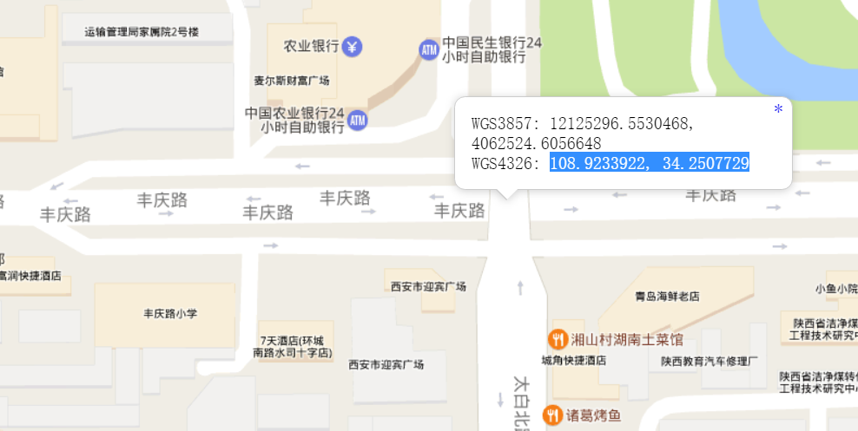

2.

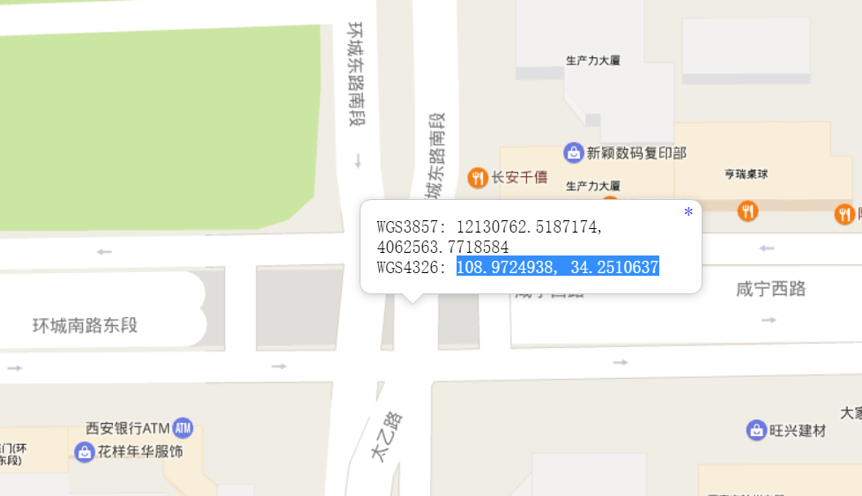

3．

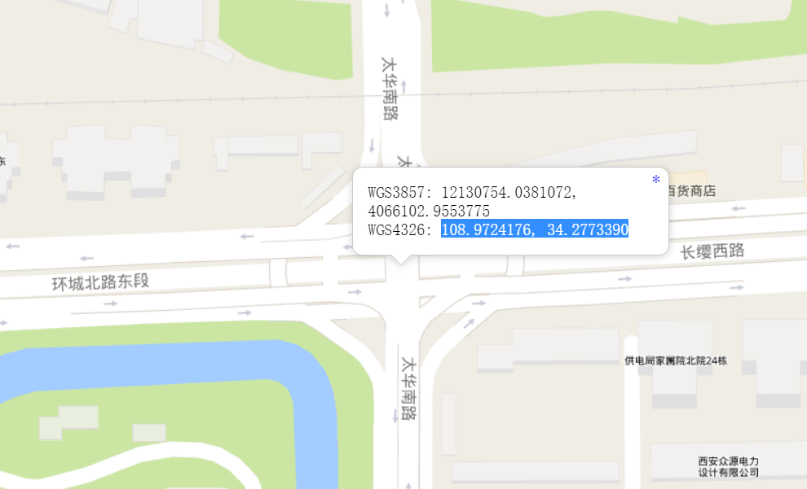

4．

