What is “pull-out torque”?

NEMA, the National Electrical Manufacturer’s Associaton, sets the standards for electric motor performance. For a standard NEMA Design B induction motor, there are four specific torque points along its torque-speed curve:

Locked rotor torque
Pull-up torque
Pull-out torque
Full load torque

Locked rotor torque is self-explanatory - it’s the amount of torque the motor will produce when 100% rated voltage and frequency is applied to the motor stator and the shaft of the motor is held still.

Pull-up torque is the amount of torque the motor will produce once it begins to spin. If the torque applied to the shaft is greater than the pull-up torque but less than the locked rotor torque, the motor will not accelerate to speed, but will instead spin slowly until the motor fails or the motor protection trips it out. Some motors don’t have a pull-up torque rating, as the speed torque curve does not dip below the locked rotor torque until after reaching the pull-out torque.

Pull-out, or breakdown torque is the maximum torque the motor can produce at full rated voltage and frequency. If the motor is running and is loaded beyond the pull-out torque, it will “pull out” or stall.

Full-load torque is the torque the motor is designed to produce when 100% of rated voltage and frequency are applied, and the motor is spinning at its designed speed.

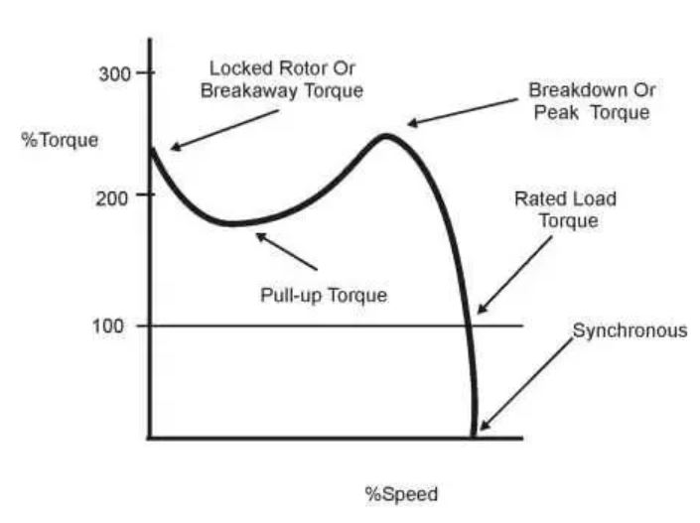
See this graph:

