**Mila, 10**

Student  
[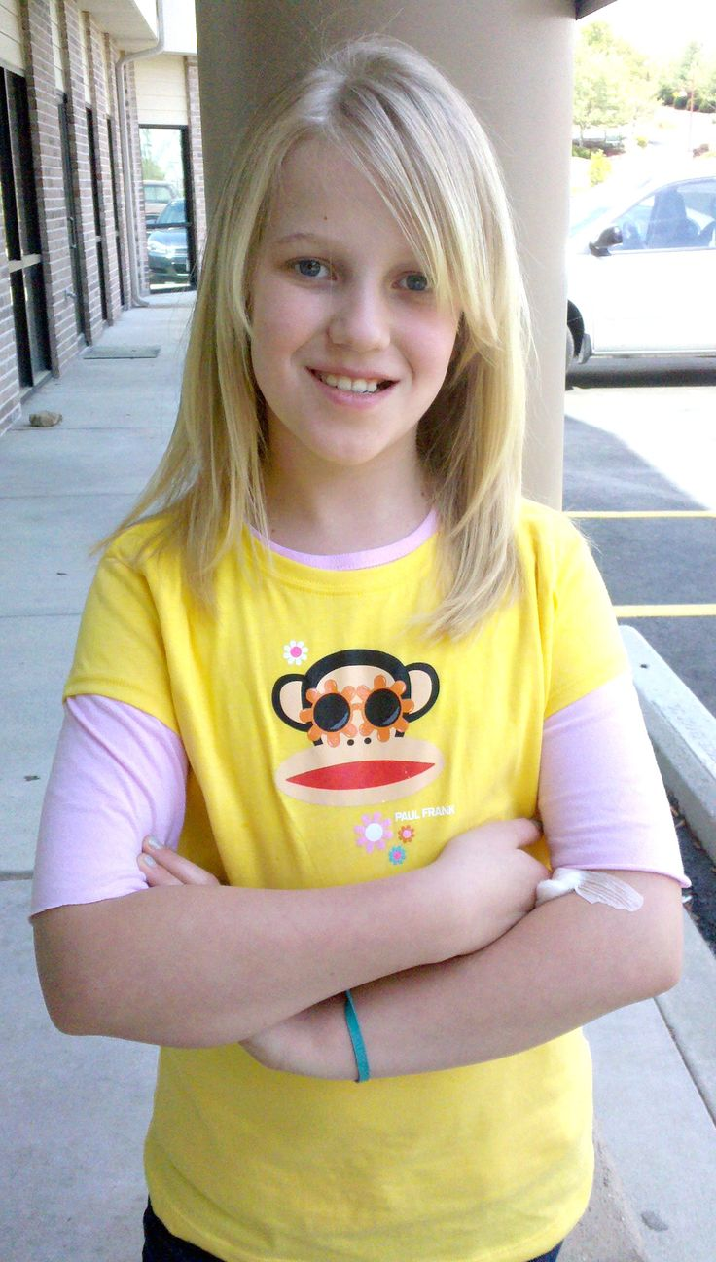](https://s-media-cache-ak0.pinimg.com/736x/9c/a9/23/9ca9236396633705d257376ee16b64a6.jpg)

"May I try this?"

She is 4th grade student and goes to school every day. She loves to learn new things and always pushes her parents and teachers to give her extra information about the world around her. She saw a few games on her brother's HTC Vive, but he doesn't let her play often and she is curious to at least buy her own Cardboard with her weekly allowances.