Teacher Tip Example

Level: Intermediate to Advanced

Purpose: This activity can help students get to know each other in a way that is a little different than the normal icebreaker game. It can get students to also learn to think about whether they fit cultural stereotypes as well, and give them a chance to use language to communicate how they are similar and/or different from a group.

Preparation and Materials: Make four signs labeled (in big letters) "First Born (Oldest)" "Middle" "Last Born (Youngest)" and "Only (No Brothers or Sisters)" in four corners of the room. Alternatively, you can use the four cards here and set them in each corner.

Procedure: (1) As students enter the room, have them assemble in correct groups. (3 minutes)

(2) Students can say what it was like to be a _____________ in their small groups. Tell them that they will report back to the class about ADVANTAGES and DISADVANTAGES. (15-30 minutes)

(3) Students from each group will report on advantages and disadvantages. The teacher will make a t-list following the students’ prompts. (10 minutes)

(4) Have students read the cards (either one card or all four, depending on level). These come from Dr. Kevin Leman’s “The New Birth Order Book.” Go over unfamiliar topic. For less advanced students, change the vocabulary to simpler terms.

(5) Next, each person can speak about these characteristics. A good way to do this is to have each person talk about one characteristic he either agrees with or disagrees with. Ask the student to give an example. As you go around the room doing this, you (and the students) will get to know a little bit more about the students.

(6) Most students will discover that only some of the words suit them. Have them fill out their own t-lists, with agree on one side, and disagree on another.

Agree Disagree

Variations: The last step can also be used as a brief writing activity in paragraph form. For less advanced students, just have them choose from the list of words (these can be modified) and they can write one word that correctly describes them, and one word that incorrectly describes them. This can turn into a yes/no question activity (Are you curious? Yes, I am curious.)

Adapted from Karin M. Abell  
Durham Technical Community College ESL Program  
[gnch@bellsouth.net](mailto:gnch@bellsouth.net)

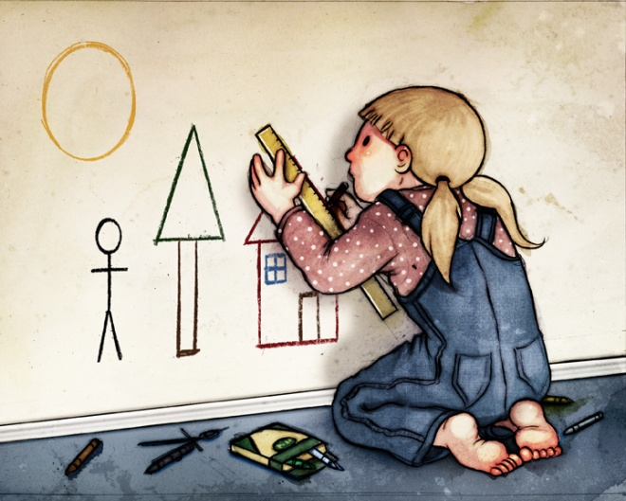

"First born: perfectionist, conscientious, list maker, well-organized, hard driving, natural leader, critical, serious, scholarly, logical. Doesn't like surprises; loves computers. Often compliant: has difficulty saying ‘No.’"



"Middle Child: mediator, compromising, diplomatic, avoids conflict, independent, loyal to peers, many friends, secretive, unspoiled, has reasonable expectations."

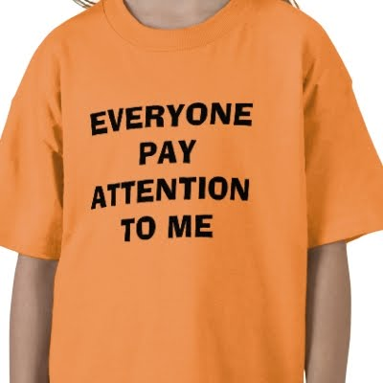

"Youngest Child: manipulative, charming, blames others, attention seeker, tenacious, people person, natural salesperson, precocious, engaging, affectionate, loves surprises."

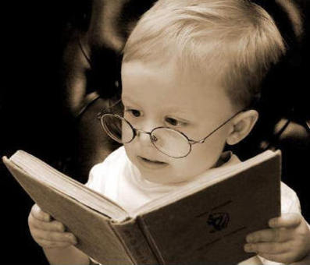

"Only Child: little adult by age seven; very thorough and deliberate; high achiever; self-motivated; fearful; cautious; voracious reader; black and white thinker; uses "very" and "extremely" a lot; can't bear to fail; has very high expectations for self; more comfortable   
with people who are older or younger." (The New Birth Order Book, page 15).