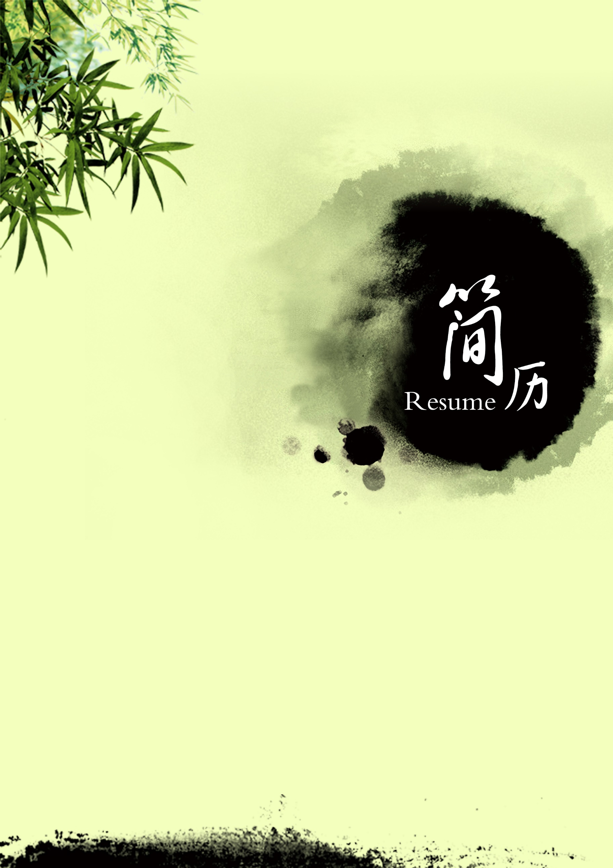

**五百丁**

13500135000

Service@500d.me