Supporting Information for
Machine learning-inferred and energy landscape-guided analyses reveal kinetic determinants of CRISPR/Cas9 gene editing

Lei Jin¹, Risi Liyanage¹, Dongsheng Duan² , and Shi-Jie Chen^{1,*}

¹ Department of Physics, Department of Biochemistry, and MU Institute for Data Science and Informatics,
University of Missouri, Columbia MO 65211
² Department of Molecular Microbiology and Immunology, Department of Neurology, School of Medicine; Department of Biomedical Sciences, College of Veterinary Medicine; and Department of Bioengineering
University of Missouri, Columbia MO 65211

* Author to whom correspondence should be addressed; E-mail: chenshi@missouri.edu
Random Forest approach
Random Forest (RF) classification approach is applied to distinguish the kinetic determinants for cleavage efficiency and the critical nucleotides from the importance ranking of different features/positions [1,2]. RF feature ranking was implemented and benchmarked using two software packages: Breiman and Cutler's Random Forests for Classification and Regression v 4.6-14 (https://www.stat.berkeley.edu/~breiman/RandomForests) and Scikit-learn 1.6.1’s RandomForestRegressor. RF Permutation Test is performed using Scikit-learn 1.6.1’s permutation_importance function. The following key hyperparameters were used during RF model training: ntest=1, nthsize=5, jbt=500, mtry=mdim/3, imp=1, th=0.1, impprint=1 for Breiman and Cutler's Random Forests; n_estimators = 500, max_depth = None, max_features = 'sqrt', min_samples_leaf = 2, bootstrap = True, random_state = 42 for Scikit-learn 1.6.1’s RandomForestRegressor.
Kinetic determinant for cleavage efficiency
To calculate the importance score for kinetic features (e.g.,$k_{R_{L}}^{\left(u\right)}$, $k_{R_{L}}^{\left(f\right)}$, $∆G\left(R_{L}\right)$, $P\left(R_{L}\right)$, etc) obtained from the R-loop folding/unfolding KMC simulations:
  - Random Forest training for data set $D_{n}={\left\{F_{k}\left(i\right),η\left(i\right)\right\}}_{i=1}^{n}$, where n is the total number of data points, $F_{k}\left(i\right)$ is the value of feature k for data point i, $η\left(i\right)$ is the experimental measured cleavage efficiency for data point i.
    - Bootstrap aggregation [2]
      - Constructing subsets through random sampling with replacement.
      - Training of regression trees for the subsets.
      - Averaging over the results from the trained regression trees.
    - Calculate averaged Out-Of-Bag (OOB) error over the forest for each data point during training.
  - Importance estimation for feature k.
    - Permutating values of feature k among the different data points.
    - Calculating OOB error for each data point after permutated.
    - Calculating the importance score by averaging difference in the OOB error before and after permutated (OOB error Rate).
  - Calculate the importance score for each feature and rank the different features.
The highest ranked (the most important) feature is the key determinant for cleavage efficiency and can be used as the predictor for cleavage efficiency.
Critical nucleotides
To identify the important nucleotides (among the 20 positions) for feature k (e.g., the unfolding rate of the R-loop):
  - Random Forest training for data set $D_{n}={\left\{{E\left(i,j\right)}_{j=1}^{20},F_{k}\left(i\right)\right\}}_{i=1}^{n}$, where n is the total number of data points, $E\left(i,j\right)$ is the energy parameters at position j in data point i, $F_{k}\left(i\right)$ is the value of feature k in data point i.
    - Bootstrap aggregation.
      - Constructing subsets through random sampling of data points with replacement.
      - Regression tree training in the subsets.
      - Averaging over the trained regression trees.
    - Calculate averaged OOB error over the forest for each data point during training.
  - Importance estimation for position j.
    - Permutating values of energy parameters at position j among the different data points.
    - Calculate the OOB error for each data point after the permutation.
    - Calculate the importance score by averaging (over the different data points) the difference in OOB error before and after permutated.
  - Calculate the importance score for all the positions and rank the positions by their importance scores.
This procedure identifies the important nucleotides from the 20 positions.
Statistical Tests
- Permutation tests to assess the significance of high-ranked features’ importance
- Train the Random Forest on original data and compute feature importance scores.
- Randomly permute (shuffle) the feature column, retrain, and compute the new importance scores. Repeat 1000 times.
- For each permutation, record the importance of the permuted feature.
- Compare the original importance to the null distribution of importances and estimate the p-value:
$p=\frac{The number of times permuted importance ≥ The original importance}{The total number of permutations}$.
- Friedman tests to validate feature rankings across multiple Random Forest models (runs).
- Wilcoxon Signed-Rank tests to compare high-ranked features across multiple Random Forest models.
Parameters for critical nucleotides
The new energy term $∆G_{i,DNA-Cas9}$ in Eq. 9 needs be determined for all the critical positions for all types of nucleotides. Direct thermodynamic parameters are quite limited; therefore, we perform Molecular Dynamic (MD) simulations to calculate the free energy of the interaction between non-target DNA nucleotide and Cas9 protein.

We used the Cryo-EM structure of SpCas9-sgRNA-DNA ternary complex (PBD: 5y36) including the non-target DNA strand as the initial pre-cleavage 3D structure of the system [3]. To ensure the full consideration of the interaction between the non-target DNA strand and the Cas9 RuvC domain, we exclude crystal structures that lack the full-length non-target DNA strand.

The structure in the simulation consists of RNA/DNA hybridized duplex, dsDNA with PAM, non-target DNA strand, Cas9 HNH domain and RuvC domain, see Fig S2B. Periodic simulation cells are constructed with the water shell of 12 $Å$. Hydrogen atoms are added assuming standard bond lengths and are constrained to their equilibrium position with the SHAKE algorithm. Buffer salt concentration is considered as 0.08 mM of NaCl, in agreement with related experimental conditions.
The Amber ff12SB force field with ff99bsc0 correction for DNA, ff99bsc0+χOL3 correction for RNA and Åqvist force field for Mg²⁺ together with TIP3P model for water are used. All the simulations are performed with GPU version of Amber 16. Long-range electrostatic interactions are evaluated using the smooth particle mesh Ewald (PME) method. Temperature of the system is controlled by Langevin Dynamics, Pressure is controlled by coupling the system to Berendsen barostat. All simulations are performed in the following protocol:
- Energy minimization is performed to relax the water and counterions, RNA, DNA and proteins are fixed with harmonic position restraints of $300{kcal}/{mol}∙Å^{2}$ .
- The system is heated from 0 to 310K by 3 steps in a 500 ps canonical ensemble (NVT) simulations with the RNA, DNA and proteins fixed.
- Isothermal-isobaric ensemble (NPT) simulation of equilibration if performed for 500 ps with the RNA/DNA hybridized duplex, dsDNA and proteins fixed and the non-target DNA unfixed.
- NVT simulation for energy calculation is performed for 50 ns with the RNA/DNA hybridized duplex, dsDNA and proteins fixed and the non-target DNA unfixed.
To calculate the free energy of the interaction between non-target DNA nucleotide and Cas9 RuvC domain $∆G_{i,DNA-Cas9}$, we perform Molecular Mechanics / Poisson Boltzmann Surface Area (MMPBSA) calculations to estimate the binding free energy of the non-target DNA strand based on the 50 ns MD simulations. The calculated free energy $∆G_{i,DNA-Cas9}$ is then used for the optimization of the weight coefficients $ω_{i}$ in Eq. 9.
Prediction evaluations
Measurement metrics
The Spearman rank correlations between the predicted scores and the experimentally measured cleavage efficiency are calculated as
$R_{s}=1-\frac{6\sum{d_{i}^{2}}}{n\left(n^{2}-1\right)}$. S1
Where $d_{i}$ is the difference between the ranks of the predicted score and experimental measured cleavage efficiency and n is the number of the data points (sequences). Predictions for on-target sequences are evaluated using Spearman rank correlation, consistent with the commonly adopted (effective) approach for on-target site (sgRNA candidate) selection, which prioritizes the ranking of cleavage efficiency. The Pearson correlations between the predicted scores and the experimental measured cleavage efficiency are calculated as
$R_{p}=\frac{\sum{\left(S_{i}-\overline{S}\right)\left({}_{i}-\overline{}\right)}}{\sqrt{\sum{{\left(S_{i}-\overline{S}\right)}^{2}}}\sqrt{\sum{{\left({}_{i}-\overline{}\right)}^{2}}}}$ S2
Where $S_{i}$ and ${}_{i}$ are the predicted score and experimental measured cleavage efficiency for the i^{th} data point (sequence) in the dataset, respectively. $\overline{S}$ and are the averaged predicted score and experimental measured cleavage efficiency for the datasets, respectively. Predictions for off-target sequences are evaluated using Pearson correlation coefficients, consistent with the commonly adopted (effective) approach for off-target effect screening.
Figure S1. (A) The kinetic scheme of the Cas9 cleavage efficacy. (B) Basic Kinetic Monte Carlo algorithm used in the kinetic simulations and the folding pathways calculated from the ensemble of simulated folding trajectories.

Figure S2. (A) The structural information of Cas9-sgRNA-dsDNA ternary complex with important factors considered in the kinetic model. The circled region shows the essential interactions between the non-target single-strand DNA and RuvC/HNH domains of Cas9. (B) Reduced MD simulation region focusing on the interactions between the non-target single-strand DNA and RuvC/HNH domains of Cas9.

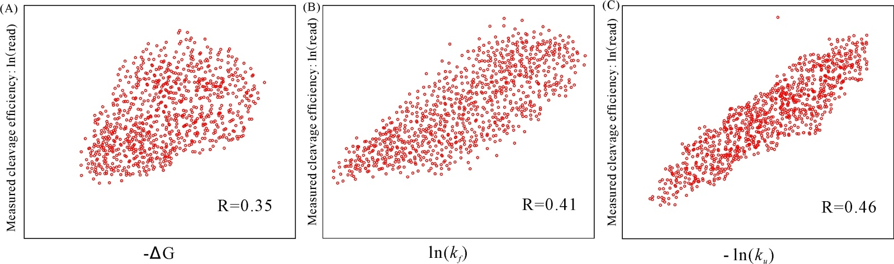
Figure S3. The correlation between the experimentally measured cleavage efficiencies and the calculated folding free energy (A), the folding rate (B) and the unfolding rate (C) for the 907 cases in the Koike-Yusa/Xu Mouse ESC on-target dataset [4], respectively. The calculated spearman correlations are labeled in each panel.

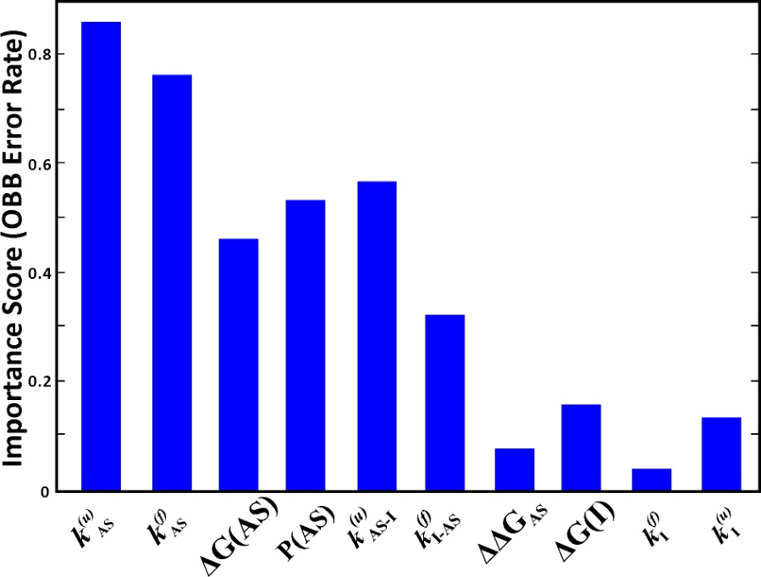
Figure S4. The importance score (OOB Error Rate (OER)) for the 10 candidate features after parameter optimization. Here $k_{x}^{\left(u\right)}$ , $k_{x}^{\left(f\right)}$, $∆G\left(x\right)$ and $k_{x1-x2}^{\left(u/f\right)}$ denote the unfolding rate ($x \overset{→}{ } U$), the folding rate ($U\overset{→}{ } x$), the folding free energy (relative to U) of state x, and the rate from $x_{1}$ to $x_{2}$, respectively. ${∆∆G}_{AS}$ is the stability of AS relative to the intermediate state I: $∆G\left(AS\right)-∆G\left(I\right)$, and $P\left(AS\right)$ is the equilibrium population of the AS.

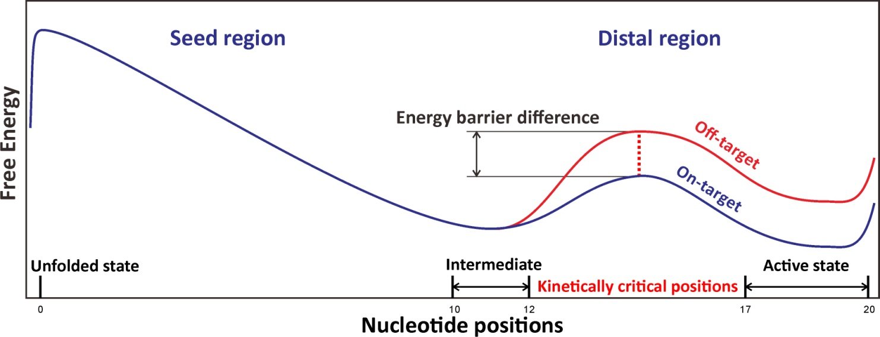
Figure S5. The different free energy landscapes for on-target and off-target cleavages. The off-target sequence (red line) contains mismatches at positions 12-14, and compared to the corresponding on-target sequence (blue line), an off target sequence shows an increased energy barrier for the transition from the partially folded, to the fully folded R-loop. The seed and distal regions, the folding states (U, I and AS), and the kinetically critical positions (+13 to +16) are labeled in the figure.

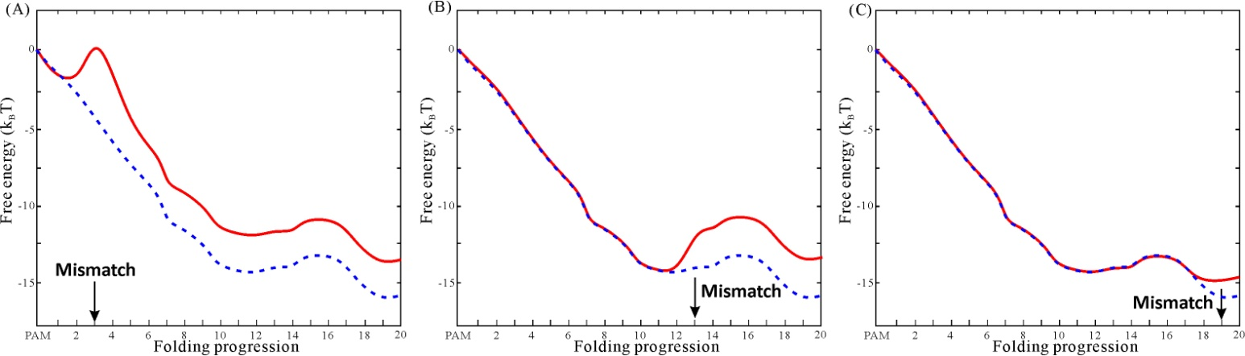
Figure S6. The free energy landscape of the R-loop for EMX1 off-target sequences [4] (the red solid lines) with single mismatch at position 3 (A), position 13 (B), and position 19 (C) compared to the free energy landscape of the corresponding on-target sequence without mismatch (the blue dashed lines).

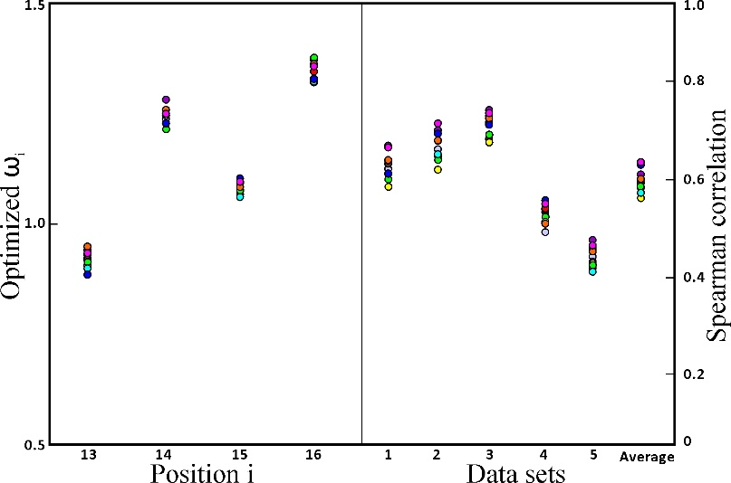
Figure S7. 10-fold cross validation for parameter optimization. Left panel: values of the optimized $ω_{i}$ of the different positions i. Right panel: Spearman correlation for all the training datasets. The results for 10 different data sets are marked in different colors.
Table S1, Summary of datasets used in the kinetic model for parameter training. On-target datasets are highlighted in light blue and off-target datasets are highlighted in light green. In total, 14538 data points were involved in the training data sets, including 7148 data points (sgRNAs) for on-target training and 7390 data points (off-target sites) for off-target training. Cleavage efficiencies are rescaled into log2 fold-change, consistent with on-target sets. Datasets Kuscu-sgRNA 1-12 are only used in parameter optimization while other datasets are used both in parameter initiation and optimization.

Dataset | Ref. | Number of gRNAs/sites | Species & Biology | Efficiency Quantification | Usage notes
Wang/Xu HL60/KBM7 | 4 | 2076 | Human HL60/KBM7 cells | log2 fold-change | On-target data sets with various gRNAs for human.  Consistent quantification method.  Frequently-used for model developing.
Doench MOLM13/NB4/TF1 | 5 | 881 | Human MOLM13/NB4/TF1 cells | log2 fold-change
Doench A375/AZD | 6 | 2333 | Human A375/AZD cells | log2 fold-change
Doench Mouse EL4 | 5 | 951 | Mouse EL4 cells | log2 fold-change | On-target data sets with various gRNAs for mouse.  Consistent quantification method.
Koike-Yusa/Xu Mouse ESC | 4 | 907 | Mouse ESC cells | log2 fold-change
Doench-CD33 | 6 | 3822 | Human MOLM13 cells | log2 fold-change | Off-target screening for human.  Training sets for CFD
Doench-H2-D | 6 | 89 | Human MOLM13 cells | log2 fold-change | Off-target screening for human.  Training sets for CFD
Hsu-EMX1 target 1,2,3,6 | 7 | 464 | Human HEK293T cells | % indels | Training sets for MIT-Zhang
Tsai-EMX1/ FANCF/ VEGFA site 1-3 | 8 | 258 | Human U2OS cells | Sequencing read counts | Genome-wide off-target screening for human.
Tsai-HEK293 site 1,3,4 | 8 | 150 | Human HEK293 cells | Sequencing read counts | Genome-wide off-target screening for human.
Kuscu-sgRNA 1-12 | 9 | 2607 | Human HEK293T cells | % indels | Genome-wide off-target screening for human.
Total |  | 14538

Table S2. Summary of on-target test datasets used in this work
Dataset | Ref. | Number of gRNAs | Species & Biology | Efficiency Quantification | Notes
Chari 293T | 10 | 1234 | Human/HEK293T cells | Relative mutation rate | On-target data sets with various gRNAs for human.  Frequently-used for model developing.
Chari K562 | 10 | 1239 | Human/K562 cells | Relative mutation rate
Hart Rpe | 11 | 4214 | Human/Rpe cells | Bayes Factors | Exhausted On-target data sets with various gRNAs for human.  Cell type environment considered.  Good test sets for human based model developing.
Hart Hct116-1 Lib 1 | 11 | 4293 | Human/ Hct116 cells | Bayes Factors
Hart Hct116-2 Lib 1 | 11 | 4239 | Human/ Hct116 cells | Bayes Factors
Hart HeLa Lib1 | 11 | 4256 | Human/HeLa cells | Bayes Factors
Hart HeLa Lib2 | 11 | 3845 | Human/HeLa cells | Bayes Factors
Varshney Zebrafish | 12 | 102 | Zebrafish/Embryos | Relative mutation rate | On-target data sets with various gRNAs for Zebrafish.  Frequently-used test sets for model developing.
Gagnon Ciona | 13 | 111 | Zebrafish/Embryos | % indels
Moreno−Mateos Zebrafish | 14 | 1020 | Zebrafish/Embryos | % indels
Shkumatava Zebrafish | 15 | 163 | Zebrafish/Embryos | % indels
Farboud C. elegans | 16 | 50 | Caenorhabditis elegans | Mutagenesis rate | Alternative On-target data sets with limited gRNAs for various species.  Often-used test sets for model developing.
Ren Drosophila | 17 | 39 | Drosophila | Heritable mutation rate
Liu Neuro2A Surveyor 1/0 | 18 | 205 | Mouse/Neuro2A cells | Mutagenesis rate
Eschstruth Zebrafish | 12 | 18 | Zebrafish/Embryos | Modification frequency
Teboul Mouse In Vivo | 12 | 30 | Mouse/Embryos | Modification frequency
Schoenig K562 LacZ Rank | 12 | 24 | Human/ K562 cells | Modification frequency
Gandhi Electrop. Ciona | 19 | 72 | Ciona/Somatic cells | Mutagenesis rate

Table S3. Performance of on-target activity predictions.
Dataset | Wang Score | Doench Score | SSC | sgRNA Score | WU-CRISPR | CRISPR scan | Azimuth | uCRISPR | Kinetic model
Wang/Xu HL60 (2076) | 0.616 | 0.343 | 0.486 | 0.321 | 0.246 | 0.201 | 0.485 | 0.577 | 0.627
Doench MOLM13/NB4/TF1 (881) | 0.366 | 0.497 | 0.33 | 0.273 | 0.307 | 0.01 | 0.657 | 0.606 | 0.662
Doench Mouse EL4 (951) | 0.427 | 0.577 | 0.4 | 0.403 | 0.369 | 0.156 | 0.7 | 0.622 | 0.694
Doench A375/AZD (2333) | 0.265 | 0.266 | 0.287 | 0.245 | 0.164 | 0.144 | 0.54 | 0.444 | 0.533
Chari 293T (1234) | 0.31 | 0.246 | 0.286 | 0.457 | 0.308 | 0.123 | 0.381 | 0.518 | 0.621
Koike-Yusa/Xu Mouse ESC (907) | 0.281 | 0.221 | 0.306 | 0.12 | 0.119 | 0.094 | 0.367 | 0.352 | 0.46
Hart Rpe (4214) | 0.232 | 0.178 | 0.201 | 0.152 | 0.162 | 0.077 | 0.281 | 0.303 | 0.44
Hart Hct116-1 Lib 1(4293) | 0.335 | 0.285 | 0.31 | 0.21 | 0.228 | 0.176 | 0.369 | 0.39 | 0.48
Hart Hct116-2 Lib 1(4239) | 0.307 | 0.288 | 0.292 | 0.208 | 0.232 | 0.159 | 0.384 | 0.4 | 0.512
Hart HeLa Lib1 (4256) | 0.322 | 0.253 | -0.002 | 0.192 | 0.32 | 0.144 | 0.353 | 0.375 | 0.465
Hart HeLa Lib2 (3845) | 0.358 | 0.232 | 0.033 | 0.186 | 0.361 | 0.18 | 0.359 | 0.389 | 0.457
Varshney Zebrafish (102) | 0.17 | 0.139 | 0.171 | 0.28 | 0.27 | 0.262 | 0.219 | 0.225 | 0.335
Gagnon Ciona (111) | 0.207 | -0.072 | 0.179 | 0.202 | 0.083 | 0.357 | 0.104 | 0.239 | 0.443
Moreno−Mateos Zebrafish(1020) | 0.14 | 0.038 | 0.171 | 0.145 | 0.037 | 0.579 | 0.12 | 0.166 | 0.319
Shkumatava Zebrafish(163) | 0.141 | 0.088 | 0.065 | 0.128 | -0.123 | 0.251 | 0.103 | 0.142 | 0.246
Wang/Xu KBM7 (2076) | 0.644 | 0.351 | 0.498 | 0.335 | 0.258 | 0.205 | 0.512 | 0.575 | 0.611
Chari K562 (1239) | -0.013 | -0.019 | -0.019 | 0.009 | 0.011 | 0.013 | -0.035 | -0.044 | 0.007
Farboud C. elegans (50) | 0.476 | 0.301 | 0.545 | 0.602 | 0.4 | 0.177 | 0.541 | 0.515 | 0.596
Ren Drosophila (39) | 0.313 | 0.178 | 0.225 | 0.152 | -0.158 | -0.347 | 0.131 | 0.156 | 0.139
Liu Neuro2A Surveyor 1/0(205) | 0.04 | 0.091 | 0.063 | 0.007 | -0.042 | -0.054 | 0.044 | 0.071 | -0.002
Eschstruth Zebrafish (18) | -0.014 | 0.647 | 0.273 | 0.33 | 0.491 | -0.043 | 0.503 | 0.302 | 0.59
Teboul Mouse In Vivo(30) | 0.188 | -0.083 | 0.072 | -0.154 | -0.219 | 0.426 | -0.304 | 0.016 | 0.103
Schoenig K562 LacZ Rank(24) | 0.219 | 0.273 | 0.011 | 0.42 | 0.283 | -0.178 | 0.415 | 0.381 | 0.487
Gandhi Electrop. Ciona(72) | 0.298 | 0.245 | 0.15 | 0.248 | 0.112 | 0.354 | 0.419 | 0.286 | 0.481
Average | 0.276 | 0.232 | 0.222 | 0.228 | 0.176 | 0.144 | 0.319 | 0.332 | 0.429

 | Table S4. Performance of off-target predictions.
Dataset |  | Reference | MIT_Zhang | CCTop | CROP-IT | CFD | uCRISPR | Kinetic model
Doench-CD33 part (3822) |  | 6 | 0.277 | 0.288 | 0.316 | 0.562 | 0.561 | 0.629
Doench-H2-D (89) |  | 6 | 0.527 | 0.261 | 0.28 | 0.575 | 0.619 | 0.779
Hsu-EMX1 target 1-SM (58) |  | 7 | 0.74 | 0.693 | 0.713 | 0.719 | 0.822 | 0.887
Hsu-EMX1 target 2-SM (58) |  | 7 | 0.719 | 0.592 | 0.658 | 0.486 | 0.743 | 0.813
Hsu-EMX1 target 3-SM (58) |  | 7 | 0.727 | 0.714 | 0.72 | 0.464 | 0.735 | 0.729
Hsu-EMX1 target 6-SM (58) |  | 7 | 0.728 | 0.58 | 0.755 | 0.678 | 0.781 | 0.804
Hsu-EMX1 target 1-MM (46) |  | 7 | 0.738 | 0.63 | 0.624 | 0.531 | 0.872 | 0.860
Hsu-EMX1 target 2-MM (46) |  | 7 | 0.689 | 0.483 | 0.524 | 0.624 | 0.922 | 0.947
Hsu-EMX1 target 3-MM (42) |  | 7 | 0.592 | 0.519 | 0.561 | 0.698 | 0.871 | 0.898
Hsu-EMX1 target 6-MM (46) |  | 7 | 0.305 | 0.354 | 0.38 | 0.668 | 0.862 | 0.859
Hsu-EMX1 target 1-OT (9) |  | 7 | 0.974 | 0.402 | 0.799 | 0.98 | 0.996 | 0.996
Hsu-EMX1 target 3-OT (33) |  | 7 | 0.221 | 0.18 | 0.227 | 0.724 | 0.875 | 0.895
Tsai-VEGFA site 1 (22) |  | 8 | 0.068 | 0.557 | 0.449 | 0.82 | 0.827 | 0.883
Tsai-VEGFA site 3 (60) |  | 8 | 0.19 | 0.197 | 0.332 | 0.543 | 0.589 | 0.672
Tsai-EMX1 (16) |  | 8 | 0.595 | 0.29 | 0.352 | 0.723 | 0.937 | 0.921
Tsai-FANCF (9) |  | 8 | 0.367 | 0.59 | 0.375 | 0.928 | 0.97 | 0.97
Tsai-HEK293 site 1 (10) |  | 8 | 0.619 | 0.492 | 0.417 | 0.871 | 0.916 | 0.949
Tsai-HEK293 site 3 (6) |  | 8 | 0.138 | 0.556 | 0.625 | 0.706 | 0.985 | 0.992
Tsai-VEGFA site 2 (151) |  | 8 | 0.499 | 0.29 | 0.299 | 0.435 | 0.39 | 0.772
Tsai-HEK293 site 4 (134) |  | 8 | 0.404 | 0.132 | 0.259 | 0.379 | 0.452 | 0.655
Wu-Nanog-sg2 (26) |  | 20 | 0.428 | 0.336 | 0.294 | 0.809 | 0.826 | 0.823
Wu-Nanog-sg3 (5957) |  | 20 | 0.067 | 0.123 | 0.065 | 0.078 | 0.103 | 0.327
Wu-Phc1-sg1 (2948) |  | 20 | 0.163 | 0.263 | 0.179 | 0.208 | 0.216 | 0.257
Wu-Phc1-sg2 (663) |  | 20 | 0.245 | 0.168 | 0.199 | 0.272 | 0.291 | 0.376
Qi-mRFP (21) |  | 21 | 0.45 | 0.759 | 0.769 | 0.674 | 0.777 | 0.613
Kuscu-sgRNA 1 (50) |  | 9 | 0.698 | 0.289 | 0.327 | 0.788 | 0.806 | 0.875
Kuscu-sgRNA 2 (17) |  | 9 | 0.533 | 0.235 | 0.466 | 0.911 | 0.963 | 0.950
Kuscu-sgRNA 3 (41) |  | 9 | 0.462 | 0.195 | 0.195 | 0.909 | 0.927 | 0.932
Kuscu-sgRNA 4 (484) |  | 9 | 0.072 | 0.047 | 0.077 | 0.135 | 0.187 | 0.218
Kuscu-sgRNA 5 (52) |  | 9 | 0.089 | 0.135 | 0.343 | 0.749 | 0.819 | 0.811
Kuscu-sgRNA 6 (1282) |  | 9 | 0.228 | 0.026 | 0.064 | 0.251 | 0.274 | 0.532
Kuscu-sgRNA 7 (285) |  | 9 | 0.614 | 0.04 | 0.14 | 0.673 | 0.73 | 0.793
Kuscu-sgRNA 8 (43) |  | 9 | 0.641 | 0.171 | 0.543 | 0.812 | 0.816 | 0.826
Kuscu-sgRNA 9 (121) |  | 9 | 0.826 | 0.062 | 0.332 | 0.844 | 0.86 | 0.881
Kuscu-sgRNA 10 (202) |  | 9 | 0.773 | 0.17 | 0.124 | 0.761 | 0.77 | 0.764
Kuscu-sgRNA 11 (16) |  | 9 | 0.643 | 0.148 | 0.475 | 0.649 | 0.645 | 0.792
Kuscu-sgRNA 12 (14) |  | 9 | 0.82 | 0.01 | 0.818 | 0.832 | 0.826 | 0.788
Fu-EGFP Site #1-SM (20) |  | 22 | 0.435 | 0.847 | 0.487 | 0.71 | 0.678 | 0.687
Fu-EGFP Site #2-SM (20) |  | 22 | 0.608 | 0.732 | 0.816 | 0.731 | 0.694 | 0.792
Fu-EGFP Site #3-SM (20) |  | 22 | 0.357 | 0.681 | 0.543 | 0.456 | 0.448 | 0.597
Fu-EGFP Site #1-MM (11) |  | 22 | 0.793 | 0.912 | 0.7 | 0.642 | 0.627 | 0.884
Fu-EGFP Site #2-MM (11) |  | 22 | 0.379 | 0.527 | 0.551 | 0.866 | 0.894 | 0.879
Fu-EGFP Site #3-MM (11) |  | 22 | 0.715 | 0.788 | 0.818 | 0.793 | 0.725 | 0.81
Fu-VEGFA Site 1 (5) |  | 22 | -0.367 | 0.715 | 0.83 | 0.952 | 0.897 | 0.951
Fu-VEGFA Site 3 (7) |  | 22 | -0.29 | 0.395 | 0.391 | 0.73 | 0.724 | 0.831
Cho-C4BPB (6) |  | 23 | 0.345 | 0.539 | 0.626 | 0.91 | 0.941 | 0.988
Cho-CCR5 (14) |  | 23 | 0.371 | 0.585 | 0.607 | 0.85 | 0.983 | 0.978
Cho-CCR5-1 (12) |  | 23 | 0.329 | 0.695 | 0.748 | 0.876 | 0.978 | 0.978
Cho-CCR5-2 (9) |  | 23 | 0.436 | 0.533 | 0.582 | 0.77 | 0.993 | 0.992
Cho-CCR5-3 (8) |  | 23 | 0.098 | 0.628 | 0.566 | 0.776 | 0.967 | 0.877
Cho-CCR5-4 (9) |  | 23 | -0.071 | 0.645 | 0.464 | 0.774 | 0.917 | 0.929
Cho-CCR5-5 (5) |  | 23 | -0.223 | 0.748 | 0.698 | 0.884 | 0.926 | 0.933
Cho-CCR5-6 (7) |  | 23 | 0.448 | 0.729 | 0.319 | 0.898 | 0.991 | 0.987
Cho-CCR5-7 (5) |  | 23 | 0.628 | 0.966 | 0.905 | 0.917 | 0.92 | 0.946
Cho-CCR5-8 (6) |  | 23 | 0.057 | 0.692 | 0.66 | 0.693 | 0.836 | 0.892
Long-DMD-mdx (33) |  | 24 | 0.187 | 0.14 | 0.357 | 0.694 | 0.772 | 0.798
Long-DMD-WT (33) |  | 24 | 0.158 | 0.183 | 0.346 | 0.773 | 0.819 | 0.806
Wang-sgAAVS1 (14) |  | 25 | 0.427 | 0.636 | 0.607 | 0.869 | 0.965 | 0.948
Frock-RAG1A (33) |  | 26 | 0.232 | 0.199 | 0.061 | 0.239 | 0.212 | 0.233
Frock-EMX1 (14) |  | 26 | 0.421 | 0.393 | 0.063 | 0.397 | 0.604 | 0.751
Frock-VEGFA (39) |  | 26 | 0.231 | 0.469 | 0.405 | 0.814 | 0.841 | 0.845
Kim-HBB/HAP1 (5) |  | 27 | 0.048 | 0.682 | 0.629 | 0.881 | 0.983 | 0.932
Kim-HBB/K562 (5) |  | 27 | 0.046 | 0.681 | 0.628 | 0.88 | 0.982 | 0.957
Kim-VEGF-A/HAP1 (9) |  | 27 | -0.199 | 0.538 | 0.446 | 0.746 | 0.924 | 0.979
Kim-VEGF-A/K562 (9) |  | 27 | -0.177 | 0.578 | 0.51 | 0.817 | 0.929 | 0.934
Ran-EMX1 target1 (12) |  | 28 | 0.471 | 0.15 | 0.527 | 0.823 | 0.811 | 0.831
Ran-EMX1 target2 (9) |  | 28 | -0.073 | 0.48 | 0.376 | 0.913 | 0.977 | 0.976
Kleinstiver-EMX1 site 1 (9) |  | 29 | 0.55 | 0.413 | 0.338 | 0.709 | 0.929 | 0.942
Kleinstiver-EMX1 site 2 (11) |  | 29 | 0.903 | 0.147 | 0.463 | 0.856 | 0.944 | 0.943
Kleinstiver-FANCF site 2 (26) |  | 29 | 0.622 | 0.266 | 0.342 | 0.527 | 0.839 | 0.908
Kleinstiver-FANCF site 3 (9) |  | 29 | 0.741 | 0.603 | 0.295 | 0.792 | 0.949 | 0.987
Kleinstiver-ZSCAN2 (9) |  | 29 | 0.267 | 0.079 | 0.497 | 0.924 | 0.977 | 0.978
Kim-VEGFA1 (26) |  | 30 | 0.039 | 0.682 | 0.586 | 0.815 | 0.798 | 0.729
Kim-VEGFA2 (22) |  | 30 | 0.002 | 0.424 | 0.383 | 0.22 | 0.637 | 0.742
Kim-VEGFA3 (25) |  | 30 | -0.074 | 0.412 | 0.404 | 0.559 | 0.465 | 0.643
Kim-EMX1 (12) |  | 30 | 0.507 | 0.485 | 0.121 | 0.674 | 0.842 | 0.932
Kim-FANCF (9) |  | 30 | 0.425 | 0.545 | 0.357 | 0.888 | 0.907 | 0.953
Kim-HEK293-1 (8) |  | 30 | 0.777 | 0.27 | 0.563 | 0.589 | 0.687 | 0.787
Kim-HEK293-3 (8) |  | 30 | 0.395 | 0.195 | 0.511 | 0.656 | 0.931 | 0.966
Kim-HEK293-4 (20) |  | 30 | -0.071 | 0.421 | 0.487 | 0.637 | 0.841 | 0.894
Slaymaker-VEGFA(1)-SM (58) |  | 31 | 0.713 | 0.63 | 0.795 | 0.746 | 0.749 | 0.863
Slaymaker-VEGFA(1)-MM (19) |  | 31 | 0.562 | 0.7 | 0.807 | 0.864 | 0.846 | 0.922
Slaymaker-VEGFA(1)-OT (11) |  | 31 | 0.153 | 0.267 | 0.503 | 0.827 | 0.801 | 0.901
Liu-Renilla (21) |  | 32 | 0.603 | 0.864 | 0.781 | 0.355 | 0.659 | 0.762
Average |  |  | 0.378 | 0.438 | 0.471 | 0.692 | 0.747 | 0.824

Table S5. The overall average correlations for$ln⁡\left(k_{AS}^{\left(u\right)}\right)$, $ln⁡\left(k_{AS}^{\left(f\right)}\right)$ and ${∆G}_{AS}$ before and after the parameter optimizations. Spearman and Pearson correlations (Spearman/ Pearson) are used for on-target and off-target training sets, respectively. The highest values for each parameter set are marked in boldface.
OP | Initialª | Optimization 1^{b} | Optimization 2^{c}
$$ln⁡\left(k_{AS}^{\left(u\right)}\right)$$ | 0.37/0.80 | 0.39/0.82 | 0.43/0.82
$$ln⁡\left(k_{AS}^{\left(f\right)}\right)$$ | 0.37/0.79 | 0.37/0.80 | 0.37/0.80
$${∆G}_{AS}$$ | 0.33/0.75 | 0.33/0.72 | 0.33/0.73
ª The initial parameters directly obtained from singular value decomposition.
^{b} Parameters trained with the correlation between the experimental data of the cleavage efficiency and $ln⁡\left(k_{AS}^{\left(u\right)}\right)$.
^{c} On-target parameters retrained with the correlation between the experimental data of the cleavage efficiency and $ln⁡\left(k_{AS}^{\left(u\right)}\right)$ calculated by Eq. 3.

References:
- Breiman, L., 1996. Bagging predictors. Machine learning, 24(2), pp.123-140
- Ho, T.K., 2002. A data complexity analysis of comparative advantages of decision forest constructors. Pattern Analysis & Applications, 5(2), pp.102-112.
- Huai C, Li G, Yao R, Zhang Y, Cao M, Kong L, Jia C, Yuan H, Chen H, Lu D, Huang Q. Structural insights into DNA cleavage activation of CRISPR-Cas9 system. Nature Communications. 2017 Nov 9;8(1):1375.
- Xu, H., Xiao, T., Chen, C.H., Li, W., Meyer, C.A., Wu, Q., Wu, D., Cong, L., Zhang, F., Liu, J.S. and Brown, M., 2015. Sequence determinants of improved CRISPR sgRNA design. Genome research, 25(8), pp.1147-1157.
- Doench, J.G., Hartenian, E., Graham, D.B., Tothova, Z., Hegde, M., Smith, I., Sullender, M., Ebert, B.L., Xavier, R.J. and Root, D.E., 2014. Rational design of highly active sgRNAs for CRISPR-Cas9–mediated gene inactivation. Nature biotechnology, 32(12), pp.1262-1267.
- Doench, J.G., Fusi, N., Sullender, M., Hegde, M., Vaimberg, E.W., Donovan, K.F., Smith, I., Tothova, Z., Wilen, C., Orchard, R. and Virgin, H.W., 2016. Optimized sgRNA design to maximize activity and minimize off-target effects of CRISPR-Cas9. Nature biotechnology, 34(2), pp.184-191
- Hsu, P.D., Scott, D.A., Weinstein, J.A., Ran, F.A., Konermann, S., Agarwala, V., Li, Y., Fine, E.J., Wu, X., Shalem, O. and Cradick, T.J., 2013. DNA targeting specificity of RNA-guided Cas9 nucleases. Nature biotechnology, 31(9), pp.827-832.
- Tsai, S.Q., Zheng, Z., Nguyen, N.T., Liebers, M., Topkar, V.V., Thapar, V., Wyvekens, N., Khayter, C., Iafrate, A.J., Le, L.P. and Aryee, M.J., 2015. GUIDE-seq enables genome-wide profiling of off-target cleavage by CRISPR-Cas nucleases. Nature biotechnology, 33(2), pp.187-197.
- Kuscu, C., Arslan, S., Singh, R., Thorpe, J. and Adli, M., 2014. Genome-wide analysis reveals characteristics of off-target sites bound by the Cas9 endonuclease. Nature biotechnology, 32(7), pp.677-683.
- Chari, R., Mali, P., Moosburner, M. and Church, G.M., 2015. Unraveling CRISPR-Cas9 genome engineering parameters via a library-on-library approach. Nature methods, 12(9), pp.823-826.
- Hart, T., Chandrashekhar, M., Aregger, M., Steinhart, Z., Brown, K.R., MacLeod, G., Mis, M., Zimmermann, M., Fradet-Turcotte, A., Sun, S. and Mero, P., 2015. High-resolution CRISPR screens reveal fitness genes and genotype-specific cancer liabilities. Cell, 163(6), pp.1515-1526.
- Varshney, G.K., Pei, W., LaFave, M.C., Idol, J., Xu, L., Gallardo, V., Carrington, B., Bishop, K., Jones, M., Li, M. and Harper, U., 2015. High-throughput gene targeting and phenotyping in zebrafish using CRISPR/Cas9. Genome research, 25(7), pp.1030-1042.
- Gagnon, J.A., Valen, E., Thyme, S.B., Huang, P., Ahkmetova, L., Pauli, A., Montague, T.G., Zimmerman, S., Richter, C. and Schier, A.F., 2014. Efficient mutagenesis by Cas9 protein-mediated oligonucleotide insertion and large-scale assessment of single-guide RNAs. PloS one, 9(5), p.e98186.
- Moreno-Mateos, M.A., Vejnar, C.E., Beaudoin, J.D., Fernandez, J.P., Mis, E.K., Khokha, M.K. and Giraldez, A.J., 2015. CRISPRscan: designing highly efficient sgRNAs for CRISPR-Cas9 targeting in vivo. Nature methods, 12(10), pp.982-988.02.
- Haeussler, M., Schönig, K., Eckert, H., Eschstruth, A., Mianné, J., Renaud, J.B., Schneider-Maunoury, S., Shkumatava, A., Teboul, L., Kent, J. and Joly, J.S., 2016. Evaluation of off-target and on-target scoring algorithms and integration into the guide RNA selection tool CRISPOR. Genome biology, 17(1), pp.1-12.
- Farboud, B. and Meyer, B.J., 2015. Dramatic enhancement of genome editing by CRISPR/Cas9 through improved guide RNA design. Genetics, 199(4), pp.959-971.
- Ren, X., Yang, Z., Xu, J., Sun, J., Mao, D., Hu, Y., Yang, S.J., Qiao, H.H., Wang, X., Hu, Q. and Deng, P., 2014. Enhanced specificity and efficiency of the CRISPR/Cas9 system with optimized sgRNA parameters in Drosophila. Cell reports, 9(3), pp.1151-1162.
- Liu, X., Homma, A., Sayadi, J., Yang, S., Ohashi, J. and Takumi, T., 2016. Sequence features associated with the cleavage efficiency of CRISPR/Cas9 system. Scientific reports, 6(1), pp.1-9.
- Gandhi, S., Haeussler, M., Razy-Krajka, F., Christiaen, L. and Stolfi, A., 2017. Evaluation and rational design of guide RNAs for efficient CRISPR/Cas9-mediated mutagenesis in Ciona. Developmental biology, 425(1), pp.8-20.
- Wu, X., Scott, D. A., Kriz, A. J., Chiu, A. C., Hsu, P. D., Dadon, D. B., ... & Sharp, P. A. (2014). Genome-wide binding of the CRISPR endonuclease Cas9 in mammalian cells. Nature biotechnology, 32(7), 670-676.
- Qi, L. S., Larson, M. H., Gilbert, L. A., Doudna, J. A., Weissman, J. S., Arkin, A. P., & Lim, W. A. (2013). Repurposing CRISPR as an RNA-guided platform for sequence-specific control of gene expression. Cell, 152(5), 1173-1183.
- Fu, Y., Sander, J. D., Reyon, D., Cascio, V. M., & Joung, J. K. (2014). Improving CRISPR-Cas nuclease specificity using truncated guide RNAs. Nature biotechnology, 32(3), 279-284.
- Cho, S. W., Kim, S., Kim, Y., Kweon, J., Kim, H. S., Bae, S., & Kim, J. S. (2014). Analysis of off-target effects of CRISPR/Cas-derived RNA-guided endonucleases and nickases. Genome research, 24(1), 132-141.
- Long, C., McAnally, J. R., Shelton, J. M., Mireault, A. A., Bassel-Duby, R., & Olson, E. N. (2014). Prevention of muscular dystrophy in mice by CRISPR/Cas9–mediated editing of germline DNA. Science, 345(6201), 1184-1188.
- Wang, T., Wei, J. J., Sabatini, D. M., & Lander, E. S. (2014). Genetic screens in human cells using the CRISPR-Cas9 system. Science, 343(6166), 80-84.
- Frock, R. L., Hu, J., Meyers, R. M., Ho, Y. J., Kii, E., & Alt, F. W. (2015). Genome-wide detection of DNA double-stranded breaks induced by engineered nucleases. Nature biotechnology, 33(2), 179-186.
- Kim, D., Bae, S., Park, J., Kim, E., Kim, S., Yu, H. R., ... & Kim, J. S. (2015). Digenome-seq: genome-wide profiling of CRISPR-Cas9 off-target effects in human cells. Nature methods, 12(3), 237-243.
- Ran, F. A., Cong, L., Yan, W. X., Scott, D. A., Gootenberg, J. S., Kriz, A. J., ... & Zhang, F. (2015). In vivo genome editing using Staphylococcus aureus Cas9. Nature, 520(7546), 186-191.
- Kleinstiver, B. P., Pattanayak, V., Prew, M. S., Tsai, S. Q., Nguyen, N. T., Zheng, Z., & Joung, J. K. (2016). High-fidelity CRISPR–Cas9 nucleases with no detectable genome-wide off-target effects. Nature, 529(7587), 490-495.
- Kim, D., Kim, S., Kim, S., Park, J., & Kim, J. S. (2016). Genome-wide target specificities of CRISPR-Cas9 nucleases revealed by multiplex Digenome-seq. Genome research, 26(3), 406-415.
- Slaymaker, I. M., Gao, L., Zetsche, B., Scott, D. A., Yan, W. X., & Zhang, F. (2016). Rationally engineered Cas9 nucleases with improved specificity. Science, 351(6268), 84-88.
- Liu, Y., Chen, Z., He, A., Zhan, Y., Li, J., Liu, L., ... & Huang, W. (2016). Targeting cellular mRNAs translation by CRISPR-Cas9. Scientific reports, 6(1), 29652.

