Q1:

对于类型三。

Write a response in which you discuss the extent to which you agree or disagree with the claim. In developing and supporting your position, be sure to address the most compelling reasons or examples that could be used to challenge your position.

需要帮对方立场想一个观点，然后再反驳它。然后常用表达是：

常用表达：

It could be argued that… because… However…

It might be also claimed that… However

Someone might argue that…because… However

Some people believe that… Further, they argue that… In my opinion…

例5：The best way for a society to prepare its young people for leadership in government, industry, or other fields is by instilling in them a sense of cooperation, not competition.

在这道例题中，**假设我的观点是竞争合作都并重（这种题型，假设的观点基础是要么选竞争，要么选合作，所以后面才会有both竞争和合作）**。

那It could be argued that… because… However…

的It could be argued that…这部分要写什么？

虽然可能有人认为竞争很重要，但是… 是这样写吗。

那如果是这样写这个要放在第几段呢。

一般这种题目，就是类似托福一边倒写完了要写写反面，提醒我们要注意全面性即可。

后两题的问题在绿色的字中

Q2:

对于这个例题：

例6： Some people believe that in order to be effective, political leaders must yield to public opinion and abandon principle for the sake of compromise. Others believe that the most essential quality of an effective leader is the ability to remain consistently committed to particular principles and objectives.

*Write a response in which you discuss which view more closely aligns with your own position and explain your reasoning for the position you take. In developing and supporting your position, you should address both of the views presented above.*

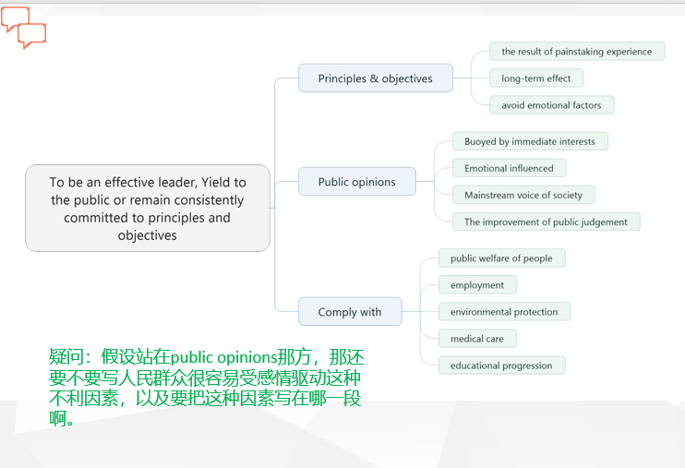

要写的。

如果支持A

一个段：A的好+B的不好；

一个段：同时A确实也存在不好，B也有点好处；

再来一段：有时候A和B是统一的。

Q3：

Write a response in which you discuss the extent to which you agree or disagree with the claim AND the reason on which that claim is based

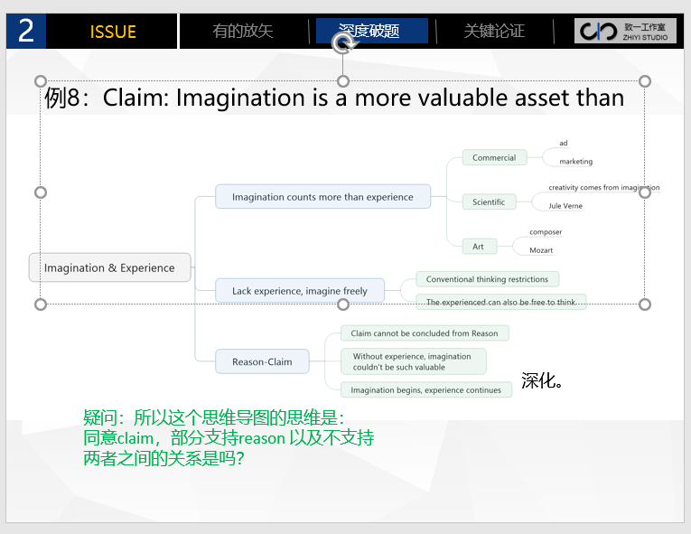

思维导图只是把可能性都展开了。

图中Commercial里就有ad依赖创意，marketing依赖经验的分别。所以claim里面可以分开写。Reason部分也是如此。

基本上这类题目都是reason不支持claim。