Job Intention：Chassis Software Engineer
Job Location: Jiang Su/Shang Hai
Lejun WANG

Personal Info

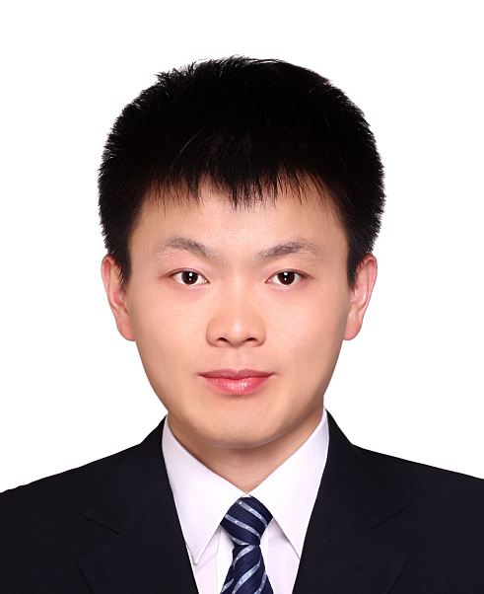
Phone: (+86) 15010251422 Birth: 1991.01
Mail: ljwangbjut@163.com Work Status: Employed
Location: Suzhou/Shanghai Marital Status: Married
Self-Assessment

- Background：6 years working experience in vehicle braking system. Familiar with the working principle and function architecture of ESP/iBooster/IPB; Knowledge about braking regulation. Capability of requirement analysis, function design, software implementation and verification.
- Technological Capability: Development experience in Cooperative Regenerative Braking System, Brake Redundant System and iBooster Service Braking System; Knowledge about vehicle stability control function.
- Project Management: Familiar with the ASPICE, possessing complete process-based development experience.
- Personality：Logical thinking; Conscientious, Persistent and dedicated; System thinking; Good team work
Work History

2021.12-Now NIO Automotive Co., Ltd Chassis Software Engineer
- Brake Redundancy System Design: Based on NIO's NT2 vehicle platform, design brake redundancy solution and develop health management software algorithm;
- Driver Brake Compensation Development：In case of boost loss of the main brake unit, the brake compensation control algorithm is developed using the regenerative braking of the motor and the dynamic braking of EPB, which not only ensures the longitudinal stability of the vehicle, but also improves the driver's braking confidence
- Development of Comfortable Stop Function: Develop algorithm for comfortable stop function in customer's brake control unit. This function can effectively restrain the vehicle's jerk during stop through reducing the brake pressure.

2017.12-2021.11 Bosch Automotive Products (Suzhou) Co. Ltd Braking Software Engineer
- Function owner of basic ESP function (ABS/TCS/VDC): Responsible for GWM specific requirement
analysis, code implementation and software verification. Currently implemented specific function
include All-Terrain System, Launch Control and Tank Steering.
- Cooperative Regenerative Braking System：Coordinator of this system for the Northern Customer
Region. Responsible for technology sharing and problem solving. Currently solved problems include
vehicle deceleration loss and NVH issue during D2N; coasting regen toggling when travelling on low
mue surface; deceleration loss issue after braking modulation.
- Brake Redundant System：Based on the E/E architecture and function requirement of the customer
L3 system，optimizing the brake redundancy algorithm, designing relevant degradation strategy,
making the vehicle deceleration continuous and smooth under single failure condition.

2016.06-2017.11 Wuxi Weifu High Technology Group Co. Ltd Power System Engineer
- Work Description：Algorithm development for common rail of diesel engine；HIL (Hardware in the
Loop) model development and test.
Education

2013.09 - 2016.06 Beijing University of Technology Power engineering Master
2009.09 - 2013.07 Beijing University of Technology Power engineering (Vehicle） Bachelor
Project Experience

2018.06-2019.04 Cooperative Regenerative Braking System Function Owner
- Project Description: This project is the pilot project of GWM equipped with ESPhevX and iBooster.
This system can achieve the brake energy regeneration without losing the brake pedal feeling.
- Project Responsibility: Function owner of project. Responsible for the pedal feeling optimization, regenerative efficiency increase, vehicle NVH issue improvement and also supporting the application work
- Project Achievements：Solving multiple customer complaints and this system is successfully applied
in GWM VV7, GWM eAD and so on

2019.03-2020.02 All-Terrain Control System Software Engineer
- Project Description: This function is independently developed in project team, it can request related ECU (e.g. EMS, TCU and ESP) entering different modes under different road conditions. With this function, vehicle performance can be improved and driver can get more fun.
- Project Responsibility: Responsible for the customer requirements analysis, function architecture design, code implementation and test case writing.
- Project Achievements：Currently this function is successfully applied in multiple SUVs (e.g. H6, Haval Dog and Tank 300) and get good feedback from market.
Skills

- Tool: Familiar Matlab/Simulink/Stateflow; INCA, CANAnalyzer, Canape
- English: CET-6, workable English, writing SCI paper during postgraduate

