Linear regression practical session one

In this practical session, we will be learning how to use Stata to fit and interpret a linear regression model. We will be using the dataset you have seen before in previous sessions and we will be examining the association between systolic blood pressure (sbp) and several exposure variables (age, sex, social class).

There are four sections to this practical. For the first three sections, there is a video, which shows you how to use the Stata commands. You can follow along at the same time or work through the practical task on your own first and then watch the video.

The final section is an optional exercise and the accompanying solution and a video will be posted on Moodle after the practical session.

- Linear Regression with a single continuous variable (age)
- Linear Regression with a single binary variable (sex)
- Linear Regression with a single categorical variable (social class)
- Optional exercise: Examine BMI against age, sex and social class

Remember!

- Open up the lecture notes/slides which match this session
- Make sure you save your commands in a do file
- Some of the Stata commands you will use in this session are ones you will have seen before, so you should open do files used in previous sessions.

Linear Regression against a continuous variable (age)

In the first model, we are going to examine the relationship between systolic blood pressure [our outcome or dependent variable] sbp and age in years [our exposure or independent variable]. However, first we need to examine these variables in our dataset.

A1: Examining and visualizing variables

Summary statistics
We want to examine the summary statistics for both of these variables. Therefore, we will use the sum command in Stata, but we will also add the detail option to show us some additional statistics about both variables.
Remember when adding an option to a Stata command, it goes after the comma!

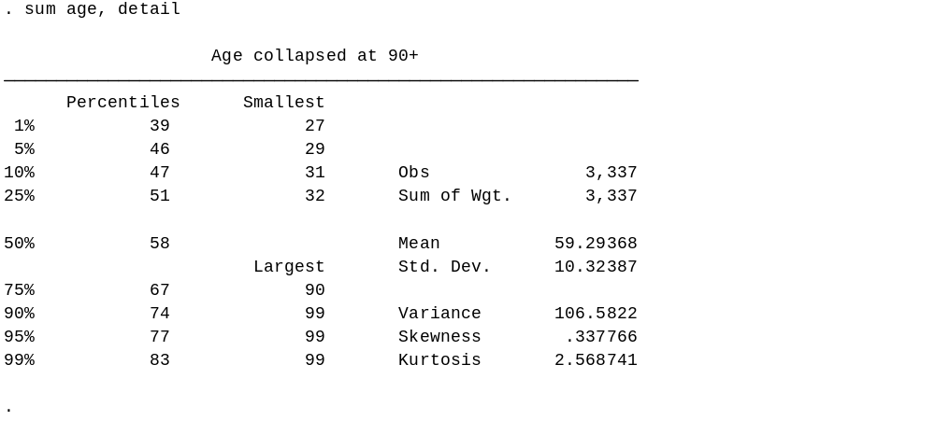

Q: What is the mean age of our sample? What is the median age?
A: We can see here that the mean age is 59 years and the median age (50%) is 58 years. They are quite similar, suggesting that age will be normally distributed in our sample. We can also see that age has been censored (collapsed) at 99 years.

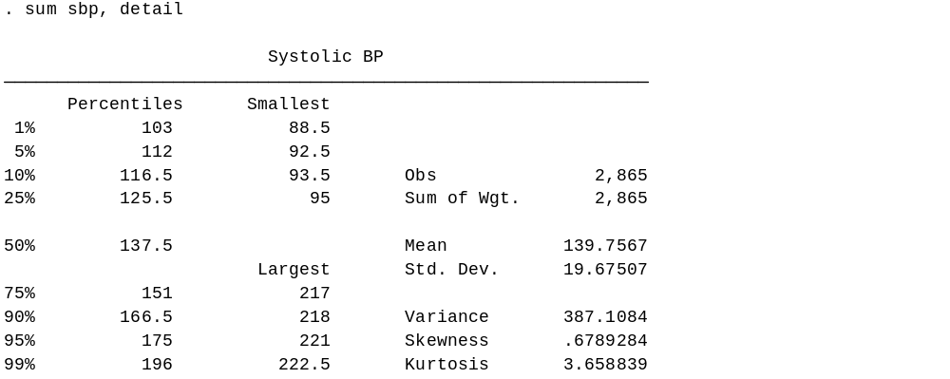

Q: What is the mean and median systolic blood pressure for our sample?
A: We can see here that the mean systolic blood pressure is 139.8 mmHg (millimeters of mercury) and the median systolic blood pressure is 137.5 mmHg.

Q: How many observations do we have for age and for systolic blood pressure?
A: We have 3,337 observations for age and 2,865 for systolic blood pressure. This means all participants answered the question about their age at last birthday or date of birth and so we have no missing observations. However, we do have missing values for systolic blood pressure, this could be for a number of reasons e.g. fewer people consented to have their blood pressure measurements taken or it not being possible for the nurse to take an accurate blood pressure measurement. For now we are going to just run the analysis on those participants with valid systolic blood pressure measurements for now but we would need to sure that we document this in our method section.

A histogram will be a useful graph to use here to see how our outcome (systolic blood pressure) is distributed and to assess whether it approximates a normal distribution type. The command histogram tells Stata to draw a histogram for the variable sbp and the normal option adds a normal approximation to the actual distribution.

histogram sbp, normal

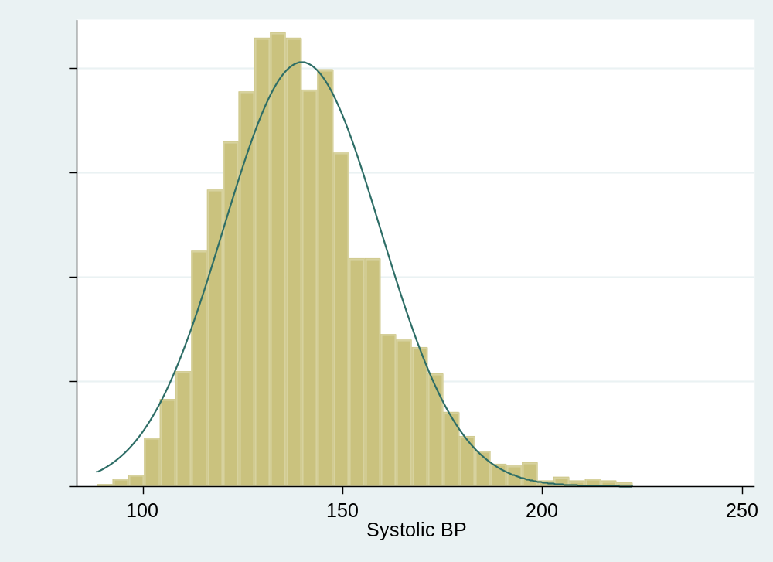

Q: Is systolic blood pressure normally distributed?
A: Almost, although it is slightly positively skewed.

Histograms are sensitive to the number and positioning of bins (or columns) that are used in the display. An alternative to histograms is the kernel density plot, which approximates the probability density of a variable. Kernel density plots have the advantage of being smooth, unlike histograms.

The relevant command is kdensity and again, you can add a normal approximation.

kdensity sbp, normal

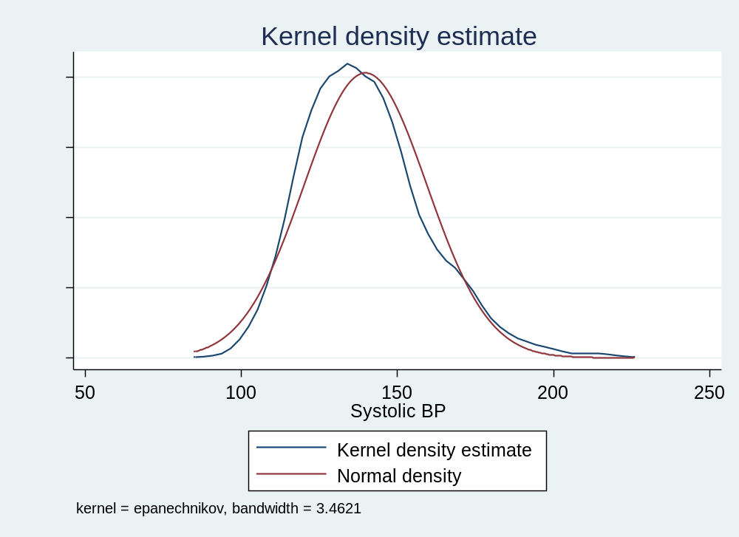

The Kernel density plot confirms that the distribution of systolic blood pressure is slightly positively skewed.

Association between two continuous variables

To examine the relationship between systolic blood pressure and age we can start by plotting a scatter plot. This graph will plot systolic blood pressure (y axis) against age (x axis) for each observation in our sample.

scatter sbp age

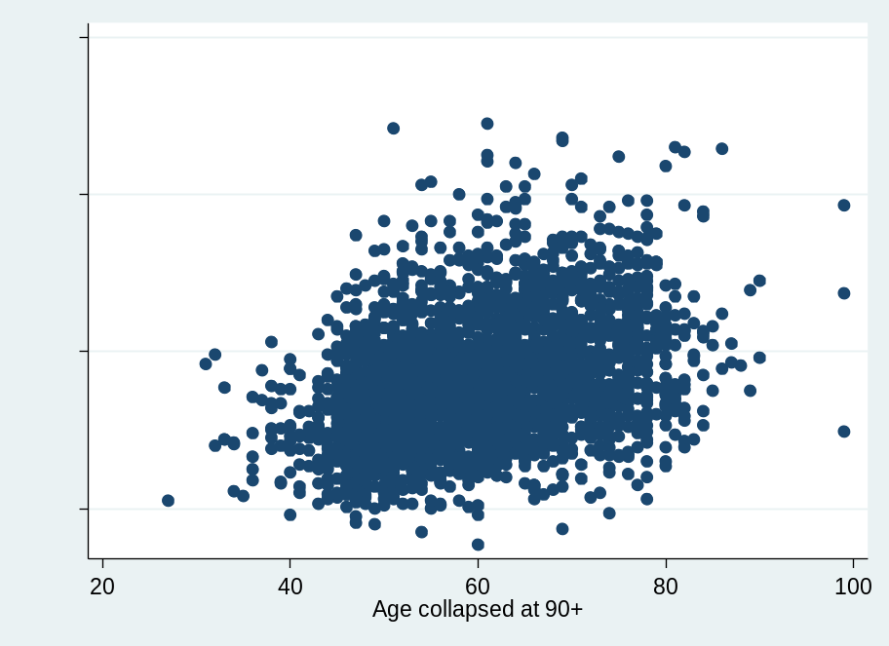

Q: What relationship exists between systolic blood pressure and age?
A: From the scatter plot, higher values of age in general correspond with higher values of blood pressure, so there is a positive linear relationship suggested, although this is quite weak. We know that systolic blood pressure usually increases with age and we do see this here. However, this linear relationship is not very steep in comparison with the wide spread of blood pressure values for any particular age.

We can also get a numerical estimate of how age and systolic blood pressure are related by running a correlation. This has been covered in session [XX] so check back to your notes if you need a reminder.

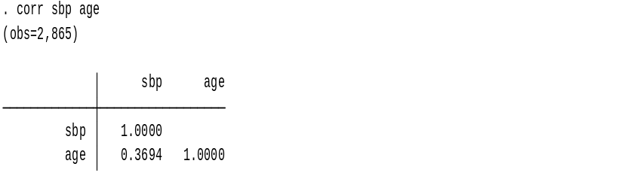

Q: What is the sign of the correlation? Is that what you expect from the scatter diagram? What about its magnitude?
A: The sign is positive, which is what we would expect as we have already observed that there is a weak but positive linear relationship between age and blood pressure in our data. Its magnitude is 0.37 which is less than halfway between 0 (i.e. no relationship) and 1 (perfect relationship), which also makes sense as the relationship is certainly not perfect in our data.

A2: Linear Regression

We will assume that the association between systolic blood pressure and age is linear and fit a linear regression model:

Linear equation with age as the exposure: sbp_{i} = 𝛽₀ + 𝛽₁age_{𝑖} + 𝑒_{i}

This equation is another way of representing the linear regression model we will be estimating. sbp_{i} is systolic blood pressure for ELSA participant i and age_{i} is their age when their blood pressure was measured. The difference between the actual systolic blood pressure for participant i and that predicted in the model is the residual 𝑒_{𝑖} .

To estimate a linear regression in Stata you use the regress command in Stata followed by your outcome variable (sbp) and then your exposure variable/s (age).

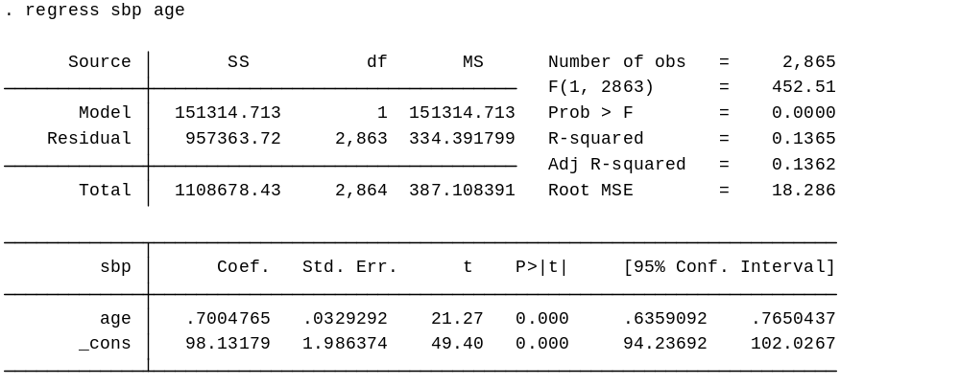

Let us review and interpret this Stata output. We are going to discuss a few key items from the output for now, but an annotated output, which shows a regression model in Stata, along with an explanation of each of the items, is available here.

Q: What is the value of R-squared, and what does it mean?
A: R2 = 0.1365 which means that only 14% of the variability of systolic blood pressure is explained by age. This statistic is also the square of the correlation coefficient that we saw earlier. This reflects what we saw from the scatter plot, that there was a large spread of blood pressure values around each age point and the linear relationship was not very steep. It is not surprising then that this model, which includes just age, explains a relatively small proportion of the variance.

Q: What is the estimated slope coefficient for age, and what does it mean?
A: The coefficient for age is 0.70, which we interpret as the increase in systolic blood pressure predicted as the age of participants increases. Since age is measured in years, this means that per 1-year increase in age there is a 0.70 mmHg (millimeters of mercury) increase in systolic blood pressure.

Q: What do the 95% confidence intervals tell us?
A: The final two columns give the 95% confidence intervals for the slope coefficient. These two number are the range within which we are 95% confident the true slope coefficient falls. So the increase in systolic blood pressure per 1 year increase could be as large as 0.76 or as small as 0.64. The t-test for age equals 21.27, and tests H₀ (the null hypothesis) that the coefficient=0 (i.e. that there is no a relationship between age and systolic blood pressure). The p value is <0.0001 so provides confirmation that this test statistic is larger than the critical value at the 5% level of significance.

Q: What is the coefficient _cons and what can it tell us?
A: In a linear regression, the coefficient for _cons is the estimated intercept, which here is 98.13, this is the predicted value of sbp when age equals zero. In most cases, the value of the outcome when the exposure is zero is not very meaningful. However, it is possible to centre the exposure variable (by subtracting it from the sample mean) so that this intercept will be then be value of sbp at the mean age of the sample.
A3: Predicted values from a regression model
We can use these model results to make predictions about systolic blood pressure using the fitted regression line. Although as we will see in later sessions, before we go on to use these predicted values in our analysis, we will need to consider how certain we are that the line fits our data.

predicted_sbp=_cons + (Coeff.*age)

Q: What is the systolic blood pressure for someone aged 55?

predicted_sbp=98.13179 + (0.7004765*55)

Tip: We can use Stata as a calculator by using the display command

A: So the predicted systolic blood pressure for someone aged 55 is 136.65 mmHg

We can also ask Stata to calculate a predicted value of systolic blood pressure for everyone in our sample and store it as a new variable using the command predict. You can name the new variable anything you like; here we have named it yhat. We have also asked Stata to list these predicted values for the first five participants in the dataset, alongside the values of sbp and age. The predicted values are close to the observed values for some participants, but further away for others.

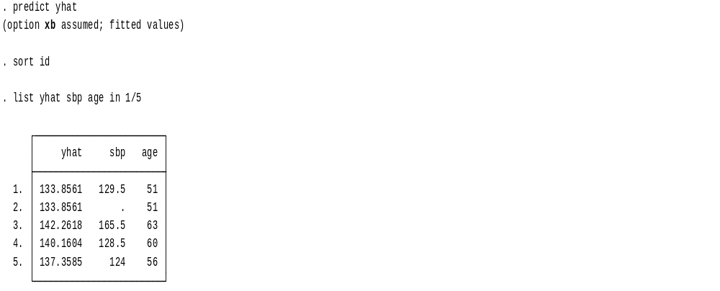

We can also use the predict command in Stata to calculate a residual: the distance between the observed value and the fitted value for each individual

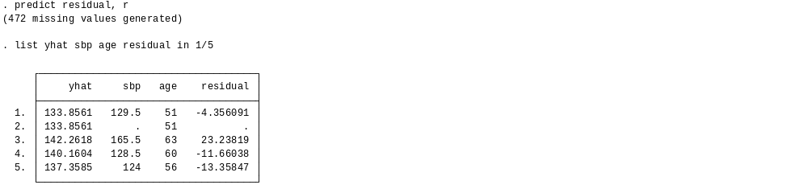

Stata Extra [You can skip this for now or come back to this section later]

We can also use Stata to do the calculation for us using information about the intercept and coefficients stored by Stata after a regression model, using a command called lincom.

You can search the Stata help directory for more information about this command.

Q: What is the systolic blood pressure for someone aged 60?

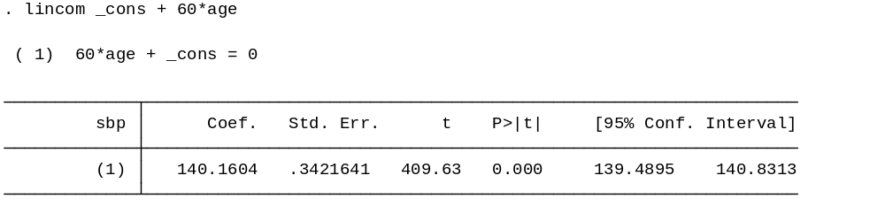

At this point you will need to check several assumptions about the fit of your regression model that you were introduced to in the lecture – but we will deal with that in the next practical session after we have completed our first multiple regression. For now, we are going to go ahead and examine a linear regression with a binary variable.

B. Linear Regression against a binary variable (sex)
We will now repeat the regression with systolic blood pressure still as the dependent variable, but now sex as the independent variable.

B1: Examining and visualizing variables
First, we will tabulate our variable sex to see the distribution of our sample by sex, and we will also examine the distribution of systolic blood pressure in men and women using the bysort (bys) command.

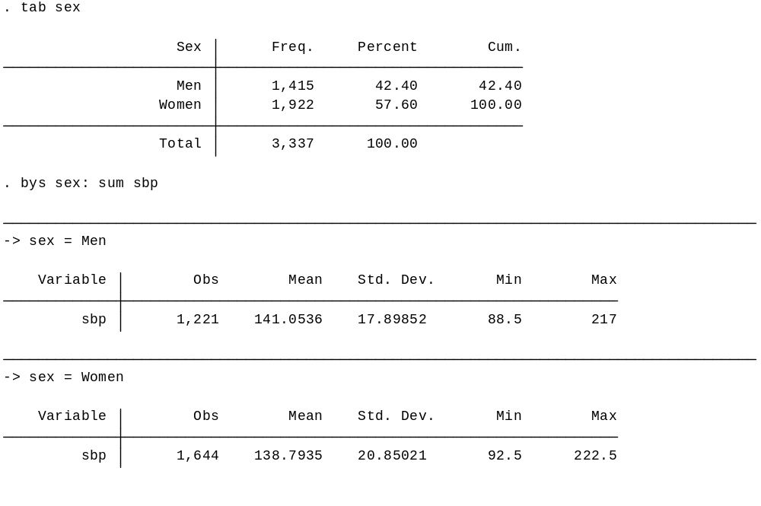
Q: What percentage of the sample are men and what is the mean systolic blood pressure for men and for women in the sample?
A: We can see that around 42% of our sample are men (n=1,415). Of these 1,1221 men have a valid systolic blood pressure measurement and the mean systolic blood pressure for men in this sample is 141.1. Compared to this 1,644 women have a valid systolic blood pressure and the mean for women in our sample is 138.8, so mean systolic blood pressure is lower in women.
Histogram

We can also examine a histogram for sbp separately for men and women. We can see that both are a bit positively skewed, but approximate a normal distribution.

histogram sbp if sex==1, normal

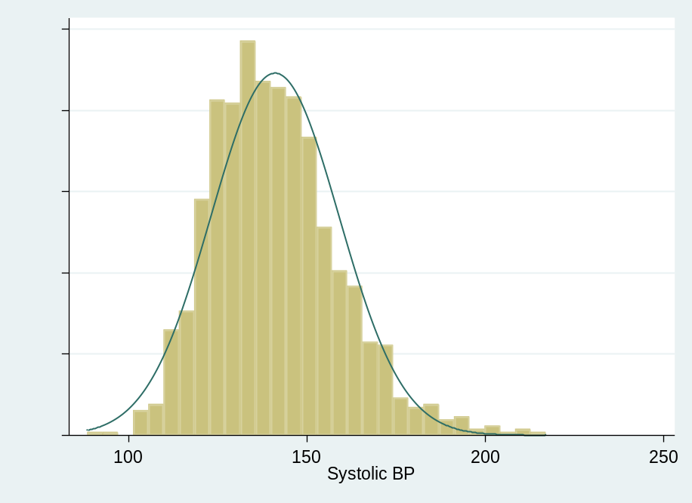

histogram sbp if sex==2, normal

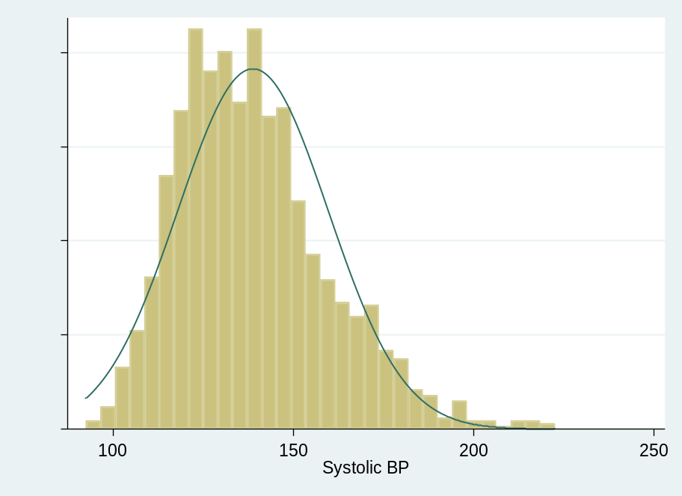

B2: Linear regression

We will now perform a linear regression of sbp against sex. This will allow us to make comparisons of the outcome between two groups, men and women. To help us interpret these models easily, we will first recode the variable sex into two new variables female and male.

recode sex (1=0) (2=1), gen(female)
recode sex (1=1) 2=0), gen(male)

Now we will run the linear regression using the variable female. Remember that the outcome variable is always placed directly after the regress command in Stata

Linear equation with sex as the exposure: sbp_{i} = 𝛽₀ + 𝛽₁female_{𝑖} + 𝑒_{i}

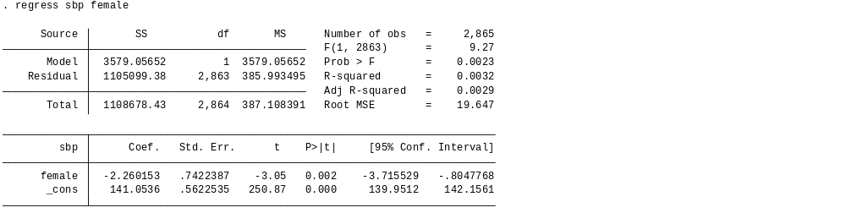

Q: What is the value of the coefficient for female? What does it mean?
A: The value of the coefficient for female is -2.3, which means that compared to men; women have lower blood pressure by 2.3 mmHg. We can also think of this as the predicted change in the outcome when the exposure is one instead of zero. Again, we should also examine the 95% confidence intervals, which show us the possible lower and upper value for our coefficient. So the difference in blood pressure for men and women could be as large as -3.7 or as small as -0.80. We are 95% confident that the true population coefficient will lie within this range. The t-test for sex tests H₀ (the null hypothesis) that there is no a relationship between sex and systolic blood pressure). The p value is 0.002 and the 95% confidence intervals do not include zero so we can reject the null hypothesis.

Q: What is the value of the R² and what is its meaning? How has it changed now we are using sex instead of age as an explanatory variable?
A: R-squared is now 0.0029, which means that sex explains less than 1% of the variability in systolic blood pressure. This is lower than the value of R² in the previous model and so there is more residual or unexplained variance in this model.

B3: Predicted values from a regression model

Q: What is the predicted systolic blood pressure for men?

Men are coded as zero (the “reference” group) in our model, so the estimated intercept will equal predicted sbp for men.

A: predicted_sbp= 141.05 + (-2.26 *0) =141.05

Q: What is the predicted systolic blood pressure for women?
A: predicted_sbp = 141.05 + (-2.26*1) = 138.79

Notice that these values match the mean sbp values for men and women we calculated earlier and the coefficient for female is the difference between them. You can also use Stata to create predicted values and residuals as we did before.

Stata Extra [You can skip this for now or come back to this section later]

What do you think will happen to the intercept and the direction of the coefficient if you run the regression model using the variable male we created?

regress sbp male

Linear Regression with a single categorical variable (social class)

Next, we are going to run a regression model using a single categorical variable and we will be examining the association between systolic blood pressure and social class.

C1: Examining and visualizing variables

Q: How many categories of social class are in our sample? Should we recode this variable?

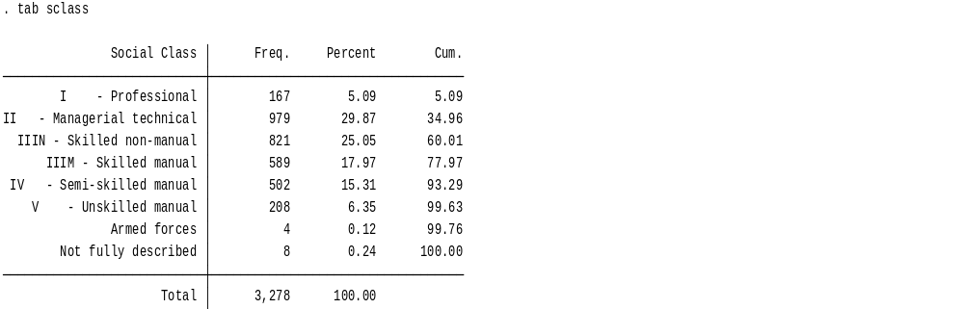

A: We can see that there are eight categories in our social class variable, however, two of these categories of very small and less useful (armed forces, unclear) and there are also some very small numbers in some of the other categories. We will recode this variable into three groups. There are pros and cons to doing this and it is important to think about what this might mean for your research. This social class classification used here is The Registrar General’s Social Class Scale (1911) (if you want to look it up).

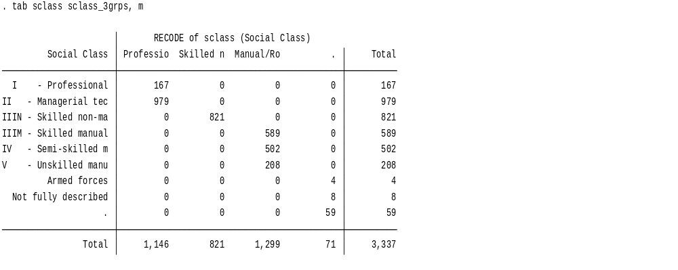

Now we can look at the mean systolic blood pressure for each of the different social class groups.

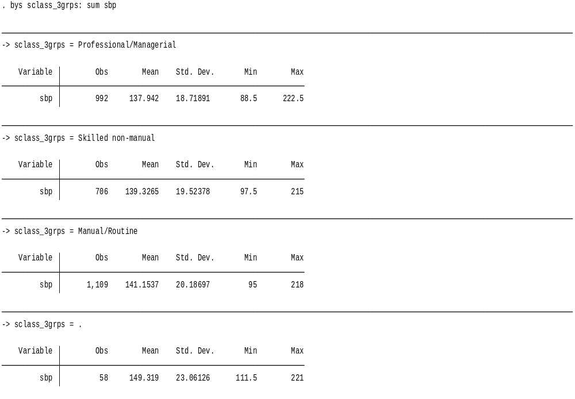

Q: What is the mean systolic blood pressure for the three groups?
A: Professional/Managerial (137.9); Skilled non-manual (139.3); Manual/Routine (141.2). These seem to suggest a social gradient in blood pressure levels.

C2: Linear Regression
We will now perform a linear regression of sbp against sclass_3grps. This will allow us to make comparisons of the outcome between the three social class groups. To help us interpret these models easily, we will ask Stata to treat each category separately in the regression and so we will add i. before the variable.

Linear equation with social class as the exposure: sbp_{i} = 𝛽₀ + 𝛽₁ sclass_3grps,_{𝑖} + 𝑒_{i}

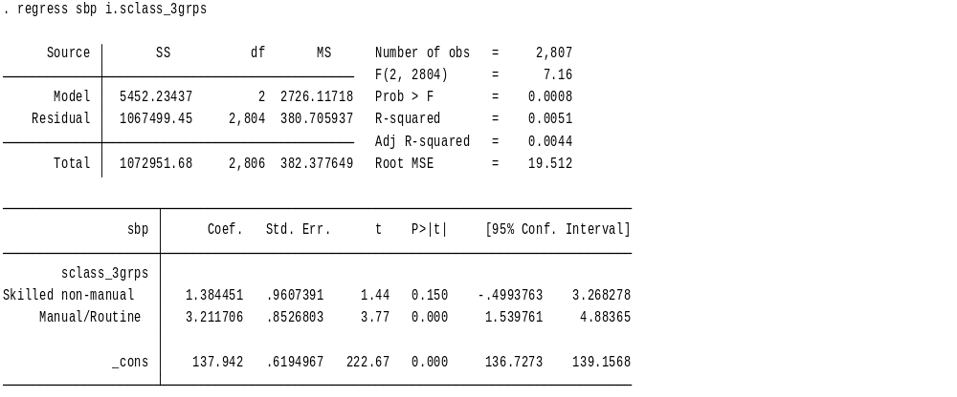

Q: How is the variable social class related to systolic blood pressure?
A: The coefficient for skilled non-manual is 1.4 meaning that workers in these occupations have 1.4 mmHg higher systolic blood pressure than managerial and professional workers. However, the range of the confidence intervals includes the value zero, meaning that we are not confident that there is actually a difference between these groups. The confidence intervals for this coefficient are quite wide, perhaps because this is quite a small category.

Those in manual/routine occupations have blood pressure 3.2 mmHg higher than managerial and professional workers. By conventional criteria the test statistic for this coefficient is t=3.77 and the p value <0.001 so we are more confident that there is evidence we should reject the null hypothesis and conclude that there is a difference between the blood pressure of those in the manual/routine occupations compared to those in the managerial and professional groups. However, we have found evidence that systolic blood pressure is related to social class

C3: Predicted values from a regression model

Q: What is the value of the estimated systolic blood pressure of each category of social class?

Systolic blood pressure for managerial and professional= 137.9 + 1.4*0 + 3.2*0 = 137.9
Systolic blood pressure for intermediate = 137.9 + 1.4*1 + 3.2*0 = 139.3
Systolic blood pressure for routine and manual = 137.9 + 1.4*0 + 3.2*1 = 141.1

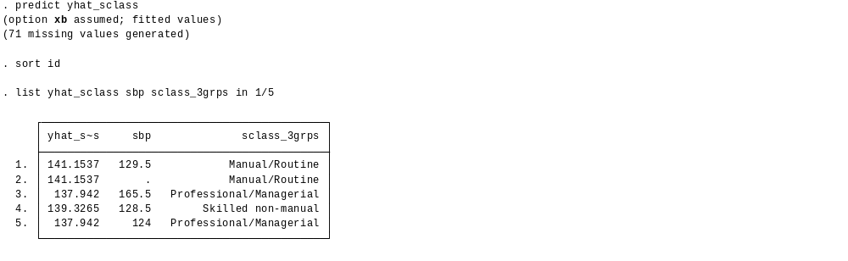

Notice that these predictions give exactly the same results as the means we calculated in the first section. However, now we know that we cannot be as confident about the difference between the means of the first two groups. Because we are comparing our results to the managerial and professional category, this is our reference category.

Optional exercise: Examine BMI against age, sex and social class

Q1: What is the mean BMI of our sample? What is the median? Are they similar?

Q2: How many observations do we have for BMI?

Q3: Is BMI normally distributed? How did you come to this decision?

Q4: Run a regression with continuous BMI as the outcome (bmi) and age as the independent variable.

- Examine the summary statistics first.
- What do the coefficient and confidence intervals mean?
- What does the R² tell you?
- Calculate the predicted sbp value for someone aged 60.

Q5: Run a regression with continuous BMI as the outcome (bmi) with Ethnicity (ethni) as the independent variable.

- Examine the summary statistics first.
- What do the coefficient and confidence intervals mean?
- What does the R² tell you?
- Calculate the predicted sbp value for someone aged 60.

Q6: Run a regression with BMI as the outcome (bmi) and self-reported general health (srh) as the independent variable. Recode this variable into three categories.

- Examine the summary statistics first.
- What do the coefficient and confidence intervals mean?
- What does the R² tell you?
- Calculate the predicted sbp value for someone aged 60.

