It seems that I should learn some c++ knowledge firstly. Otherwise I can’t debug the program quickly.

1. What is the name space, how to use the name space.
   1. Why we use namespace, because when we define some variables, they may be mixed up, in order to tell apart them, we can use different name space, so that we can use different variables in different namespace.
   2. When you want to use the std function cout, you must use the namespace std.
   3. When you want to use your own name space, you must define it first, then you can use it.
2. A little demo,
   1. In the main function, you can use the name space.

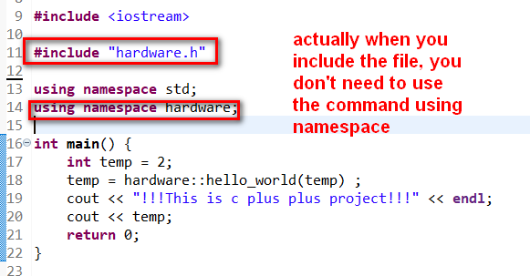

Then in the hardware.h file, you can define the function.

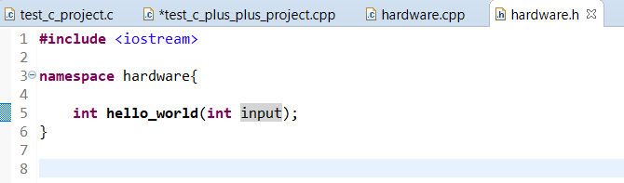

In the hardware.cpp file, you can implement the function, so you can call it in the main.cpp file.

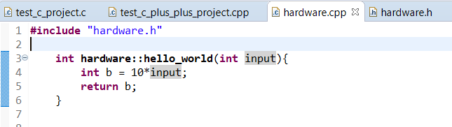

1. The remain question is that how to define the variables in the name space, then you can use it anywhere.