
FACULTY OF APPLIED SCIENCES
DOCTOR OF PHILOSOPHY IN ARTIFICIAL INTELLIGENCE DRIVEN DRUG DISCOVERY

AIDD8122 – Advanced Topics in Artificial Intelligence & Drug Discovery

Molecular Representations, Model Families and Evaluation Protocols for Predicting BACE-1 Inhibition: A Systematic Benchmark with Graph Neural Networks
Student ID: | P2600332
Student Name: | Jiayang Li
Submission Date: | 02/11/2026

Table of Contents

§1. Introduction 1
§2. Literature Review 2
2.1. Molecular representation 2
2.2. What benchmarks have found 2
2.3. Evaluation protocol 2
§3. Research Questions and Objectives 3
§4. Methods and Materials 4
4.1. Data and curation 4
4.2. Data splitting 4
4.3. Molecular representations 5
4.4. Models 5
4.5. Graph neural network 5
4.6. Experimental design and evaluation 6
§5. Results and Discussion 7
5.1. Representation matters more than model family (RQ1) 7
5.2. Random splits are measurably optimistic (RQ2) 9
5.3. Hyperparameter tuning returns little at this data scale 10
5.4. The graph neural network does not beat fingerprints at this scale (RQ3) 11
5.5. Ensembling, interpretation and applicability domain (RQ4) 13
5.6. Strengths, limitations and future work 15
§6. Conclusions 16
§7. References 18

Introduction
Alzheimer's disease affects an estimated 55 million people worldwide and remains without a disease-modifying therapy that works reliably in the clinic. The amyloid cascade hypothesis places the aggregation of amyloid-beta (A-beta) peptides upstream of the neurodegeneration that follows, and beta-site amyloid precursor protein cleaving enzyme 1 (BACE-1, beta-secretase) performs the first and rate-limiting proteolytic step that releases those peptides. Inhibiting BACE-1 therefore reduces A-beta production at its source, and the target has attracted sustained medicinal-chemistry effort for two decades.
That effort has been expensive and largely unsuccessful. BACE-1 has a large, solvent-exposed, catalytic aspartyl dyad that favours peptidomimetic ligands too polar and too large to cross the blood-brain barrier, so the chemistry needed to reach brain exposure is demanding. Several clinical candidates (verubecestat, atabecestat, lanabecestat, umibecestat) reached late-stage trials and were discontinued for lack of efficacy or for cognitive worsening. Whatever the eventual therapeutic verdict on the target, the two decades of work left behind an unusually rich, well-annotated structure-activity dataset, which is precisely what makes BACE-1 a useful testbed for computational methods.
Machine learning promises to compress the cost of the early stages of this process. A model trained on measured potencies can rank a virtual library in minutes rather than the months an assay campaign requires. The accuracy such a model reports, however, depends on three choices that are often made implicitly: how molecules are encoded as numbers, which learning algorithm consumes that encoding, and how the test set is constructed. The third choice is the one most often got wrong. A random train/test split places close analogues of the test molecules in the training set, which is not the situation a prospective screening campaign faces, and it inflates every reported metric.
This project treats those three choices as the object of study rather than as implementation details. Using the public MoleculeNet BACE dataset (1,512 molecules after curation), six molecular representations are crossed with six model families and evaluated under two splitting protocols, for both a classification task (active versus inactive at IC50 = 100 nM) and a regression task (pIC50). A message-passing graph neural network, which learns its own representation instead of consuming a fixed one, is added as a contrast, and the resulting models are tuned, ablated, combined and interpreted. The intent is a careful, reproducible answer to a question practitioners face constantly: given a dataset of this size and character, what actually matters?

Literature Review

Molecular representation
Before a molecule can be a model input it must become a vector. Extended-connectivity fingerprints (ECFP, Rogers and Hahn 2010) remain the workhorse: each atom's circular environment up to a radius is hashed into a bit of a fixed-length vector, giving a sparse binary encoding of substructure presence that is fast, deterministic and surprisingly hard to beat. Variants change what is hashed - FCFP replaces element identity with pharmacophoric atom types, making it more tolerant of bioisosteric replacement, while atom-pair fingerprints encode through-bond distances between atom pairs and so capture longer-range topology. MACCS keys take the opposite approach: 166 hand-curated yes/no structural questions, which is interpretable but coarse. A separate tradition uses physicochemical descriptors - molecular weight, cLogP, topological polar surface area and a few hundred relatives - which describe bulk properties rather than specific substructures.
Learned representations displaced fixed ones in many other domains, and graph neural networks (GNNs) extend that idea to chemistry by treating a molecule as a graph of atoms and bonds and learning atom embeddings through iterative message passing (Duvenaud et al. 2015; Gilmer et al. 2017). Graph Isomorphism Networks (Xu et al. 2019) and their edge-aware variant GINE (Hu et al. 2020) give this family a theoretical grounding in graph-isomorphism testing. Directed message passing (Yang et al. 2019, Chemprop) is the best-established chemistry-specific architecture.

What benchmarks have found
The practical question is whether learned representations repay their cost on the dataset sizes typical of medicinal chemistry. The evidence says: often not. MoleculeNet (Wu et al. 2018) assembled standardised datasets, BACE among them, and found graph models competitive but not dominant. Yang et al. (2019) reported that a well-tuned directed message-passing network beats fingerprint baselines on large datasets while the advantage shrinks or disappears below a few thousand molecules. Jiang et al. (2021) compared descriptor-based models against GNNs across many datasets and concluded that gradient boosting on descriptors remained the stronger default. Most pointedly, van Tilborg et al. (2022) showed that on activity-cliff-rich datasets - exactly the regime of a congeneric optimisation series - classical descriptor models outperform deep ones.

Evaluation protocol
A parallel literature concerns how performance is measured. Scaffold splitting, which assigns whole Bemis-Murcko scaffold classes (Bemis and Murcko 1996) to a single subset, estimates generalisation to new chemotypes and is now standard in MoleculeNet-derived benchmarks. Sheridan (2013) made the general point earlier: time-split and cluster-split validation correlate far better with prospective performance than random cross-validation. Tropsha and Golbraikh's applicability-domain work established the complementary idea that a QSAR model should declare where its predictions are trustworthy, usually via similarity to the training set. Interpretation methods - SHAP (Lundberg and Lee 2017) applied to fingerprint bits, or atom-level attribution - address a different objection, that a model which cannot explain its reasoning is hard to act on in a design cycle.
The gap this project addresses is that these threads are usually explored separately and on different datasets. Holding the target, the data curation and the splitting protocol fixed while varying representation, model family and evaluation lets the contributions be compared on equal terms.

Research Questions and Objectives
The project is organised around four questions, each answerable with a controlled experiment on a single target.
RQ1. How much does the molecular representation matter relative to the model family? Practitioners spend effort on both; the relative return on each is rarely quantified on the same data. If one dominates, that is where effort belongs.
RQ2. How large is the optimism introduced by a random split? Quantifying the gap between random and scaffold splitting on identical models converts a widely repeated methodological warning into a number for this dataset, and tests whether the ranking of methods - not just their absolute scores - survives the change of protocol.
RQ3. Does a graph neural network that learns its representation beat fixed fingerprints at this data scale, and which architectural choices drive its behaviour? This is tested directly and then decomposed by ablation, since a single aggregate number does not explain which component carries the performance.
RQ4. Can the resulting model be made more reliable and more interpretable? Three avenues are examined: hyperparameter optimisation and ensembling for accuracy, SHAP and atom attribution for chemical interpretability, and an applicability-domain analysis that asks whether the model's confidence tracks its actual error.
The corresponding objectives are to curate the BACE dataset reproducibly; to benchmark 6 representations against 6 model families under both splits and both tasks with five random seeds throughout; to implement and ablate a GINE-style graph network; to apply random-search tuning, ensembling, SHAP and applicability-domain analysis; and to release the complete pipeline as a reproducible repository.

Methods and Materials

Data and curation
The MoleculeNet BACE dataset was obtained from the DeepChem public repository. It contains 1,513 molecules with IC50 values measured against human BACE-1, assembled by Subramanian et al. (2016) from ChEMBL and the primary literature. Structures were standardised with RDKit: cleanup (sanitisation, normalisation of functional-group tautomers), extraction of the largest organic parent fragment to remove counter-ions, and neutralisation of charges. Standardised structures were canonicalised and de-duplicated, merging one pair of records that collapsed onto the same parent; 1,512 molecules remained.
Two targets were derived. For regression, pIC50 = -log10(IC50 in M), spanning 2.54 to 10.52 (mean 6.52, SD 1.34). For classification, the MoleculeNet convention labels a molecule active at pIC50 >= 7, i.e. IC50 <= 100 nM, giving 690 actives and 822 inactives (45.6 per cent active) - close enough to balanced that no resampling was applied. The molecules are large and lipophilic (median molecular weight 464 Da, median cLogP 3.7, median 33 heavy atoms), consistent with a peptidomimetic chemical series, and occupy 648 distinct Bemis-Murcko scaffolds of which 452 appear once. Figure 2 summarises the dataset.
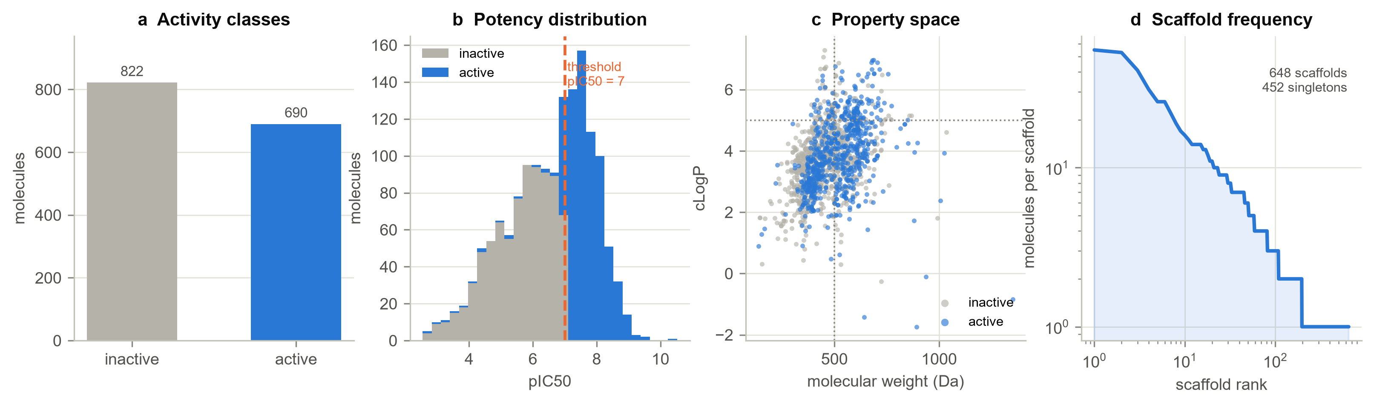
Figure 1. The curated BACE-1 dataset. (a) Activity classes at the pIC50 = 7 threshold. (b) Distribution of measured potency. (c) Molecular weight against cLogP, with Lipinski limits marked. (d) Bemis-Murcko scaffold frequency.

Data splitting
Two protocols were used, each with five seeds (0-4) and 80/10/10 proportions. The random split is stratified by activity class. The scaffold split assigns whole Bemis-Murcko scaffold groups to one subset, placing groups larger than half the validation size first so that they fall in the training set and shuffling the remainder per seed; this balanced randomised variant follows Chemprop and, unlike a deterministic scaffold split, exposes genuine seed-to-seed variation. The two protocols differ exactly as intended: the mean maximum Tanimoto similarity between a test molecule and the training set is 0.80 under random splitting but 0.71 under scaffold splitting (Figure 3), so scaffold test sets genuinely contain less familiar chemistry.
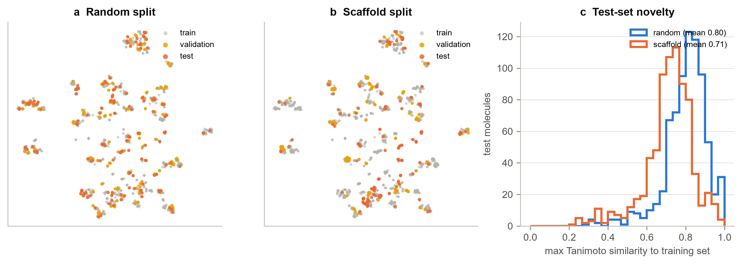
Figure 2. Random against scaffold splitting. (a, b) t-SNE of ECFP4 space coloured by subset for one seed. (c) Maximum Tanimoto similarity of each test molecule to the training set, pooled over five seeds.

Molecular representations
Six representations were compared. ECFP4 (Morgan fingerprint, radius 2, 2048 bits) encodes circular substructures. FCFP4 is the same construction over pharmacophoric atom types. AtomPair (2048 bits) encodes through-bond atom-pair distances. MACCS supplies 166 curated structural keys. RDKit2D is the full set of 216 RDKit 2D descriptors (the Ipc index was dropped as it spans more than thirty orders of magnitude and is numerically unusable). ECFP4+RDKit2D concatenates substructure and property information to test whether the two are complementary. Fingerprints were computed once and cached.

Models
Six model families span the usual range of capacity and inductive bias: k-nearest neighbours, a linear model (logistic regression for classification, ridge for regression), random forest, support vector machine, gradient boosting (XGBoost) and a multilayer perceptron. Binary fingerprints are compared with the Tanimoto coefficient rather than the Euclidean distance - as a similarity-weighted kNN and as a precomputed SVM kernel, Tanimoto being a valid Mercer kernel on binary vectors - which is standard cheminformatics practice and substantially better here than an RBF kernel on raw bits. Real-valued descriptors are median-imputed, variance-filtered and standardised inside the model pipeline, with all statistics fitted on the training set only.

Graph neural network
The GNN is a GINE-style message-passing network implemented directly in PyTorch (no graph-learning framework), which keeps the architecture explicit and auditable. Atoms carry one-hot element, degree, formal charge, hybridisation, hydrogen count, aromaticity, ring membership and chiral tag; bonds carry bond type, conjugation and ring membership. Each layer updates an atom from the sum of ReLU-rectified messages from its neighbours, with bond features added to each message, followed by a two-layer MLP with batch normalisation, a residual connection and dropout. Three layers are the default. A concatenated sum/mean/max readout pools atoms into a molecule vector that an MLP head maps to a logit or a standardised pIC50. Training uses Adam (learning rate 1e-3, weight decay 1e-5), batch size 64, and early stopping on the validation primary metric with patience 25 and a 150-epoch cap.

Experimental design and evaluation
Classification is scored by ROC-AUC (primary), PR-AUC, Matthews correlation coefficient, F1 and balanced accuracy; regression by RMSE (primary), MAE, R-squared and Spearman correlation. Every configuration is run across five seeds and reported as mean plus or minus standard deviation. Hyperparameters were tuned by random search over 20 configurations per model, task and seed, with the configuration selected on the validation split and only that configuration evaluated on test. The same discipline applies throughout: the GNN's early-stopping epoch, each model's best representation, and the ensemble's membership are all chosen on validation data, so no test information enters model selection at any point. Figure 1 shows the complete workflow.
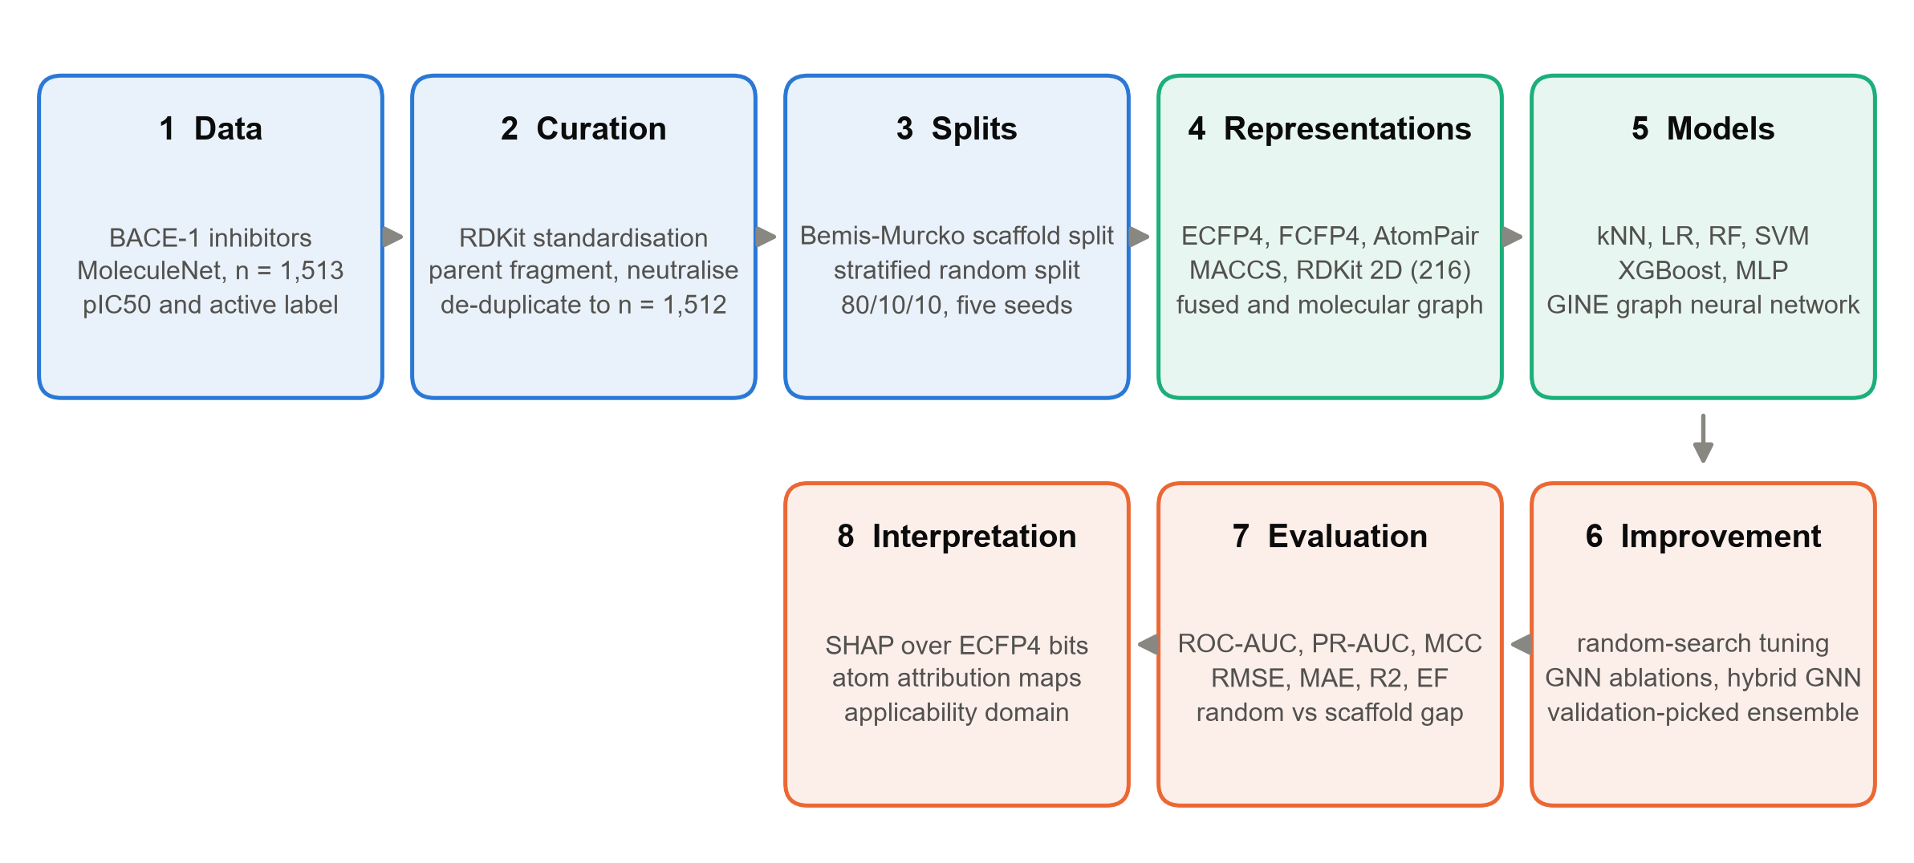
Figure 3. Computational workflow, from dataset curation through representation and model benchmarking to evaluation and interpretation.

Results and Discussion

Representation matters more than model family (RQ1)
Figure 4 shows the full representation-by-model grid on the scaffold split. The best classifier is ECFP4 + SVM at ROC-AUC 0.906 (SD 0.027); the best regressor is AtomPair + XGBoost at RMSE 0.742 (SD 0.054). Table 1 and Table 2 give the complete results.
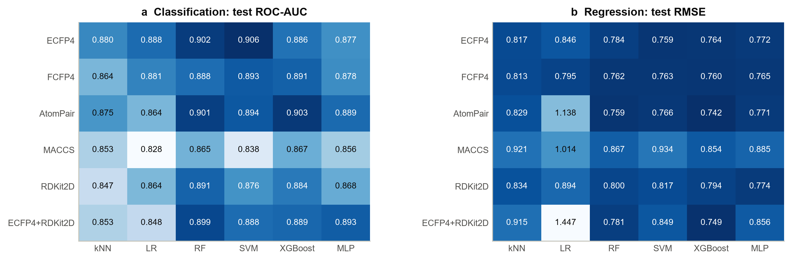
Figure 4. Representation by model family on scaffold-split test sets, averaged over five seeds. Darker is better in both panels.
Table 1. Classification performance for every representation and model family on scaffold-split test sets (mean plus or minus SD over five seeds).
feature | model | ROC AUC | PR AUC | MCC | F1 | BACC
AtomPair | LR | 0.864 ± 0.048 | 0.796 ± 0.039 | 0.570 ± 0.086 | 0.748 ± 0.037 | 0.789 ± 0.049
AtomPair | MLP | 0.889 ± 0.048 | 0.825 ± 0.076 | 0.672 ± 0.050 | 0.812 ± 0.033 | 0.840 ± 0.027
AtomPair | RF | 0.901 ± 0.040 | 0.850 ± 0.065 | 0.632 ± 0.072 | 0.786 ± 0.049 | 0.820 ± 0.038
AtomPair | SVM | 0.894 ± 0.038 | 0.825 ± 0.078 | 0.644 ± 0.091 | 0.793 ± 0.066 | 0.828 ± 0.044
AtomPair | XGBoost | 0.903 ± 0.032 | 0.853 ± 0.053 | 0.630 ± 0.061 | 0.781 ± 0.040 | 0.819 ± 0.034
AtomPair | kNN | 0.875 ± 0.045 | 0.779 ± 0.075 | 0.595 ± 0.101 | 0.770 ± 0.066 | 0.803 ± 0.051
ECFP4 | LR | 0.888 ± 0.046 | 0.825 ± 0.074 | 0.631 ± 0.101 | 0.782 ± 0.067 | 0.820 ± 0.051
ECFP4 | MLP | 0.877 ± 0.054 | 0.829 ± 0.072 | 0.588 ± 0.119 | 0.747 ± 0.089 | 0.791 ± 0.067
ECFP4 | RF | 0.902 ± 0.029 | 0.853 ± 0.050 | 0.645 ± 0.084 | 0.792 ± 0.056 | 0.827 ± 0.042
ECFP4 | SVM | 0.906 ± 0.027 | 0.851 ± 0.040 | 0.628 ± 0.074 | 0.782 ± 0.048 | 0.819 ± 0.041
ECFP4 | XGBoost | 0.886 ± 0.049 | 0.826 ± 0.070 | 0.639 ± 0.115 | 0.785 ± 0.075 | 0.822 ± 0.059
ECFP4 | kNN | 0.880 ± 0.039 | 0.800 ± 0.044 | 0.614 ± 0.073 | 0.778 ± 0.056 | 0.813 ± 0.035
ECFP4+RDKit2D | LR | 0.848 ± 0.030 | 0.777 ± 0.068 | 0.545 ± 0.060 | 0.736 ± 0.050 | 0.777 ± 0.029
ECFP4+RDKit2D | MLP | 0.893 ± 0.049 | 0.853 ± 0.065 | 0.603 ± 0.094 | 0.765 ± 0.067 | 0.806 ± 0.048
ECFP4+RDKit2D | RF | 0.899 ± 0.040 | 0.840 ± 0.069 | 0.641 ± 0.089 | 0.791 ± 0.059 | 0.827 ± 0.044
ECFP4+RDKit2D | SVM | 0.888 ± 0.017 | 0.814 ± 0.035 | 0.605 ± 0.051 | 0.763 ± 0.041 | 0.804 ± 0.027
ECFP4+RDKit2D | XGBoost | 0.889 ± 0.040 | 0.816 ± 0.076 | 0.640 ± 0.066 | 0.790 ± 0.041 | 0.825 ± 0.033
ECFP4+RDKit2D | kNN | 0.853 ± 0.045 | 0.771 ± 0.075 | 0.553 ± 0.066 | 0.726 ± 0.071 | 0.775 ± 0.042
FCFP4 | LR | 0.881 ± 0.048 | 0.825 ± 0.077 | 0.622 ± 0.098 | 0.778 ± 0.060 | 0.815 ± 0.051
FCFP4 | MLP | 0.878 ± 0.052 | 0.825 ± 0.068 | 0.594 ± 0.141 | 0.755 ± 0.097 | 0.797 ± 0.072
FCFP4 | RF | 0.888 ± 0.036 | 0.834 ± 0.054 | 0.573 ± 0.100 | 0.744 ± 0.070 | 0.787 ± 0.050
FCFP4 | SVM | 0.893 ± 0.035 | 0.825 ± 0.067 | 0.611 ± 0.091 | 0.771 ± 0.063 | 0.809 ± 0.047
FCFP4 | XGBoost | 0.891 ± 0.046 | 0.831 ± 0.072 | 0.614 ± 0.109 | 0.772 ± 0.075 | 0.811 ± 0.053
FCFP4 | kNN | 0.864 ± 0.036 | 0.787 ± 0.059 | 0.554 ± 0.112 | 0.735 ± 0.084 | 0.778 ± 0.054
MACCS | LR | 0.828 ± 0.030 | 0.766 ± 0.060 | 0.514 ± 0.039 | 0.716 ± 0.039 | 0.761 ± 0.019
MACCS | MLP | 0.856 ± 0.044 | 0.805 ± 0.062 | 0.560 ± 0.124 | 0.735 ± 0.088 | 0.783 ± 0.066
MACCS | RF | 0.865 ± 0.019 | 0.816 ± 0.021 | 0.597 ± 0.049 | 0.766 ± 0.045 | 0.803 ± 0.027
MACCS | SVM | 0.838 ± 0.030 | 0.765 ± 0.059 | 0.531 ± 0.058 | 0.723 ± 0.060 | 0.767 ± 0.027
MACCS | XGBoost | 0.867 ± 0.022 | 0.807 ± 0.042 | 0.589 ± 0.049 | 0.761 ± 0.043 | 0.799 ± 0.026
MACCS | kNN | 0.853 ± 0.024 | 0.766 ± 0.063 | 0.567 ± 0.074 | 0.752 ± 0.061 | 0.789 ± 0.035
RDKit2D | LR | 0.864 ± 0.063 | 0.767 ± 0.109 | 0.579 ± 0.126 | 0.756 ± 0.079 | 0.795 ± 0.062
RDKit2D | MLP | 0.868 ± 0.030 | 0.793 ± 0.048 | 0.578 ± 0.066 | 0.748 ± 0.037 | 0.794 ± 0.041
RDKit2D | RF | 0.891 ± 0.038 | 0.827 ± 0.064 | 0.630 ± 0.067 | 0.785 ± 0.046 | 0.821 ± 0.033
RDKit2D | SVM | 0.876 ± 0.040 | 0.778 ± 0.090 | 0.602 ± 0.073 | 0.769 ± 0.055 | 0.807 ± 0.035
RDKit2D | XGBoost | 0.884 ± 0.036 | 0.813 ± 0.067 | 0.626 ± 0.067 | 0.780 ± 0.048 | 0.819 ± 0.032
RDKit2D | kNN | 0.847 ± 0.038 | 0.760 ± 0.050 | 0.560 ± 0.099 | 0.742 ± 0.071 | 0.784 ± 0.050

Table 2. Regression performance for every representation and model family on scaffold-split test sets (mean plus or minus SD over five seeds).
feature | model | RMSE | MAE | R2 | Spearman
AtomPair | LR | 1.138 ± 0.108 | 0.884 ± 0.098 | 0.270 ± 0.121 | 0.632 ± 0.115
AtomPair | MLP | 0.771 ± 0.068 | 0.587 ± 0.068 | 0.663 ± 0.064 | 0.800 ± 0.062
AtomPair | RF | 0.759 ± 0.047 | 0.597 ± 0.047 | 0.676 ± 0.041 | 0.818 ± 0.037
AtomPair | SVM | 0.766 ± 0.058 | 0.580 ± 0.055 | 0.668 ± 0.056 | 0.804 ± 0.055
AtomPair | XGBoost | 0.742 ± 0.054 | 0.556 ± 0.046 | 0.689 ± 0.049 | 0.814 ± 0.042
AtomPair | kNN | 0.829 ± 0.094 | 0.601 ± 0.065 | 0.607 ± 0.100 | 0.780 ± 0.051
ECFP4 | LR | 0.846 ± 0.055 | 0.636 ± 0.042 | 0.596 ± 0.064 | 0.780 ± 0.060
ECFP4 | MLP | 0.772 ± 0.065 | 0.582 ± 0.053 | 0.662 ± 0.067 | 0.802 ± 0.054
ECFP4 | RF | 0.784 ± 0.074 | 0.588 ± 0.049 | 0.650 ± 0.078 | 0.793 ± 0.049
ECFP4 | SVM | 0.759 ± 0.073 | 0.569 ± 0.047 | 0.673 ± 0.074 | 0.807 ± 0.053
ECFP4 | XGBoost | 0.764 ± 0.082 | 0.564 ± 0.062 | 0.668 ± 0.082 | 0.799 ± 0.055
ECFP4 | kNN | 0.817 ± 0.104 | 0.607 ± 0.074 | 0.618 ± 0.106 | 0.771 ± 0.056
ECFP4+RDKit2D | LR | 1.447 ± 0.129 | 1.046 ± 0.082 | -0.175 ± 0.158 | 0.612 ± 0.071
ECFP4+RDKit2D | MLP | 0.856 ± 0.061 | 0.655 ± 0.049 | 0.586 ± 0.069 | 0.750 ± 0.061
ECFP4+RDKit2D | RF | 0.781 ± 0.040 | 0.608 ± 0.029 | 0.656 ± 0.044 | 0.807 ± 0.039
ECFP4+RDKit2D | SVM | 0.849 ± 0.051 | 0.652 ± 0.042 | 0.594 ± 0.055 | 0.794 ± 0.042
ECFP4+RDKit2D | XGBoost | 0.749 ± 0.053 | 0.574 ± 0.041 | 0.683 ± 0.054 | 0.811 ± 0.039
ECFP4+RDKit2D | kNN | 0.915 ± 0.066 | 0.706 ± 0.061 | 0.525 ± 0.088 | 0.711 ± 0.063
FCFP4 | LR | 0.795 ± 0.056 | 0.611 ± 0.035 | 0.644 ± 0.055 | 0.797 ± 0.046
FCFP4 | MLP | 0.765 ± 0.033 | 0.583 ± 0.039 | 0.670 ± 0.041 | 0.802 ± 0.038
FCFP4 | RF | 0.762 ± 0.070 | 0.575 ± 0.053 | 0.670 ± 0.072 | 0.802 ± 0.056
FCFP4 | SVM | 0.763 ± 0.056 | 0.586 ± 0.038 | 0.671 ± 0.060 | 0.807 ± 0.046
FCFP4 | XGBoost | 0.760 ± 0.061 | 0.575 ± 0.045 | 0.673 ± 0.063 | 0.801 ± 0.046
FCFP4 | kNN | 0.813 ± 0.086 | 0.607 ± 0.055 | 0.623 ± 0.093 | 0.769 ± 0.048
MACCS | LR | 1.014 ± 0.076 | 0.775 ± 0.063 | 0.417 ± 0.111 | 0.633 ± 0.061
MACCS | MLP | 0.885 ± 0.104 | 0.675 ± 0.061 | 0.552 ± 0.121 | 0.731 ± 0.054
MACCS | RF | 0.867 ± 0.057 | 0.654 ± 0.037 | 0.575 ± 0.069 | 0.746 ± 0.048
MACCS | SVM | 0.934 ± 0.072 | 0.714 ± 0.035 | 0.506 ± 0.094 | 0.691 ± 0.061
MACCS | XGBoost | 0.854 ± 0.054 | 0.649 ± 0.037 | 0.588 ± 0.067 | 0.752 ± 0.041
MACCS | kNN | 0.921 ± 0.085 | 0.675 ± 0.057 | 0.518 ± 0.108 | 0.711 ± 0.057
RDKit2D | LR | 0.894 ± 0.069 | 0.706 ± 0.042 | 0.547 ± 0.082 | 0.750 ± 0.051
RDKit2D | MLP | 0.774 ± 0.064 | 0.597 ± 0.049 | 0.660 ± 0.068 | 0.802 ± 0.045
RDKit2D | RF | 0.800 ± 0.042 | 0.631 ± 0.035 | 0.640 ± 0.042 | 0.798 ± 0.040
RDKit2D | SVM | 0.817 ± 0.073 | 0.627 ± 0.043 | 0.621 ± 0.082 | 0.789 ± 0.041
RDKit2D | XGBoost | 0.794 ± 0.057 | 0.612 ± 0.045 | 0.644 ± 0.057 | 0.796 ± 0.042
RDKit2D | kNN | 0.834 ± 0.060 | 0.635 ± 0.042 | 0.606 ± 0.071 | 0.762 ± 0.024

The structure of the grid is more informative than its maximum. Averaging over models, the spread between the best and worst representation is 0.039 ROC-AUC, while averaging over representations the spread between the best and worst model family is 0.029. For regression the corresponding spreads are 0.157 and 0.245 RMSE. Representation choice therefore accounts for a comparable or larger share of the variation than model choice, and the pattern is consistent: MACCS is the weakest representation on both tasks, trailing ECFP4 by a clear margin, which is the expected consequence of compressing a molecule into 166 predefined keys. The practical reading is that a practitioner choosing between a careful representation and a fashionable model should spend the effort on the representation.
Two negative results deserve comment. First, concatenating substructure and property information (ECFP4+RDKit2D) did not help: it ranks mid-table on classification and is actively harmful for the linear model on regression, where the unregularised mixture of 2048 sparse binary features with 216 correlated continuous ones produces RMSE above 1.4. Fusion needs feature selection or a model that handles heterogeneous scales, not simple concatenation. Second, the two nonlinear-but-shallow models - kNN and the linear model - are consistently the weakest, confirming that the structure-activity relationship here is not locally smooth in fingerprint space.

Random splits are measurably optimistic (RQ2)
Running identical models under both protocols isolates the effect of the evaluation design (Figure 5). Every one of the 18 model-representation combinations scored better on the random split for classification, by 0.025 ROC-AUC on average and up to 0.046; the same held for all 18 combinations on regression, where the random split understated RMSE by 0.065 log units on average.
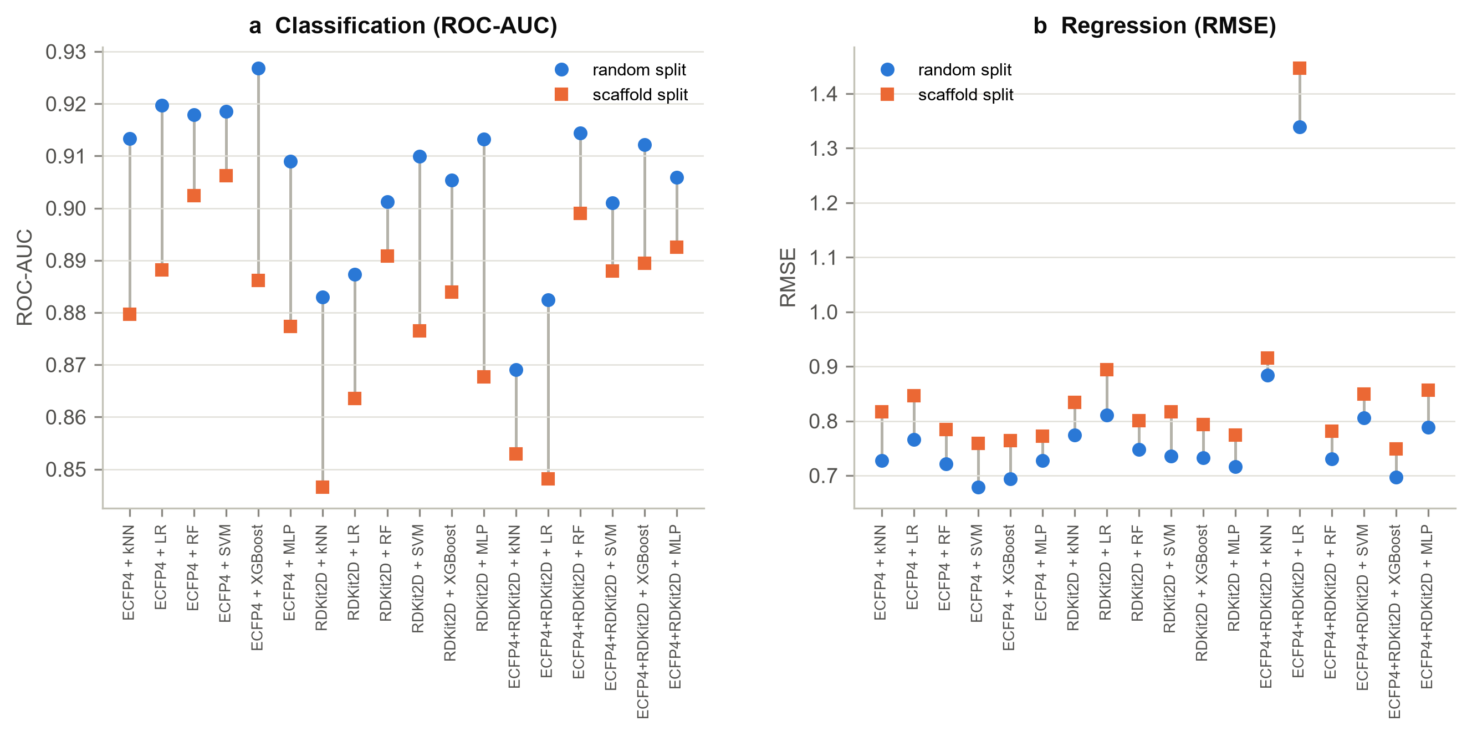
Figure 5. Paired comparison of random and scaffold splitting for identical models. Every configuration scores better under random splitting.
An average optimism of about 0.025 ROC-AUC may look modest, but it is the difference between a model that appears to generalise to new chemotypes and one that is partly memorising a congeneric series - and it is a lower bound, since the scaffold split still leaves considerable similarity between subsets (mean maximum Tanimoto 0.71; only 6 per cent of scaffold-split test molecules fall below 0.5 similarity to their training set). Notably, the ranking of representations and models is largely preserved across protocols, so a random split misleads about absolute performance more than about relative merit. That distinction matters: comparative benchmarking on random splits is less harmful than using one to promise a collaborator a hit rate.

Hyperparameter tuning returns little at this data scale
Random search over 20 configurations per model, task and seed produced a mean change of -0.0001 ROC-AUC for classification, improving only 2 of 6 model families, and +0.0066 RMSE for regression, improving 4 of 6 (Figure 6, Table 3). The SVM was the clear beneficiary on both tasks; several other families were slightly worse after tuning.
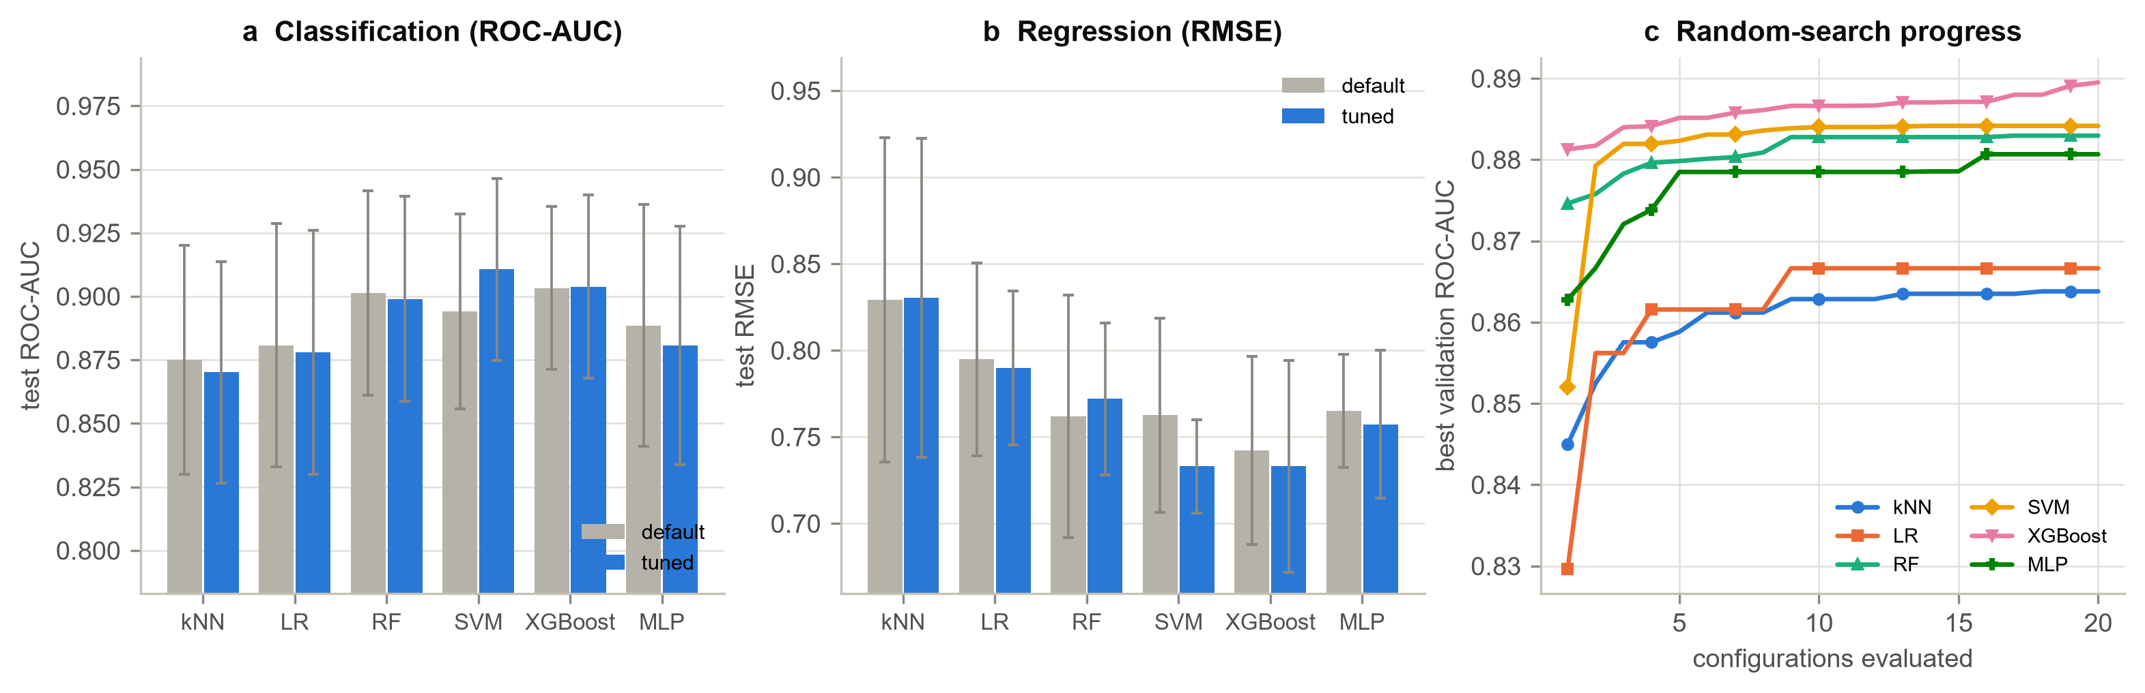
Figure 6. Effect of random-search hyperparameter optimisation. (a, b) Default against tuned performance per model family. (c) Best validation ROC-AUC against the number of configurations evaluated.
Table 3. Effect of hyperparameter tuning on classification, per model family.
model | representation | default ROC AUC | tuned ROC AUC | delta
kNN | ECFP4 | 0.880 ± 0.039 | 0.870 ± 0.044 | -0.01
LR | ECFP4 | 0.888 ± 0.046 | 0.878 ± 0.048 | -0.01
RF | ECFP4 | 0.902 ± 0.029 | 0.899 ± 0.040 | -0.003
SVM | ECFP4 | 0.906 ± 0.027 | 0.911 ± 0.036 | 0.004
XGBoost | AtomPair | 0.903 ± 0.032 | 0.904 ± 0.036 | 0.0
MLP | ECFP4+RDKit2D | 0.893 ± 0.049 | 0.881 ± 0.047 | -0.012

This is a real and instructive result rather than a failed experiment. With about 1,200 training molecules the validation split holds roughly 150, so a validation ROC-AUC is itself uncertain to a few hundredths; selecting the best of twenty configurations on such a noisy signal captures validation noise as readily as genuine improvement, and the gain does not transfer to test. Panel (c) of Figure 6 shows validation scores still creeping upward as configurations accumulate while test performance does not follow. The lesson for small-data QSAR is that sensible defaults plus honest evaluation beat aggressive tuning on a small validation set, and that tuning budget is better spent on nested cross-validation if it is to be spent at all. Table 4 reports the same comparison for regression, where the pattern is milder but the conclusion unchanged.
Table 4. Effect of hyperparameter tuning on regression, per model family.
model | representation | default RMSE | tuned RMSE | delta
kNN | FCFP4 | 0.813 ± 0.086 | 0.830 ± 0.092 | -0.017
LR | FCFP4 | 0.795 ± 0.056 | 0.790 ± 0.044 | 0.005
RF | AtomPair | 0.759 ± 0.047 | 0.772 ± 0.044 | -0.013
SVM | ECFP4 | 0.759 ± 0.073 | 0.733 ± 0.027 | 0.026
XGBoost | AtomPair | 0.742 ± 0.054 | 0.733 ± 0.061 | 0.009
MLP | FCFP4 | 0.765 ± 0.033 | 0.757 ± 0.043 | 0.008

Figure 7 shows the behaviour behind these aggregate numbers for one scaffold-split seed. The ROC curves of the leading models are nearly superimposed over most of the operating range and separate mainly at low false-positive rates - the region a screening campaign actually uses - while the predicted-against-measured plot for the best regression model shows errors distributed evenly about the diagonal with the majority of molecules inside one log unit, and no systematic compression towards the mean. The residual structure that remains is concentrated among the most potent compounds, which are under-predicted: a familiar consequence of a training set in which high-potency examples are the minority.
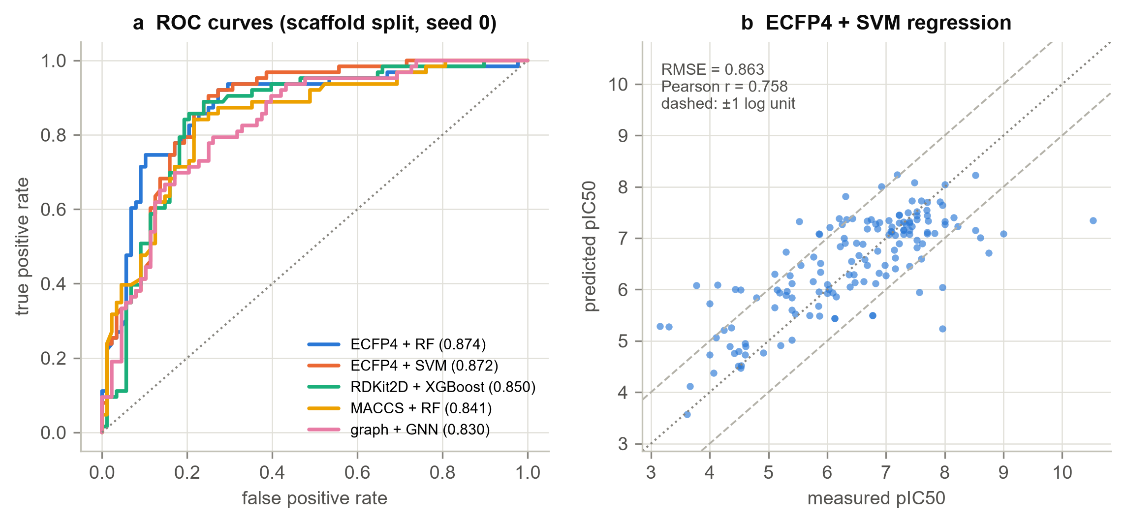
Figure 7. (a) ROC curves for representative models on one scaffold-split seed. (b) Predicted against measured pIC50 for the best regression model.

The graph neural network does not beat fingerprints at this scale (RQ3)
The GINE-style network reached ROC-AUC 0.870 (SD 0.041) for classification and RMSE 0.817 (SD 0.057) for regression on scaffold-split test sets, converging in 64 epochs on average. Both fall short of the best fixed-representation models (0.906 ROC-AUC for ECFP4 + SVM, 0.742 RMSE for AtomPair + XGBoost), by 0.036 ROC-AUC and 0.075 log units respectively. The result is consistent across seeds rather than driven by one bad run, and it agrees with Yang et al. (2019) and Jiang et al. (2021): learned representations need more data than this to repay their flexibility. Augmenting the graph network with RDKit descriptors at the readout recovered a substantial part of the regression gap (RMSE 0.760 against 0.817), which suggests the network struggles to infer bulk physicochemical properties from topology alone - exactly the information descriptors supply directly.
The ablations (Figure 8, Table 5 and Table 6) decompose this behaviour. Depth follows the expected inverted-U: performance improves from one layer (0.843) to three (0.870) and then degrades at five (0.843), the classic over-smoothing pattern in which repeated aggregation makes atom embeddings converge towards one another. The concatenated sum/mean/max readout beat every single pooling function on both tasks, confirming that different aggregations capture complementary aspects of molecular size and composition. Removing stereochemistry cost 0.026 ROC-AUC, which is chemically sensible for a dataset of aspartyl-protease inhibitors whose binding depends on the configuration of hydroxyethylamine transition-state isosteres. Removing bond features cost almost nothing (0.868 against 0.870), implying that for these molecules bond type is largely recoverable from the atom features and connectivity already supplied.
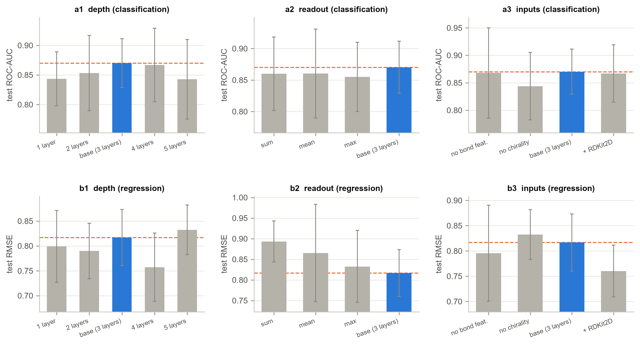
Figure 8. Graph neural network ablations on scaffold-split test sets. The dashed line marks the base configuration.
Table 5. Graph neural network and its ablations, classification.
model | ROC AUC | PR AUC | MCC | F1 | BACC
1 layer | 0.843 ± 0.046 | 0.761 ± 0.048 | 0.536 ± 0.072 | 0.727 ± 0.060 | 0.758 ± 0.056
2 layers | 0.853 ± 0.063 | 0.795 ± 0.069 | 0.556 ± 0.131 | 0.731 ± 0.098 | 0.779 ± 0.077
4 layers | 0.867 ± 0.062 | 0.809 ± 0.076 | 0.560 ± 0.114 | 0.749 ± 0.060 | 0.782 ± 0.069
5 layers | 0.843 ± 0.067 | 0.773 ± 0.089 | 0.554 ± 0.096 | 0.744 ± 0.065 | 0.783 ± 0.048
GNN (base) | 0.870 ± 0.041 | 0.807 ± 0.066 | 0.572 ± 0.076 | 0.753 ± 0.049 | 0.789 ± 0.043
GNN + RDKit2D | 0.867 ± 0.052 | 0.804 ± 0.067 | 0.572 ± 0.115 | 0.754 ± 0.071 | 0.792 ± 0.060
max readout | 0.855 ± 0.055 | 0.787 ± 0.070 | 0.505 ± 0.144 | 0.717 ± 0.084 | 0.752 ± 0.079
mean readout | 0.860 ± 0.071 | 0.768 ± 0.082 | 0.550 ± 0.177 | 0.719 ± 0.130 | 0.779 ± 0.098
no bond features | 0.868 ± 0.082 | 0.805 ± 0.110 | 0.618 ± 0.123 | 0.784 ± 0.068 | 0.812 ± 0.063
no chirality | 0.844 ± 0.061 | 0.770 ± 0.078 | 0.555 ± 0.107 | 0.732 ± 0.079 | 0.778 ± 0.058
sum readout | 0.860 ± 0.058 | 0.804 ± 0.075 | 0.570 ± 0.089 | 0.741 ± 0.063 | 0.784 ± 0.051

Table 6. Graph neural network and its ablations, regression.
model | RMSE | MAE | R2 | Spearman
1 layer | 0.799 ± 0.072 | 0.629 ± 0.070 | 0.639 ± 0.071 | 0.781 ± 0.052
2 layers | 0.790 ± 0.056 | 0.615 ± 0.038 | 0.647 ± 0.059 | 0.788 ± 0.044
4 layers | 0.757 ± 0.069 | 0.582 ± 0.049 | 0.675 ± 0.068 | 0.819 ± 0.059
5 layers | 0.832 ± 0.050 | 0.633 ± 0.044 | 0.609 ± 0.058 | 0.793 ± 0.046
GNN (base) | 0.817 ± 0.057 | 0.641 ± 0.043 | 0.623 ± 0.062 | 0.780 ± 0.056
GNN + RDKit2D | 0.760 ± 0.051 | 0.579 ± 0.046 | 0.674 ± 0.050 | 0.808 ± 0.043
max readout | 0.832 ± 0.087 | 0.654 ± 0.053 | 0.605 ± 0.097 | 0.767 ± 0.072
mean readout | 0.865 ± 0.118 | 0.670 ± 0.097 | 0.571 ± 0.129 | 0.745 ± 0.090
no bond features | 0.795 ± 0.095 | 0.618 ± 0.067 | 0.639 ± 0.087 | 0.800 ± 0.059
no chirality | 0.832 ± 0.049 | 0.643 ± 0.046 | 0.609 ± 0.060 | 0.804 ± 0.038
sum readout | 0.893 ± 0.050 | 0.691 ± 0.036 | 0.550 ± 0.059 | 0.756 ± 0.061

The GNN was also the model most helped by an easier evaluation protocol: its random-split ROC-AUC of 0.907 exceeds its scaffold-split score by 0.037, a larger gap than most fingerprint models showed. A flexible model with many parameters exploits near analogues more readily than a constrained one, so the protocol choice matters most precisely for the models whose capacity is greatest.

Ensembling, interpretation and applicability domain (RQ4)
Members of different model families make partly independent errors, so averaging them should help. Candidates were the tuned classical models plus the two graph networks; members were added greedily in order of validation score and the ensemble size that maximised the validation score was carried to the test set, so the composition uses no test information. The result differs sharply between tasks. For classification the ensemble reached ROC-AUC 0.906 (SD 0.039) from 2.8 members on average, which does not improve on the best single tuned model (SVM at 0.911). For regression it reached RMSE 0.707 (SD 0.047), the best result obtained in this project and an improvement of 0.026 log units over the best single model (XGBoost at 0.733). The members selected most often for regression were XGBoost (AtomPair), MLP (FCFP4), GNN + RDKit2D (graph), spanning boosted trees, a neural network on fingerprints and a descriptor-augmented graph network - genuinely different inductive biases, which is the condition under which averaging pays. Figure 12 places every final configuration side by side.
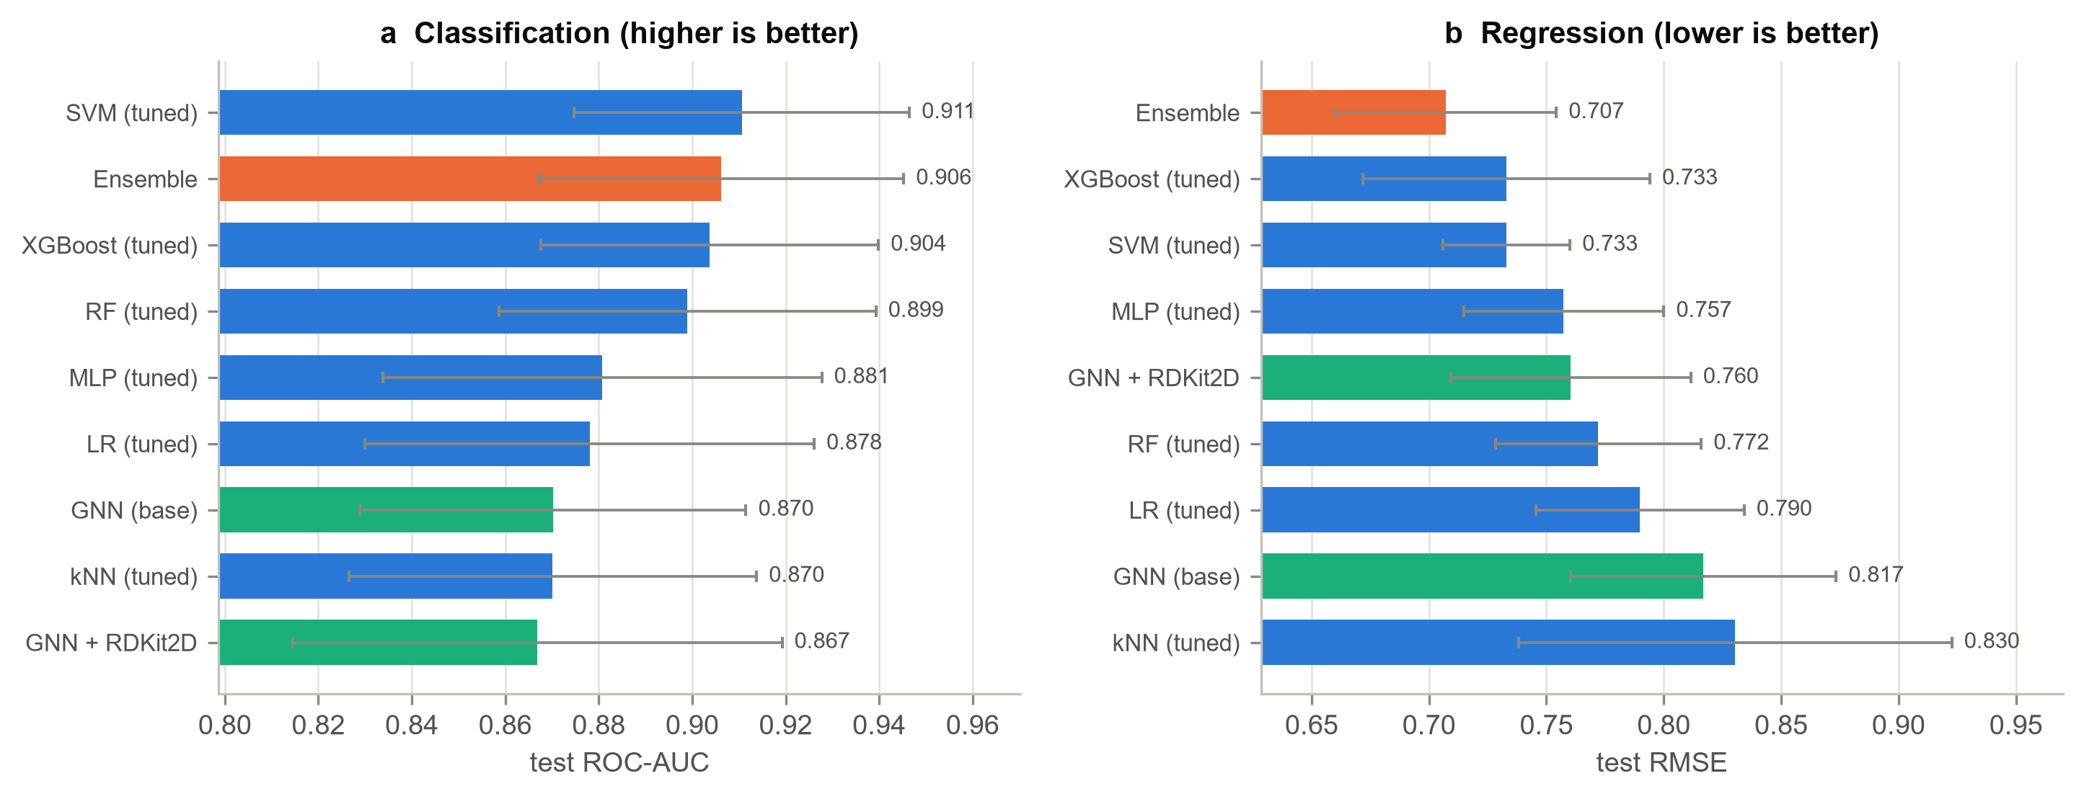
Figure 9. Final comparison of the best configuration from each model family, the graph neural network and the ensemble, on scaffold-split test sets.
The contrast between the two tasks is itself informative. Classification scores are bounded above by label noise near the activity threshold - a compound at pIC50 6.9 and one at 7.1 are chemically indistinguishable but carry opposite labels - so averaging several models that already agree on the easy cases cannot help. Regression has no such ceiling, and the members disagree in ways that partly cancel, which is the condition under which ensembling works. The greedy selection also exposes the same small-validation problem seen in tuning: on two seeds it stopped after a single member, because no addition improved a validation score computed on 151 molecules.
Interpretation was performed on a random forest over ECFP4, chosen because it is both competitive and directly explainable. SHAP values over the test set identify which fingerprint bits drive predictions, and because each bit corresponds to a concrete circular substructure, the explanation is chemically legible (Figure 9). The bits that most raise the predicted probability of activity are fluorinated and aromatic-nitrogen environments characteristic of the later, optimised BACE-1 chemotypes, while bits that lower it correspond to simple aliphatic amine and chloro-aromatic environments typical of the earlier, weaker compounds. A notable asymmetry is that bit presence is far more informative than bit absence: among the most influential bits, presence consistently shifts the prediction, which follows from fingerprints encoding the presence of substructures rather than their absence. Figure 10 projects the same analysis onto individual atoms by measuring how much deleting each atom's bits changes the prediction, producing the kind of per-atom map a medicinal chemist can read directly.
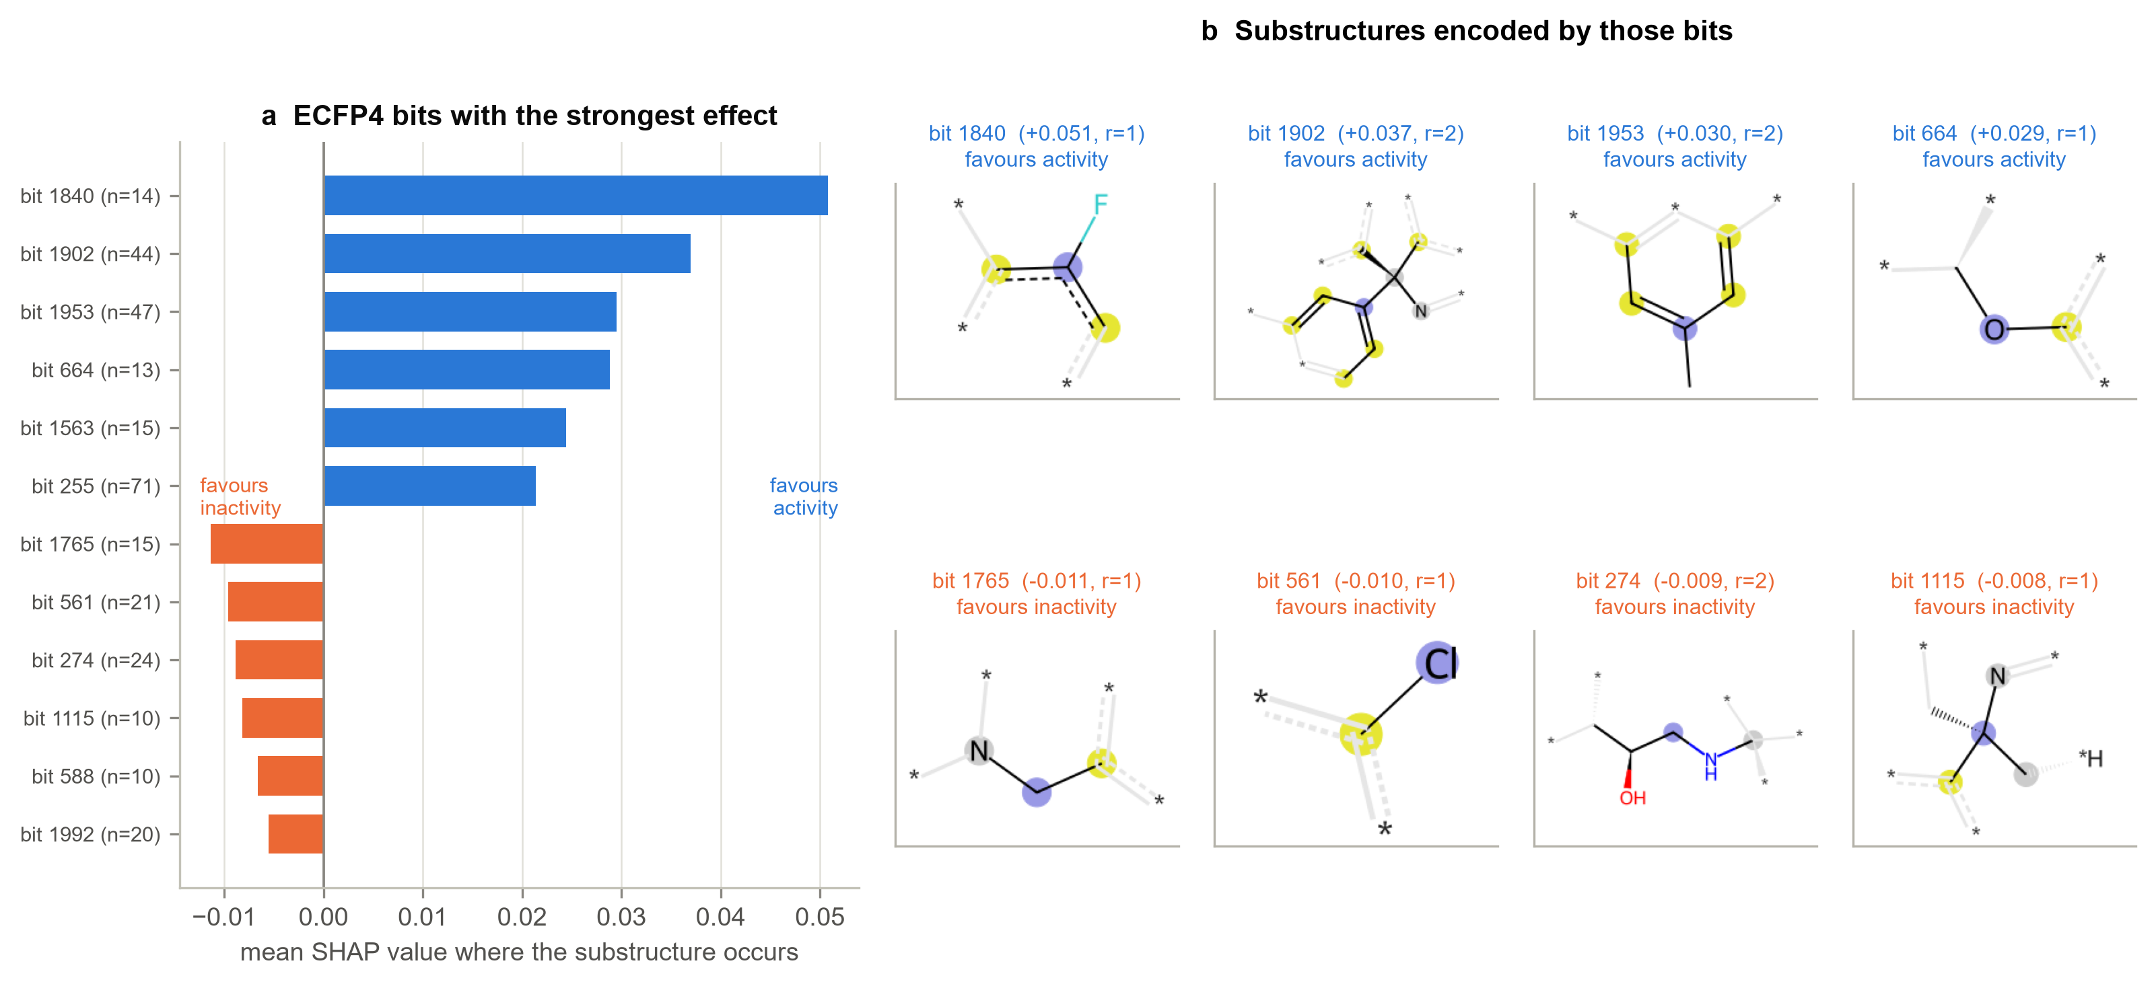
Figure 10. SHAP attribution over ECFP4 bits for a random forest classifier. (a) Bits with the strongest mean effect where the substructure occurs. (b) The circular environments those bits encode.
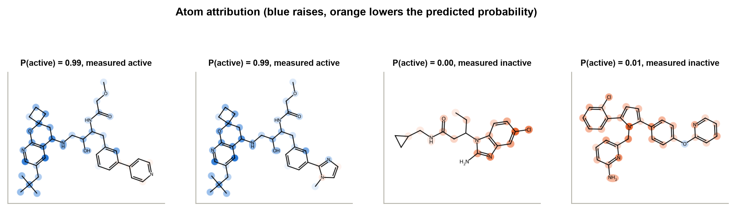
Figure 11. Atom-level attribution for confidently predicted test molecules, measured as the change in predicted probability when each atom's fingerprint bits are removed.
The applicability-domain analysis (Figure 11) is the most practically consequential result. Binning test molecules by their maximum Tanimoto similarity to the training set shows classification accuracy rising monotonically from 67 per cent for the least similar molecules to 88 per cent for the most similar, and regression RMSE falling from 1.41 to 0.60 log units across the same range. A single aggregate score therefore conceals a factor-of-two difference in reliability between familiar and unfamiliar chemistry. Encouragingly, the model's own confidence tracks this: retaining only the most confident 10 per cent of predictions raises accuracy from 83 to 97 per cent, and the enrichment factor in the top 5 per cent of the ranked list is 2.40. For a screening campaign this means a usable triage rule: trust confident predictions on familiar chemistry, and treat a prediction for a novel scaffold as a hypothesis to be tested rather than a result.
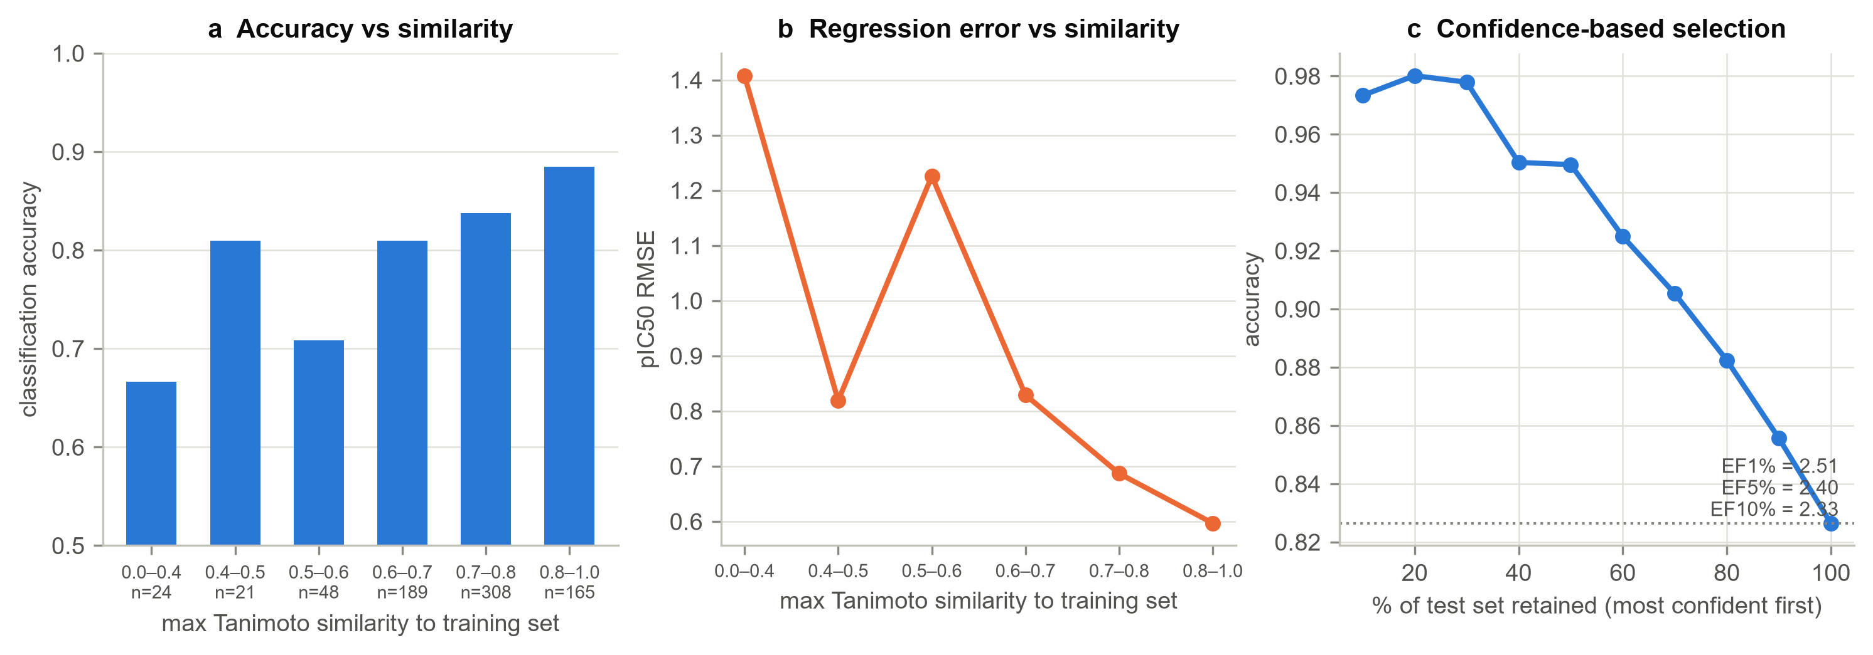
Figure 12. Applicability domain. (a, b) Accuracy and error against maximum Tanimoto similarity to the training set. (c) Accuracy when only the most confident predictions are retained.

Strengths, limitations and future work
The main strength of this study is control. A single target, one curation pipeline, one set of split indices and five seeds throughout mean the comparisons are like-for-like, and every selection decision was made on validation data, so the test estimates are honest. The pipeline is cached end to end and fully seeded, so the numbers reported here reproduce exactly.
Several limitations bound the conclusions. The dataset is a single congeneric-rich series of 1,512 molecules from one target, so conclusions about representation dominance may not transfer to diverse screening libraries or to larger datasets where graph models are known to improve. The activity labels aggregate IC50 values measured in different laboratories and assay formats, which places an irreducible floor of perhaps 0.3-0.5 log units on achievable RMSE - the best models here, at roughly 0.73, are within a factor of two of that floor. Only 2D information is used: no conformers, no docking scores, no structural information about the BACE-1 active site, even though a crystal structure is available. Finally, the GNN was trained from scratch on 1,200 molecules, which is the regime least favourable to it.
Three extensions follow directly. Pre-training the graph network on a large unlabelled corpus and fine-tuning on BACE would test whether the data-scale explanation for its performance is correct. Adding structure-based features - docking scores against the BACE-1 crystal structure, or interaction fingerprints - would test whether 3D information adds anything beyond 2D topology. And a prospective evaluation on compounds published after the dataset was assembled, a time split rather than a scaffold split, would give the most honest estimate of what such a model delivers in practice.

Conclusions
This project benchmarked 6 molecular representations against 6 model families and a graph neural network for BACE-1 inhibitor prediction, under two evaluation protocols and across five seeds. The best configurations reached ROC-AUC 0.906 for activity classification (ECFP4 + SVM) and RMSE 0.742 log units for pIC50 regression (AtomPair + XGBoost) on scaffold-split test sets, comparable to published results on this dataset.
Four findings answer the research questions. On RQ1, the choice of molecular representation accounted for a comparable or larger share of performance variation than the choice of model family (0.039 versus 0.029 ROC-AUC between best and worst), with circular and atom-pair fingerprints consistently ahead of MACCS keys, and naive concatenation of fingerprints with descriptors offering no benefit. On RQ2, random splitting was optimistic for every one of the 18 configurations tested, by 0.025 ROC-AUC and 0.065 RMSE on average, although the relative ranking of methods survived the change of protocol.
On RQ3, the graph neural network reached ROC-AUC 0.870 (SD 0.041), which does not beat the best fingerprint model at this data scale; the ablations showed the architecture behaving sensibly but confirmed that roughly 1,200 training molecules are too few for a representation learned from scratch to overtake one designed by chemists.
On RQ4, hyperparameter tuning and ensembling delivered marginal gains that were largely absorbed by the noise of a 150-molecule validation set, whereas the applicability-domain analysis was decisive: accuracy varied from 67 to 88 per cent and RMSE from 1.41 to 0.60 log units depending on how close a test molecule sat to the training data, and model confidence tracked that variation closely enough to be used as a triage rule.
Taken together, the results support a conservative recommendation for small-data QSAR of this kind: invest in the representation and in an honest, scaffold-aware evaluation protocol before investing in model capacity or tuning budget, and report an applicability domain alongside any aggregate metric, since the aggregate alone conceals where the model can and cannot be trusted. All code, cached splits, per-molecule predictions and figure-generation scripts are available at the repository linked below, and the entire pipeline reproduces from a single sequence of commands.
Source code: https://github.com/ljyhh0826-coder/AIDD8122-BACE1-ML

References
[1] Bemis, G. W.; Murcko, M. A. The Properties of Known Drugs. 1. Molecular Frameworks. J. Med. Chem. 1996, 39 (15), 2887-2893.
[2] Duvenaud, D.; Maclaurin, D.; Aguilera-Iparraguirre, J.; Gomez-Bombarelli, R.; Hirzel, T.; Aspuru-Guzik, A.; Adams, R. P. Convolutional Networks on Graphs for Learning Molecular Fingerprints. Adv. Neural Inf. Process. Syst. 2015, 28, 2224-2232.
[3] Gilmer, J.; Schoenholz, S. S.; Riley, P. F.; Vinyals, O.; Dahl, G. E. Neural Message Passing for Quantum Chemistry. Proc. 34th Int. Conf. Mach. Learn. 2017, 70, 1263-1272.
[4] Hu, W.; Liu, B.; Gomes, J.; Zitnik, M.; Liang, P.; Pande, V.; Leskovec, J. Strategies for Pre-Training Graph Neural Networks. Int. Conf. Learn. Represent. 2020.
[5] Jiang, D.; Wu, Z.; Hsieh, C.-Y.; Chen, G.; Liao, B.; Wang, Z.; Shen, C.; Cao, D.; Wu, J.; Hou, T. Could Graph Neural Networks Learn Better Molecular Representation for Drug Discovery? A Comparison Study of Descriptor-Based and Graph-Based Models. J. Cheminform. 2021, 13 (1), 12.
[6] Lundberg, S. M.; Lee, S.-I. A Unified Approach to Interpreting Model Predictions. Adv. Neural Inf. Process. Syst. 2017, 30, 4765-4774.
[7] Rogers, D.; Hahn, M. Extended-Connectivity Fingerprints. J. Chem. Inf. Model. 2010, 50 (5), 742-754.
[8] Sheridan, R. P. Time-Split Cross-Validation as a Method for Estimating the Goodness of Prospective Prediction. J. Chem. Inf. Model. 2013, 53 (4), 783-790.
[9] Subramanian, G.; Ramsundar, B.; Pande, V.; Denny, R. A. Computational Modeling of beta-Secretase 1 (BACE-1) Inhibitors Using Ligand Based Approaches. J. Chem. Inf. Model. 2016, 56 (10), 1936-1949.
[10] Tropsha, A. Best Practices for QSAR Model Development, Validation, and Exploitation. Mol. Inform. 2010, 29 (6-7), 476-488.
[11] van Tilborg, D.; Alenicheva, A.; Grisoni, F. Exposing the Limitations of Molecular Machine Learning with Activity Cliffs. J. Chem. Inf. Model. 2022, 62 (23), 5938-5951.
[12] Vassar, R.; Bennett, B. D.; Babu-Khan, S.; Kahn, S.; Mendiaz, E. A.; Denis, P.; et al. beta-Secretase Cleavage of Alzheimer's Amyloid Precursor Protein by the Transmembrane Aspartic Protease BACE. Science 1999, 286 (5440), 735-741.
[13] Wu, Z.; Ramsundar, B.; Feinberg, E. N.; Gomes, J.; Geniesse, C.; Pappu, A. S.; Leswing, K.; Pande, V. MoleculeNet: A Benchmark for Molecular Machine Learning. Chem. Sci. 2018, 9 (2), 513-530.
[14] Xu, K.; Hu, W.; Leskovec, J.; Jegelka, S. How Powerful Are Graph Neural Networks? Int. Conf. Learn. Represent. 2019.
[15] Yang, K.; Swanson, K.; Jin, W.; Coley, C.; Eiden, P.; Gao, H.; et al. Analyzing Learned Molecular Representations for Property Prediction. J. Chem. Inf. Model. 2019, 59 (8), 3370-3388.

