**Getting Started - Chapter 1 - Enhancing Your Website**

**@@启程-第一章-增强你的网站@@**

**First Model on a Web Page.**

**@@网页上的第一个模型@@**

Provided the file type is one recognized by Babylon.js then you can use the Babylon.js [Viewer](https://doc.babylonjs.com/extensions/babylonViewer) to display your scene or model on a web page using the *<babylon>* element. Examples of suitable file types are *.babylon*, *.gltf* and *glb* with *.glb* recommended. It makes no difference whether the scene was built with Babylon.js or created with your favorite design software. The *<babylon>* element will be sized to fit its container.

@@如果模型文件是Babylon.js能够识别的类型，那么你可以使用Babylon.js的“观察器”在网页中显示你的场景或模型，只需使用<babylon>标签即可。可用的文件类型包括.babylon、.gltf以及推荐的.glb等。无论这个场景是通过Babylon.js的代码构建还是通过你最喜欢的设计软件构建都没有使用上的差别。<babylon>标签将自动适应它的容器标签。@@

In order to use the Viewer you need to add its code to your HTML page in a *<script>* element

@@要使用这个观察器，你需要将这段代码添加到你的HTML页面的<script>标签中@@

<script src="https://cdn.babylonjs.com/viewer/babylon.viewer.js"></script>

Once this is added you place the *<babylon>* element in an appropriate container and points its *model* attribute to the file source.

@@以上代码添加完毕之后，你就可以将<babylon>标签放在合适的容器中，然后把它的“模型”属性指向文件源。@@

<babylon model="Path to File"></babylon>

[Example Web Page](https://doc.babylonjs.com/webpages/page1.html) 示例网页

<https://doc.babylonjs.com/webpages/page1>

（译者注：示例网页没有再引入，babylon.js库，可见观察器库包含了babylon.js主库）

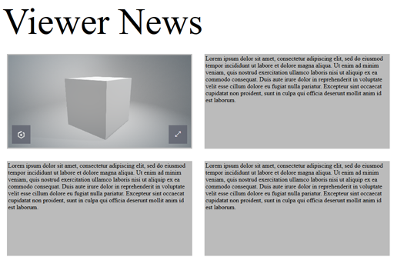

When you want to use your models for a game or application on a web page you need first to know how to import them.

@@如果你想在一个网页游戏或应用中使用你的模型，你首先要知道如何导入它们。@@