**Getting Started - Chapter 2 – Ground**

**@@启程-第二章-地面@@**

**Grounding the World**

**@@为世界创造大地@@**

At the moment we have a box floating in space. To make the scene more world like let's add ground and think of our box as a building set on the ground.

@@在我们拥有了一个漂浮在空中的盒子之后，为了让这个场景看起来更像一个真实的世界，让我们添加大地，并且想象这个盒子是大地上的一座建筑。@@

Adding a ground is simple using

@@使用以下代码可以容易地添加地面@@

const ground = BABYLON.MeshBuilder.CreateGround("ground", {width:10, height:10});

As we need to create a ground large enough, to put some buildings (boxes) on, the options parameter has two properties set, width in the x direction and height in the z direction. (Yes, we agree, since y is vertical it would make more sense for the properties to be width and depth.)

@@因为我们要建立足够大的大地，来放置一些建筑（盒子网格），我们需要为选项参数设置两个属性，其中width属性是x方向的尺寸，height属性是z方向的尺寸。（是的，我们承认，考虑到y才是垂直的坐标轴，可能把这两个属性叫做width和depth更合适）（译者注：其实也没什么不合适的，从俯视的角度看，这不就是二维地图的宽和高嘛）@@

Adding a Ground Playground

添加地面的训练场例子

https://playground.babylonjs.com/#KBS9I5#67

The immediate thing to note is that the ground cuts through the middle of the box. This is because when they are created meshes are positioned at the origin.

@@最需要注意的是，默认的地面穿过了默认盒子网格的中心。这是因为所有默认网格都定位在坐标原点@@

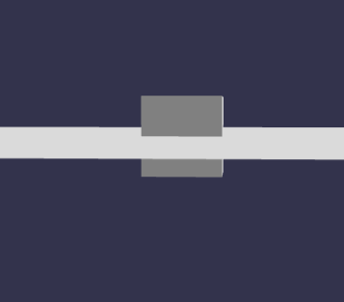

We need to move the box up half its height using

@@我们要用以下方法把盒子网格上移它高度的一半@@

box.position.y = 0.5; //box created with default size so height is 1 盒子网格是用默认属性建立的，所以高度是1

Adjusting the Box position.

调整盒子的位置

https://playground.babylonjs.com/#KBS9I5#66

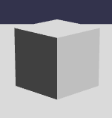

Currently our world is silent. Let's add some sound.

@@现在我们的世界是寂静无声的，接下来让我们添加一些声音@@