**Getting Started - Chapter 2 - Making Copies**

**@@启程-第二章-建立复制体@@**

**Copying Meshes**

**@@复制网格@@**

The two main ways to copy a mesh is to clone it or create an instance of it. Cloning gives you an independent copy of a mesh whereas an instance is still linked to the original for its material. You cannot change the material of an instance of a mesh. There are also advanced ways of creating copies which are available in the *Mesh Chapter*

@@复制网格的两种主流方法是“克隆”和“建立网格实例”。克隆能够为你提供一个不受限制的网格复制体，而实例的材质则仍然和复制源相连。你不能单独修改网格的实例的材质。在“网格的章节”还有更高端的创造复制体的方法。@@

To clone the house use

@@使用以下方法克隆房子（参数是复制体的名字）@@

clonedHouse = house.clone("clonedHouse")

and for an instance it is

@@以下则是建立实例的方法@@

instanceHouse = house.createInstance("instanceHouse")

As at this point in our world all the houses will use the same material we will go with *createInstance*.

@@此时我们世界中的所有房子都使用相同的材质，所以我们将使用“*createInstance*”方法@@

Before we do that we combine the building functions to produce a house of width 1 or 2, a detached or semi-detached house respectively.

@@在创建网格实例之前，我们先分别封装好建立单体和双体房子的两个方法@@

Expanding the House Building Function

扩展建房方法

[https://playground.babylonjs.com/#KBS9I5#77](https://playground.babylonjs.com/#77)

We now enlarge the ground and increase the camera radius a little to fit several house on and be able to view them. To begin with we build one house of each type position them. After we will create instances of these for the remaining houses. After deciding on the type, position and orientation for the other houses we will use a loop to create the them.

@@现在我们把地面扩大一点，把相机拉远一些，以便观察多个房子。首先我们每一种房子各建一座，并且把它们放置好，然后我们建立它们的实例以生成其他的房子。在计划好其他房子的类型、位置和朝向之后，我们用一个循环来建立它们。@@

const houses = [];

for (let i = 0; i < places.length; i++) {

if (places[i][0] === 1) {

houses[i] = detached_house.createInstance("house" + i);

}

else {

houses[i] = semi_house.createInstance("house" + i);

}

houses[i].rotation.y = places[i][1];

houses[i].position.x = places[i][2];

houses[i].position.z = places[i][3];

}

Creating Multiple House Instances

建立多座房屋的示例

https://playground.babylonjs.com/#KBS9I5#78

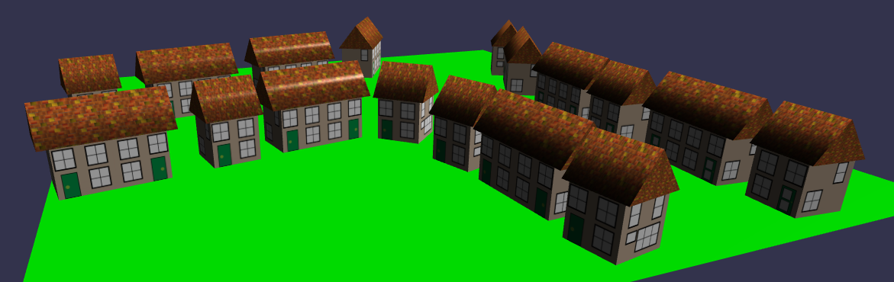

As before, in order to keep the upper parts of the playground editor for newer code we will put the building of these houses into a function.

@@和前面一样，为了把训练场编辑器的上半部分留给新的代码，我们把这些房子建造代码封装成一个函数：@@

Wrapping Instances Into a Function

把生成实例的代码封装为函数

https://playground.babylonjs.com/#KBS9I5#79

Now the world we are building is a little more complex let's take a file of the village and re-visit viewing it as part of a web site we want to enhance.

@@现在我们正在建造的世界变得更加复杂了，让我们把这个村庄保存为一个模型文件，然后把它作为一个网站的一部分来浏览。@@

Importing the Village as a .glb File

以.glb格式导入这个村庄

https://playground.babylonjs.com/#KBS9I5#80