**Getting Started - Chapter 8 - Have a Look Around**

**@@启程-第八章-四处看看@@**

**Have a Look Around**

**@@四处看看@@**

Currently we are using the *ArcRotateCamera* which has us orbiting the village world from a distance. How about a view from inside the village? Let's parent the camera to the character walking around the village and with a few adjustments to values look around from over his shoulder. The creation of the *ArcRotateCamera* has this form,

@@目前我们使用的是“弧形旋转相机”，这种相机能在村庄的一定范围之外，环绕观察世界。那么一个从村庄内出发的视角是什么样呢？让我们把绕村庄移动的角色设置为弧形旋转相机的父元素，然后通过一些调整，越过他的肩部观察这个村庄。弧形旋转相机的构造函数格式如下：@@

const camera = new BABYLON.ArcRotateCamera("name", alpha angle, beta angle, radius, target position);

As will all cameras in order to move it in response to user input we need to attach it to the canvas.

@@与所有相机一样，为了让它根据用户输入而移动，我们需要把它和画布标签绑定起来。@@

camera.attachControl(canvas, true);

Think of this camera as one orbiting its target position, or more imaginatively as a spy satellite orbiting the earth. Its position relative to the target (earth) can be set by three parameters, *alpha* (radians) the longitudinal rotation, *beta* (radians) the latitudinal rotation and *radius* the distance from the target position.

@@想象一下相机是环绕着它的目标点旋转的事物，或者更形象的——一颗环绕地球旋转的间谍卫星。它相对于目标点（地球）的位置可以通过三个参数设置：alpha（弧度）表示纵向的旋转，beta（弧度）表示沿水平圆弧的旋转（也就是说纵向旋转并不会导致水平旋转转轴得倾斜），以及半径表示相机到目标点的距离。@@

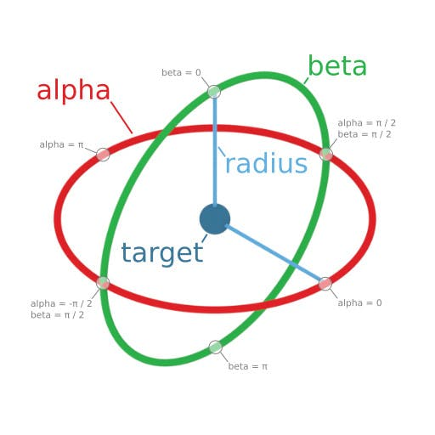

In our case we want to have the camera parented to the character

@@在我们的例子中，我们希望把角色作为相机的父元素。@@

camera.parent = dude;

and, because the dude is scaled in size we use a large radius which as parented to the dude will be scaled down. To track him we use

@@还有，因为这个老哥模型在尺寸上进行了缩放，所以我们要使用一个更大的半径参数，因为这个参数将在相机成为模型的子元素后也会被缩放变小。我们用如下方法追踪他：@@

const camera = new BABYLON.ArcRotateCamera("camera", Math.PI / 2, Math.PI / 2.5, 150, new BABYLON.Vector3(0, 60, 0));

Since the character makes instant turns the camera also does. To make the viewing smoother a smoother track for the character to follow would be needed.

@@因为当角色急转弯时相机也会转向。为了使视角转变更平滑，我们还需要让角色的行动轨迹更平滑一些。@@

Over The Shoulder

越肩

https://playground.babylonjs.com/#KBS9I5#97

We can also use a different type of camera to follow the character another way.

@@我们还可以用另一种相机以另一种方式跟随角色。@@