Report on Information Communication Technology (ICT)

M H B N Ariyaratne
251012
Bachelor of Medicine, Bachelor of Surgery
MED1151 Information Technology for Healthcare
Faculty of Medicine, Wayamba University of Sri Lanka
Dr. Gayan Chathuranga
2026

Table of Contents
Table of Contents ii
List of Figures iii
List of Tables iv
CHAPTER 1: INTRODUCTION TO DATA AND INFORMATION 1
1.1 DATA 1
1.2 INFORMATION 1
1.2.1 Key Differences Between Data and Information 2
CHAPTER 2: INFORMATION SYSTEMS 3
2.1 CORE COMPONENTS OF AN INFORMATION SYSTEM 3
2.2 ROLE OF INFORMATION SYSTEMS IN VARIOUS SECTORS 4
CHAPTER 3: INFORMATION AND COMMUNICATION TECHNOLOGY (ICT) 5
3.1 OVERVIEW OF ICT AND ITS SIGNIFICANCE 5
CHAPTER 4: APPLICATIONS OF ICT 7
4.1 E-GOVERNMENT 7
4.2 EDUCATION 8
4.3 HEALTH SECTOR 8
4.3.1 Use of ICT in Diagnosis 8
4.3.2 Telemedicine 12
CHAPTER 5: DEMERITS OF ICT 14
References 16

List of Figures

Figure 1: Data
Figure 2: Data visualization
Figure 3: Communication of information
Figure 4: Information
Figure 5: Information System
Figure 6: Components of an information system
Figure 7: Medical professional utilizing ICT
Figure 8: E-government
Figure 9: Use of ICT for governance
Figure 10: Digital resources for education
Figure 11: E-learning
Figure 12: ICT in healthcare
Figure 13: Use of ICT in the medical field
Figure 14: CAT Scanner
Figure 15: Patient being scanned with CAT machine
Figure 16: MRI Machine
Figure 17: Patient undergoing MRI scan
Figure 18: ECG Machine
Figure 19: Echocardiogram machine
Figure 20: Echocardiogram display
Figure 21: EEG Machine
Figure 22: EEG monitoring procedure
Figure 23: Glucometer
Figure 24: Blood pressure monitor

List of Tables

Table 1: Differences between data and information
Table 2: Key Significance of ICT
Table 3: Comparison of ICT Usage

CHAPTER 1: INTRODUCTION TO DATA AND INFORMATION

1.1 DATA
In ICT, data refers to raw, unorganized facts, figures, symbols, or observations (e.g., numbers, text, images, sounds) that have not yet been processed to reveal meaning. It acts as the fundamental, digital input for computer systems, processed into information to become useful, structured, or actionable.
Data is often considered the plural form (singular: datum) and is typically stored in binary format (0s and 1s) within computers. Raw data like "10082006" is meaningless until given context, such as a date format (10/08/2006).
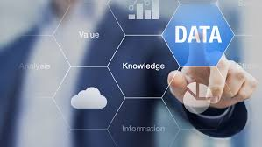 | 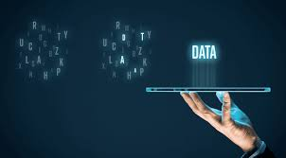
Figure 1: Data | Figure 2: Data visualization

Types of Data:
• Structured: Organized, such as spreadsheets or SQL databases.
• Unstructured: Unorganized, including video, audio, and social media posts.
• Numerical/Textual: Basic numbers, measurements, and strings.

1.2 INFORMATION
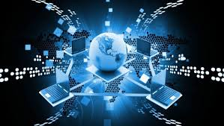 | 
Figure 3: Communication of information | Figure 4: Information

In Information and Communication Technology (ICT), information is defined as processed, organized, and structured data presented within a meaningful context. It is the result of applying computing power (hardware/software) and communication tools (networks, internet) to raw data, turning it into actionable knowledge for decision-making.
Key aspects of information in ICT include:
• Data Transformation: Data (raw facts/figures) becomes information when it is analyzed, structured, or processed, adding meaning.
• Role in Communication: It is the content communicated, received, or stored via digital platforms like email, video conferencing, and internet systems.
• Contextual Utility: Information is used for decision-making, monitoring, and solving problems in various sectors, including business and government.
• Management: ICT provides the tools to collect, store, retrieve, and transmit this information efficiently.
Information can take many forms, including text, data, images, and voice.

1.2.1 Key Differences Between Data and Information
• Definition: Data represents basic, raw facts. Information is data with added meaning and context.
• Context: Data is unstructured and often without purpose. Information is structured, organized, and purposeful.
• Dependency: Data is independent (it can exist without being used). Information is dependent on data (it cannot exist without it).
• Usability: Raw data is not directly useful for decision-making. Information is critical for making decisions.
Examples:
Table 1: Differences between data and information
Scenario | Raw Data (Raw Facts) | Information (Processed Data)
Sales | 100, 150, -50, 200, -30 | "Total income is €450, total expenditure is €80, with a positive balance of €370".
Website | 1,000 visitors, 500 clicks | "60% of visitors came from organic search, indicating a strong SEO strategy".
Survey | "Yes", "No", "Yes", "Yes" | "75% of customers are satisfied with the service".
Weather | 20°C, 22°C, 19°C | "Average daily temperature is 20.3°C".
Classroom | A student list with grades 50, 90, 40, 80 | "Average grade is 65; 2 students passed and 2 failed."

CHAPTER 2: INFORMATION SYSTEMS
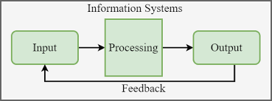
Figure 5: Information System
An information system (IS) is a formal, sociotechnical, organizational system designed to collect, process, store, and distribute information to support decision-making and operations. It integrates people, data, processes, and technology—specifically hardware and software—to convert raw data into valuable information, typically aiding in business workflows and communication.

2.1 CORE COMPONENTS OF AN INFORMATION SYSTEM
An information system consists of five main interdependent components:
• Hardware: The physical technology, including computers, servers, storage devices, and networking equipment.
• Software: The applications and operating systems that instruct the hardware to process data.
• Data: The raw facts, figures, and knowledge stored within databases and processed by the system.
• Procedures: The policies, rules, and steps for using the system, including how data is processed to generate results.
• People: The users, IT professionals, and managers who operate, maintain, and interact with the system.
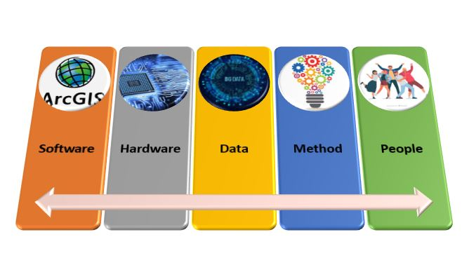
Figure 6: Components of an information system
Sometimes, networks are classified as a distinct component, covering the infrastructure (hubs, communication media) that connects hardware. These components function together to transform data into useful knowledge.

2.2 ROLE OF INFORMATION SYSTEMS IN VARIOUS SECTORS
Information systems (IS) are critical across all sectors for driving operational efficiency, automating routine tasks, and enabling data-driven decision-making, which reduces costs and enhances competitiveness. They integrate processes, improve communication, and optimize resource allocation in industries ranging from manufacturing to healthcare.
Key roles of information systems in various sectors include:
• Business & Retail: Point of Sale (POS) and Customer Relationship Management (CRM) systems track inventory, sales, and customer preferences, while ERP systems streamline supply chains.
• Healthcare: Electronic Health Records (EHR) improve patient care coordination, safety, and operational efficiency.
• Manufacturing: Manufacturing Execution Systems (MES) monitor production in real-time, reducing waste and optimizing material usage.
• Finance: Financial systems manage transactions, monitor market trends, and ensure regulatory compliance.
• Transportation & Logistics: Fleet management systems enhance route optimization, reducing fuel costs and improving delivery times.
• Government & Public Sector: Information systems manage citizen data, support policy formulation, and facilitate online service delivery.
• Education & Entertainment: Systems enable digital learning platforms, streaming services, and personalized content delivery.
Overall, these systems facilitate agility, allowing organizations to adapt quickly to market changes.

CHAPTER 3: INFORMATION AND COMMUNICATION TECHNOLOGY (ICT)

3.1 OVERVIEW OF ICT AND ITS SIGNIFICANCE
Information and Communication Technology (ICT) refers to the comprehensive, integrated network of technologies—including hardware, software, telecommunications, and the internet—used to create, store, process, and transmit digital information. It drives modern global infrastructure, enabling instant communication, remote work, data management, and automation across sectors like education, healthcare, and finance.

Figure 7: Medical professional utilizing ICT
Key Components of ICT include:
• Hardware: Servers, Computers, Laptops, Mobile Devices
• Software: Operating Systems, Applications, Databases
• Communication Technologies: Internet, Mobile Networks, Wireless Signals
• Data Management: Cloud Storage, Data Processing, Security Systems
Significance of ICT:
• Enhanced Communication and Connectivity: Facilitates real-time interaction through email, video calls, and social media, bridging global, geographical gaps.
• Business Transformation & Productivity: Drives automation, improves efficiency, and supports e-commerce, leading to significant cost reductions and new market opportunities.
• Educational Advancement: Enables distance learning (e-learning) and provides access to vast information resources for students and educators.
• Improved Healthcare: Supports telemedicine, remote diagnosis, and digital management of patient records for better care.
• Information Management & Storage: Provides robust tools for analyzing big data and securing information through cloud services and advanced software.
In essence, ICT is the backbone of the digital economy, crucial for everyday tasks and societal development.
Table 2: Key Significance of ICT
Area | Significance of ICT
Communication | Enables fast and reliable global communication
Business | Improves efficiency and supports digital commerce
Education | Facilitates online learning and access to resources
Healthcare | Supports remote care and digital record management
Data Management | Ensures efficient storage and processing of information

CHAPTER 4: APPLICATIONS OF ICT

4.1 E-GOVERNMENT
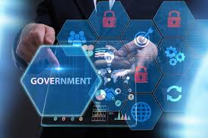 | 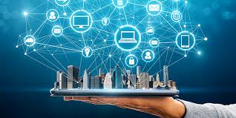
Figure 8: E-government | Figure 9: Use of ICT for governance

E-Government, or electronic government, refers to the use of Information and Communication Technologies (ICT) by government agencies to enhance the efficiency, transparency, and accessibility of public services. It transforms the relationship between citizens, businesses, and government, enabling 24/7 access to services and reducing the need for physical visits to government offices.
Governments leverage ICT tools like the internet, mobile apps, artificial intelligence, and databases to modernize administration and enhance service delivery in several ways:
• Automation of Public Services: Routine tasks and administrative processes are digitized to reduce paperwork and speed up service delivery.
• Single-Window Portals: Many governments provide a "single-window" principle, where numerous services from various state agencies are combined into one online portal for convenience.
• Digital Identity Management: Systems with biometric components are used to automatically generate documents and provide secure access to services.
• Interconnected Governance (G2G): ICT enables secure, high-speed data exchange between government departments, reducing, for example, the need for citizens to submit the same document to multiple agencies.
Examples of E-Government Services:
• Online Tax Filing & Payment: Citizens and businesses can calculate, file, and pay income or corporate taxes through secure online portals.
• E-Voting: Used to increase participation in elections by allowing citizens to vote remotely or via electronic poll sites.
• Digital Licensing and Registration: Services such as vehicle registration, driver’s license renewal, and company/freelancer registration can be completed online.
• E-Procurement: Governments use digital platforms to manage tenders and procurement, increasing transparency and reducing corruption.
• Electronic Land Records (eLand): Digitizing land deeds and titles allows for faster, more secure, and transparent property transactions.
• Online Health Services: Public services like booking doctor appointments and managing electronic health records.
• Police Services: Digital filing of First Information Reports (FIRs) and other reporting systems.

4.2 EDUCATION
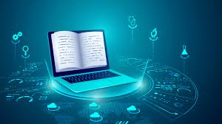 | 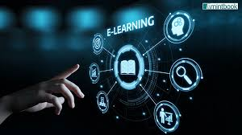
Figure 10: Digital resources for education | Figure 11: E-learning

Information and Communication Technology (ICT) in education acts as a transformative catalyst, enhancing learning through digital tools, online platforms, and virtual classrooms. It provides, personalized, accessible, and interactive experiences such as VR, smartboards, and AI tutors that break geographical barriers, promote digital literacy, and improve both student engagement and administrative efficiency.

4.3 HEALTH SECTOR
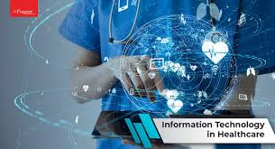 | 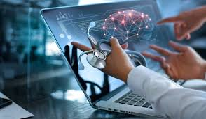
Figure 12: ICT in healthcare | Figure 13: Use of ICT in the medical field

4.3.1 Use of ICT in Diagnosis
ICT plays a critical role in modern medical diagnosis through advanced imaging and monitoring equipment. The following are key diagnostic machines that rely heavily on ICT:
1. CAT (Computed Axial Tomography) Scanner
A CAT scan uses X-rays taken from multiple angles, processed by a computer to create detailed cross-sectional images. The ICT component reconstructs 3D images from 2D X-ray slices using complex algorithms. Used to detect tumours, internal bleeding, bone fractures, and organ damage.
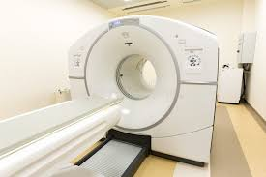 | 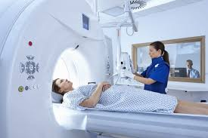
Figure 14: CAT Scanner | Figure 15: Patient being scanned with CAT machine

2. MRI (Magnetic Resonance Imaging) Machine
Unlike CT scans, MRIs use powerful magnets and radio waves rather than radiation. The machine detects how hydrogen atoms in the body react to a magnetic field. ICT software translates these complex radio frequency signals into high-contrast images of soft tissues (like the brain or ligaments). Essential for diagnosing brain injuries, spinal cord issues, and ligament tears.
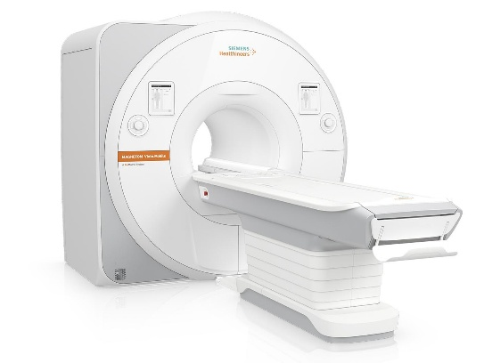 | 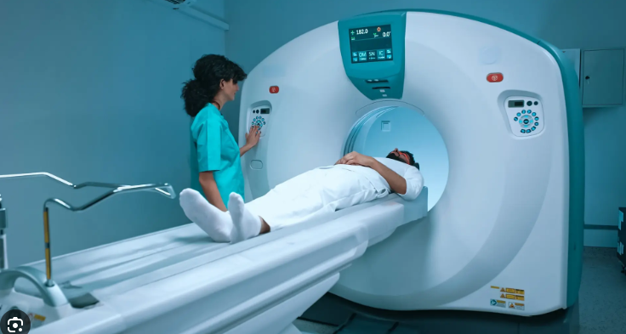
Figure 16: MRI Machine | Figure 17: Patient undergoing MRI scan

3. ECG (Electrocardiogram) Machine
An ECG records the electrical activity of the heart over a period of time using electrodes placed on the skin. The machine filters out "noise" (other electrical signals from muscles) and produces a digital waveform. Modern ECGs use pattern recognition software to automatically flag arrhythmias (irregular heartbeats). Used to identify heart attacks, thickened heart muscles, and heart rhythm problems.
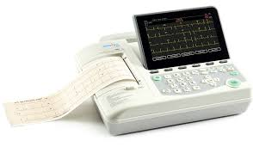
Figure 18: ECG Machine
4. Cardiac Screening Machine (Echocardiogram)
Cardiac screening often involves an Echocardiogram, which uses high-frequency sound waves (ultrasound) to create images of the heart. The machine processes sound wave echoes to calculate the Ejection Fraction (how much blood the heart pumps out) and creates real-time video of the heart valves in motion. Used to check for heart valve disease, congenital heart defects, and overall heart strength.
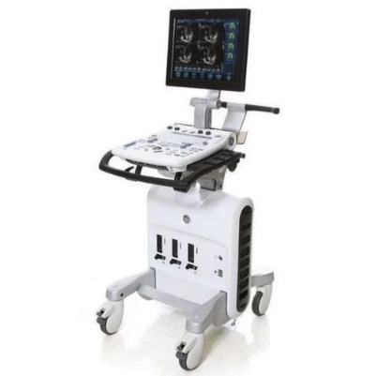 | 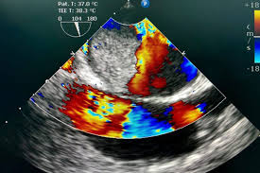
Figure 19: Echocardiogram machine | Figure 20: Echocardiogram display

5. EEG (Electro-encephalography) Machine
The EEG tracks and records brain wave patterns using small metal discs (electrodes) attached to the scalp. Because brain signals are incredibly faint (measured in microvolts), the ICT system amplifies these signals and converts them into digital "traces" on a screen. The primary tool for diagnosing epilepsy, sleep disorders, and brain death.
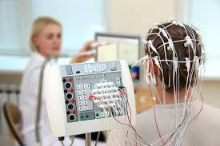 | 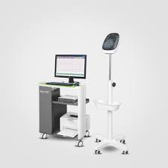
Figure 21: EEG Machine | Figure 22: EEG monitoring procedure

6. Blood Sugar Testing Machine (Glucometer)
These are small, portable devices used primarily by diabetics to monitor blood glucose levels. When a blood sample hits the test strip, a chemical reaction creates a small electrical current. The internal microprocessor measures this current and converts it into a digital numerical value. Used to manage diabetes and diagnose hypoglycemia (low sugar) or hyperglycemia (high sugar) in real-time.
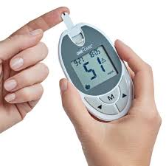
Figure 23: Glucometer
7. Blood Pressure Measuring Machine (Sphygmomanometer)
Modern digital blood pressure monitors use the oscillometric method. As the cuff deflates, a digital pressure sensor detects vibrations in the arterial wall. An algorithm calculates the Systolic (pressure when heart beats) and Diastolic (pressure when heart rests) numbers. Critical for identifying hypertension (high blood pressure), which is a leading risk factor for stroke and heart disease.
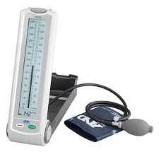
Figure 24: Blood pressure monitor
Table 3: Comparison of ICT Usage
Machine | Input Signal | ICT Process | Diagnostic Output
CAT | X-Rays | 3D Image Reconstruction | Structural anomalies/Tumors
MRI | Radio Waves | Signal Processing (Soft Tissue) | Soft tissue/Brain damage
ECG | Electricity | Waveform Analysis | Heart rhythm/Heart attack
EEG | Electricity | Signal Amplification | Brain activity/Epilepsy
Glucometer | Chemical/Electric | Digital Conversion | Blood sugar levels

4.3.2 Telemedicine
Telemedicine is the use of digital information and communication technologies (such as video calls, mobile apps, and remote monitoring) to provide clinical healthcare services from a distance. It allows providers to evaluate, diagnose, and treat patients without an in-person visit, bridging geographical gaps and improving the efficiency of medical delivery.
Core Benefits:
• Increased Accessibility: Connects patients in rural or underserved areas with specialists they otherwise couldn’t reach.
• Convenience and Comfort: Patients can receive care from home, eliminating travel time, parking fees, and the need for childcare or time off work.
• Cost-Effectiveness: Reduces overhead for providers and saves patients money on travel and lost wages.
• Infection Control: Minimizes the spread of contagious diseases like the flu or COVID-19 by keeping sick individuals out of crowded waiting rooms.
• Better Chronic Care: Facilitates continuous monitoring and regular check-ins for long-term conditions like diabetes or hypertension.
Specific Types of Telemedicine:
• Emergency Telemedicine (Tele-Emergency): Connects rural or smaller "spoke" hospitals with specialists at a central "hub" to provide real-time guidance during critical events, such as stroke assessments or trauma triage.
• Home Health Medicine: Blends virtual care with traditional home nursing. It uses tools like Remote Patient Monitoring (RPM) to track vitals (blood pressure, glucose) and allows elderly or homebound patients to "age in place" with constant clinical oversight.
• Telemedicine Consultation: The most common form, involving real-time interactive video or phone calls for primary care, mental health therapy, or specialist second opinions.
• Telesurgery (Remote Surgery): An advanced application using high-speed data links and robotics to allow a surgeon to perform a procedure on a patient located in a different geographical area.
• Medical Teletraining: Uses telecommunications to provide distance learning and mentoring for healthcare professionals. This includes live-streaming surgeries for student observation or expert-to-expert training on new clinical techniques.

CHAPTER 5: DEMERITS OF ICT
While Information and Communication Technology (ICT) has revolutionized modern life, it introduces several significant drawbacks across social, health, economic, and security domains.
1. Security and Privacy Risks
• Cybersecurity Threats: Increased reliance on ICT exposes individuals and organizations to hacking, malware, and data breaches.
• Privacy Concerns: The collection of vast amounts of personal data increases the risk of identity theft, unauthorized surveillance, and the loss of control over personal information.
• Cybercrime: Platforms can be misused for illegal activities such as phishing, financial fraud, and cyberstalking.
2. Health and Psychological Impacts
• Physical Health Issues: Prolonged screen time is linked to eye strain, headaches, poor posture, and a sedentary lifestyle that can lead to obesity and heart problems.
• Mental Health & Addiction: Excessive use can result in internet addiction, social isolation, and "technostress" from constant digital connectivity.
• Digital Distraction: Constant notifications and access to entertainment can reduce attention spans and decrease productivity in both work and education.
3. Economic and Employment Challenges
• Job Displacement: Automation and AI can replace manual labor and administrative tasks, leading to unemployment or the need for significant workforce retraining.
• Digital Divide: There is a growing gap between those who have access to high-speed internet and modern devices and those who do not, often based on socioeconomic status or geography.
• High Costs: The initial investment in ICT infrastructure, hardware, and ongoing software maintenance can be prohibitively expensive for some individuals and small businesses.
4. Social and Developmental Drawbacks
• Reduced Face-to-Face Interaction: Over-reliance on digital communication can weaken traditional social skills and lead to a loss of non-verbal cues (like body language) in interactions.
• Cyberbullying: ICT provides a platform for online harassment and bullying, which can be more pervasive and harder to escape than traditional bullying.
• Misinformation: The rapid spread of "fake news" and misleading information on the internet can influence public opinion and hinder critical thinking.
5. Educational and Cognitive Demerits
• Over-reliance: Students may depend too heavily on technology for answers (e.g., using AI or search engines), which can stifle critical thinking and problem-solving abilities.
• Academic Dishonesty: Digital tools can facilitate cheating through easy access to unauthorized resources during assessments.
In summary, ICT has become an essential part of modern life, offering incredible efficiency, instant global communication, and easy access to knowledge. While it is important to stay mindful of challenges, the primary focus remains on how these tools empower us to work smarter and stay connected. By using technology thoughtfully, we can harness its full potential to drive innovation and simplify daily tasks while maintaining a healthy personal and professional life.

References
Bajwa, J., Munir, U., Nori, A., & Williams, B. (2021). Artificial intelligence in healthcare: Transforming the practice of medicine. Future Healthcare Journal, 8(2), e188–e194. https://doi.org/10.7861/fhj.2021-0095
Popenici, S. A. D., & Kerr, S. (2017). Exploring the impact of artificial intelligence on teaching and learning in higher education. Research and Practice in Technology Enhanced Learning, 12(1), 22. https://doi.org/10.1186/s41039-017-0062-8
Secinaro, S., Calandra, D., Secinaro, A., Muthurangu, V., & Biancone, P. (2021). The role of artificial intelligence in healthcare: A structured literature review. BMC Medical Informatics and Decision Making, 21(1), 125. https://doi.org/10.1186/s12911-021-01488-9

