
THE CATHOLIC UNIVERSITY OF EASTERN AFRICA
FACULTY OF SCIENCE
DEPARTMENT OF COMPUTER SCIENCE
UNIT: CMT 429
STUDENTS
LUCY MWONGELI-1045121
SHARON CHEPKORIR-1046045
BRENDA MWIKALI -1049506

TITLE: KE-Expo Crop Recommender

1. Introduction
Agriculture being the main sector in the Kenyan economy contributes about 1/3 of the GDP and supports more than 40% of the population. In the rural areas this figure is even higher thus highlighting the importance of agriculture sector in the food security. Kenya is also among the leading producers and exporters of tea and coffee among other crops (Njura, H. J., Kubai, K. I., Taaliu, S. T., & Shem Khakame, K., 2020). However, the sector faces challenges such as; fluctuating weather, fluctuations in global markets and improper utilization of resources among conditions (Mutea, F. M., Kibera, F. N., Kinoti, M. W., & Njeru, W. G., 2024).
In the recent years the global economy is shifting towards using data driven decisions. This is where data science comes to solve these challenges in agriculture. Through data analysis, stakeholders are able to make better decisions with the aim of enhancing agricultural output, predicting export trends and coping with shifts in market trends.
This project (KE-Expo Crop Recommender) aims to apply data science techniques, tools and concept on Kenya’s agricultural to forecast crops exports trends to be used for decision making thus increasing the sector’s yield to the economy.

2. Problem Statement
Kenya’s agricultural export sector though being critical to the country’s economy, faces many challenges that affects its profitability, including:
- Market Volatility: Exporters often face fluctuating global demand and prices, making it very difficult to plan and get maximum profits.
- Uncertain Climatic Conditions: Uncertain weather patterns significantly influence agricultural throughput, affecting supply chains and export quantities.
- Limited and Scattered Data for Informed Decision Making: Most of the stakeholders operate on limited data and thus often rely on incomplete information, which leads to inefficient production and resource allocation. (Wanguru, G. W. , 2019)

Data science brings solutions to such challenges through the analysis of historical data, forecasting future trends, and providing insights to farmers and exporters. This project aims to address these challenges by using data science in the provision of accurate export forecasts to stakeholders for better decision-making on production, distribution, and resource allocation.

3. Research Questions
The challenges mentioned above will be addressed by the project based on the following research questions:
- What are the major trends in Kenya's agricultural exports over the past years?
This will show the historical patterns and periodical variations of Kenya's export commodities.

- What external factors (e.g. most notably, global demand, exchange rates, and climate conditions) best explain the fluctuations in agricultural exports?
Identifying these factors will help stakeholders prepare in advance against risks arising from export volatility.

- How can predictive models be utilized to forecast future export trends for Kenya's top agricultural commodities?
The question aims to apply the time series models to generate an accurate forecast of future export prices.

- What role can real time data collection and analysis play in supporting Kenyan farmers and exporters in decision-making?
The question will analyze how real-time data can help make production and distribution decisions by stakeholders and adapt quickly to market changes.

- What data-driven strategies and policies can be recommended to enhance the export performance of Kenya's agricultural sector?
Here, the focus is on translating data insights into actionable strategies that can boost export efficiency and profitability.

4. Justification
The agricultural sector in Kenya operates within a very uncertain and unpredictable environment. The application of data science-driven approaches would significantly enhance decision-making processes and operational efficiency among the stakeholders concerned. This project is justified based on the following key reasons:
- Efficient Resource Utilization: Data-driven insights may lead farmers and exporters to plan an optimal production level by efficiently using precious resources such as water, labor, and fertilizers.
- Risk Management: Trends in exports can be predicted from historical data to help stakeholders prepare for market fluctuations or weather disruptions, thus limiting exposure to risk.
- Policy Guidance: Data insights provided can help policymakers devise policies that favor export growth, access to markets, and agricultural sustainability.
- Increased Profitability: With better predictions of global demand and optimal use of resources, players will contribute to increased profitability for the economy at large in Kenya.
The application of data science in the project offers an encompassing solution to several challenges facing Kenya's agricultural export market.

5. Methodology for Data Collection
This effort will collect and gather data from such authoritative sources as:
- Online Databases and APIs:
KILIMOSTAT API: Provides economic and agricultural statistics from the Kenyan agricultural production sector.
FAOSTAT (Food and Agriculture Organization): Offers statistics on world agricultural production, trade, and markets.
Kaggle API : India based crop performance metrics data from Kaggle.

- Web Scraping:
Real-time data will also be gathered from Kenya National Bureau of Statistics website to capture up-to-date information on Kenyan agricultural production rates.

PHASE 2

Data Collection
Data was collected from KILIMOSTAT API that showed the best enviromental conditions favourable for major kenyan cash crops e.g Tea and coffee.
The dataset cintains key agricultural and climatic variables including:
- N - Nitrogen
- P - Phosphorus
- K - Potassium
- Temperature (⁰C)
- Humidity (%)
- pH - Soil acidity or alkalinity
- Rainfall (mm)
- Label - Type of cash crop (e.g Tea)

Data Cleaning

2.1 Load data
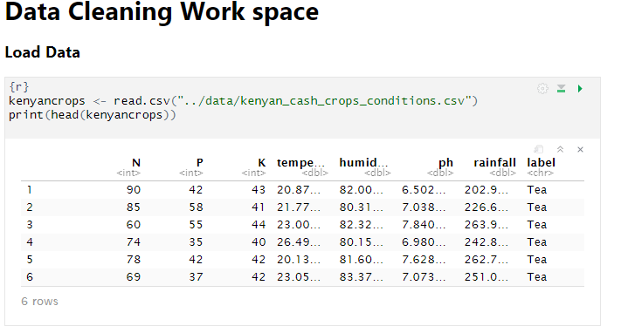
The dataset was imported into R notebook, with the above preview confirming successful loading with relevant columns displayed for the first six records.

2.2 Checking for Duplicate values
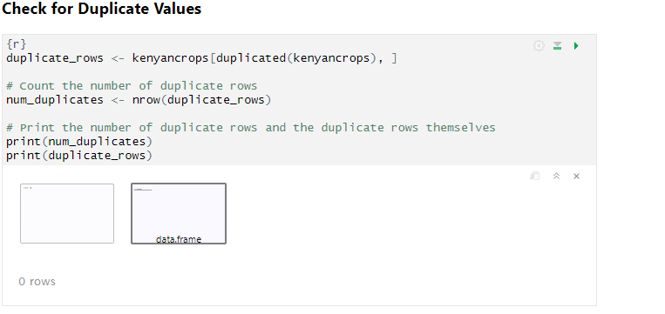
The output indicated 0 duplicate rows, confirming that all observations in the dataset were unique.

2.3 Check for Missing Values
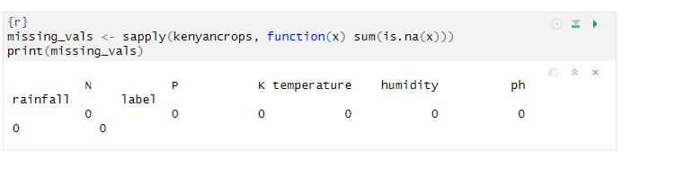

The results showed there were no missing values across all columns, meaning the dataset was clean and ready for analysis.

Data Visualization and Exploratory Analysis

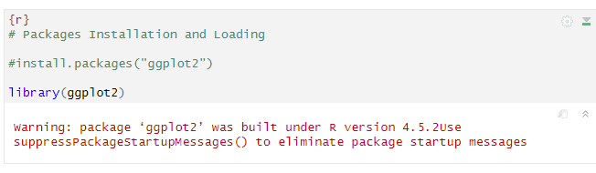
After confirming data quality, the ggplot2 library was loaded for visualization.

Histogram of Soil pH
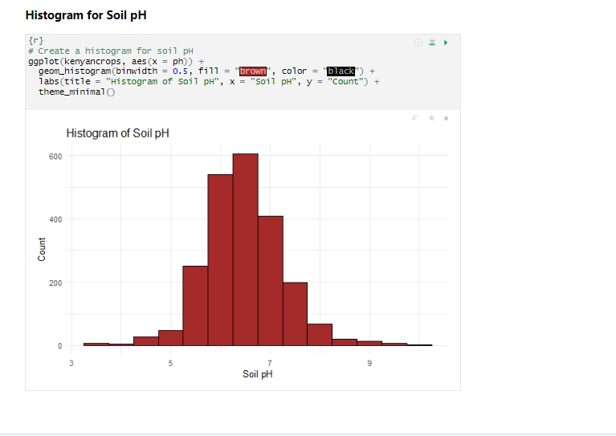
The histogram shows a bell-shaped (approximately normal) distribution of soil pH. The majority of samples fall within the 6.0 – 7.5 range, indicating slightly acidic to neutral soils. Soils with pH in this range are ideal for Tea, which thrives best at pH between 5.5 and 6.5, and Coffee, which prefers slightly acidic conditions as well. Only a few observations exist below pH 5 or above pH 8, suggesting that extreme acidity or alkalinity is uncommon in the dataset. The balanced distribution also suggests minimal data bias, meaning samples were collected across a variety of conditions without overrepresentation of extreme cases.

Bar Plot

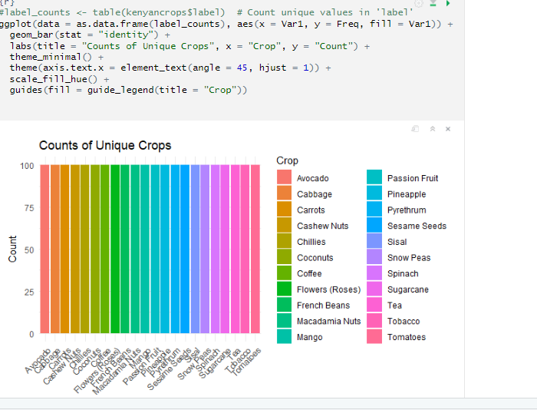
The bar plot displays the frequency of each unique crop label in the kenyancrops dataset. The near-perfect uniform height of all the bars indicates that every single crop in the dataset (Avocado, Cabbage, Carrots, etc.) has been observed almost the exact same number of times. This makes the dataset easy to interpret and ensures that all 22 crop types contribute equally to any subsequent analysis or training process.

Box Plot
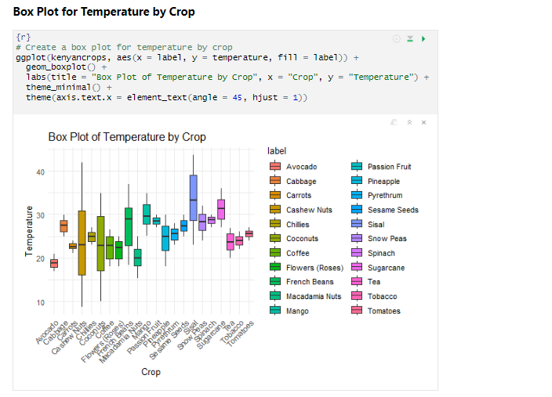
The full range of temperatures across all crops spans between 8⁰C to 40⁰C
The Key observations include:
- Low Temperature Preference: Crops like Coffee and Macadamia Nuts show the lowest median temperatures (around 18⁰C - 20⁰c) and tighter interquartile ranges, indicating they prefer cooler, more stable temperatures.
- High Temperature Preference: Snow Peas, Spinach, and Sugarcane tend to have the highest median temperatures (around 28⁰C - 30⁰C). Sugarcane also exhibits one of the largest variations in its full range, suggesting it can tolerate a wide spectrum of temperatures.
- Wide Temperature Tolerance (Large IQR): Crops such as Avocado, Cabbage, and Carrots have wider interquartile ranges (IQR), meaning 50% of their required temperatures are spread over a larger range. This suggests these crops are more resilient and can be grown successfully in a wider variety of temperature conditions.

Source Code Link:
https://github.com/lk-labs/KE-Expo-Crop-Recommender/blob/main/CashCropModel.Rmd

Conclusion

In conclusion, the dataset is well-structured and balanced, eliminating the risk of data bias. Furthermore, the analysis confirms that soil pH, temperature, rainfall, and humidity are highly informative features that, when combined, create unique environmental signatures for each crop. These distinct patterns make the dataset highly suitable for building an accurate machine learning recommender system capable of suggesting the most appropriate crop given a set of environmental inputs.

References
Mutea, F. M., Kibera, F. N., Kinoti, M. W., & Njeru, W. G. (2024). Corporate Social Capital and Performance of Certified Small Tea Producer Organizations in Kenya. African Development Finance Journal, 8(1), 18-45.
Njura, H. J., Kubai, K. I., Taaliu, S. T., & Shem Khakame, K. (2020). The relationship between agricultural teaching approaches and food security in Kenya. Education Research International, 2020(1), 8847864.
Wanguru, G. W. . (2019). Effect of Foreign Exchange Rates Volatility on Financial Performance of Agricultural Sector in Kenya (Doctoral dissertation, University of Nairobi).

