**Let’s start,**

**Step 1:** Open Visual Studio->New Project->Templates->Visual C#->Android->Blank app

Select blank app. Give the project name and project location.  
  
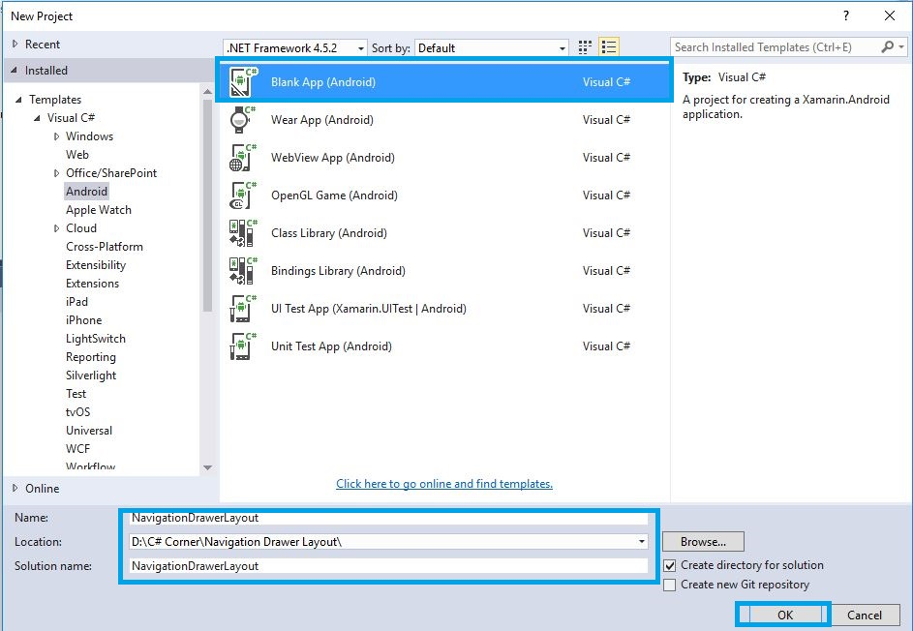  
 **Step 2**: Go to Solution Explorer-> Project Name-> Components, right click to Get More Components, open new dialog box. This dialog box is required to search the Design, add Android Support Design Library Packages.  
  
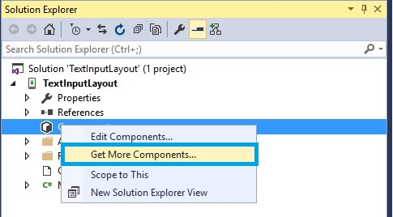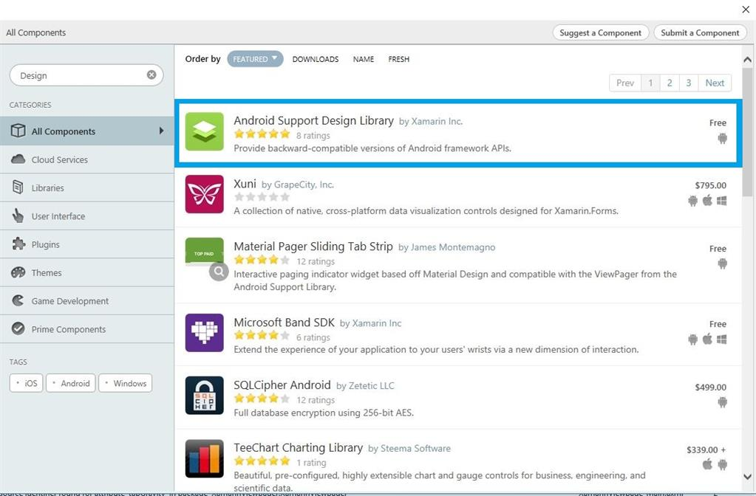  
 **Step 3**: Add Theme.AppCompat.Light.NoActionBar. Create styles.xml file. Go to Solution Explorer-> Project Name->Resources->values, right click to Add->New Item, open new dialog box. Select XML file and give the name for styles.xml,  
  
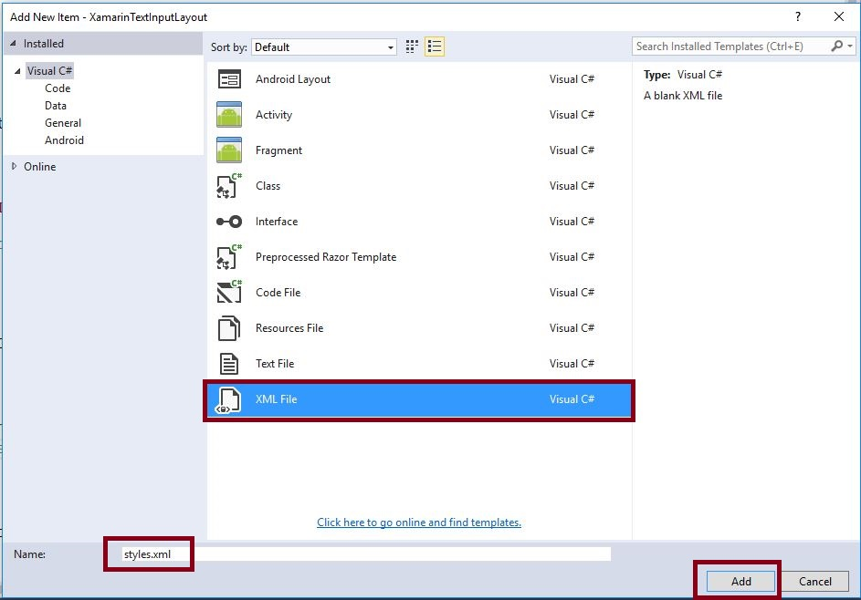  
 **Step 4**: Create colors.xml file. Go to Solution Explorer-> Project Name->Resources->values. Right click to Add->New, open new dialog box. Select XML file give for colors.xml.  
  
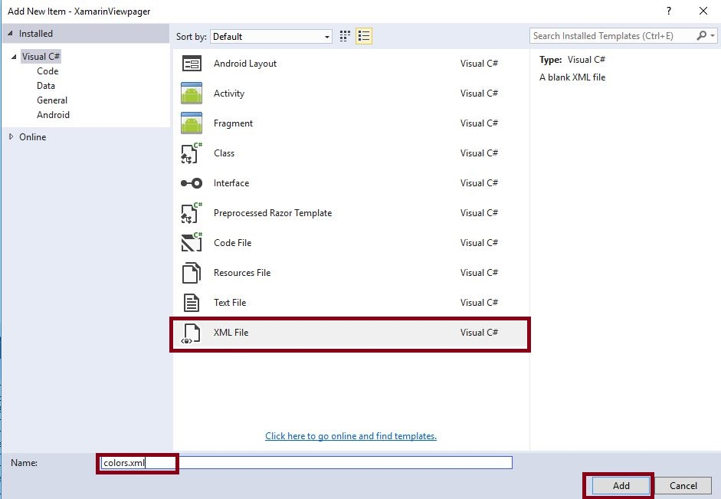  
 **Step 5**: Open Solution Explorer-> Project Name->Resources->values->colors.xml. Click to open Design View and the code, given below:

1. <?xml version="1.0" encoding="utf-8" ?>
2. <resources>
3. <color name="window_background">#8AA5B9</color>
4. </resources>

**Step 6**: Open Solution Explorer-> Project Name->Resources->values->styles.xml. Click to open Design View and the code, given below:  
  
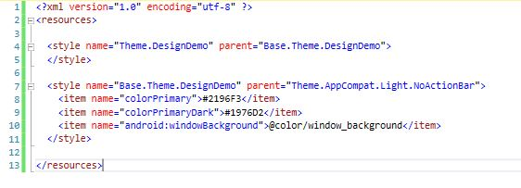

1. <?xml version="1.0" encoding="utf-8" ?>
2. <resources>
3. <style name="Theme.DesignDemo" parent="Base.Theme.DesignDemo">
5. </style>
6. <style name="Base.Theme.DesignDemo" parent="Theme.AppCompat.Light.NoActionBar">
7. <item name="colorPrimary">#2196F3</item> <item name="colorPrimaryDark">#1976D2</item> <item name="android:windowBackground">@color/window_background</item>
8. </style>
9. </resources>

**Step 7**: Open Solution Explorer-> Project Name->Resources->values->Strings.xml. Click to open Design View and the code, given below:

1. <string name="drawer_open">Open</string>
2. <string name="drawer_close">Close</string>

**Step 8**: Open the menu list to add one XML file. Go to Solution Explorer-> Project Name->Resources->right click to Add->New Folder and give the name to the menu.

**Step 9**: Open Solution Explorer-> Project Name->Resources->menu. Right click to Add->New Item, open new Dialog box. Select XML file and give the name for nav_menu.xml,  
  
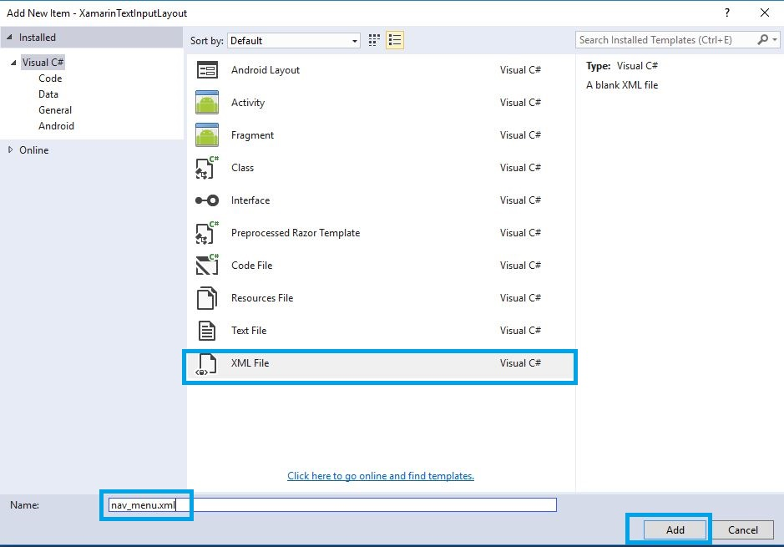  
 **Step 10**: Open Solution Explorer-> Project Name->Resources->menu->nav_menu.xml. Click to open Design View and the code, given below:

1. <?xml version="1.0" encoding="utf-8" ?>
2. <menu xmlns:android="http://schemas.android.com/apk/res/android">
3. <group android:checkableBehavior="single">
4. <item android:id="@+id/nav_home" android:icon="@drawable/ic_dashboard" android:title="Home" />
5. <item android:id="@+id/nav_messages" android:icon="@drawable/ic_event" android:title="Messages" />
6. <item android:id="@+id/nav_friends" android:icon="@drawable/ic_headset" android:title="Friends" />
7. <item android:id="@+id/nav_discussion" android:icon="@drawable/ic_forum" android:title="Discussion" /> </group>
8. <item android:title="Sub items">
9. <menu>
10. <item android:icon="@drawable/ic_dashboard" android:title="Sub item 1" />
11. <item android:icon="@drawable/ic_forum" android:title="Sub item 2" />
12. <item android:icon="@drawable/ic_done" android:title="Sub item 5" /> </menu>
13. </item>
14. </menu>

**Step 11**: Open Solution Explorer-> Project Name->Resources->layout. Right click to Add->New Item and open the new Dialog box. Select axml file and give name for nav_header.axml.  
  
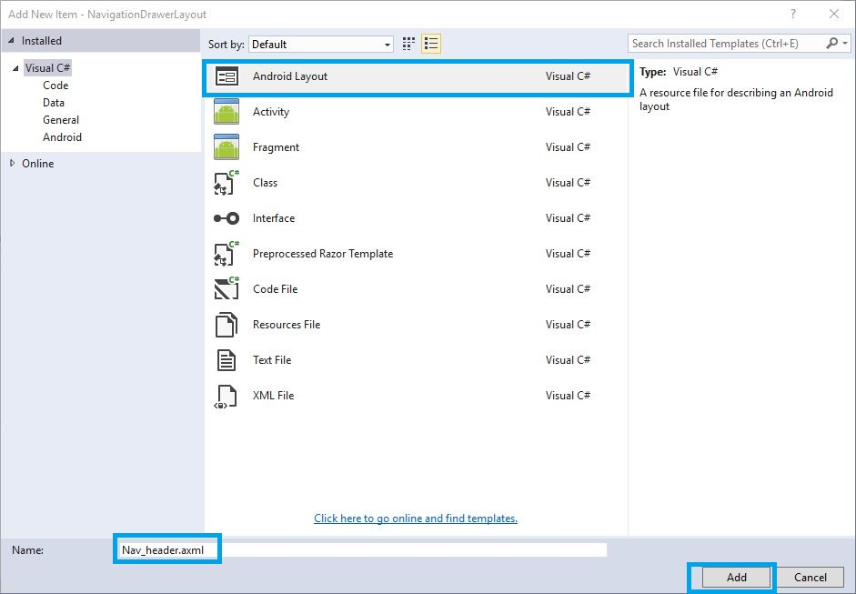

**Step 12**: Open Solution Explorer-> Project Name->Resources->Layout->nav_header.axml. Click to open Design View and the code, given below:

1. <?xml version="1.0" encoding="utf-8"?>
2. <LinearLayout xmlns:android="http://schemas.android.com/apk/res/android"
3. xmlns:app="http://schemas.android.com/apk/res-auto"
4. android:layout_width="match_parent"
5. android:layout_height="210dp"
6. android:background="#0099ff"
7. android:padding="16dp"
8. android:orientation="vertical"
9. android:gravity="bottom">
10. <TextView
11. android:text="User Name"
12. android:layout_width="match_parent"
13. android:layout_height="wrap_content"
14. android:id="@+id/navheader_username"
15. android:textAppearance="@style/TextAppearance.AppCompat.Body1" />
16. </LinearLayout>

**Step 13**: Open Solution Explorer-> Project Name->Resources->layout, right click to Add->New Item. Open new Dialog box. Select axml file and give the name for toolbar.axml,  
  
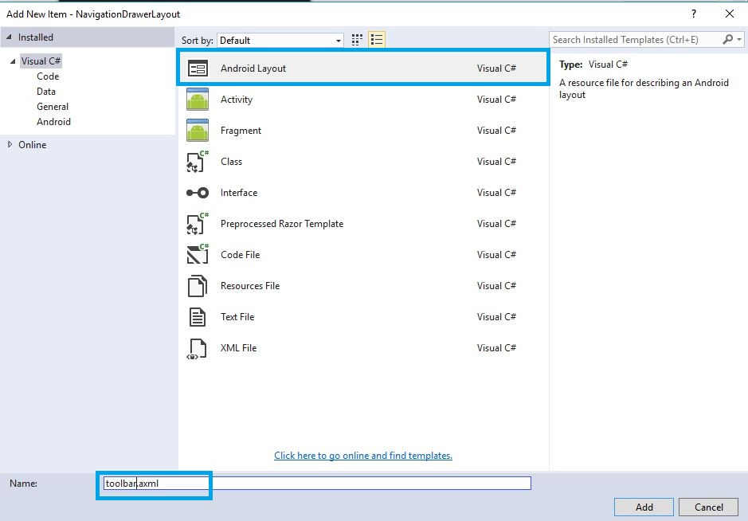  
 **Step 14**: Open Solution Explorer-> Project Name->Resources->Layout->toolbar.axml. Click to open Design View and the code, given below:

1. <?xml version="1.0" encoding="utf-8"?>
2. <android.support.design.widget.CoordinatorLayout xmlns:android="http://schemas.android.com/apk/res/android"
3. xmlns:app="http://schemas.android.com/apk/res-auto"
4. android:id="@+id/main_content"
5. android:layout_width="match_parent"
6. android:layout_height="match_parent">
7. <android.support.design.widget.AppBarLayout
8. android:id="@+id/appbar"
9. android:layout_width="match_parent"
10. android:layout_height="wrap_content"
11. android:theme="@style/ThemeOverlay.AppCompat.Dark.ActionBar">
12. <android.support.v7.widget.Toolbar
13. android:id="@+id/toolbar"
14. android:layout_width="match_parent"
15. android:layout_height="wrap_content"
16. android:elevation="4dp"
17. android:background="?attr/colorPrimary" />
18. </android.support.design.widget.AppBarLayout>
19. </android.support.design.widget.CoordinatorLayout>

**Step 15**: Open Solution Explorer-> Project Name->Resources->Layout->Main.axml. Click to open Design View and the code, given below:  
  
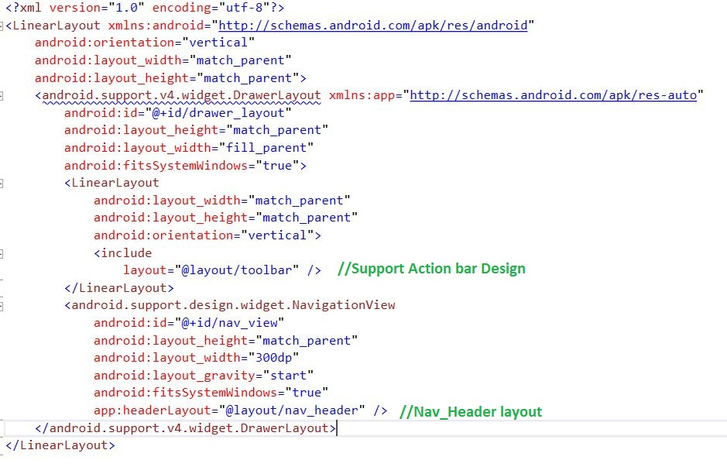

1. <?xml version="1.0" encoding="utf-8"?>
2. <LinearLayout xmlns:android="http://schemas.android.com/apk/res/android"
3. android:orientation="vertical"
4. android:layout_width="match_parent"
5. android:layout_height="match_parent">
6. <android.support.v4.widget.DrawerLayout xmlns:app="http://schemas.android.com/apk/res-auto"
7. android:id="@+id/drawer_layout"
8. android:layout_height="match_parent"
9. android:layout_width="fill_parent"
10. android:fitsSystemWindows="true">
11. <LinearLayout
12. android:layout_width="match_parent"
13. android:layout_height="match_parent"
14. android:orientation="vertical">
15. <include layout="@layout/toolbar" />
16. </LinearLayout>
17. <android.support.design.widget.NavigationView
18. android:id="@+id/nav_view"
19. android:layout_height="match_parent"
20. android:layout_width="300dp"
21. android:layout_gravity="start"
22. android:fitsSystemWindows="true"
23. app:headerLayout="@layout/nav_header" />
24. </android.support.v4.widget.DrawerLayout>
25. </LinearLayout>

**Step 16**: After Design view creation, open Solution Explorer-> Project Name->MainActivity.cs  and the steps, given below:

**Step 17:** Add below Namespaces and Theme Name,

1. **using** Android.Support.V7.App;
2. **using** Android.Support.V4.Widget;
3. **using** V7Toolbar = Android.Support.V7.Widget.Toolbar;
4. **using** Android.Support.Design.Widget;
5. [Activity(Theme = "@style/Theme.DesignDemo"])

**Step 18:** Create Drawer Layout and Navigation View variable, declare the Drawer Layout and Navigation View within the OnCreate().before to change the Activity to AppCompatActivity.

1. **protected** **override** **void** OnCreate(Bundle bundle)
2. {
3. **base**.OnCreate(bundle);
4. // Set our view from the "main" layout resource
5. SetContentView(Resource.Layout.Main);
6. drawerLayout = FindViewById < DrawerLayout > (Resource.Id.drawer_layout);
7. // Create ActionBarDrawerToggle button and add it to the toolbar
8. var toolbar = FindViewById < V7Toolbar > (Resource.Id.toolbar);
9. SetSupportActionBar(toolbar);
10. var drawerToggle = **new** ActionBarDrawerToggle(**this**, drawerLayout, toolbar, Resource.String.drawer_open, Resource.String.drawer_close);
11. drawerLayout.SetDrawerListener(drawerToggle);
12. drawerToggle.SyncState();
13. navigationView = FindViewById < NavigationView > (Resource.Id.nav_view);
14. setupDrawerContent(navigationView); //Calling Function
15. }
16. **void** setupDrawerContent(NavigationView navigationView)
17. {
18. navigationView.NavigationItemSelected += (sender, e) =>
19. {
20. e.MenuItem.SetChecked(**true**);
21. drawerLayout.CloseDrawers();
22. };
23. }
24. **public** **override** **bool** OnCreateOptionsMenu(IMenu menu)
25. {
26. navigationView.InflateMenu(Resource.Menu.nav_menu); //Navigation Drawer Layout Menu Creation
27. **return** **true**;
28. }

**Step 19:** Press F5 or build and run the Application.  
  
