Supplementary Material for Frozen Cross-Dataset Reliability of Healthy-Only PMSM Stator-Fault Detection
Author: LI KAICHEN, Department of Artificial Intelligence Convergence Engineering, Changwon National University

S0. Status, analysis purposes, and provenance
This supplement separates the original pre-reveal decisions from later diagnostics. The historical Chinese protocols retain their original titles and hypotheses; the English reporting does not reinterpret their internal Git freeze as an external preregistration. The frozen primary Log-Euclidean score, external interval, health roles, thresholds, record inclusion, and primary seed are unchanged.
Evidence component | Status | Permitted inference
KAIST three-motor comparison and sensitivities | Exploratory; target faults inspected during development | Conditional same-family comparison; no untouched confirmation
External primary scoring and ten preimplemented comparators | Frozen before external fault-value access | Complete pre-reveal comparison on one external motor
External paired contrasts, horizon cuts, block-position AUROC, and first alarms | Post-reveal diagnostics of saved scores | Conditional explanation of ranking and trajectory coverage
Five-seed stochastic refits | Post-reveal audit using previously fixed seeds and healthy-only fits | Stability range; no best-seed selection or revised primary
Feature geometry reconstruction | Post-reveal, analysis-only | Exact reconstruction and descriptive contribution allocation
KAIST 100-to-10 kHz sampling control | Post-reveal sensitivity | Result under one changed source sampling arm; no primary replacement
Secondary transient parser | Prospectively frozen compatibility audit; accepted 0/21 | Parser failure; no detector comparison at primary reveal
Repaired 200 W transient analysis | Post-reveal, one physical motor, non-confirmatory | Descriptive cross-record sensitivity only

The secondary transient dataset has no independent healthy-only records. Its frozen parser failure and repaired single-motor analysis supply no usable confirmatory cross-motor replication. The two subsystems of the primary external motor are also not independent motors. All results are offline; latency, memory, and embedded stability were not measured. No analysis here establishes a safety guarantee.
The current submission-package audit verifies saved numerical outputs in the specified Conda environment, which contains scikit-learn 1.9.1. The original external output metadata records scikit-learn 1.9.0; a complete historical environment lock was not located. Dependency specifications and recorded tool versions support provenance, but do not establish a byte-identical historical runtime. Saved-result evidence verification is therefore distinguished from any current-environment stochastic refit. The original scores and primary seed remain unchanged; the reproducibility guide records this version boundary.
The following purposes explain why the already completed post-reveal diagnostics are retained. They are reporting rationales, not newly claimed pre-reveal hypotheses. No additional diagnostic in this reporting revision uses external labels to alter fitting, features, inclusion, time support, seed choice, or alarm thresholds.
Diagnostic purpose | Diagnostic and data boundary | Interpretation rule
Does 100% record-any detection hide late alarms? | Fixed-prefix counts and first alarms from saved external prediction rows | Report all prefix denominators and preserve full-interval primary; early trajectory is not fault-onset latency
Does source health help relative to target health? | Estimator-family paired record differences using saved outputs; fit-derived masks disclosed | Attribute the observed contrast to this source-augmentation protocol; covariance-estimator contrasts are qualified
Is the best comparator's seed stable? | Five fixed healthy-only stochastic fits, same calibration rule, all seed results | Report range and gate pass count; never select a seed after fault inspection
Is operating position associated with score? | Saved block scores with healthy speed proxies; no score refit | Association only; block/time/speed and unmeasured factors co-vary
Does the frozen geometry emphasize useful fault directions? | Hash-locked covariance reconstruction plus common-support pooled feature summaries and matched differences | Contribution decomposition is descriptive and non-unique, not a causal feature-selection rule
Can sampling mismatch alone rescue transfer? | Antialiased 10 kHz source arm with otherwise unchanged settings | Preserve original result; a null rescue narrows one explanation under this pipeline
Can a repaired transient parser count as confirmation? | Separate opt-in repair directory; unchanged signal/onset contract | Retain primary 0/21 failure and motor-level incompatibility; label repaired analysis post-reveal

Original sources are Mendeley Data 10.17632/rgn5brrgrn.5, Zenodo 10.5281/zenodo.13889418, and Zenodo 10.5281/zenodo.15631383; all carry CC BY 4.0 [1, 2, 3]. The associated external machine description is [4]. Raw data are obtained from those repositories; this supplement and the code bundle provide derived outputs and reconstruction instructions rather than redistributing raw archives.

Technical summary
The complete frozen external comparison favors Target MinCovDet, not Proposed: Target MinCovDet detected 70.05% of 384 fault blocks with 0/32 held-out healthy false alarms, whereas Proposed detected 25.00% with 1/32 false alarms. Conditional complete-record comparisons show reduced detection under the frozen source-augmentation pipelines, including MinCovDet configurations with different fit-derived masks, except that target-only and source+target OC-SVM tied in mean detection. The apparent performance increase late in each record is coupled to the shared acceleration ramp. Five-seed, feature-geometry, and 100 kHz-to-10 kHz sensitivity analyses did not change the frozen primary result. All external intervals and post-reveal comparisons remain conditional on a single physical motor. The secondary 21-record transient audit did not supply confirmatory evidence: the frozen parser accepted 0/21 records, the repaired 20 kW arm failed its compatibility gate, and all methods had zero first-second detection in the repaired 200 W sensitivity.

S1. Data, experimental units, and locked splits
The physical motor is the generalization unit, the MAT/TDMS record is the condition-level resampling unit, the 3 s block is the alarm unit, and the 0.2 s window is the feature-extraction unit. Repeated windows and ordered blocks from one record are not independent replications. The external dataset contains only one physical motor; its 48 fault records are operating-condition records, not 48 motors.
Dataset | Physical motors | Physical records | Record-subsystem streams | Sampling | Frozen analysis grain
KAIST source | 3 (1, 1.5, and 3 kW) | 45 (3 healthy; 42 fault) | not applicable | 100 kHz; leading 120 s | 600 non-overlapping 0.2 s windows and 40 3 s blocks per record
External dual-three-phase PMSM | 1 (custom 30.16 kW) | 56 (8 healthy; 48 fault) | 112 (2 subsystems per record) | 10 kHz; [12, 36) s | 120 windows and 8 blocks per record-subsystem; one system block after maxima

The external MAT records contain two three-phase current subsystems (SubSys1 and SubSys2). Each subsystem is scored separately. A block score is the maximum over 15 windows within a subsystem followed by the maximum over the two subsystems. Thus, each physical record contributes exactly eight system block scores.

S1.1. Ordered split definitions
Stage | KAIST leave-one-motor-out | External validation
Source reference | healthy blocks 0-23 for each of the two source motors; balanced subset 0, 8, 15, 23 | three KAIST source motors; covariance blocks 0-23 and balanced blocks 0, 8, 15, 23
Target adaptation | blocks 0-3 (4 blocks; 60 windows) from the held-out motor's healthy record | 0 N m healthy record, blocks 0-3 (60 windows per subsystem)
Guard / unused | blocks 4 and 25 | 0 N m blocks 4-7 are unused for validation
Calibration | healthy blocks 5-24 (20 blocks) | healthy loads 10, 20, and 30 N m; all 8 blocks (3 records; 24 system blocks)
Held-out health test | healthy blocks 26-39 (14 blocks) | healthy loads 5, 15, 25, and 35 N m; all 8 blocks (4 records; 32 system blocks)
Fault test | 14 records × 40 blocks = 560 blocks per target motor | 6 turn-fault states × 8 loads = 48 records; 8 blocks each = 384 system blocks

The external 6-by-8 grid is not crossed by fault phase. Fault-turn levels 1, 3, 5, and 6 use phase U, whereas levels 2 and 4 use phase V. Consequently, fault-turn count and phase effects are not separately identifiable; the turn-stratified record bootstrap conditions on this fixed assignment rather than resolving it.
All primary two-dataset models use the named 27-feature scale-free arm. Electrical fundamental frequency remains in this arm, so it is neither wholly dimensionless nor guaranteed speed invariant. The unchanged feature order is: fundamental_hz, sequence_unbalance, fundamental_amplitude_cv, phase_rms_cv, clarke_radius_cv, zero_sequence_ratio, spectral_entropy, sideband_lower_ratio, sideband_upper_ratio, harmonic_2_ratio_mean, harmonic_2_ratio_max, harmonic_3_ratio_mean, harmonic_3_ratio_max, harmonic_4_ratio_mean, harmonic_4_ratio_max, harmonic_5_ratio_mean, harmonic_5_ratio_max, thd_2_to_5_mean, rms_ratio_a, crest_a, kurtosis_a, rms_ratio_b, crest_b, kurtosis_b, rms_ratio_c, crest_c, kurtosis_c. Source features are robustly centered and scaled within source motor; external target features are robustly centered and scaled within subsystem from the frozen adaptation subset. The split-conformal alarm level is alpha = 0.05. Arithmetic covariance methods use ridge fraction 0.001 and the Proposed Log-Euclidean method uses the source-selected ridge fraction 0.01. No external fault row enters fitting, scaling, calibration, or threshold construction.

S1.2. Frozen feature and fitting definitions
Each phase is demeaned and Hann-windowed before a real FFT, with amplitude normalization 2/sum(Hann) and no zero padding. The 0.2 s windows give 5 Hz bins. fundamental_hz is the bin maximizing three-phase mean spectral magnitude in 20-500 Hz, not a directly measured speed. Harmonic orders 2-5 use the nearest bin to each multiple of that frequency, divided by the same-phase fundamental magnitude plus machine epsilon; each order reports the phase mean and maximum. THD is the phase mean of the root sum of squared order-2-5 ratios. The lower/upper sideband ratios use nearest bins at 0.75/1.25 times the fundamental, normalized by mean fundamental magnitude. These are fixed spectral heuristics, not order tracking.
At the fundamental bin, sequence_unbalance is min(|I1|, |I2|)/max(|I1|, |I2|) for the two rotating sequence components (zero if both vanish), making it invariant to phase-sequence orientation; it is not always a fixed negative/positive ratio. The amplitude-invariant Clarke transform supplies radius coefficient of variation (CV) and zero-sequence RMS divided by mean phase RMS. Per-phase RMS ratios use the three-phase mean RMS; crest factors use absolute peak/RMS; kurtosis is Pearson kurtosis (fisher=False, default biased estimator). CVs use population standard deviation divided by the corresponding mean plus machine epsilon. Spectral entropy uses phase-averaged power from 20-2000 Hz, probability normalization and division by the log bin count.
Healthy normalization uses the coordinate median and 1.4826 times median absolute deviation. A scale no greater than 1e-8 times max(|median|, 1) falls back to population standard deviation, then to 1.0 if still too small. Only permitted healthy fitting rows enter these statistics. Source-label ridge development maximized mean source fault-block detection minus twice mean source healthy false-alarm rate over 0.0001/0.001/0.01/0.1, excluding each outer KAIST target; all selected 0.01. The selection table and JSON are retained in results/log_ridge_selection/.
MinCovDet centers healthy fitting rows for pivoted QR and retains the estimated independent columns, with rank tolerance sqrt(machine epsilon) times the first absolute diagonal of R. Both external target-only fits retain 26/27 columns, excluding rms_ratio_c (60 rows); both source-plus-target fits retain 27/27 (240 rows). The full augmentation pipeline changes both sample count and effective mask. At alpha 0.05 with 20 or 24 calibration blocks, alarm requires a score strictly above the calibration maximum; ties are not alarmed. H1 uses the upper endpoint of the descriptive two-sided 95% Wilson score interval, not a one-sided 95% limit.

S2. Complete frozen external comparison across 11 methods
At the prespecified external seed, Target MinCovDet had the highest detection: 70.05% fault-block detection, zero false alarms among 32 held-out healthy blocks, and AUROC 0.9268. It was also the only method satisfying the prespecified empirical H1 rule. Proposed achieved 25.00% detection, one false alarm (3.12%), and AUROC 0.6354. These external results are reported in full below; method-specific score thresholds are not comparable in magnitude across estimators.
The external pooled AUROC compares 384 fault blocks spanning all eight loads with 32 held-out health blocks from only 5, 15, 25, and 35 N m. It is therefore a descriptive ranking statistic under unequal load support, not a load-matched population estimand. Fault prevalence is 384/416 (92.31%), the no-skill average-precision baseline. AUPRC is prevalence dependent and does not estimate deployed alarm precision. Training/reference labels describe covariance shape or one-class fitting; all methods still use target-health normalization and calibration.
The following two column groups share the first-column identifiers and preserve every original row, value, and row order. Read corresponding rows together; splitting is a layout change only.
Table S2a. Complete frozen external comparison across 11 methods (column group 1 of 2).
Method | Healthy training/reference | Threshold | Health FA | H1 | Fault block detection
Target Ledoit-Wolf | target adaptation | 183.887 | 1/32 (3.12%) | fail | 141/384 (36.72%)
Target sample covariance | target adaptation | 738.703 | 1/32 (3.12%) | fail | 215/384 (55.99%)
Source covariance | source healthy | 109212 | 1/32 (3.12%) | fail | 49/384 (12.76%)
Entity-balanced covariance | source entities + target | 1250.37 | 1/32 (3.12%) | fail | 105/384 (27.34%)
Proposed: Log-Euclidean entity covariance | source entities + target | 4983.29 | 1/32 (3.12%) | fail | 96/384 (25.00%)
Target OC-SVM (RBF) | target adaptation | 0.401736 | 1/32 (3.12%) | fail | 49/384 (12.76%)
Source+target OC-SVM (RBF) | source-balanced + target | 0.827663 | 1/32 (3.12%) | fail | 49/384 (12.76%)
Target Isolation Forest | target adaptation | 0.569218 | 3/32 (9.38%) | fail | 230/384 (59.90%)
Source+target Isolation Forest | source-balanced + target | 0.581677 | 2/32 (6.25%) | fail | 194/384 (50.52%)
Target MinCovDet | target adaptation | 1238.1 | 0/32 (0.00%) | pass | 269/384 (70.05%)
Source+target MinCovDet | source-balanced + target | 9802.52 | 1/32 (3.12%) | fail | 116/384 (30.21%)

Table S2b. Complete frozen external comparison across 11 methods (column group 2 of 2; continued).
Method | Record-macro detection | Descriptive bootstrap interval (%) | Record any-alarm | AUROC | AUPRC
Target Ledoit-Wolf | 36.72% | [32.55, 41.41] | 100.00% | 0.7675 | 0.9747
Target sample covariance | 55.99% | [51.04, 61.46] | 100.00% | 0.8757 | 0.9883
Source covariance | 12.76% | [12.50, 13.28] | 100.00% | 0.5747 | 0.9435
Entity-balanced covariance | 27.34% | [23.18, 32.03] | 100.00% | 0.6972 | 0.9648
Proposed: Log-Euclidean entity covariance | 25.00% | [21.09, 29.43] | 100.00% | 0.6354 | 0.9583
Target OC-SVM (RBF) | 12.76% | [10.68, 15.36] | 87.50% | 0.7209 | 0.9622
Source+target OC-SVM (RBF) | 12.76% | [11.20, 14.58] | 91.67% | 0.6876 | 0.9558
Target Isolation Forest | 59.90% | [57.29, 62.76] | 100.00% | 0.8670 | 0.9876
Source+target Isolation Forest | 50.52% | [47.92, 53.12] | 100.00% | 0.8245 | 0.9833
Target MinCovDet | 70.05% | [65.36, 75.26] | 100.00% | 0.9268 | 0.9934
Source+target MinCovDet | 30.21% | [26.04, 34.90] | 100.00% | 0.7013 | 0.9666

H1 requires both a descriptive Wilson upper bound no greater than 0.12 and a maximum held-out-load false-alarm rate no greater than 0.15. The record-bootstrap interval resamples complete fault records within the six fault-turn strata (10,000 draws, seed 711). Because every fault record has eight blocks, block-weighted and record-macro detection coincide here. The 2.5th-97.5th bootstrap percentiles are descriptive record-weighting sensitivities conditional on the observed single motor; population coverage has not been established.

S3. Conditional paired comparisons and source-transfer contrasts

S3.1. Every frozen candidate versus Proposed
The following two column groups share the first-column identifiers and preserve every original row, value, and row order. Read corresponding rows together; splitting is a layout change only.
Table S3.1a. Every frozen candidate versus Proposed (column group 1 of 2).
Candidate | Candidate detection | Proposed detection | Candidate - Proposed | Descriptive paired interval (pp) | Bootstrap p
Target MinCovDet | 70.05% | 25.00% | +45.05 pp | [+40.62, +49.48] | 0.0001
Target Isolation Forest | 59.90% | 25.00% | +34.90 pp | [+31.77, +38.02] | 0.0001
Target sample covariance | 55.99% | 25.00% | +30.99 pp | [+28.12, +34.38] | 0.0001
Source+target Isolation Forest | 50.52% | 25.00% | +25.52 pp | [+21.88, +28.91] | 0.0001
Target Ledoit-Wolf | 36.72% | 25.00% | +11.72 pp | [+9.90, +13.54] | 0.0001
Source+target MinCovDet | 30.21% | 25.00% | +5.21 pp | [+3.91, +6.51] | 0.0001
Entity-balanced covariance | 27.34% | 25.00% | +2.34 pp | [+1.04, +3.65] | 0.0001
Source+target OC-SVM (RBF) | 12.76% | 25.00% | -12.24 pp | [-16.15, -8.59] | 0.0001
Source covariance | 12.76% | 25.00% | -12.24 pp | [-16.41, -8.33] | 0.0001
Target OC-SVM (RBF) | 12.76% | 25.00% | -12.24 pp | [-16.41, -8.59] | 0.0001

Table S3.1b. Every frozen candidate versus Proposed (column group 2 of 2; continued).
Candidate | Holm p | Candidate / tie / Proposed records | Candidate / Proposed health FA
Target MinCovDet | 0.0010 | 43 / 5 / 0 | 0 / 1
Target Isolation Forest | 0.0010 | 47 / 1 / 0 | 3 / 1
Target sample covariance | 0.0010 | 48 / 0 / 0 | 1 / 1
Source+target Isolation Forest | 0.0010 | 41 / 7 / 0 | 2 / 1
Target Ledoit-Wolf | 0.0010 | 33 / 15 / 0 | 1 / 1
Source+target MinCovDet | 0.0010 | 21 / 26 / 1 | 1 / 1
Entity-balanced covariance | 0.0010 | 10 / 36 / 2 | 1 / 1
Source+target OC-SVM (RBF) | 0.0010 | 0 / 23 / 25 | 1 / 1
Source covariance | 0.0010 | 0 / 23 / 25 | 1 / 1
Target OC-SVM (RBF) | 0.0010 | 0 / 22 / 26 | 1 / 1

S3.2. Target-only versus source-balanced training/reference
The following two column groups share the first-column identifiers and preserve every original row, value, and row order. Read corresponding rows together; splitting is a layout change only.
Table S3.2a. Target-only versus source-balanced training/reference (column group 1 of 2).
Contrast family | Target-only | Source-balanced counterpart | Target detection | Balanced detection | Target - balanced
min cov det | Target MinCovDet | Source+target MinCovDet | 70.05% | 30.21% | +39.84 pp
sample vs log euclidean entity covariance | Target sample covariance | Proposed: Log-Euclidean entity covariance | 55.99% | 25.00% | +30.99 pp
sample vs arithmetic entity covariance | Target sample covariance | Entity-balanced covariance | 55.99% | 27.34% | +28.65 pp
isolation forest | Target Isolation Forest | Source+target Isolation Forest | 59.90% | 50.52% | +9.38 pp
ocsvm | Target OC-SVM (RBF) | Source+target OC-SVM (RBF) | 12.76% | 12.76% | +0.00 pp

Table S3.2b. Target-only versus source-balanced training/reference (column group 2 of 2; continued).
Contrast family | Descriptive paired interval (pp) | Holm p | Target / tie / balanced records
min cov det | [+35.42, +44.27] | 0.0005 | 42 / 6 / 0
sample vs log euclidean entity covariance | [+28.12, +34.38] | 0.0005 | 48 / 0 / 0
sample vs arithmetic entity covariance | [+25.78, +32.03] | 0.0005 | 47 / 1 / 0
isolation forest | [+7.29, +11.46] | 0.0005 | 32 / 15 / 1
ocsvm | [-1.04, +1.04] | 1.0000 | 2 / 44 / 2

The MinCovDet contrast preserves the 60-row/26-feature versus 240-row/27-feature fitting difference described in S1.2; it does not isolate source information in a fixed feature space.
Both tables use complete-record paired differences across the same 48 fault records, stratified by fault turns. Two-sided centered bootstrap p-values use 10,000 draws (seed 711); Holm adjustment is applied separately to the 10 candidate-vs-Proposed comparisons and the five transfer contrasts. The smallest attainable nonzero bootstrap estimate is 0.0001. These post-reveal comparisons quantify conditional differences on one motor; their nominal p-values and adjusted values are diagnostics of the resampling scheme, without established inferential validity under the dependent record grid. Holm adjustment does not remove dependence or establish cross-motor generalization. The two covariance contrasts against target sample covariance are the closest covariance transfer comparisons but do not hold the matrix estimator fixed. Isolation Forest's max_samples="auto" and OC-SVM's gamma="scale" are data adaptive; fixed implementations do not imply identical numerical fitting parameters after source augmentation. The Holm summaries also do not account for all post-reveal analysis choices.

S4. Horizon, first-alarm, and acceleration-position diagnostics
All records follow the same [12, 36) s acceleration segment, divided into block IDs 0-7. Block position therefore co-moves with speed. The all-eight-block detection rate weights each position equally. Record-any detection accumulates alarm opportunities over the full horizon and can be driven by late high-score positions. The following fixed-prefix diagnostics retain the frozen scores and thresholds and describe early-trajectory coverage.

S4.1. First four, first seven, and all eight blocks
Method | Blocks 0-3: detection / any / health FA (%) | Blocks 0-6: detection / any / health FA (%) | Blocks 0-7: detection / any / health FA (%)
Target Ledoit-Wolf | 6.77 / 16.67 / 0.00 | 27.68 / 87.50 / 0.00 | 36.72 / 100.00 / 3.12
Target sample covariance | 25.00 / 35.42 / 0.00 | 49.70 / 100.00 / 0.00 | 55.99 / 100.00 / 3.12
Source covariance | 0.00 / 0.00 / 0.00 | 0.30 / 2.08 / 0.00 | 12.76 / 100.00 / 3.12
Entity-balanced covariance | 3.12 / 10.42 / 0.00 | 16.96 / 62.50 / 0.00 | 27.34 / 100.00 / 3.12
Proposed: Log-Euclidean entity covariance | 2.60 / 10.42 / 0.00 | 14.29 / 52.08 / 0.00 | 25.00 / 100.00 / 3.12
Target OC-SVM (RBF) | 0.00 / 0.00 / 0.00 | 2.08 / 6.25 / 0.00 | 12.76 / 87.50 / 3.12
Source+target OC-SVM (RBF) | 0.00 / 0.00 / 0.00 | 1.49 / 6.25 / 0.00 | 12.76 / 91.67 / 3.12
Target Isolation Forest | 29.17 / 85.42 / 18.75 | 54.46 / 100.00 / 10.71 | 59.90 / 100.00 / 9.38
Source+target Isolation Forest | 19.79 / 75.00 / 12.50 | 44.35 / 97.92 / 7.14 | 50.52 / 100.00 / 6.25
Target MinCovDet | 54.69 / 64.58 / 0.00 | 65.77 / 89.58 / 0.00 | 70.05 / 100.00 / 0.00
Source+target MinCovDet | 5.21 / 14.58 / 0.00 | 20.24 / 62.50 / 0.00 | 30.21 / 100.00 / 3.12

Each cell reports fault-block detection, fault-record any-alarm, and held-out healthy block false-alarm rate. Denominators are respectively 192/48/16 for blocks 0-3, 336/48/28 for blocks 0-6, and 384/48/32 for blocks 0-7.

S4.2. First alarm by physical fault record
Method | Records ever alarmed | Never alarmed | First block Q1 / median / Q3 | Healthy-RPM proxy Q1 / median / Q3
Target Ledoit-Wolf | 48/48 | 0 | 4 / 5 / 6 | 889 / 1216 / 1643
Target sample covariance | 48/48 | 0 | 2 / 4 / 5 | 463 / 889 / 1216
Source covariance | 48/48 | 0 | 7 / 7 / 7 | 2214 / 2214 / 2214
Entity-balanced covariance | 48/48 | 0 | 5 / 6 / 7 | 1216 / 1643 / 2214
Proposed: Log-Euclidean entity covariance | 48/48 | 0 | 6 / 6 / 7 | 1642 / 1643 / 2214
Target OC-SVM (RBF) | 42/48 | 6 | 7 / 7 / 7 | 2214 / 2214 / 2214
Source+target OC-SVM (RBF) | 44/48 | 4 | 7 / 7 / 7 | 2214 / 2214 / 2214
Target Isolation Forest | 48/48 | 0 | 0 / 2 / 3 | 218 / 463 / 644
Source+target Isolation Forest | 48/48 | 0 | 0 / 1 / 3.2 | 218 / 340 / 706
Target MinCovDet | 48/48 | 0 | 0 / 1 / 5 | 218 / 318 / 1216
Source+target MinCovDet | 48/48 | 0 | 5 / 6 / 7 | 1216 / 1643 / 2214

First-alarm quantiles are calculated only among records that ever alarm. The RPM quantity is the median RPM from the matching-load healthy record and block; it is a proxy, not a measured fault-record RPM and not a stationary time-to-detection estimate. Proposed first alarm occurred at median block 6, while Target MinCovDet first alarm occurred at median block 1.

S4.3. AUROC matched by acceleration block
The following two column groups share the first-column identifiers and preserve every original row, value, and row order. Read corresponding rows together; splitting is a layout change only.
Table S4.3a. AUROC matched by acceleration block (column group 1 of 2).
Method | B0 | B1 | B2 | B3 | B4
Target Ledoit-Wolf | 0.385 | 0.922 | 1.000 | 1.000 | 1.000
Target sample covariance | 0.844 | 0.906 | 0.958 | 0.990 | 1.000
Source covariance | 0.703 | 0.896 | 0.948 | 0.995 | 1.000
Entity-balanced covariance | 0.589 | 0.917 | 1.000 | 1.000 | 1.000
Proposed: Log-Euclidean entity covariance | 0.526 | 0.453 | 0.734 | 0.854 | 0.911
Target OC-SVM (RBF) | 0.464 | 0.823 | 0.953 | 0.990 | 1.000
Source+target OC-SVM (RBF) | 0.464 | 0.802 | 0.948 | 0.990 | 0.995
Target Isolation Forest | 0.453 | 0.724 | 0.979 | 0.964 | 0.974
Source+target Isolation Forest | 0.505 | 0.807 | 0.885 | 0.990 | 0.990
Target MinCovDet | 0.755 | 0.880 | 0.969 | 1.000 | 1.000
Source+target MinCovDet | 0.698 | 0.917 | 1.000 | 0.969 | 0.932

Table S4.3b. AUROC matched by acceleration block (column group 2 of 2; continued).
Method | B5 | B6 | B7 | Equal-weight mean | Pooled
Target Ledoit-Wolf | 1.000 | 1.000 | 1.000 | 0.913 | 0.767
Target sample covariance | 1.000 | 1.000 | 1.000 | 0.962 | 0.876
Source covariance | 1.000 | 1.000 | 1.000 | 0.943 | 0.575
Entity-balanced covariance | 1.000 | 1.000 | 1.000 | 0.938 | 0.697
Proposed: Log-Euclidean entity covariance | 0.958 | 1.000 | 1.000 | 0.805 | 0.635
Target OC-SVM (RBF) | 1.000 | 1.000 | 0.891 | 0.890 | 0.721
Source+target OC-SVM (RBF) | 1.000 | 1.000 | 0.917 | 0.889 | 0.688
Target Isolation Forest | 0.984 | 1.000 | 1.000 | 0.885 | 0.867
Source+target Isolation Forest | 1.000 | 1.000 | 1.000 | 0.897 | 0.825
Target MinCovDet | 1.000 | 1.000 | 1.000 | 0.951 | 0.927
Source+target MinCovDet | 0.979 | 1.000 | 1.000 | 0.937 | 0.701

Blocks B0-B7 correspond to [12,15), [15,18), [18,21), [21,24), [24,27), [27,30), [30,33), and [33,36) s. Each position-specific AUROC compares four held-out healthy blocks with 48 fault blocks at the same position. The equal-weight mean describes matched-position discrimination; the pooled AUROC remains the frozen primary ranking metric. Neither treats the eight ordered blocks as independent motors.

S5. Five-seed stochastic sensitivity
The following two column groups share the first-column identifiers and preserve every original row, value, and row order. Read corresponding rows together; splitting is a layout change only.
Table S5a. Five-seed stochastic sensitivity (column group 1 of 2).
Stochastic method | Primary detection | Five-seed detection | Range | Max |change| from primary | Health FA range
Target Isolation Forest | 59.90% | 51.30-59.90% | 8.59 pp | 8.59 pp | 1-3/32 (3.12-9.38%)
Source+target Isolation Forest | 50.52% | 47.92-53.65% | 5.73 pp | 3.12 pp | 0-3/32 (0.00-9.38%)
Target MinCovDet | 70.05% | 65.36-77.08% | 11.72 pp | 7.03 pp | 0-2/32 (0.00-6.25%)
Source+target MinCovDet | 30.21% | 30.21-33.85% | 3.65 pp | 3.65 pp | 1-1/32 (3.12-3.12%)

Table S5b. Five-seed stochastic sensitivity (column group 2 of 2; continued).
Stochastic method | H1 passes | Threshold range | AUROC range
Target Isolation Forest | 0/5 | 0.562858-0.569218 | 0.8371-0.8906
Source+target Isolation Forest | 2/5 | 0.578661-0.593532 | 0.8062-0.8530
Target MinCovDet | 3/5 | 934.173-1396.26 | 0.9219-0.9352
Source+target MinCovDet | 0/5 | 8857.36-9802.52 | 0.6795-0.7320

The five-seed list 20260820, 1201, 2402, 3603, 4804 was fixed for exploratory KAIST baselines before external reveal; the external five-seed audit itself was post-reveal. Only 20260820 is the prespecified external seed. For each seed, the estimator is refitted only on the same frozen healthy training subset, and its threshold is mechanically recalibrated from the same 24 healthy calibration blocks at alpha 0.05. No fault score affects a threshold. Primary-seed reconciliation gave zero alarm mismatches for all four methods (maximum score discrepancy 1.46 × 10^-11). No formal seed-stability gate was specified before reveal, so the full ranges are descriptive and were not used to change the reported model or protocol.

S6. Post-reveal feature drift and frozen-geometry reconstruction
The feature diagnostic is post-reveal and descriptive. Single-feature AUROC pools 64 healthy and 384 fault record-subsystem-block means over the four held-out healthy loads; each mean contains 15 windows. This is common-support pooled AUROC, not pair-conditional AUROC. Direction-free values equal max(AUROC, 1-AUROC), choosing orientation after reveal. The displayed top-eight ranking uses robust-z direction-free AUROC on these revealed labels; it is not independently validated feature performance. Matched differences and their dz separately match load, subsystem, and block position; one healthy condition is reused across six fault conditions. Here dz is the mean paired robust-z difference divided by its sample standard deviation (ddof=1). The matched units are not independent motor replications.
Frozen-score allocation instead uses the winning subsystem/window of each physical system block: 32 held-out health blocks and 384 fault blocks at all eight loads. For target-standardized coordinates z, c_j = z_j(Pz)_j sums to z^T Pz. Individual terms can be negative. Each winning window's absolute share is |c_j|/sum_k |c_k|, then averaged over blocks. Thus these allocation shares and single-feature AUROCs have different units and load support; they are not an ablation comparison.
The following two column groups share the first-column identifiers and preserve every original row, value, and row order. Read corresponding rows together; splitting is a layout change only.
Table S6a. Post-reveal feature drift and frozen-geometry reconstruction (column group 1 of 2).
Feature | Family | Raw direction-free AUROC | Robust-z direction-free AUROC | Matched robust-z dz | Fault |contribution| share
harmonic_3_ratio_max | harmonic sideband | 0.927 | 0.933 | +1.032 | 0.35%
harmonic_3_ratio_mean | harmonic sideband | 0.925 | 0.925 | +0.992 | 0.24%
rms_ratio_a | current shape | 0.815 | 0.862 | +0.679 | 21.62%
phase_rms_cv | sequence imbalance | 0.769 | 0.825 | +0.662 | 9.42%
fundamental_amplitude_cv | current shape | 0.769 | 0.797 | +0.661 | 3.34%
thd_2_to_5_mean | harmonic sideband | 0.788 | 0.795 | +0.840 | 1.21%
rms_ratio_c | current shape | 0.664 | 0.741 | -0.179 | 2.30%
zero_sequence_ratio | sequence imbalance | 0.695 | 0.701 | -0.998 | 8.50%

Table S6b. Post-reveal feature drift and frozen-geometry reconstruction (column group 2 of 2; continued).
Feature | Health |contribution| share | Max |speed rho|
harmonic_3_ratio_max | 0.71% | 0.509
harmonic_3_ratio_mean | 0.52% | 0.501
rms_ratio_a | 3.86% | 0.469
phase_rms_cv | 8.08% | 0.513
fundamental_amplitude_cv | 1.26% | 0.598
thd_2_to_5_mean | 0.96% | 0.588
rms_ratio_c | 0.45% | 0.080
zero_sequence_ratio | 8.79% | 0.067

Harmonic-3 ratios discriminate fault from health individually but receive less than 1% of the frozen score's absolute contribution, whereas rms_ratio_a receives 21.62%. These distinct summaries motivate a locked-reference misalignment hypothesis. Low absolute allocation does not establish feature irrelevance, and this coordinate- dependent, non-unique decomposition did not select or reweight features. Block and fundamental frequency co-move, and the reported speed associations do not identify causal fault features.

S6.1. Exact reconstruction checks
Subsystem | Adaptation windows | Rank / 27 | Condition number | Max contribution-sum error | Center match | Scale match
SubSys1 | 60 | 27 | 309.53 | 2.910e-11 | yes | yes
SubSys2 | 60 | 27 | 300.11 | 7.276e-11 | yes | yes

Across all 448 physical-record block scores, the maximum absolute reconstructed- versus-frozen score error was 3.638e-12; the maximum feature-contribution sum error was 7.276e-11. The reconstructed center, scale, Log-Euclidean covariance, winning subsystem/window, system maximum, p-value, and alarm were checked without fitting a new model or recomputing a threshold. Fault labels did not enter covariance reconstruction.

S7. Post-reveal 100 kHz to 10 kHz sampling-rate sensitivity
The KAIST three-phase current was mechanically anti-aliased and decimated from 100 kHz to 10 kHz with scipy.signal.resample_poly (up=1, down=10, Kaiser beta 5.0, line padding) over each complete leading 120 s record before the frozen 0.2 s windows were cut. The feature definitions, 3 s maximum block aggregation, splits, ridge values, methods, seeds, calibration rule, and external feature table were unchanged. This analysis was specified after fault reveal and was not used for model or protocol selection.
Source feature arm | Rows | Records | Windows / record | Blocks / record | Duplicate keys | Nonfinite values
native_100khz | 27000 | 45 | 600-600 | 40-40 | 0 | 0
polyphase_10khz | 27000 | 45 | 600-600 | 40-40 | 0 | 0

The following two column groups share the first-column identifiers and preserve every original row, value, and row order. Read corresponding rows together; splitting is a layout change only.
Table S7a. Post-reveal 100 kHz to 10 kHz sampling-rate sensitivity (column group 1 of 2).
Method | Sampling dependency | Detection, 100 kHz source | Detection, 10 kHz source | Change | Health FAR, 100 kHz
Target Ledoit-Wolf | target-only control | 36.72% | 36.72% | +0.00 pp | 3.12%
Target sample covariance | target-only control | 55.99% | 55.99% | +0.00 pp | 3.12%
Source covariance | source-sensitive | 12.76% | 12.50% | -0.26 pp | 3.12%
Entity-balanced covariance | source-sensitive | 27.34% | 25.26% | -2.08 pp | 3.12%
Proposed: Log-Euclidean entity covariance | source-sensitive | 25.00% | 24.74% | -0.26 pp | 3.12%
Target OC-SVM (RBF) | target-only control | 12.76% | 12.76% | +0.00 pp | 3.12%
Source+target OC-SVM (RBF) | source-sensitive | 12.76% | 12.50% | -0.26 pp | 3.12%
Target Isolation Forest | target-only control | 59.90% | 59.90% | +0.00 pp | 9.38%
Source+target Isolation Forest | source-sensitive | 50.52% | 52.08% | +1.56 pp | 6.25%
Target MinCovDet | target-only control | 70.05% | 70.05% | +0.00 pp | 0.00%
Source+target MinCovDet | source-sensitive | 30.21% | 27.60% | -2.60 pp | 3.12%

Table S7b. Post-reveal 100 kHz to 10 kHz sampling-rate sensitivity (column group 2 of 2; continued).
Method | Health FAR, 10 kHz | AUROC, 100 kHz | AUROC, 10 kHz
Target Ledoit-Wolf | 3.12% | 0.7675 | 0.7675
Target sample covariance | 3.12% | 0.8757 | 0.8757
Source covariance | 3.12% | 0.5747 | 0.5496
Entity-balanced covariance | 6.25% | 0.6972 | 0.6849
Proposed: Log-Euclidean entity covariance | 3.12% | 0.6354 | 0.6331
Target OC-SVM (RBF) | 3.12% | 0.7209 | 0.7209
Source+target OC-SVM (RBF) | 3.12% | 0.6876 | 0.6977
Target Isolation Forest | 9.38% | 0.8670 | 0.8670
Source+target Isolation Forest | 3.12% | 0.8245 | 0.8643
Target MinCovDet | 0.00% | 0.9268 | 0.9268
Source+target MinCovDet | 3.12% | 0.7013 | 0.6966

Proposed detection changed from 25.00% to 24.74% (-0.26 percentage points), and AUROC changed from 0.6354 to 0.6331. Across the 48 physical fault records, alarm rate improved for 0, tied for 47, and worsened for 1. Its KAIST leave-one-motor-out source detection remained 91.96% (100 kHz: 95.71%) and AUROC remained 0.9947 (100 kHz: 0.9993), so the 10 kHz arm was not globally unusable. All five target-only controls reproduced 448/448 block scores, p-values, and alarms with zero mismatches. Matching the nominal source sampling rate by this procedure did not recover performance. It narrows that explanation under the fixed extractor, while leaving sensor, analog-filter, controller, noise, and other acquisition-chain differences unresolved.

S8. Hash registry, interpretation limits, and next validation step
Role | Artifact | SHA-256
processed input | data/processed/kaist_current_features.csv.gz | 6276bfae67169f0e70a3b1bd3c4fdbf42c08631a4d4dcfd097ef8246ef970d20
processed input | data/processed/external_dual_three_phase_health_features.csv.gz | cef907bd7c7fef66170a87672df937827bd9a0e8c3f2083599ab277a19de9f0e
sampling input | data/processed/kaist_current_features_10khz.csv.gz | 4d196d756b01ab43bd6431a2334a5922787eaf83df7836927c4f1d4d436b13ad
raw-file hash registry | data/processed/external_dual_three_phase_health_features.csv.metadata.json | f5a2925970af69db85eaa3699841600b4f9457396ba7250078147a8beb9448ad
primary result | results/external_pmsm_validation/aggregate_summary.csv | d21ae9068e39ecfb0c3d4b597fdf150f490079ccd0739bfc4b14a79cdad38cfa
paired diagnostic | results/external_failure_diagnostics/paired_vs_proposed.csv | 7a5794bb4470c1bd97a17776b40ed469eac8322270dea79d1e5f84410cb1122b
horizon diagnostic | results/external_failure_diagnostics/horizon_detection_record_any.csv | 658e1136d0d3cbac95b7a261139fbf4730e93dc41332e505321bf5fb78db25c4
position diagnostic | results/external_failure_diagnostics/block_auroc.csv | 225cc74409c08cedeb292eadd3c664381062aab180c36cd93c402d8c61e969a5
seed diagnostic | results/external_seed_sensitivity/aggregate_seed_ranges.csv | f8634fc426c6bed9091a2cdd246b08bd014c74f07992658b2f47da95c182a8bb
feature diagnostic | results/external_feature_drift/feature_diagnostic_summary.csv | 6eda1b2d27f262d23782774d58c9887ae1161e58e84499c94eca9e1349fc1720
geometry check | results/external_feature_drift/score_reconstruction_checks.csv | 1607861e42f0dbd0ad10422c64dc42a0551e7bf159a2e7af2d0ab138b10eac18
sampling diagnostic | results/sampling_rate_sensitivity/external_method_comparison.csv | 77697abc45ab32648118e23f468b499e5b52c8383ac73b94aa4ccb8ed2931373

The external processed-feature metadata JSON contains the individual SHA-256 hash, sampling rate, length, health/fault metadata, and subsystem/window counts for all 56 MAT records. The hash registry above fixes the inputs and derived result tables from which this supplement was mechanically generated.

S8.1. Limits on inference
- One external motor. The eight loads, six fault-turn configurations, two subsystems, and eight ordered blocks are repeated conditions on one physical dual-three-phase motor. Neither record bootstrap nor Holm correction creates independent motor replication.
- Dependent calibration and test blocks. The 24 calibration blocks come from three healthy load records and the 32 held-out health blocks from four records. Conformal p-values and Wilson intervals are therefore empirical/descriptive, not guarantees under arbitrary within-record dependence.
- Post-reveal diagnostics. Sections S3-S7 were specified after external fault reveal. They retain the frozen predictions or mechanically rerun an explicitly defined sampling arm; they introduce no new selected model, feature, ridge, threshold, aggregation, or primary claim.
- Speed-position coupling. The analyzed record segment is an acceleration ramp. Block ID, time, electrical-frequency proxy, and speed co-move, so first-alarm and feature associations cannot isolate causal effects or stationary detection delay.
- Current-only scope. The pipeline reads only the two three-phase current sets. Voltage, dq variables, and other modalities were not used. The test therefore does not cover faults whose detectable signature requires those channels.
- Dataset-specific target adaptation. Target-only methods use 60 healthy adaptation windows per subsystem, while source-balanced variants combine these with source healthy references. Performance gaps describe this locked protocol, not every possible transfer strategy.
The decisive next validation is a prospectively frozen replication on additional independent external motors, preferably with stationary speed/load segments as well as ramps. Until that experiment, external uncertainty is conditional on the single observed motor and the failure of source balancing should not be generalized as a population-level effect.

S9. Prospectively logged secondary transient-set audit
This audit used Zenodo 10.5281/zenodo.15631383: 12 records from one 200 W PMSM and nine records from one 20 kW PMSM, all sampled at 10 kHz and all containing a transition from prefault operation to an interturn short circuit. It has no separate healthy-only records. Signal values remained sealed until the parser, onset rule, whole-record split, 80% motor-compatibility gate, detector family, and outputs had been frozen.
The predefined detector input is measured ialbt_meas alpha-beta current, mechanically mapped to pseudo three-phase currents: ia = alpha, ib = (-alpha + sqrt(3) beta)/2, and ic = (-alpha - sqrt(3) beta)/2. True zero sequence is unobservable, not demonstrated to be zero. Both source and target therefore use the predeclared 26-feature arm excluding zero_sequence_ratio; KAIST 10 kHz features are the fixed source. The independent if_meas onset rule uses 10 ms causal RMS and threshold max(b + 10 sigma, 0.02 max(RMS)), where b is the median of the initial min(0.5 s, 20% of record duration) baseline and sigma is 1.4826 times its median absolute deviation. Onset is the start of the first 20 ms interval continuously at or above the threshold, with a 0.2 s prefault guard. Detector scores do not set onset. Unlike the primary external 3 s system-block analysis, this protocol calibrates and alarms 0.2 s windows at alpha 0.05.

S9.1. Compatibility gate and preserved primary failure
Stage | Motor | Compatible records | Fraction (%) | Use
Frozen primary parser | 200W | 0/12 | 0.00 | no features or scores
Frozen primary parser | 20kW | 0/9 | 0.00 | no features or scores
Post-reveal implicit-time repair | 200W | 12/12 | 100.00 | descriptive sensitivity only
Post-reveal implicit-time repair | 20kW | 4/9 | 44.44 | 44.44%; failed the frozen 80% gate

The frozen primary parser required an explicit monotonic 10 kHz time candidate. All 21 MATLAB timeseries objects instead stored uniform timing in TimeInfo while their explicit Time_ arrays were empty. The run therefore stopped before feature extraction and produced no detector scores. After that failure was committed, a separate opt-in parser reconstructed time from the stored start, increment, and length. Five 20 kW records then remained incompatible because detected onset overlapped the frozen 0.5 s baseline. No alternative baseline or record subset was selected, so the 20 kW motor has no quantitative endpoint.

S9.2. Post-reveal 200 W single-motor sensitivity
The secondary protocol specified twelve configurations, adding a target-only log-ridge covariance control to the primary evaluation's eleven configurations. Each of 12 200 W records was held out in turn. Depending on the hash split, 6 other records supplied prefault fit windows and 5 records supplied 67-88 calibration windows. Across all twelve held-out records there were 176 prefault test windows, 60 primary first-second windows, and 120 windows over the full 2 s post-onset horizon. Each record contributed five first-second and ten 2 s post-onset windows; the 176 prefault windows are a pooled total rather than a per-record count.
Method | Held-out prefault alarms | First 1 s fault alarms | Record-any alarms | Full 2 s fault alarms | Mean record AUROC
Target Ledoit-Wolf | 7/176 | 0/60 | 0/12 | 0/120 | 0.280
Target sample covariance | 11/176 | 0/60 | 0/12 | 0/120 | 0.562
Target Log-Euclidean covariance | 11/176 | 0/60 | 0/12 | 0/120 | 0.546
Source covariance | 9/176 | 0/60 | 0/12 | 0/120 | 0.532
Entity-balanced covariance | 13/176 | 0/60 | 0/12 | 0/120 | 0.559
Proposed: Log-Euclidean entity covariance | 8/176 | 0/60 | 0/12 | 0/120 | 0.541
Target OC-SVM (RBF) | 9/176 | 0/60 | 0/12 | 0/120 | 0.389
Source+target OC-SVM (RBF) | 8/176 | 0/60 | 0/12 | 0/120 | 0.161
Target Isolation Forest | 11/176 | 0/60 | 0/12 | 0/120 | 0.447
Source+target Isolation Forest | 12/176 | 0/60 | 0/12 | 0/120 | 0.524
Target MinCovDet | 9/176 | 0/60 | 0/12 | 0/120 | 0.564
Source+target MinCovDet | 9/176 | 0/60 | 0/12 | 0/120 | 0.539

Mean record AUROC averages twelve within-record AUROCs comparing each held-out record's eligible prefault windows with its five first-second fault windows; it is not the full-2-second AUROC.
Every method produced zero thresholded alarms in both post-onset horizons. Held-out prefault alarms ranged from 7/176 to 13/176. Proposed produced 8/176 prefault alarms and mean record AUROC 0.541; Target MinCovDet produced 9/176 and AUROC 0.564. Because all 12 methods tie at zero detection, paired thresholded transfer comparisons are uninformative; score-ranking differences do not rescue the missed early alarms. This analysis is post-reveal, contains one physical motor, and reuses prefault and fault segments from the same transition records. It cannot confirm cross-capacity transfer or support population inference.

S9.3. Audit hashes
Role | Artifact | SHA-256
prospectively frozen pre-reveal protocol | docs/secondary_transient_validation_protocol.md | d5f072dd6b494e6b09c1ec6c8956c5d0e60310fc724711d4a66792a78b1b8a08
chronological reveal log | docs/secondary_transient_reveal_log.md | 2620b53b6a6ef16d093d74f9b7522fd937dff8c3d61f6bef2ecbb515ad374801
frozen parser compatibility | results/transient_feature_build/record_compatibility.csv | b2f737ca6d2dfbd20f211b1e083dd7a045954658f21f7a7553bcf8fb93aa219e
post-reveal compatibility | results/transient_feature_build_post_reveal_implicit_time/record_compatibility.csv | 315d0887fc8db78d87f6ac8db3c120bc91977b4ee4b4e42a8b65748a5c7172a0
post-reveal features | data/processed/transient_pmsm_features_post_reveal_implicit_time.csv.gz | 92fea2691ea737319dd43469130b0275bce596bab1e98f0bc4c391f109899ad1
200 W method summary | results/transient_pmsm_validation_post_reveal_200w/aggregate_summary.csv | aa4904f52069c94e3d5ddf885b63fffa54cd35b71671fc5ab85cc9ee1bede41b
200 W record summary | results/transient_pmsm_validation_post_reveal_200w/per_record_summary.csv | b73c1260342d09d1d52546d6fbded7106e352127e80e6dacc67538d556447ad8
200 W predictions | results/transient_pmsm_validation_post_reveal_200w/window_predictions.csv.gz | 4c474ac9da88f2b34daff2bb2151939ccc2b77b004ea3e4dfb959fe5da19e3d6

The immutable frozen parser failure and the opt-in repaired analysis are stored in separate result directories. The repaired feature-table hash is checked against both the extractor and validation metadata before this section is generated.

S10. Exploratory KAIST comparisons, sensitivities, and failed hypotheses
These results were used in method development and are exploratory. Their retention allows the same-family finding to be evaluated without crowding the main external reliability question. None selects a new external feature, threshold, seed, record, or aggregation. Three KAIST motors provide the physical holdout units, but each has only one unique healthy record; the fourteen later-time health blocks per motor remain dependent parts of that record.

S10.1. Covariance references and paired record differences
Covariance method | Health alarms | Wilson upper (%) | Mean detection (%) | Worst motor (%) | Mean fold AUROC
Target Ledoit-Wolf | 1/42 | 12.32 | 90.30 | 82.14 | 0.9969
Target sample covariance | 0/42 | 8.38 | 93.87 | 86.79 | 0.9983
Source-only covariance | 0/42 | 8.38 | 89.11 | 70.18 | 0.9968
Arithmetic entity covariance | 0/42 | 8.38 | 95.48 | 87.86 | 0.9989
Primary Log-Euclidean | 0/42 | 8.38 | 95.71 | 90.00 | 0.9993

The primary detected 1608 of 1680 fault blocks across 42 complete fault records. Per-target detection was 100.00%, 90.00%, and 97.14% for 1.0, 1.5, and 3.0 kW. The mean is 95.71% and the worst motor is 90.00%; zero observed health alarms is not evidence of zero population risk.
Contrast: primary minus comparator | Mean difference (pp) | Paired 95% interval (pp)
Target Ledoit-Wolf | +5.42 | [0.59, 11.19]
Target sample covariance | +1.85 | [-2.14, 6.01]
Source-only covariance | +6.61 | [1.79, 12.32]
Arithmetic entity covariance | +0.24 | [-1.37, 2.32]

Ten thousand bootstrap replicates resample complete records within target motor, then average the three motor means. The comparisons do not establish uniform superiority of Log-Euclidean geometry. Figure S1 displays these paired results.
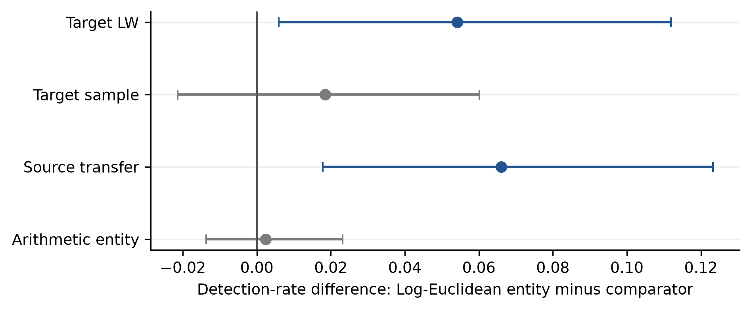
Figure S1. Record-level paired primary-minus-covariance detection differences. Points are equal-motor means and intervals are motor-stratified complete-record percentile bootstrap intervals over the 42 KAIST fault records. Positive values favor the primary. The KAIST comparison is exploratory.

S10.2. Established one-class controls
One-class method | Health alarms | Mean detection (%) | Worst motor (%)
Target OC-SVM | 0/42 | 89.70 | 82.68
Source+target OC-SVM | 0/42 | 91.25 | 82.86
Target Isolation Forest | 1/42 | 97.56 | 95.36
Source+target Isolation Forest | 0/42 | 96.07 | 90.71
Target MinCovDet | 1/42 | 89.82 | 84.11
Source+target MinCovDet | 1/42 | 92.32 | 87.32
Primary Log-Euclidean | 0/42 | 95.71 | 90.00

Primary minus source+target Isolation Forest was -0.36 percentage points ([-3.93, 3.45]), leaving their difference unresolved. Primary minus target OC-SVM was +6.01 points ([1.07, 11.90]); primary minus target MinCovDet +5.89 ([0.95, 11.67]); and primary minus source+target MinCovDet +3.39 ([0.30, 6.85]). The primary-versus-source+target OC-SVM interval included zero. Target Isolation Forest's higher detection was accompanied by 1/42 health alarms and a 12.32% descriptive Wilson upper bound, just above H1. Across five seeds, source+target Isolation Forest varied from 96.01% to 96.85% detection and zero to two health alarms. These findings constrain a superiority claim; they do not provide new independent-motor confirmation.
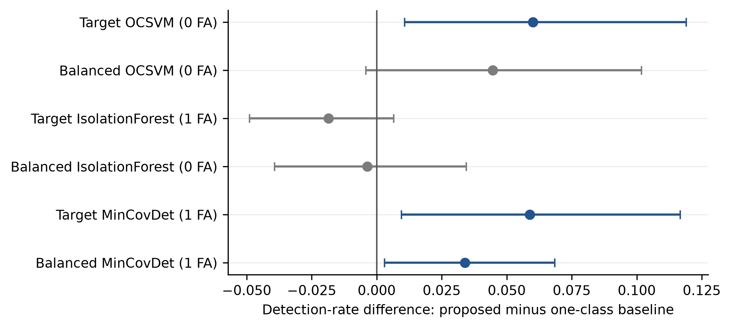
Figure S2. Primary-minus-one-class record-level detection differences. Points and intervals use the same complete-record, motor-stratified exploratory bootstrap as Figure S1. Parenthetical false-alarm counts refer to 42 later-time health blocks.

S10.3. Adaptation budget and calibration feasibility
The fixed-horizon sensitivity keeps calibration and test time common while varying the adaptation prefix. Its health denominator is 30 blocks rather than the 42 of the primary split. The different denominators must not be pooled as independent health evidence.
Adaptation (s) | Adaptation blocks | Fixed-horizon detection (%) | Health alarms | Minimum p if adaptation alone calibrated
3 | 1 | 94.64 | 0/30 | 0.500
6 | 2 | 96.90 | 0/30 | 0.333
12 | 4 | 96.25 | 0/30 | 0.200
24 | 8 | 94.94 | 0/30 | 0.111

In a separate sequential sensitivity, calibration follows the adaptation prefix; the pattern was also nonmonotone. The apparent maximum at 6 s cannot select a primary setting after fault inspection. The original 12 s adaptation remains unchanged. Four adaptation blocks fit a reference but cannot resolve a p-value of 0.05; at least nineteen calibration units are required. Both sensitivities retain an independent calibration role rather than conflating adaptation with alarm calibration.
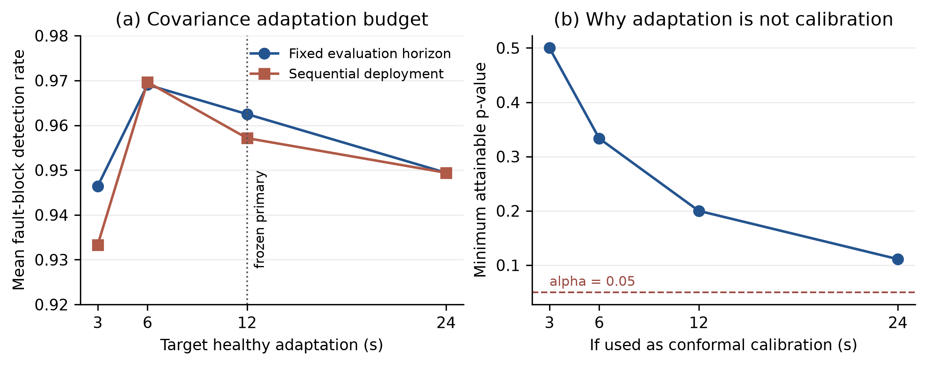
Figure S3. Exploratory adaptation-budget sensitivity and arithmetic calibration feasibility. Fixed-horizon and sequential designs change different time roles and do not replace the primary chronological split. Minimum attainable p-values use 1/(n+1); none of these adaptation prefixes alone resolves 0.05.

S10.4. Block length and aggregation
Alarm block rule | Detection (%) | Health alarms | Calibration units | Disposition
1 s maximum | 93.61 | 2/138 | 60 | Exploratory
2 s maximum | 93.73 | 0/66 | 30 | Exploratory
3 s maximum | 95.71 | 0/42 | 20 | Exact primary reconstruction
3 s 90th percentile | 97.32 | 1/42 | 20 | H1 failed; not selected
5 s maximum | Not scored | Not scored | 12 | 0.05 alarm unresolved
6 s maximum | Not scored | Not scored | 10 | 0.05 alarm unresolved

The 3 s maximum reproduces the primary output. The 90th percentile increases detection but its 12.32% Wilson upper health bound misses the predeclared 12% gate. Five- and six-second blocks do not supply enough calibration units within 60 s. The 3 s maximum was motivated by healthy autocorrelation and remains the primary; fault outcomes cannot change it.
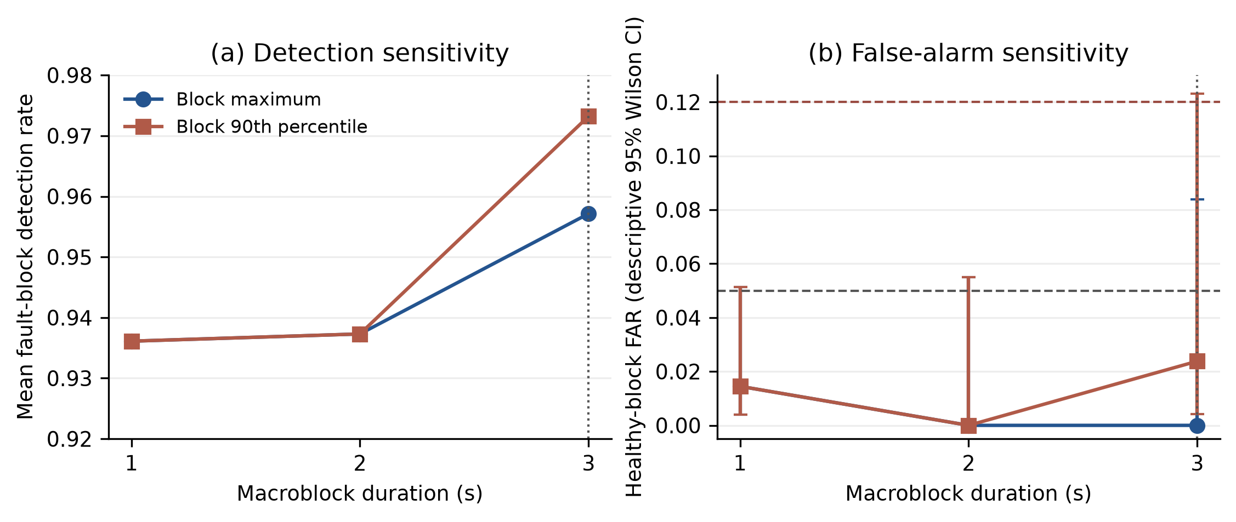
Figure S4. Exploratory block length and aggregation. The figure includes the health-count and calibration-resolution evidence for each tested setting. Changes in block duration also change the temporal analysis denominator; blocks are not independent motor replications.

S10.5. Preserved failed hypotheses
The original protocol hypothesized improved detection at the lowest two nominal severities. All covariance methods reached 100% there, making the proposed difference uninformative rather than proven. The original positive severity-score ordering hypothesis also failed: three of six motor-by-fault-family Spearman associations were negative, including both families for the 1.0 kW motor. Severity labels therefore cannot support severity regression or a monotone physical-response claim from this representation.
The hypothesis that window calibration underestimates deployment risk also lacks a strong causal test here. Later-time KAIST health comes from the same acquisition, so split or resampling differences cannot establish independent-session behavior. The protocol avoids adjacent-window mixing, but it does not quantify a specific amount of leakage-induced inflation on this dataset.
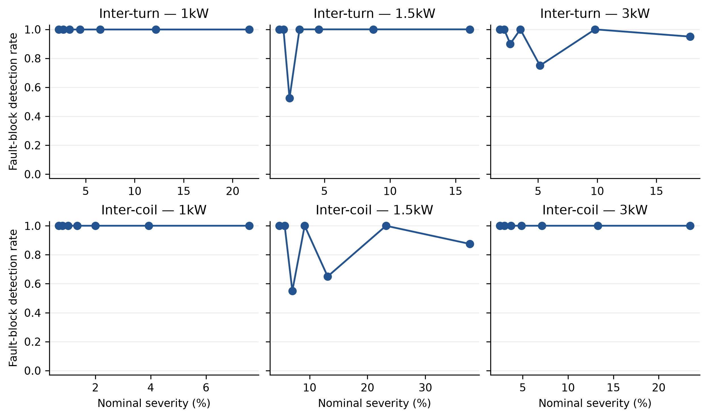
Figure S5. Exploratory detection across labeled nominal severity. Nonmonotone patterns and the low-severity ceiling are retained. The plot does not establish severity estimation or a monotone causal relationship.

S11. Reporting and reproducibility boundary
The main manuscript retains the frozen failed primary result and six core figures; this supplement retains complete comparator, diagnostic, compatibility, and exploratory sensitivity details. The code package provides commands to reconstruct the reported tables and figures, plus the immutable reveal outputs used for evidence checking. Full raw recomputation requires the original licensed archives.
This reporting revision preserves the original protocols and first external/secondary reveal evidence as distinct historical artifacts. Diagnostic explanations and repaired compatibility analyses do not replace the frozen outcomes. The original scores and result files remain unchanged; current-environment checks and stochastic refits are distinguished from byte-identical historical execution.

References
[1] W. Jung, S. Yun, Y. S. Lim, S. Cheong, Y. H. Park, Vibration and Current Dataset of Three-Phase Permanent Magnet Synchronous Motors with Stator Faults, Mendeley Data (2022). doi:10.17632/rgn5brrgrn.5
[2] M. Kozovsky, Measurement of Interturn Short-Circuits Emulation on Dual Three-Phase PMS Motor, Zenodo (2024). doi:10.5281/zenodo.13889418
[3] L. Zezula, M. Kozovsky, P. Blaha, Diagnostics of Interturn Short Circuits in PMSMs With Online Fault Indicators Estimation -- Dataset, Zenodo (2024). doi:10.5281/zenodo.15631383
[4] M. Kozovský, L. Buchta, P. Blaha, Interturn Short Circuit Modelling in Dual Three-Phase PMSM, IECON 2022 -- 48th Annual Conference of the IEEE Industrial Electronics Society, 1-6 (2022). doi:10.1109/IECON49645.2022.9968364

