Title

Author1^{1*}, Author2¹ and Author3^{2*}

¹Affiliation, Address, Country
²Affiliation, Address, Country

The abstract of 100-150 words should contain all the substance of the methods and the results achieved.

Keywords : Keyword1, Keyword2, Keyword3 (3~6 keywords)

*Corresponding author: Tel:+82-2-345-6789, Fax: +82-2-345-6788,
e-mail: kms@kms.or.kr

1. Headings
Set numbered headings to the center, with an initial letter capitalized and bold faces. (for example 1. Introduction)

2. Units
SI (MKS) units are preferred and CGS units may be used.

3. Formulae
Displayed formulae should be numbered and typed. Symbols, superscript, and subscript in any formulae should be written in italics (ex. Hs, Br , T, x). Units should be one spaced with numbers, and chemical symbols and units should be erectly typed. (ex. 10 Oe, 100 emu/g)

4. Figures and tables
The drawings for the figures must be submitted on separate sheets, either as good sharp, dark, and thick enough laser-generated graphics or drawn in black indian ink in large size and carefully lettered (with the use of stencils). The lettering as well as the details should have proportionate dimensions so as not to become illegible or unclear after the usual reduction by the printers. Photos should be submitted as the original photoprints (glossy prints) and micrographs should have magnification markers. Each figure should have an Arabic number and a caption should be collected on a separate sheet. The appropriate place of a figure should be indicated in the text. Color plates: Illustrations can be printed in color when they are necessary. The Author will be asked the extra costs involved. Tables should be typed on separate sheets. Each table should have a Roman number and a caption. The appropriate places for the insertion of the tables should be indicated in the text.

References
[1] K. D. Hong, J. Magnetics 1, 111 (1996).
[2] B. D. Cullity, Introduction to Magnetic Materials, Addison-Wesley, London (1972) pp. 100~110.
[3] K. D. Hong, Ph.D. Thesis, Korea University, Korea (1996).

Fig. 1. Figure caption should be here.

Table 1. The data in column 1 (Ref. [XX] ) are of primary importance. The other . . .
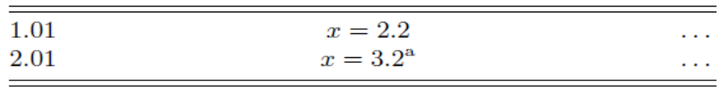
ªRef. [XXX]

Fig. 1.

