When Healthy-Only Alarm Calibration Does Not Transport Across Permanent-Magnet Synchronous Machines: A Protocol-Frozen External Validation
Anonymous review manuscript | author details withheld
Evidence status. Development draft, 2026-08-21. The external PMSG signal protocol, selected method, feature schema, healthy split, time windows, alarm level, and failure gates were frozen before any PMSG signal array was deserialized or inspected. All session-anchor analyses are explicitly post-reveal and cannot replace the failed independent confirmation.

Abstract
Healthy-only fault detection is attractive when labeled machine faults are scarce, but a low false-alarm rate on one test bench does not establish that its alarm calibration will transport to another machine and laboratory. We selected a current-only detector on a dual-three-phase permanent-magnet synchronous motor (PMSM), froze its algorithm and external evaluation protocol, and then revealed an independently collected 2.5 kVA permanent-magnet synchronous generator (PMSG) dataset. The detector uses 26 scale-free current features, a whole-record cross-fitted spline model of healthy speed/load variation, shrinkage residual covariance, a healthy-calibrated rank threshold, and operating-context abstention. On six interpolation loads of the development PMSM, the selected method produced 1/48 actionable healthy-block alarms (2.08%) and 82.29% record-macro fault-block detection. In the frozen PMSG confirmation, however, it alarmed in 71/216 pre-fault sessions (32.87%; descriptive 95% Wilson interval 26.95-39.39%) and detected 156/216 fault sessions within 0.4 s (72.22%; 65.90-77.77%). Both false-alarm gates and the point-detection gate failed. All six frozen comparators also exceeded the 5% session false-alarm limit. A post-reveal two-window session anchor reduced false alarms to 17/216 (7.87%) and detected 167/216 sessions (77.31%), but still failed the false-alarm gate. Topology-disjoint cross-fitting gave 6.48-8.33% false alarms and 70.83-71.30% detection, while healthy calibration thresholds varied 2.5-2.9-fold between folds. Thus, session offset explained part, but not all, of the external failure. The evidence is conditional on one development motor and one confirmation generator and does not identify which component of the compound shift caused failure. It does show that a healthy-only score, an alpha-level rank threshold, and operating-point support are separate deployment objects; all require prospective target-session validation.
Keywords: permanent-magnet synchronous machine; healthy-only fault detection; external validation; false-alarm calibration; inter-turn short circuit; dataset shift

1. Introduction
Inter-turn short circuits disrupt the electrical symmetry of permanent-magnet synchronous machines and can progress from a local winding defect to severe thermal and magnetic damage. Three-phase stator current is an attractive monitoring signal because it is already measured by most drives and carries negative-sequence, harmonic, and current-vector signatures of electrical faults [1, 2, 3]. The diagnostic problem is nevertheless difficult under changing speed and load: the same operating variables that alter fault signatures also change healthy current spectra and amplitudes [4, 5]. A detector can therefore learn an operating condition rather than health.
Healthy-only learning offers a practical response to the shortage of representative fault data. A normal-behavior model or one-class boundary is fitted without fault examples, and a large deviation becomes an alarm [6, 7]. Recent permanent-magnet monitoring work likewise uses normal current data to construct an anomaly score before classifying fault type or severity [8]. Healthy-only fitting removes one unrealistic data requirement, but it does not remove the need to select an operating threshold. That threshold depends on the score distribution of healthy data at the deployed machine.
This distinction matters when a model leaves its development bench. Cross-domain and cross-machine fault diagnosis are already established research areas [9, 10, 11, 12]. Much of that literature evaluates fault-class accuracy, often with target fault classes available during evaluation or adaptation. A deployed healthy-only alarm has a different endpoint: it must maintain an acceptable false-alarm incidence before any target fault is observed. A transfer method can rank faults above healthy samples and still be unusable if the entire healthy score distribution moves beyond the old threshold.
Evaluation design compounds this problem. Adjacent windows from one recording are not independent machine replicates. Randomly splitting such windows can leak run-, day-, or specimen-specific information. In a bearing-diagnosis audit, physically separated split strategies changed some reported accuracies by more than 40 percentage points [13]. Structured cross-validation is consequently required whenever data have temporal or hierarchical dependence [14]. For an external deployment claim, an even stronger separation is needed: model and failure criteria should be fixed before the external signal is inspected.
Rank-based conformal calibration offers an auditable way to map anomaly scores to p-values under exchangeability [15]. Conformal anomaly alarms have been used in heterogeneous industrial fleets [16, 17], and recent process-monitoring work compares their false alarms with classical thresholds [18]. However, exchangeability does not follow from non-overlapping windows, and distribution shift can invalidate the operating behavior of a frozen conformal rule [19, 20, 21]. We therefore treat the rank threshold in this study as a predeclared operational calibration rule and report empirical record/session false alarms; we do not claim a distribution-free session-risk guarantee.
The present study asks a deliberately narrow question: does a healthy-only, operating-conditioned detector selected on one PMSM retain its alarm operating point on an independently collected permanent-magnet synchronous generator? The study contributes four elements.
1. The development method is fitted and calibrated only on healthy records, with whole-record load folds and explicit abstention outside healthy operating support.
2. The selected method, feature schema, PMSG healthy split, time windows, alpha level, and pass/fail gates were hash-frozen before the first PMSG signal reveal.
3. The independent outcome is reported at the pre-fault session and fault-record level rather than treating hundreds of adjacent windows as physical replicates; all seven frozen methods remain visible.
4. After the confirmatory failure, session-local repair mechanisms are evaluated in a separately labeled, topology-disjoint internal analysis. Their results cannot replace the independent confirmation.
The headline result is negative but operationally useful. Development calibration did not transport, and the remaining error was not removed by simply subtracting a short healthy session anchor or reapplying the selected spline conditioning. This result changes the design requirement for the next experiment: independent healthy sessions and prospective target-session calibration are not optional implementation details; they are part of the detector.

2. Related work and contribution boundary

2.1 Current-based short-circuit diagnosis under operating variation
Inter-turn fault diagnosis in PMSMs includes model-based observers, negative-sequence indicators, spectral/order-tracking methods, and learned classifiers. Extended reviews and experimental studies already establish the physical fault mechanisms and the dependence of current signatures on winding configuration, speed, load, and control [1, 4]. Hybrid physical-data methods also address sparse fault data and changing speed [22]. The present work does not propose a new electrical signature. It intentionally uses a fixed set of scale-free current features so that the evaluation focuses on healthy calibration and external transport.
The development data are a published dual-three-phase PMSM experiment with controlled inter-turn emulation [23, 24]. The confirmation data are a separately published PMSG benchmark with controlled inter-turn and inter-winding short circuits [25]. These machines differ in role, winding topology, instrumentation, acquisition rate, operating grid, and fault construction. Their comparison is therefore an external compound-shift stress test, not a controlled causal experiment that isolates one difference.

2.2 Healthy-only learning and cross-machine generalization
Healthy-only rotating-machine detection predates this work. One-class support estimation, robust covariance, isolation methods, autoencoders, and self-supervised representations all provide precedents [26, 27, 28, 6, 7]. Similarly, supervised domain generalization has been tested over multiple machines and operating conditions [10]. Our candidate spline residual, Isolation Forest, and Minimum Covariance Determinant (MinCovDet) are thus comparators and engineering choices, not novelty claims.
What remains less commonly reported is whether a preselected healthy-only alarm operating point survives an external signal reveal. AUROC is threshold-free and can remain respectable even when the deployed threshold produces unacceptable false alarms. Choosing a new threshold after target faults are viewed confounds external evaluation with method development. Paper 3 therefore freezes the alpha-level calibration and evaluates a pre-fault session endpoint before examining fault detection.

2.3 Conformal alarms under dependent and shifted observations
Given healthy calibration scores, an upper-tail rank p-value is transparent and model-agnostic. Its ordinary finite-sample guarantee, however, requires exchangeability of calibration and test scores. Neither multiple windows from one physical record nor sessions collected at a different laboratory automatically meet that condition. Dependent conformal inference and time-series analyses provide specialized theory, but do not justify labeling arbitrary motor windows as independent [19, 20]. This paper accordingly uses conformal ranking for threshold construction but labels all Wilson intervals and false-alarm estimates as descriptive for the evaluated records. The contribution is the observed calibration-transport failure and its documented chronology, not a new conformal guarantee.

3. Study chronology and datasets

3.1 Evidence statuses
Three evidence statuses were fixed. Developmental results may use development fault labels to choose among seven candidates. Confirmatory results use the selected method and PMSG protocol frozen before signal reveal; comparator outputs cannot replace the selected method. Post-reveal analyses were specified only after the confirmatory result was known and are used to investigate mechanisms. The complete chronology, protocol hashes, input hashes, and an execution-incident disclosure are recorded in docs/paper3_reveal_log.md.
Before the freeze, repository filenames and file metadata were enumerated. A Git size query inadvertently fetched some objects containing MAT blobs into local object storage, but no MAT signal variable was checked out for analysis, deserialized, plotted, summarized, or used for a decision. We therefore use the precise phrase signal-unrevealed metadata freeze, not the stronger claim that no signal bytes were ever transferred.

3.2 Development dual-three-phase PMSM
The development archive contains one dual-three-phase PMSM sampled at 10 kHz, with two three-phase current subsystems. Eight healthy records cover commanded loads from 0 to 35 N m in 5 N m steps; 48 fault records cover six shorted-turn/phase configurations at the same loads. Each file contains a rising-speed experiment. A common preselected interval of [12,36) s yields 120 non-overlapping 0.2 s windows and eight 3 s blocks per subsystem. Over that interval, filename/command context spans 191.5-2708.3 r/min. Only the six phase currents, time, commanded speed, and filename load are used. Measured speed, dq signals, voltage, electrical angle, and fault-control variables are excluded.
Eight load folds hold out one complete healthy record and the six corresponding fault records at a time. Each fold uses four other healthy loads for fitting and three for threshold calibration. The six interior loads (5-30 N m) are the primary interpolation folds. The 0 and 35 N m folds deliberately lie outside the fit-axis bounds and serve as abstention stress tests. The development feature table contains 56 physical records and 13,440 record-subsystem-window rows.

3.3 Independent PMSG confirmation
The external dataset was collected at a different laboratory from one 2.5 kVA, four-pole PMSG [25]. The frozen v1.1.0 inventory contains 225 three-second MAT files: nine standalone healthy files and 216 controlled fault files. The fault files comprise 108 inter-turn and 108 inter-winding records, formed by 24 terminal topologies at three nominal speeds (1200, 1500, and 1800 r/min) and three torque setting codes (52, 64, and 80). The codes are retained as dataset setting labels; they are not relabeled as N m. Signals were sampled at 20 kHz.
The container audit required all 225 files, a common schema, and aligned finite vectors. Exactly four variables were whitelisted: time and three phase currents (t, Ia, Ib, Ic). Fault current, fault relay, angle, measured speed, voltage, torque, dq variables, and all other fields were not loaded by the feature builder. All files passed without a compatibility patch. The resulting table contains 2,493 0.2 s windows.
Standalone healthy files contribute [0.2,2.8) s (13 windows each). Four corner operating settings form the healthy fit set (52 windows), the three middle-torque settings form the calibration set (39 windows), and two 1500 r/min edge-torque files form the untouched healthy test set (26 windows). Every fault record contributes three pre-fault windows from [0.2,0.8), two commanded-fault windows from [1.0,1.4), and six recovery windows from [1.6,2.8). The first fault window includes possible relay delay by design.
PMSG role | Physical files | Frozen interval per file | Feature windows | Permitted use
Healthy fit | 4 | [0.2,2.8) s | 52 | fit score geometry only
Healthy calibration | 3 | [0.2,2.8) s | 39 | set rank threshold only
Standalone healthy test | 2 | [0.2,2.8) s | 26 | external healthy diagnostic
Fault-record pre-period | 216 | [0.2,0.8) s | 648 | primary session FAR only
Commanded-fault period | 216 | [1.0,1.4) s | 432 | detection and alarm time
Recovery period | 216 | [1.6,2.8) s | 1,296 | secondary diagnostic only

The following comparison makes the experimental unit explicit.
Property | Development PMSM | Independent PMSG confirmation
Physical machines | 1 | 1
Standalone healthy records | 8 | 9
Fault records | 48 | 216
Operating grid | 8 loads during a common speed rise | 3 speeds x 3 setting codes
Fault configurations | 6 | 24 terminal topologies in 2 families
Sampling rate | 10 kHz | 20 kHz
Basic feature window | 0.2 s | 0.2 s
Primary alarm unit | 3 s subsystem/system-max block | complete pre-fault or fault session
Healthy split | four load records fit, three calibrate, one test per fold | four records fit, three calibrate, two healthy-test
Population inference | one motor; blocks are dependent | one generator; 216 files are not machines

4. Healthy-only detector and frozen evaluation

4.1 Current feature vector
Each 0.2 s three-phase window is mapped to 26 dimensionless features. They cover sequence unbalance; coefficient of variation of fundamental amplitude, phase RMS, and Clarke-vector radius; zero-sequence ratio; spectral entropy; lower and upper sideband ratios; mean and maximum second-to-fifth harmonic ratios; aggregate harmonic distortion; and per-phase RMS ratios, crest factors, and kurtosis. Absolute current scale and current-derived fundamental frequency are excluded. Context is strictly exogenous: commanded/filename speed and load/setting code.
Let z be the feature vector and c the two-dimensional operating context. A healthy mean model m(c) is fitted with additive uniform-knot quadratic splines and ridge penalty one. Predictions used to estimate residual geometry are obtained by four-fold cross-fitting with complete healthy records held together. If r = z - m(c), the componentwise residual median is removed, robust scales are computed from median absolute deviations with standard-deviation fallback, and a Ledoit-Wolf covariance estimate stabilizes the 26-dimensional geometry. The anomaly score is the squared Mahalanobis distance of the standardized residual. Larger scores are more anomalous.
The six comparators preserve the same information boundary: constant, linear, and quadratic conditional residuals; the same spline with a context-local residual scale; Isolation Forest; and MinCovDet. All fit only healthy features. Candidate order, hyperparameters, random seed, and preprocessing were frozen in the development protocol.

4.2 Operating-context support and abstention
Fit context is robustly normalized. A nearest-fit radius is set to 1.1 times the largest nearest-fit distance among disjoint healthy calibration rows, and a test point must also lie inside every fit-context axis bound. A 3 s development block is supported only when all 15 windows of both subsystems are supported. Unsupported samples abstain; abstention is neither a healthy decision nor a detected fault. The support rule is a geometric deployment warning, not a conformal set. On the PMSG grid every evaluation context was supported, so external abstention was zero and could not protect against outcome-distribution shift.

4.3 Rank threshold
For calibration scores A_1,...,A_n and a test score A, the upper-tail p-value is
p(A) = [1 + sum_i 1(A_i >= A)] / (n + 1).
An actionable alarm requires p <= 0.05 and supported context. In development, each method uses 24 healthy 3 s calibration blocks; the block score is the maximum over 15 windows and both current subsystems. In confirmation, n=39 healthy calibration windows and the threshold is the 38th order statistic because ceil(40 x 0.95)=38. These units are dependent within a small number of physical records. The rank construction is therefore reproducible, but its usual exchangeable finite-sample guarantee is not asserted.

4.4 Development selection
A method is development-eligible when its pooled actionable healthy-block FAR across the six interpolation loads is no greater than 5% and fault abstention is no greater than 20%. Among eligible candidates, the rule maximizes fault-record-macro actionable block detection, then uses lower FAR, lower abstention, and frozen candidate order as tie breaks. Fault labels select the method only at this stage. Edge-load results cannot select a method.

4.5 Confirmatory endpoints and gates
The selected spline residual is the sole confirmatory method. The six other candidates are mechanically applied secondary comparators. The primary PMSG endpoints are:
1. pre-fault session FAR: any actionable alarm among three pre-fault windows;
2. fault-record detection: any actionable alarm among two active-fault windows;
3. command-to-alarm time: 0.2 s, 0.4 s, or right-censored beyond 0.4 s;
4. fault-record abstention.
The joint gate requires point FAR no greater than 5%, descriptive Wilson upper bound no greater than 10%, point detection at least 75%, descriptive Wilson lower bound at least 65%, and abstention no greater than 10%. All gates were written before signal reveal and none may be relaxed after observing PMSG results.

5. Results

5.1 Development selection
The spline residual detector was the best eligible candidate on the six interpolation loads. It produced 1/48 actionable healthy-block alarms (2.08%), no primary abstention, and 82.29% record-macro actionable block detection across 36 fault records and 288 blocks. Every fault record raised at least one alarm. The local-scale spline reached 93.75% detection but produced 10/48 healthy alarms (20.83%) and was ineligible. Both boundary loads were rejected by the fit-axis support rule, as intended; their abstention is not evidence of fault detection.
Table 2 shows that method ranking did not transport. Development and confirmation endpoints have different observation horizons, so absolute percentages should not be subtracted as a single treatment effect; the relevant comparison is the within-dataset operating point and the predeclared confirmation gate.
Method | Development FAR (%) | Development detection (%) | Eligible/selected | PMSG pre-fault session FAR (%) | PMSG fault-record detection (%)
Unconditioned residual | 2.08 | 28.47 | yes | 51.39 | 80.09
Linear residual | 2.08 | 76.39 | yes | 26.39 | 68.52
Quadratic residual | 2.08 | 81.25 | yes | 39.81 | 75.93
Spline residual | 2.08 | 82.29 | selected | 32.87 | 72.22
Spline + local scale | 20.83 | 93.75 | no | 25.93 | 64.35
Isolation Forest | 2.08 | 65.97 | yes | 41.67 | 68.98
MinCovDet | 2.08 | 7.64 | yes | 12.50 | 56.48

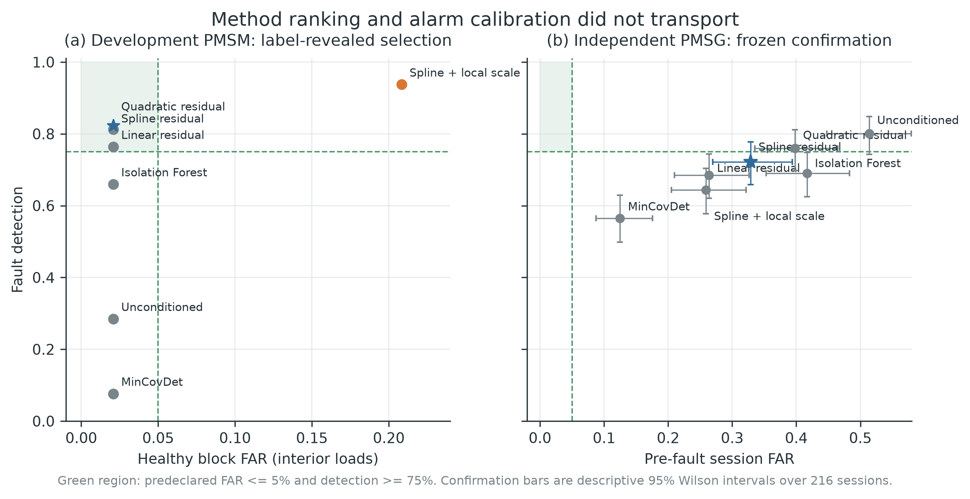

5.2 Frozen independent confirmation failed
The selected spline threshold was 55.31. It alarmed in 10/26 untouched standalone healthy windows and both healthy-test files. More importantly, 116/648 pre-fault windows alarmed, placing at least one false alarm in 71/216 sessions. The pre-fault session FAR was therefore 32.87% (95% Wilson interval 26.95-39.39%), well above both predeclared FAR gates.
Among the 216 fault sessions, 156 raised an actionable alarm in the two-window active interval (72.22%, 65.90-77.77%). The lower confidence limit exceeded 65%, but the point estimate did not reach 75%. There was no PMSG abstention. The joint confirmation failed three of five gates (Table 3). The selected method's record-level AUROC was 0.780 and AUPRC was 0.829, illustrating why discrimination metrics alone cannot establish a usable alarm threshold.
Confirmatory criterion | Observed | Required | Result
Pre-fault session FAR | 71/216 = 32.87% | <= 5% | fail
Descriptive FAR upper bound | 39.39% | <= 10% | fail
Fault-record detection | 156/216 = 72.22% | >= 75% | fail
Descriptive detection lower bound | 65.90% | >= 65% | pass
Fault-record abstention | 0/216 = 0% | <= 10% | pass

No frozen comparator rescued the external conclusion. MinCovDet had the lowest pre-fault session FAR, but 12.50% still exceeded the 5% point gate and its detection was only 56.48%. The unconditioned residual detected 80.09% of faults but falsely alarmed in 51.39% of pre-fault sessions. Because the selected method and confirmatory endpoint were fixed, neither comparator can be promoted after reveal.

5.3 Operating-condition and fault-family heterogeneity
The frozen detector's errors varied systematically across the PMSG grid. Pre-fault session FAR was 29.17%, 50.00%, and 19.44% at 1200, 1500, and 1800 r/min. Across torque setting codes 52, 64, and 80, it decreased from 48.61% to 30.56% and 19.44%, while detection also decreased from 83.33% to 70.83% and 62.50%. The 1500/52 cell combined 91.67% detection with 66.67% FAR; the 1800/80 cell combined 66.67% detection with 0% FAR. These patterns show that an apparently strong cell can be achieved by moving the entire score distribution upward, not by separating health from fault.
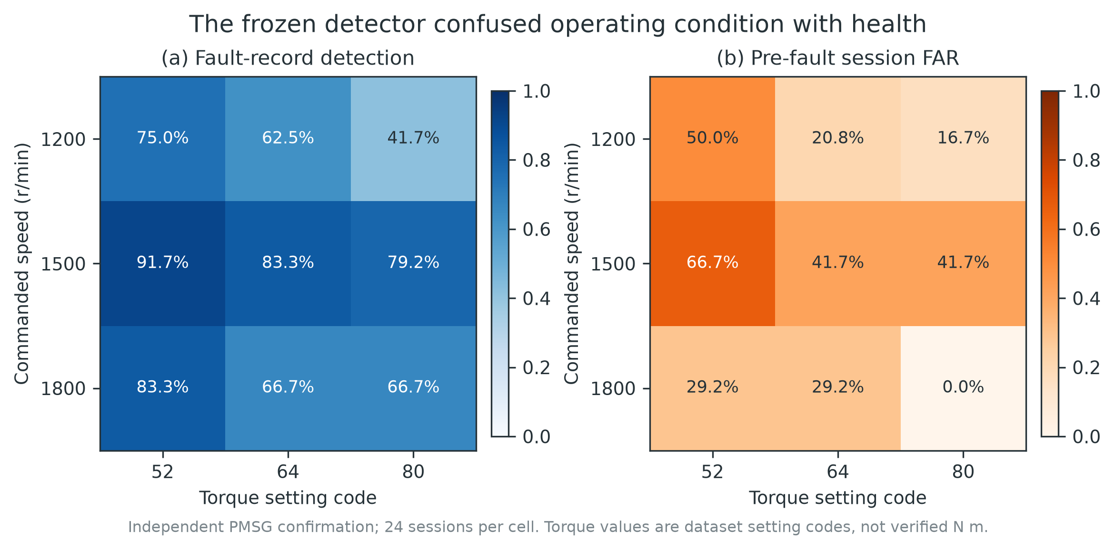
Inter-winding records were detected more often than inter-turn records (90.74% versus 53.70%) but also had slightly higher pre-fault FAR (35.19% versus 30.56%). Terminal span, family, and physical severity are not separable in this designed dataset, and the same operating cells are reused across topologies. These strata are descriptive and cannot establish causal fault effects.
Of the 156 detected sessions, 127 alarmed in the first 0.2 s window and 29 only in the second; 60 were right-censored beyond 0.4 s. Right-censoring means that the fixed active-fault horizon ended, not that a later detector could never alarm.

6. Post-reveal mechanism analyses
The analyses in this section were conceived after the failed confirmation was visible. They remain useful for mechanism assessment, but they are not independent validation and cannot change the confirmatory verdict.

6.1 Two-window session anchor
Each PMSG record begins with a healthy interval. The first two 0.2 s windows were therefore used to form a coordinatewise median anchor, and every later feature vector was replaced by its within-session difference from that anchor. A shrinkage Mahalanobis geometry was fit to 44 residual windows from the four standalone healthy fit files; 33 residual windows from the three calibration files set the alpha-level threshold. This preserves the original 4/3/2 healthy file split.
The session anchor lowered pre-fault session FAR from 32.87% to 7.87% (17/216; 95% Wilson 4.97-12.24%) and increased detection to 77.31% (167/216; 71.28-82.39%). It therefore demonstrated that session offset was material. It did not pass the original FAR gates: the point FAR exceeded 5% and its upper bound exceeded 10%. Moreover, the untouched standalone healthy-test residuals produced 10/22 window alarms, showing that the standalone calibration files themselves did not define a stable residual threshold.
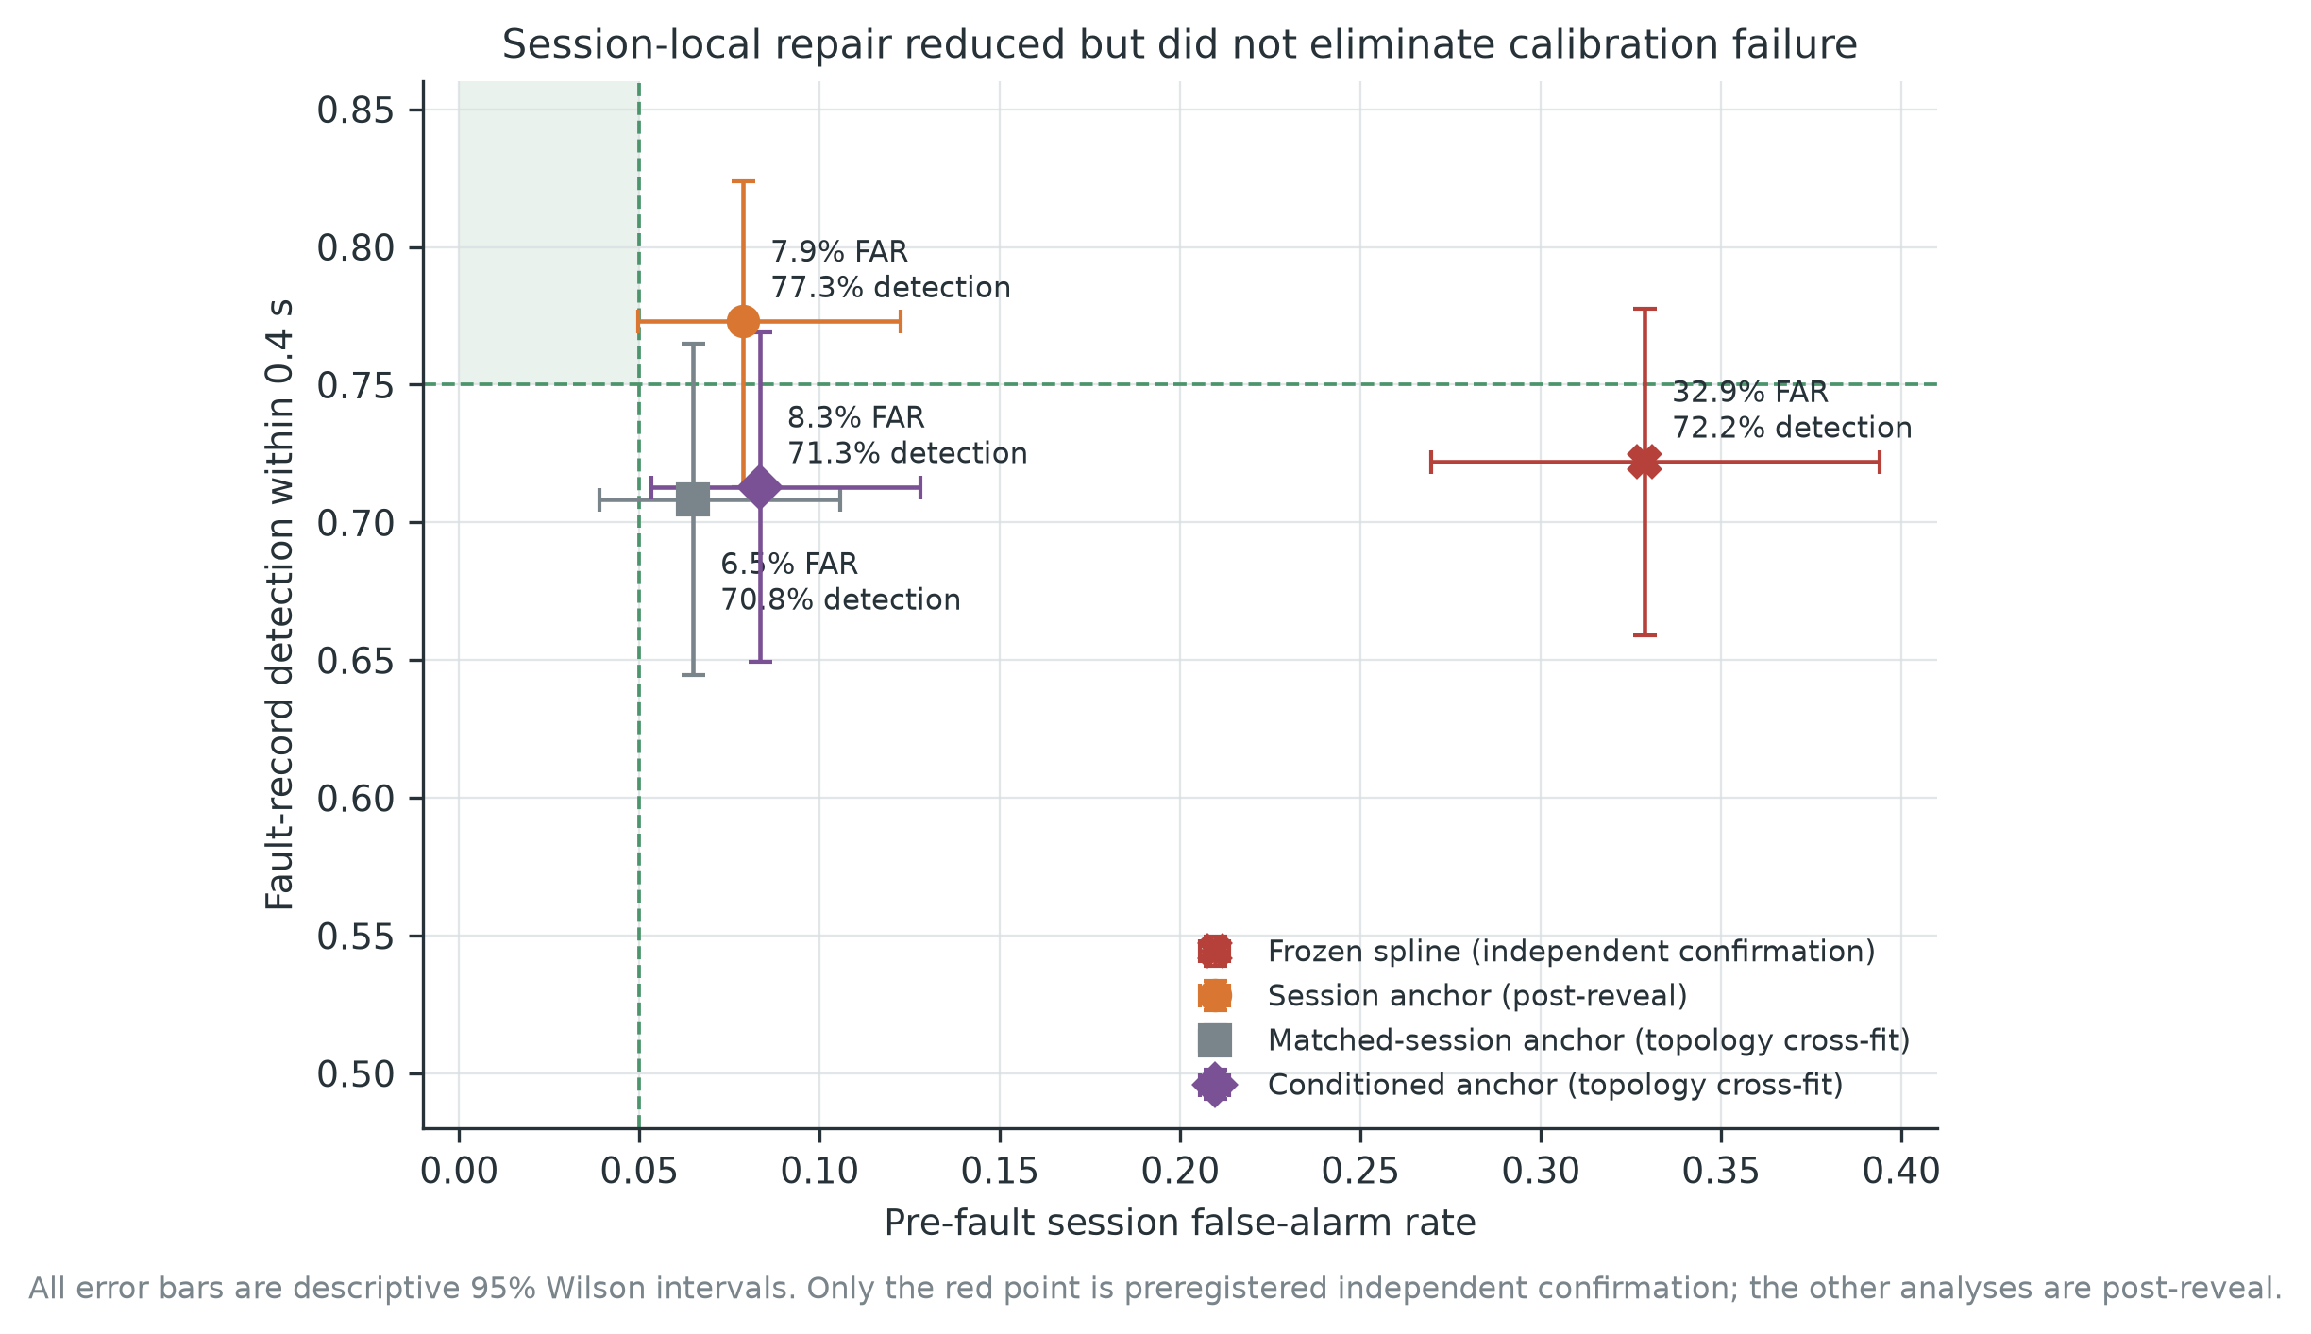

6.2 Topology-disjoint matched-session calibration
The remaining calibration-source mismatch was tested using only the healthy pre-fault portion of fault sessions. Twenty-four fault topologies (12 per family) were sorted within family and assigned modulo three to balanced buckets. In each of three outer folds, eight topologies (72 operating-condition records) fit residual geometry, eight calibrated the threshold, and eight formed the test set. Only pre-fault residuals entered fitting and calibration; the two active windows were revealed for the test bucket. Every topology was tested once.
Matched-session cross-fitting produced 14/216 pre-fault false alarms (6.48%, 3.90-10.58%) and detected 153/216 faults (70.83%, 64.45-76.49%). Neither point endpoint met its original gate. Fold results exposed substantial instability: healthy thresholds were 35.15, 88.08, and 53.93; FARs were 9.72%, 1.39%, and 8.33%; and detection was 86.11%, 54.17%, and 72.22%.

6.3 Conditioned session anchor
As the final allowed PMSG mechanism check, the already selected spline model was applied to the session residuals using the same topology buckets, ridge, knots, alpha, and support rule. No additional feature or detector was searched. The conditioned anchor produced 18/216 false alarms (8.33%, 5.34-12.79%) and 154/216 detections (71.30%, 64.93-76.92%). Thresholds were 31.80, 93.13, and 49.56, again varying by almost threefold. The original joint gate failed.
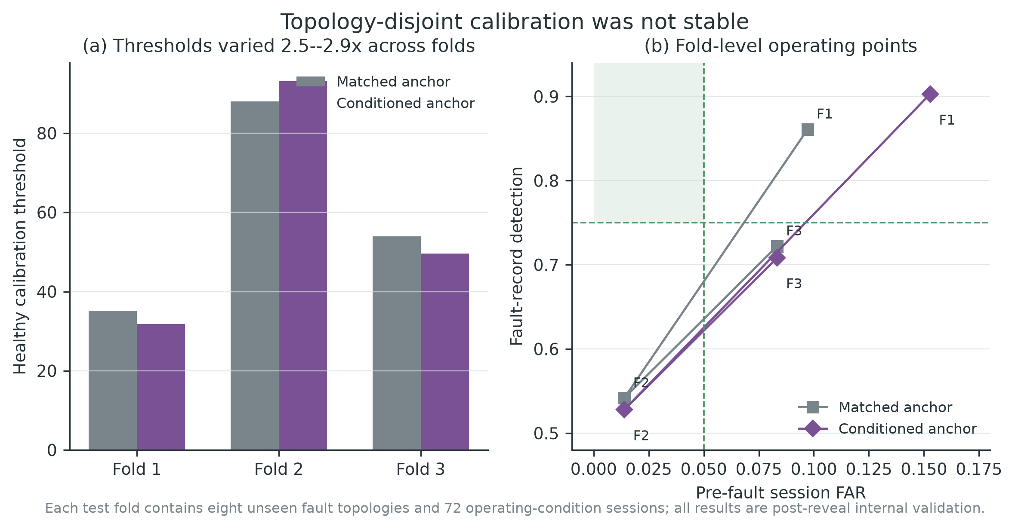
Across the four PMSG analyses, the number detected in the first fault window ranged from 127 to 149 and the number censored beyond 0.4 s ranged from 49 to 63. The repair mechanisms mainly moved the healthy threshold and first-window sensitivity; none simultaneously stabilized FAR and detection.
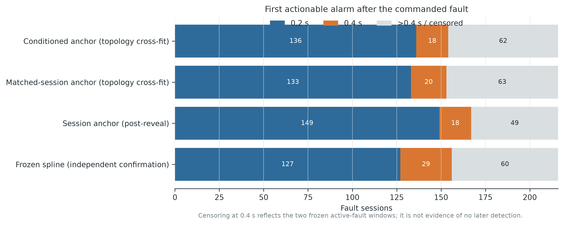
PMSG analysis | Evidence status | Calibration source | Pre-fault FAR | Detection <=0.4 s | First-window / censored
Frozen spline | independent confirmation | 3 standalone healthy files | 71/216 (32.87%) | 156/216 (72.22%) | 127 / 60
Session anchor | post-reveal exploratory | 3 standalone healthy files | 17/216 (7.87%) | 167/216 (77.31%) | 149 / 49
Matched anchor | post-reveal topology cross-fit | healthy pre-periods from disjoint topology bucket | 14/216 (6.48%) | 153/216 (70.83%) | 133 / 63
Conditioned anchor | final post-reveal topology cross-fit | same matched-session design | 18/216 (8.33%) | 154/216 (71.30%) | 136 / 62

7. Discussion

7.1 The calibration set is part of the deployed detector
The central finding is not simply that accuracy decreased. The healthy score distribution and its threshold did not transport. On development interpolation loads, five of seven candidates shared an actionable FAR of 2.08% because the rank threshold and support rule were effective within that bench. On the PMSG, every candidate exceeded the 5% session FAR gate, despite being refit and recalibrated from PMSG standalone healthy files. The problem was therefore not only zero-shot parameter transfer. Three healthy calibration records did not represent the pre-fault distribution of the 216 fault experiments.
This distinction changes how a healthy-only detector should be specified. The deployed object is not just a feature extractor and anomaly score. It includes the source of healthy calibration sessions, their acquisition timing, the aggregation horizon, the support rule, and the threshold-update policy. Reporting only AUROC or fault-record-any detection leaves these components untested.

7.2 Operating-context support cannot detect every domain shift
The support rule correctly abstained on development loads outside the fit range. It abstained on no PMSG record because all nominal speed/setting combinations lay inside the healthy context box. Nevertheless, external false alarms were high. This is an important negative result: exogenous context support detects geometric extrapolation in c, not a change in the conditional distribution P(z|c) caused by another winding topology, sensor chain, controller, laboratory, or session procedure. A deployment warning therefore needs both context support and direct monitoring of healthy residual transport.
The PMSG heatmap further shows why conditioning alone is insufficient. High detection and high false alarms co-occurred at several settings. A regression can remove the mean trend with nominal speed and setting code while leaving condition-dependent covariance or session-specific offsets. The final conditioned-anchor analysis retained almost threefold threshold variation, consistent with residual calibration instability rather than a missing single mean curve.

7.3 Session anchoring helped, but was not independently confirmed
Subtracting two initial healthy windows reduced false alarms by 25 percentage points relative to the frozen spline and produced the highest detection among the four PMSG analyses. This is engineering evidence that a short commissioning prefix can remove acquisition/session offset. It is not permission to deploy the anchor. The method was proposed after PMSG faults and per-condition results were visible, its standalone healthy-test FAR remained high, and its topology-disjoint internal validation did not pass the original gate. A genuinely new machine with a prospectively frozen anchor protocol is needed.

7.4 Why the negative result is useful
Negative external validation can prevent a more consequential failure: interpreting a within-bench alarm rate as a field guarantee. The current experiment provides a complete record of what was fixed, what failed, and what was tried afterward. It also shows that a stronger detector score need not yield a better alarm. The unconditioned residual had the highest frozen PMSG detection but the worst false-alarm incidence; MinCovDet had the lowest false alarms but inadequate detection. Model ranking depends on the operational loss, not only discrimination.
The next study should collect multiple independent healthy sessions per operating cell and date, reserve entire sessions for prospective calibration, and hold out a physical machine or laboratory for the final reveal. Alarm burden should be reported per session and per operating hour. A sequential rule should distinguish a transient isolated score from persistent evidence, and its reset/update policy must be frozen. If a session anchor is used, anchor duration, contamination checks, and fallback abstention must be specified before faults are observed.

8. Limitations
First, the study contains two physical machines: one development motor and one confirmation generator. The 216 PMSG fault files are not independent machines, and their speed/setting and topology repetitions do not support a fleet-population confidence interval. Wilson intervals describe the observed session proportions only.
Second, external shift is compound. Motor versus generator operation, single versus dual three-phase winding, sensors, sampling rates, controller dynamics, laboratory procedure, and fault construction change together. The study establishes conditional failure for this transport path but cannot assign causal responsibility to one factor.
Third, controlled short circuits may not reproduce gradual insulation degradation, thermal propagation, or field noise. The fixed active interval is only 0.4 s, so undetected records are right-censored rather than proven permanently undetectable. No vibration, voltage, temperature, or flux measurement was used.
Fourth, windows within records and records collected from one machine are dependent. The alpha-level rank rule is operational, not a formal guarantee of 5% session FAR under this dependence. The small number of standalone healthy PMSG files limits calibration resolution and representativeness.
Fifth, development amendments to load roles and support geometry were made after developmental fault outputs were visible, before the PMSG signal reveal. They are documented and allowed only for development. All session-anchor methods were conceived after confirmation and remain post-reveal. There is no untouched validation target for those repairs.

9. Conclusion
A healthy-only, speed/load-conditioned current detector that appeared operationally acceptable on a development PMSM did not retain its alarm calibration on an independent PMSG bench. The frozen detector falsely alarmed in 32.87% of pre-fault sessions and detected 72.22% of fault records within 0.4 s, failing its predeclared joint gate. Every frozen comparator also exceeded the 5% false-alarm limit. Session anchoring reduced false alarms substantially, but topology-disjoint analyses retained 6.48-8.33% FAR, 70.83-71.30% detection, and large fold-to-fold threshold variation.
The practical conclusion is direct: within-bench healthy calibration, nominal operating-point support, and a conformal-style rank threshold do not by themselves authorize cross-machine deployment. A prospective target-session calibration design, repeated independent healthy sessions, and an untouched machine/laboratory reveal are required. Until such evidence exists, the correct output is an abstention or a commissioning study, not a claimed low-risk alarm.

Data and code availability
The development archive is available under DOI 10.5281/zenodo.13889418. The independent PMSG data article and versioned archive are available under DOIs 10.1016/j.dib.2025.112040 and 10.5281/zenodo.15741561. Analysis code, protocol files, file hashes, processed-feature builders, frozen summaries, figures, and a reproducibility bundle will be deposited in a public repository upon acceptance. The raw third-party data are not redistributed in the manuscript bundle; download instructions and immutable source identifiers are included.

Declarations
Funding: Author input required.
Competing interests: The authors declare no competing interests, subject to author confirmation.
Author contributions: Author input required.
Ethics approval: Not applicable; the study uses public machine-test datasets and no human or animal participants.
Use of generative AI: The authors must complete this statement according to the selected journal's policy and disclose any language or coding assistance as required.

References
[1] Zafarani, M., Bostanci, E., Qi, Y., Goktas, T., & Akin, B. (2018). Interturn Short-Circuit Faults in Permanent Magnet Synchronous Machines: An Extended Review and Comprehensive Analysis. IEEE Journal of Emerging and Selected Topics in Power Electronics, 6(4), 2173-2191. https://doi.org/10.1109/JESTPE.2018.2811538
[2] Jeong, H., Moon, S., & Kim, S. W. (2017). An Early Stage Interturn Fault Diagnosis of PMSMs by Using Negative-Sequence Components. IEEE Transactions on Industrial Electronics, 64(7), 5701-5708. https://doi.org/10.1109/TIE.2017.2677355
[3] Li, D., Zhu, M., Zhao, Y., & Lin, S. (2024). Detection and Location of Inter-Turn Short-Circuit in a PMSM Based on Square of Negative Sequence Current Vector Modulus. IEICE Electronics Express, 21(22), 20240550. https://doi.org/10.1587/elex.21.20240550
[4] Urresty, J. C., Riba, J. R., & Romeral, L. (2013). Diagnosis of Interturn Faults in PMSMs Operating Under Nonstationary Conditions by Applying Order Tracking Filtering. IEEE Transactions on Power Electronics, 28(1), 507-515. https://doi.org/10.1109/TPEL.2012.2198077
[5] Zhou, H., Wang, B., Zio, E., Wen, G., Liu, Z., Su, Y., & Chen, X. (2023). Hybrid System Response Model for Condition Monitoring of Bearings Under Time-Varying Operating Conditions. Reliability Engineering & System Safety, 239, 109528. https://doi.org/10.1016/j.ress.2023.109528
[6] Yang, Z., Huang, Y., Nazeer, F., Zi, Y., Valentino, G., Li, C., Long, J., & Huang, H. (2023). A Novel Fault Detection Method for Rotating Machinery Based on Self-Supervised Contrastive Representations. Computers in Industry, 147, 103878. https://doi.org/10.1016/j.compind.2023.103878
[7] Yoon, D., & Yu, J. (2024). Machinery Fault Signal Detection with Deep One-Class Classification. Applied Sciences, 14(1), 221. https://doi.org/10.3390/app14010221
[8] Wang, H., Wang, L., Wu, Q., Pei, H., & Diao, L. (2025). A Data-Driven Intelligent Fault Diagnosis Framework for Permanent Magnet in PMSM. Alexandria Engineering Journal, 113, 331-346. https://doi.org/10.1016/j.aej.2024.11.030
[9] Li, X., Zhang, W., Ma, H., Luo, Z., & Li, X. (2020). Domain Generalization in Rotating Machinery Fault Diagnostics Using Deep Neural Networks. Neurocomputing, 403, 409-420. https://doi.org/10.1016/j.neucom.2020.05.014
[10] Li, J., Wang, Y., Zi, Y., Zhang, H., & Li, C. (2023). Causal Consistency Network: A Collaborative Multimachine Generalization Method for Bearing Fault Diagnosis. IEEE Transactions on Industrial Informatics, 19(4), 5915-5924. https://doi.org/10.1109/TII.2022.3174711
[11] Zhao, C., Zio, E., & Shen, W. (2024). Domain Generalization for Cross-Domain Fault Diagnosis: An Application-Oriented Perspective and a Benchmark Study. Reliability Engineering & System Safety, 245, 109964. https://doi.org/10.1016/j.ress.2024.109964
[12] Xiao, Y., Shao, H., Yan, S., Wang, J., Peng, Y., & Liu, B. (2025). Domain Generalization for Rotating Machinery Fault Diagnosis: A Survey. Advanced Engineering Informatics, 64, 103063. https://doi.org/10.1016/j.aei.2024.103063
[13] Wheat, L., von Mohrenschildt, M. V., Habibi, S., & Al-Ani, D. (2024). Impact of Data Leakage in Vibration Signals Used for Bearing Fault Diagnosis. IEEE Access, 12, 169879-169895. https://doi.org/10.1109/ACCESS.2024.3497716
[14] Roberts, D. R., Bahn, V., Ciuti, S., Boyce, M. S., Elith, J., Guillera-Arroita, G., Hauenstein, S., Lahoz-Monfort, J. J., Schröder, B., Thuiller, W., Warton, D. I., Wintle, B. A., Hartig, F., & Dormann, C. F. (2017). Cross-Validation Strategies for Data with Temporal, Spatial, Hierarchical, or Phylogenetic Structure. Ecography, 40(8), 913-929. https://doi.org/10.1111/ecog.02881
[15] Angelopoulos, A. N., & Bates, S. (2023). Conformal Prediction: A Gentle Introduction. Foundations and Trends in Machine Learning, 16(4), 494-591. https://doi.org/10.1561/2200000101
[16] Farouq, S., Byttner, S., Bouguelia, M. R., & Gadd, H. (2021). Mondrian Conformal Anomaly Detection for Fault Sequence Identification in Heterogeneous Fleets. Neurocomputing, 462, 591-606. https://doi.org/10.1016/j.neucom.2021.08.016
[17] Farouq, S., Byttner, S., Bouguelia, M. R., & Gadd, H. (2022). A Conformal Anomaly Detection Based Industrial Fleet Monitoring Framework: A Case Study in District Heating. Expert Systems with Applications, 201, 116864. https://doi.org/10.1016/j.eswa.2022.116864
[18] Diallo, A. R., Homri, L., & Dantan, J. Y. (2025). Reducing False Alarms in Fault Detection: A Comparative Analysis Between Conformal Prediction and Classical Methods Applied to PCA and Autoencoders. Journal of Process Control, 152, 103495. https://doi.org/10.1016/j.jprocont.2025.103495
[19] Chernozhukov, V., Wüthrich, K., & Zhu, Y. (2018). Exact and Robust Conformal Inference Methods for Predictive Machine Learning with Dependent Data. In Proceedings of the 31st Conference on Learning Theory (Vol. 75, pp. 732-749). https://proceedings.mlr.press/v75/chernozhukov18a.html
[20] Barber, R. F., & Pananjady, A. (2026). Predictive Inference for Time Series: Why Is Split Conformal Effective Despite Temporal Dependence?. In Proceedings of the 37th International Conference on Algorithmic Learning Theory (Vol. 313, pp. 1-24). https://proceedings.mlr.press/v313/barber26a.html
[21] Lee, C. (2026). Diagnosing Conformal Prediction Failures Under Distribution Shift: A COVID-19 Case Study. In Proceedings of the 42nd Conference on Uncertainty in Artificial Intelligence (Vol. 337, pp. 3453-3476). https://proceedings.mlr.press/v337/lee26g.html
[22] Li, M., Geng, Y., Wang, W., Tu, M., & Wu, X. (2024). Permanent Magnet Synchronous Motor Inter-Turn Short Circuit Diagnosis Based on Physical-Data Dual Model Under Oil-Drilling Environment. Engineering Applications of Artificial Intelligence, 132, 107938. https://doi.org/10.1016/j.engappai.2024.107938
[23] Kozovský, M., Buchta, L., & Blaha, P. (2022). Interturn Short Circuit Modelling in Dual Three-Phase PMSM. In IECON 2022 - 48th Annual Conference of the IEEE Industrial Electronics Society (pp. 1-6). https://doi.org/10.1109/IECON49645.2022.9968364
[24] Kozovsky, M. (2024). Measurement of Interturn Short-Circuits Emulation on Dual Three-Phase PMS Motor [Data set]. Zenodo. https://doi.org/10.5281/zenodo.13889418
[25] Tominaga, R. N., Barbosa, S. S., Sousa, L. A., Lunardi, A. d. S., Rocha, R. V., \'Avila, S. L., Carmo, B. S., Monaro, R. M., & Salles, M. B. d. C. (2025). A Benchmark Dataset of Electrical Signals from a Permanent Magnet Synchronous Generator for Condition Monitoring. Data in Brief, 62, 112040. https://doi.org/10.1016/j.dib.2025.112040
[26] Schölkopf, B., Platt, J. C., Shawe-Taylor, J., Smola, A. J., & Williamson, R. C. (2001). Estimating the Support of a High-Dimensional Distribution. Neural Computation, 13(7), 1443-1471. https://doi.org/10.1162/089976601750264965
[27] Liu, F. T., Ting, K. M., & Zhou, Z. H. (2008). Isolation Forest. In 2008 Eighth IEEE International Conference on Data Mining (pp. 413-422). https://doi.org/10.1109/ICDM.2008.17
[28] Rousseeuw, P. J., & Van Driessen, K. (1999). A Fast Algorithm for the Minimum Covariance Determinant Estimator. Technometrics, 41(3), 212-223. https://doi.org/10.1080/00401706.1999.10485670

