Do Electrothermal Models Transport Across PMSMs? A Protocol-Frozen Benchmark of Source Priors, Five-Minute Calibration, and Support-Aware Uncertainty
Anonymous review manuscript | author details withheld
Evidence status. Complete development manuscript, 2026-08-21. The data contract, complete-profile splits, methods, hyperparameter grids, commissioning budgets, rollout horizons, support rule, trajectory-band construction, endpoints, and pass/fail gates were frozen before source-test or external-machine prediction errors were computed. Post-reveal analyses are labelled as diagnostics and do not replace the all-profile primary results.

Abstract
Thermal models of permanent-magnet synchronous motors (PMSMs) are commonly validated on held-out operating profiles from the same physical machine. Whether their dynamics, source priors, and uncertainty estimates transport to a second machine is less often tested under a target-label budget fixed before external outcomes are known. We harmonized two public PMSM datasets into winding, stator-core, and rotor temperature states and froze a complete-profile benchmark before evaluating the locked test sets. The source comprised 69 profiles from one 52 kW PMSM; the external set comprised 16 profiles from a second interior PMSM. Eight target-blind or five-minute commissioning methods were compared through 20-minute recursive rollouts. A nonnegative raw-unit thermal network achieved 1.87 °C profile-macro RMSE on 14 source-test profiles but 24.49 °C externally, a 13.12-fold degradation; its source-calibrated joint trajectory band covered only 1/16 external profiles. Source-prior prefix calibration reduced external RMSE relative to the frozen normalized source network (21.98 to 13.61 °C; paired improvement interval lower bound 0.13 °C), yet failed the source adaptation gate, was worse overall than target-only five-minute fitting (6.02 °C) and boundary persistence (6.17 °C), and activated the numerical temperature guard 999 times on one external profile. A predeclared exogenous-support rule accepted 6/16 external profiles. Within that secondary subset, source-prior calibration achieved 3.19 °C versus 4.57 °C for target-only fitting, but its 62.5% abstention rate prevents a broad deployment claim. Source-prior bands reached 15/16 external joint coverage only with a mean half-width of 106.07 °C. With 15 minutes of target labels, target-only fitting reached 2.07 °C external RMSE on a common 10-minute horizon without guard activation. These results show that within-machine accuracy, cross-machine transport, numerical reliability, support, and useful uncertainty are distinct requirements. For the two machines studied, target-only commissioning was safer than assuming that a source electrothermal prior would help everywhere.
Keywords: permanent-magnet synchronous motor; temperature estimation; electrothermal model; negative transfer; digital twin commissioning; uncertainty quantification; dataset shift

1. Introduction
Permanent-magnet synchronous motors combine high power density and efficiency with thermal limits that are difficult to observe directly. Winding temperature affects insulation life, stator-core temperature reflects distributed losses and cooling, and rotor or magnet temperature affects both demagnetization risk and torque production. Embedded sensors are costly or unavailable at critical rotating locations, so real-time estimators are used to reconstruct internal temperatures from electrical, mechanical, coolant, and ambient measurements.
The literature spans lumped-parameter thermal networks (LPTNs), black-box regressors, recurrent networks, and hybrid physics-learning models. Deep residual estimation demonstrated the value of data-driven temporal structure [1], while thermal neural networks made the LPTN state-space structure trainable from data [2]. Later work incorporated LPTN priors into recurrent networks for multinode estimation [3], combined multiphysics priors with operator learning [4], and explored dynamic topology and hot-spot forecasting [5]. These methods make within-system temperature estimation increasingly accurate.
Deployment, however, introduces a different question. A source model can be accurate on new duty cycles of the motor that generated its training data while failing on a second motor with different power, cooling, sensor locations, controller scaling, and excitation. Transferable networks, incremental learning, and adaptive digital twins have begun to address this problem [6, 7, 8]. Yet a favorable result can depend strongly on how target labels are allocated, whether adjacent time samples leak across splits, and whether unsupported target conditions or numerically unstable trajectories are silently removed. Negative transfer is not a rare theoretical corner case: source information can increase target risk when the source-target relationship is misspecified [9, 10].
Thermal time series amplify these evaluation risks. Thousands of seconds from one drive profile are dependent observations, not thousands of independent machines. Random sample splits can reward interpolation within a trajectory instead of generalization to a new operating profile. Hierarchy- and time-aware validation is therefore required [11, 12]. Closed-loop evaluation is also essential: using the measured temperature at every prediction step evaluates one-step correction, whereas an online thermal state estimator must survive error accumulation once target labels disappear.
Uncertainty and deployment support create two additional layers. Split conformal methods can turn complete-profile maximum errors into trajectory bands under an exchangeability assumption [13, 14]. That assumption is plausible only within a carefully defined population and does not automatically survive a physical-machine shift; covariate-shift conformal methods require additional structure or weighting information [15]. Furthermore, coverage alone is inadequate: a band can cover nearly everything by becoming too wide to support a thermal limit decision. Likewise, rejecting an unsupported profile may prevent a dangerous prediction but can leave most intended deployments unserved.
This study asks: Do a low-order electrothermal model, a five-minute source-prior calibration, and source-calibrated trajectory uncertainty transport from one recorded PMSM to a second? The aim is not a new neural architecture. It is an auditable transport benchmark with a deliberately frozen decision structure. Four contributions follow.
1. Two public, physically distinct PMSMs are harmonized into a documented three-node contract while preserving semantic differences and blocking published target-model estimates from the primary pipeline.
2. Eight methods are compared under identical complete-profile splits and recursive rollouts, including raw and normalized source thermal networks, target-only prefix fitting, source-prior prefix calibration, persistence controls, linear ARX, and a nonlinear residual comparator.
3. Model selection, five-minute target-label access, support, uncertainty, numerical guards, and pass/fail gates are fixed before the 14 source-test and 16 external profiles are revealed.
4. Negative results remain primary: direct transfer, adaptation, uncertainty width, and abstention are reported together so that a conditional success cannot conceal an all-profile failure.
The main finding is asymmetric. The source model is excellent within its own machine but transports poorly. A source prior can help in a narrow, predeclared external support region, yet target-only commissioning is more reliable overall. This shifts the engineering question from “Which source architecture has the lowest held-out error?” to “When should a deployed estimator trust, adapt, or abstain from its source prior?”

2. Related work and contribution boundary

2.1 Physics-guided motor-temperature estimation
Classical LPTNs express heat storage and transfer through coupled first-order states. They are compact and interpretable but require topology and parameter choices that may not be identifiable from limited drive data. Purely learned estimators avoid explicit thermal circuits but can exploit spurious operating correlations. Physics-guided models occupy the middle ground: they retain state-space evolution or sign constraints while learning effective couplings and loss mappings. Thermal neural networks are a prominent example [2], and LPTN-informed recurrent learning extends this idea to multinode estimation [3].
The present positive thermal network belongs to this broad grey-box family. Its coefficients are effective, nonnegative heat-transfer and heat-source terms. They are not claimed to be unique physical resistances or capacitances. The paper therefore does not claim architectural novelty, first use of physics guidance, or state-of-the-art within-machine RMSE. The benchmark instead uses a transparent low-order model because its source parameters can be explicitly retained, discarded, or regularized during target commissioning.

2.2 Transfer, adaptation, and digital-twin commissioning
Transferable permanent-magnet temperature estimation has been studied with data augmentation and domain adaptation [6]. Incremental deep learning updates a rotor temperature estimator during operation [7], while recent adaptive digital-twin work combines Bayesian self-calibration and hierarchical physics-aware learning [8]. These studies establish that cross-domain adaptation is an active area; they also make a “first adaptive estimator” claim untenable here.
Our narrower gap concerns protocol and decision accounting. We distinguish four deployment objects: the frozen source dynamics, the target prefix used for commissioning, the exogenous support region, and trajectory uncertainty. We compare source-prior and target-only fitting with the same model class and labels. This isolates whether source information helps beyond the target prefix rather than conflating transfer with a change in architecture. Every external profile remains in the primary endpoint, including unsupported profiles and guarded rollouts.

2.3 Complete-profile evaluation and trajectory uncertainty
The experimental unit is a complete operating profile. This choice follows general warnings about pseudoreplication [11] and structured cross-validation [12]. Profile-macro error gives each duty cycle equal weight regardless of duration. Paired bootstrap intervals resample complete profiles, preserving within-profile temporal dependence. Because each dataset contains only one physical motor, these intervals quantify condition-to-condition variability for the recorded machines; they are not fleet-population intervals.
For uncertainty, a single maximum absolute error per validation profile and node calibrates a constant-width band over the entire recursive trajectory. This construction is related to functional conformal bands [14, 16] and engineering surrogate uncertainty [17, 18, 19, 20]. With 11 calibration profiles and nominal coverage 0.90, the required finite-sample rank is 11, so the band uses the maximum validation-profile score. The ordinary within-machine interpretation still depends on profile exchangeability. External application is a stress test, not a distribution-free cross-machine guarantee.

3. Materials and methods

3.1 Datasets, audits, and analysis units
The source dataset is the public Electric Motor Temperature dataset [21], used in the thermal-neural-network study [2]. It contains 1,330,816 rows from 69 operating profiles of one 52 kW PMSM, sampled at 2 Hz for 184.836 h. The raw file SHA-256 is 78f3d150f0f2ad9c5dc7ff24dd12c00d386ad530f48c1589ad24fcd88867d3ad.
The external dataset accompanies the LPTN-informed LSTM study [3]. Sixteen raw profile files contain 97,725 rows from a second interior PMSM at the published one-second update step. The frozen repository commit is 98e4566b5fb7c70499996fda18dd73179ec16509. The files imply 27.146 h at 1 Hz, although the repository README states 23.8 h; both values are disclosed and all calculations use the auditable row count and code-defined step. The aggregate file contains three published target-specific estimates. active_wind_est, stator_est, and rotor_est were blocked from preprocessing, model fitting, tuning, support scoring, and primary evaluation. They were used only after the frozen run as a clearly labelled contextual oracle.
All required variables were finite, exact duplicate rows were absent, and every profile occupied a single contiguous block. Source profiles ranged from 18.13 to 366.43 min; external profiles ranged from 25.60 to 220.60 min. Thus, every locked profile supported a five-minute prefix followed by the common 20-minute primary rollout. One complete profile is the statistical unit. No inference treats seconds as independent replicates.

3.2 Three-node semantic bridge and resampling
Table 1 defines the harmonized state. Winding is direct in the source and the mean of two active- winding sensors externally. Stator core is the mean of tooth and yoke temperatures in the source and of slot-bottom and outer-yoke temperatures externally. The source permanent-magnet temperature is mapped to the external rotor measurement. The latter is a semantic proxy, not an assertion of identical sensor placement.
Table 1. Harmonized variables and non-equivalence boundaries.
Quantity | 52 kW source PMSM | External IPMSM | Treatment
Winding state | stator_winding | mean(activewind_1, activewind_2) | Common winding node
Stator-core state | mean(stator_tooth, stator_yoke) | mean(slotbottom, outer_yoke) | Constructed core mean
Rotor state | pm | rotor | Semantic transport proxy
Boundaries | ambient, coolant | ambient, water_outlet | Temperatures in °C
Electrical inputs | u_d, u_q, i_d, i_q | Ud, Uq, IdFbk, IqFbk | dq channels in published units
Mechanical inputs | motor_speed, torque | speed, Torque | rpm and N m per source documentation

The source was reduced deterministically to 1 Hz in non-overlapping two-row bins. Exogenous and boundary variables were averaged, while the thermal state used the bin endpoint. An odd terminal bin was retained. External data remained at native 1 Hz. No interpolation or imputation was used.

3.3 Frozen source split and deployment timeline
A grouped split with seed 42 assigned 44 source profiles to training, 11 to validation, and 14 to a locked source test. The exact IDs are stored in the machine-readable configuration. No profile crossed roles, and all 16 external profiles were forbidden during model or hyperparameter selection.
For the primary deployment simulation, temperatures were observed for the first 300 s. All methods started the rollout from the state at second 299. A frozen method could use this boundary state but could not update parameters from prefix labels. Target-only and source-prior models could fit only the 299 one-second transitions inside the prefix. Temperatures from [300,1500) s were then hidden until the full 1,200-s recursive trajectory was generated. The source test additionally used [300,3600) s as a 55-min long-horizon endpoint. Numerical states were clipped to [-50,250] °C for all methods, and every clip or non-finite state was counted. Any guard activation was treated as a reliability failure even when clipping kept the reported error finite.
Sensitivity analyses used 60-, 300-, and 900-s commissioning prefixes, each followed by the same 600-s hidden-label rollout. This makes the budget comparison a fixed-horizon analysis; it does not replace the primary 300-s/1,200-s endpoint.

3.4 Electrothermal state model
Let T(j,t) denote one of three temperatures at second t. For node j, the model predicts
ΔT(j,t) = Σ(k≠j) a(j,k)[T(k,t-1)-T(j,t-1)] + b(j,c)[Tc(t)-T(j,t-1)] + b(j,a)[Ta(t)-T(j,t-1)] + Σ(m=1…5) q(j,m) φm(t).
All a(j,k), b(j,c), b(j,a), and q(j,m) are constrained nonnegative. The five loss proxies are squared current magnitude, squared current times absolute speed, voltage magnitude times current magnitude, absolute mechanical-power proxy, and squared speed. This sign-constrained parameterization encodes effective heat exchange and nonnegative generation while remaining linear in coefficients.
Two source representations were frozen. The raw-unit network divided each loss proxy by a numerical scale learned only from source-train profiles; it preserved absolute machine magnitude. The normalized network divided current, voltage, speed, and torque by each deployment profile's first-five-minute 95th percentile, subject to positive floors learned from source prefixes, before forming the proxies. It therefore attempted capacity-insensitive scaling without using target temperatures. Source fitting used at most the first 60 min of each training profile and assigned equal total regression weight to every physical profile.

3.5 Locked methods and target commissioning
Eight methods were fixed before test reveal:
1. Initial-state persistence: all temperatures remain at their prefix-boundary values.
2. Boundary-shift persistence: the initial state follows the change in the mean ambient/coolant boundary.
3. Source Ridge ARX: unconstrained linear one-second increments with an intercept.
4. Raw source thermal network: the nonnegative model with source-unit loss scales.
5. Normalized source thermal network: the same model with prefix-derived magnitude scales.
6. Target-only prefix network: a new nonnegative model fitted only to the target prefix.
7. Source-prior prefix network: the target-prefix objective plus a quadratic penalty toward the normalized source parameters.
8. Source thermal plus residual: the normalized source network with fixed histogram-gradient boosters fitted to source transition residuals.
For target-only fitting, the source penalty was zero. For source-prior calibration, the objective for each node was the mean prefix squared transition error plus λ ||θ - θsource||², subject to nonnegative coefficients. Ridge alpha was selected from {0.01, 0.1, 1, 10, 100}; λ was selected from {0.1, 1, 10, 100, 1000}. Only the 11 source-validation profiles were used, selecting alpha 100 and λ = 0.1. Positive models used bounded least squares with tolerance 10⁻¹⁰ and no intercept. The residual comparator used three histogram-gradient regressors with learning rate 0.05, 200 iterations, 15 leaves, minimum leaf size 50, L2 penalty 1.0, and seed 20260821.
The external authors' published LPTN estimates were evaluated only as target-specific context. They had access to target-machine development information unavailable to the target-blind methods and are not treated as a fair competing baseline.

3.6 Support rule
Support used no target temperature labels. For each profile, median and 95th-percentile summaries of current magnitude, voltage magnitude, absolute speed, absolute torque, electrical- and mechanical- power proxies, coolant, and ambient were computed over the first 300 s. Features were robust-scaled by source-train medians and median absolute deviations. The score was distance to the nearest source-train profile. The rejection threshold was the 95th percentile of source-train leave-one- profile-out nearest-neighbour distances, fixed at 7.8263. Unsupported profiles remained in all primary error, interval, and numerical-failure results. The accepted subset is explicitly secondary.

3.7 Trajectory bands
For every method and node, each source-validation profile supplied one score: maximum absolute closed-loop error over the declared horizon. A constant half-width was set to the ceil[(n+1)(1-α)] order statistic for n = 11 and 1-α = 0.90. The rank is 11, so the maximum validation score defines the band. We report node-wise simultaneous-in-time coverage, joint all-node coverage, and half-width. External coverage is descriptive because physical-machine shift violates the basis for an ordinary exchangeable-profile guarantee.

3.8 Endpoints, bootstrap, and predeclared gates
RMSE and MAE were calculated separately for each node within each complete profile. Profile-macro RMSE is the arithmetic mean of the three node RMSEs, followed by an equal-weight mean over profiles. We also report medians, 90th percentiles, worst-profile error, maximum absolute error, guard counts, and per-profile results.
Paired method differences used 10,000 bootstrap resamples of complete profiles with seed 20260821. Intervals describe the recorded profile population, not unseen motors. Holm adjustment was applied within declared comparison families.
Three gates were frozen. Source and external adaptation each required at least 10% RMSE reduction versus the normalized source network and a positive lower bound for the paired improvement interval. Source uncertainty required at least 0.80 node-wise trajectory coverage for every node. Passing one gate did not override failure of another, a numerical guard event, or poor comparison with simpler controls.

4. Results

4.1 Within-machine accuracy did not predict transport
On the 14 source-test profiles, the raw source thermal network was clearly strongest at the primary 20-min horizon: 1.8673 °C profile-macro RMSE, median 1.7860 °C, and worst-profile RMSE 4.0679 °C (Table 2; Figure 1). Its source 55-min RMSE remained 2.3761 °C. These values show that the low-order state model captured the source machine's recorded dynamics and was not merely a weak model that failed everywhere.
The same frozen model produced 24.4928 °C external RMSE, median 27.2797 °C, and worst-profile RMSE 44.3206 °C. The external/source mean ratio was 13.1167. Winding error was particularly large (43.3457 °C), compared with 20.2454 °C for stator core and 9.8874 °C for the rotor proxy. Absolute- unit source parameters therefore did not survive the compound shift in machine scale, thermal topology, cooling, sensors, controls, and excitation.
Table 2. Frozen matched-horizon profile-macro performance. Lower is better. The target-specific LPTN is external context, not a target-blind comparator.
Method | Source RMSE (°C), n=14 | External RMSE (°C), n=16 | External median (°C) | External worst (°C) | External clips
Raw source thermal network | 1.867 | 24.493 | 27.280 | 44.321 | 0
Normalized source thermal network | 8.918 | 21.984 | 9.786 | 122.962 | 683
Source Ridge ARX | 9.570 | 16.760 | 8.072 | 86.487 | 306
Source thermal + residual | 9.153 | 26.128 | 17.719 | 120.950 | 684
Target-only prefix network | 6.023 | 6.018 | 5.205 | 23.499 | 0
Source-prior prefix network | 13.508 | 13.610 | 4.291 | 151.018 | 999
Initial-state persistence | 14.303 | 6.385 | 6.664 | 13.124 | 0
Boundary-shift persistence | 13.555 | 6.166 | 6.274 | 12.609 | 0
Published target-specific LPTN | - | 3.468 | 3.067 | 8.393 | 0

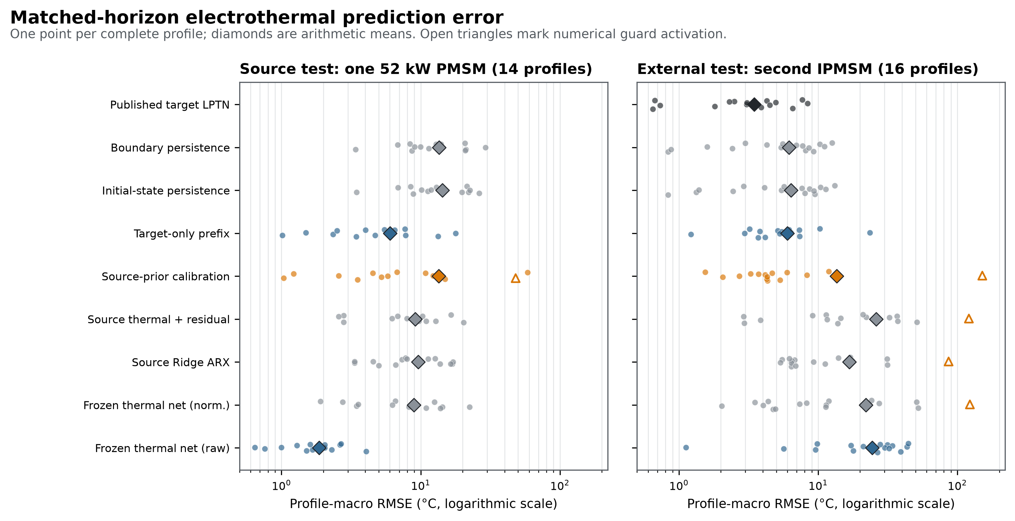

4.2 Five-minute source-prior adaptation was conditionally beneficial, not generally safe
The source-prior method failed its source adaptation gate. Against the normalized source network, RMSE increased from 8.9178 to 13.5076 °C, a relative “improvement” of -51.47%; the paired improvement interval had lower bound -15.6420 °C. It also activated 45 source guard clips on profile
45. On the 55-min source horizon its RMSE rose to 28.6545 °C with 4,441 clips. A short prefix could therefore pull a previously stable source parameter vector toward a locally fitted transition model that became unstable under recursive extrapolation.
The external gate passed arithmetically against its declared normalized-source comparator. RMSE fell from 21.9838 to 13.6104 °C, a 38.09% relative reduction. The paired mean improvement was 8.3734 °C with lower interval bound 0.1296 °C. This narrow pass does not establish deployment success. The source-prior method remained 7.5929 °C worse on average than target-only fitting and 7.4440 °C worse than boundary persistence. Its worst external profile reached 151.0185 °C RMSE after the common guard clipped 999 states. Thus, the declared comparator gate and operational reliability led to different decisions.
The profile distribution explains the apparent contradiction between mean and median. Source-prior calibration had a moderate external median of 4.2914 °C, but one catastrophic profile dominated the mean and exposed the risk that a source penalty does not guarantee stable long-horizon dynamics. Figure 5 shows both a supported profile and the unedited profile-14 failure.

4.3 The support rule identified a useful subset but rejected most external profiles
The predeclared threshold accepted 6/16 external profiles and rejected 10/16, an abstention rate of 62.5% (Figure 2). On the six accepted profiles, source-prior calibration achieved 3.1933 °C mean RMSE, versus 4.5655 °C for target-only fitting and 5.1440 °C for boundary persistence. The paired post-reveal diagnostic improvement over target-only fitting was 1.3722 °C, with profile-bootstrap interval [0.3751, 2.4060] °C. No supported external profile activated the source-prior guard.
On the ten rejected profiles, source-prior RMSE was 19.8607 °C, target-only RMSE was 6.8888 °C, and all 999 proposed-method external clips occurred in the rejected set. Profile 14 was rejected and accounted for the catastrophic guarded trajectory. These observations are consistent with support being useful as a safety screen. They do not prove that the rule generalizes: only one external machine was available, and two of 14 source-test profiles were also rejected. Most importantly, the accepted-subset result cannot replace the all-profile primary result. A method that abstains on 62.5% of target profiles has limited coverage of the intended operating envelope.
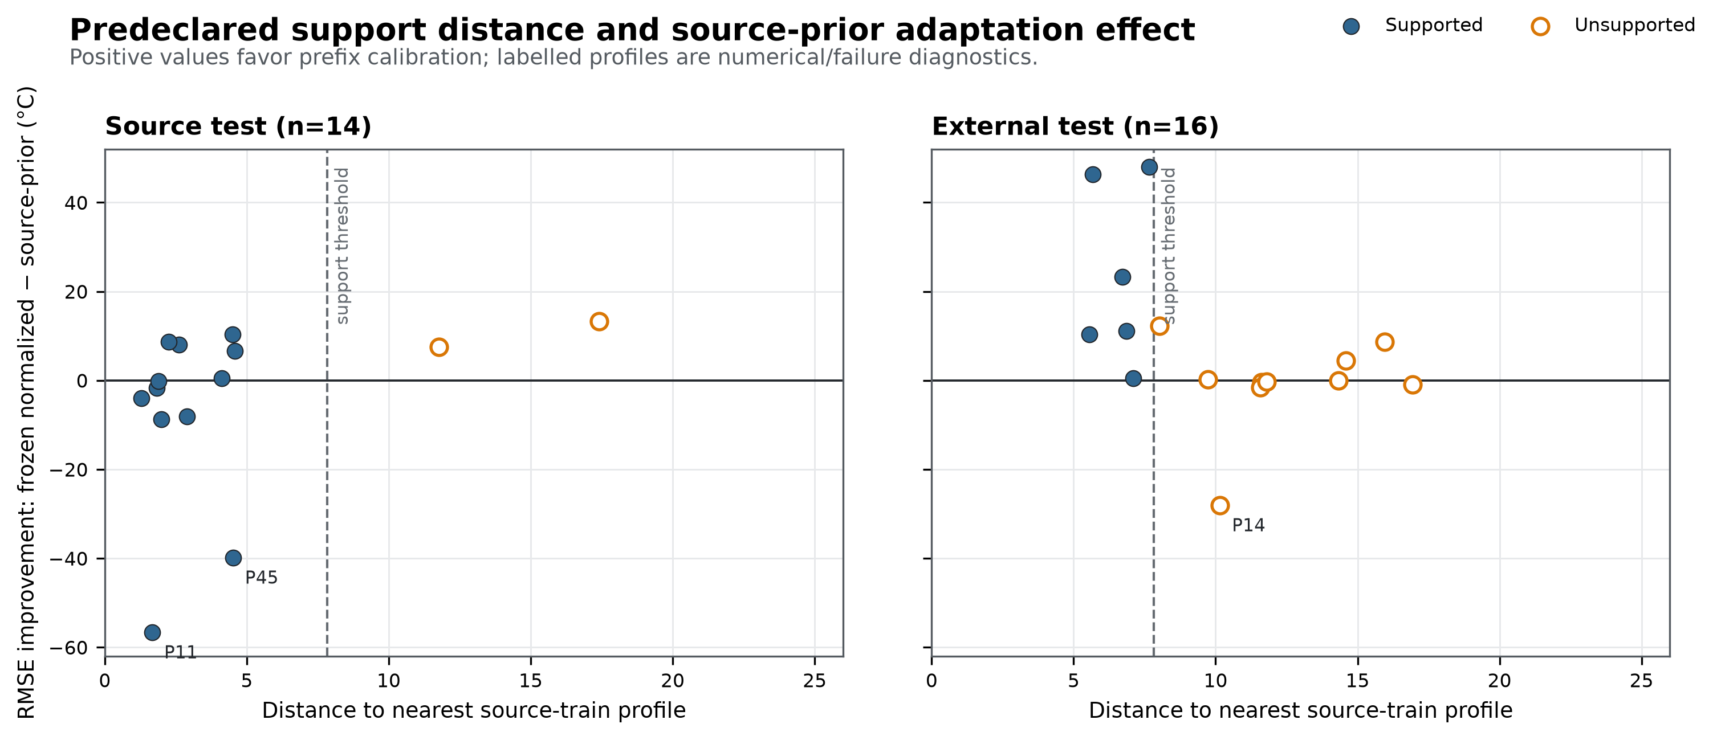

4.4 More target labels reduced error; target-only fitting remained the safer default
Budget sensitivity used a common 10-min rollout after 1, 5, or 15 min of labels (Table 3; Figure 3). At one minute, source priors helped relative to a freshly fitted target-only model on the source test (20.6487 versus 22.3954 °C), but both were poor and activated guards. Externally, target-only was already better (9.3166 versus 23.9308 °C). At five minutes on this common horizon, target-only reached 3.5228 °C on source profiles and 3.4077 °C externally, with no clips; source-prior values were 7.4630 and 8.0900 °C, respectively.
At 15 minutes, both target-fitted methods improved substantially. Target-only fitting achieved 2.0346 °C on source and 2.0653 °C externally, while source-prior calibration achieved 2.2465 and 2.5659 °C. Neither activated a guard. The source prior therefore did not improve average accuracy once the target prefix was sufficiently informative. For these machines, a commissioning policy that gathers more target data and fits the transparent target model was safer than assuming source parameters would stabilize a short prefix.
Table 3. Commissioning-budget sensitivity; each prefix is followed by the same 10-min hidden-label rollout. Values are profile-macro RMSE in °C.
Dataset | Method | 1 min | 5 min | 15 min | Clips at 1/5/15 min
Source test | Normalized source | 11.502 | 6.019 | 6.550 | 0 / 0 / 0
Source test | Target-only prefix | 22.395 | 3.523 | 2.035 | 34 / 0 / 0
Source test | Source-prior prefix | 20.649 | 7.463 | 2.247 | 202 / 0 / 0
External test | Normalized source | 44.218 | 12.454 | 4.897 | 2294 / 83 / 0
External test | Target-only prefix | 9.317 | 3.408 | 2.065 | 153 / 0 / 0
External test | Source-prior prefix | 23.931 | 8.090 | 2.566 | 1213 / 129 / 0

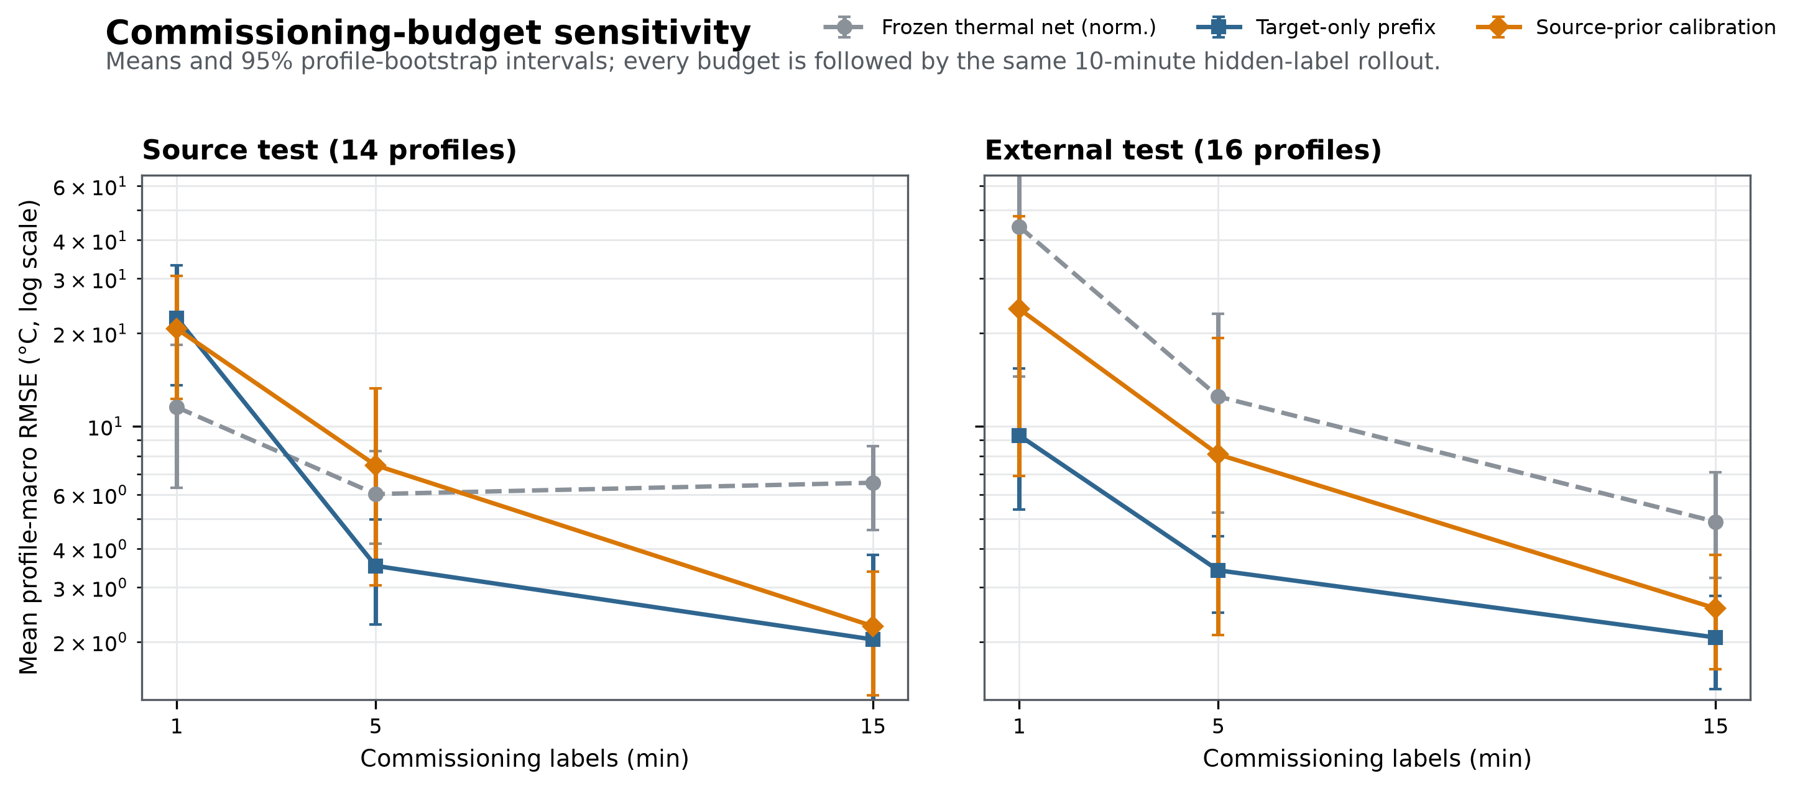

4.5 Nominal coverage could be accurate but operationally empty
The raw source network's narrow bands averaged 5.3954 °C half-width across nodes. On the source test, joint all-node trajectory coverage was 9/14 (64.29%); externally it collapsed to 1/16 (6.25%). This is direct evidence that a band calibrated on source profiles did not transport with the raw model.
The source-prior method passed the predeclared source uncertainty gate: every node covered at least 13/14 source profiles (92.86%), and joint all-node coverage was also 13/14. External joint coverage was 15/16 (93.75%). However, the matched-horizon half-widths were 72.06 °C for rotor, 87.26 °C for stator core, and 158.88 °C for winding, averaging 106.07 °C. A 90% band this wide cannot provide a useful warning margin for ordinary motor thermal limits. Persistence bands similarly obtained high coverage by being broad. Figure 4 makes the coverage-width trade-off explicit.
Table 4. Matched-horizon trajectory-band audit. Bands were calibrated only on 11 complete source- validation profiles.
Method | Source joint coverage | External joint coverage | Mean half-width (°C) | Interpretation
Raw source network | 9/14 (64.3%) | 1/16 (6.3%) | 5.40 | Sharp but non-transportable
Normalized source network | 14/14 (100%) | 13/16 (81.3%) | 55.03 | Broad
Target-only prefix | 14/14 (100%) | 15/16 (93.8%) | 60.87 | Broad
Source-prior prefix | 13/14 (92.9%) | 15/16 (93.8%) | 106.07 | Coverage operationally vacuous
Boundary persistence | 13/14 (92.9%) | 16/16 (100%) | 56.05 | High coverage, weak point predictor

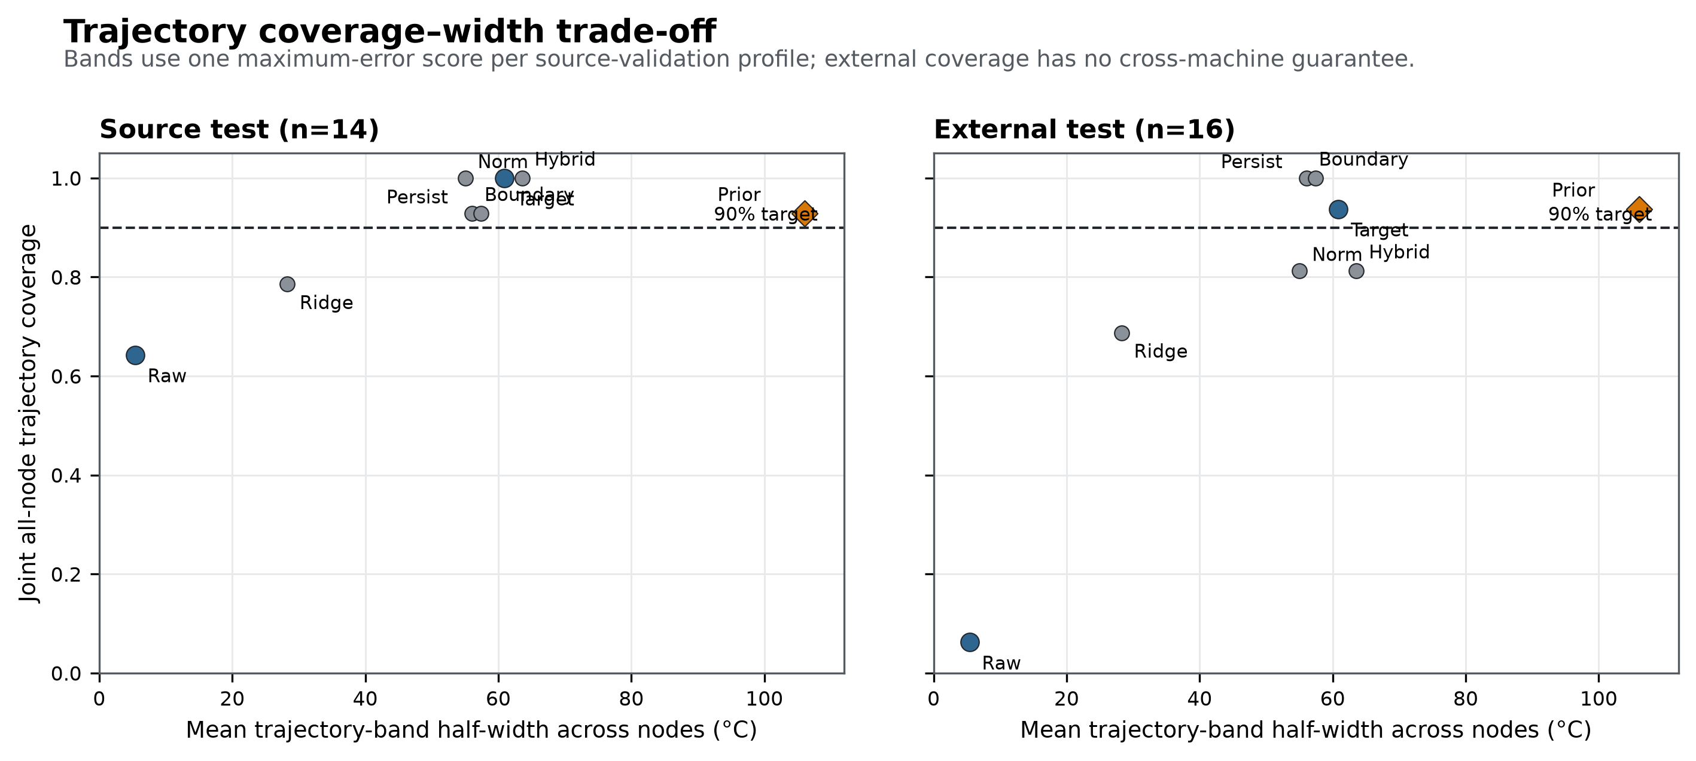

4.6 Trajectories expose both conditional utility and catastrophic extrapolation
For the nearest supported external profile, source-prior calibration followed winding and stator-core dynamics substantially better than the raw source network, while rotor estimates remained biased (Figure 5, top). This is the scenario represented by the favorable accepted-subset average. In external profile 14, by contrast, source-prior winding and stator-core predictions rose to the 250 °C guard and rotor predictions exceeded 200 °C, while measured states remained near ordinary operating temperatures (Figure 5, bottom). Target-only predictions also drifted in two nodes but did not activate the guard.
The failure is not hidden by averaging or early termination. Every second in the declared horizon remained in the prediction file; guarded values and counts are reported. The trajectory illustrates why a finite clipped RMSE must not be interpreted as stable model behavior.
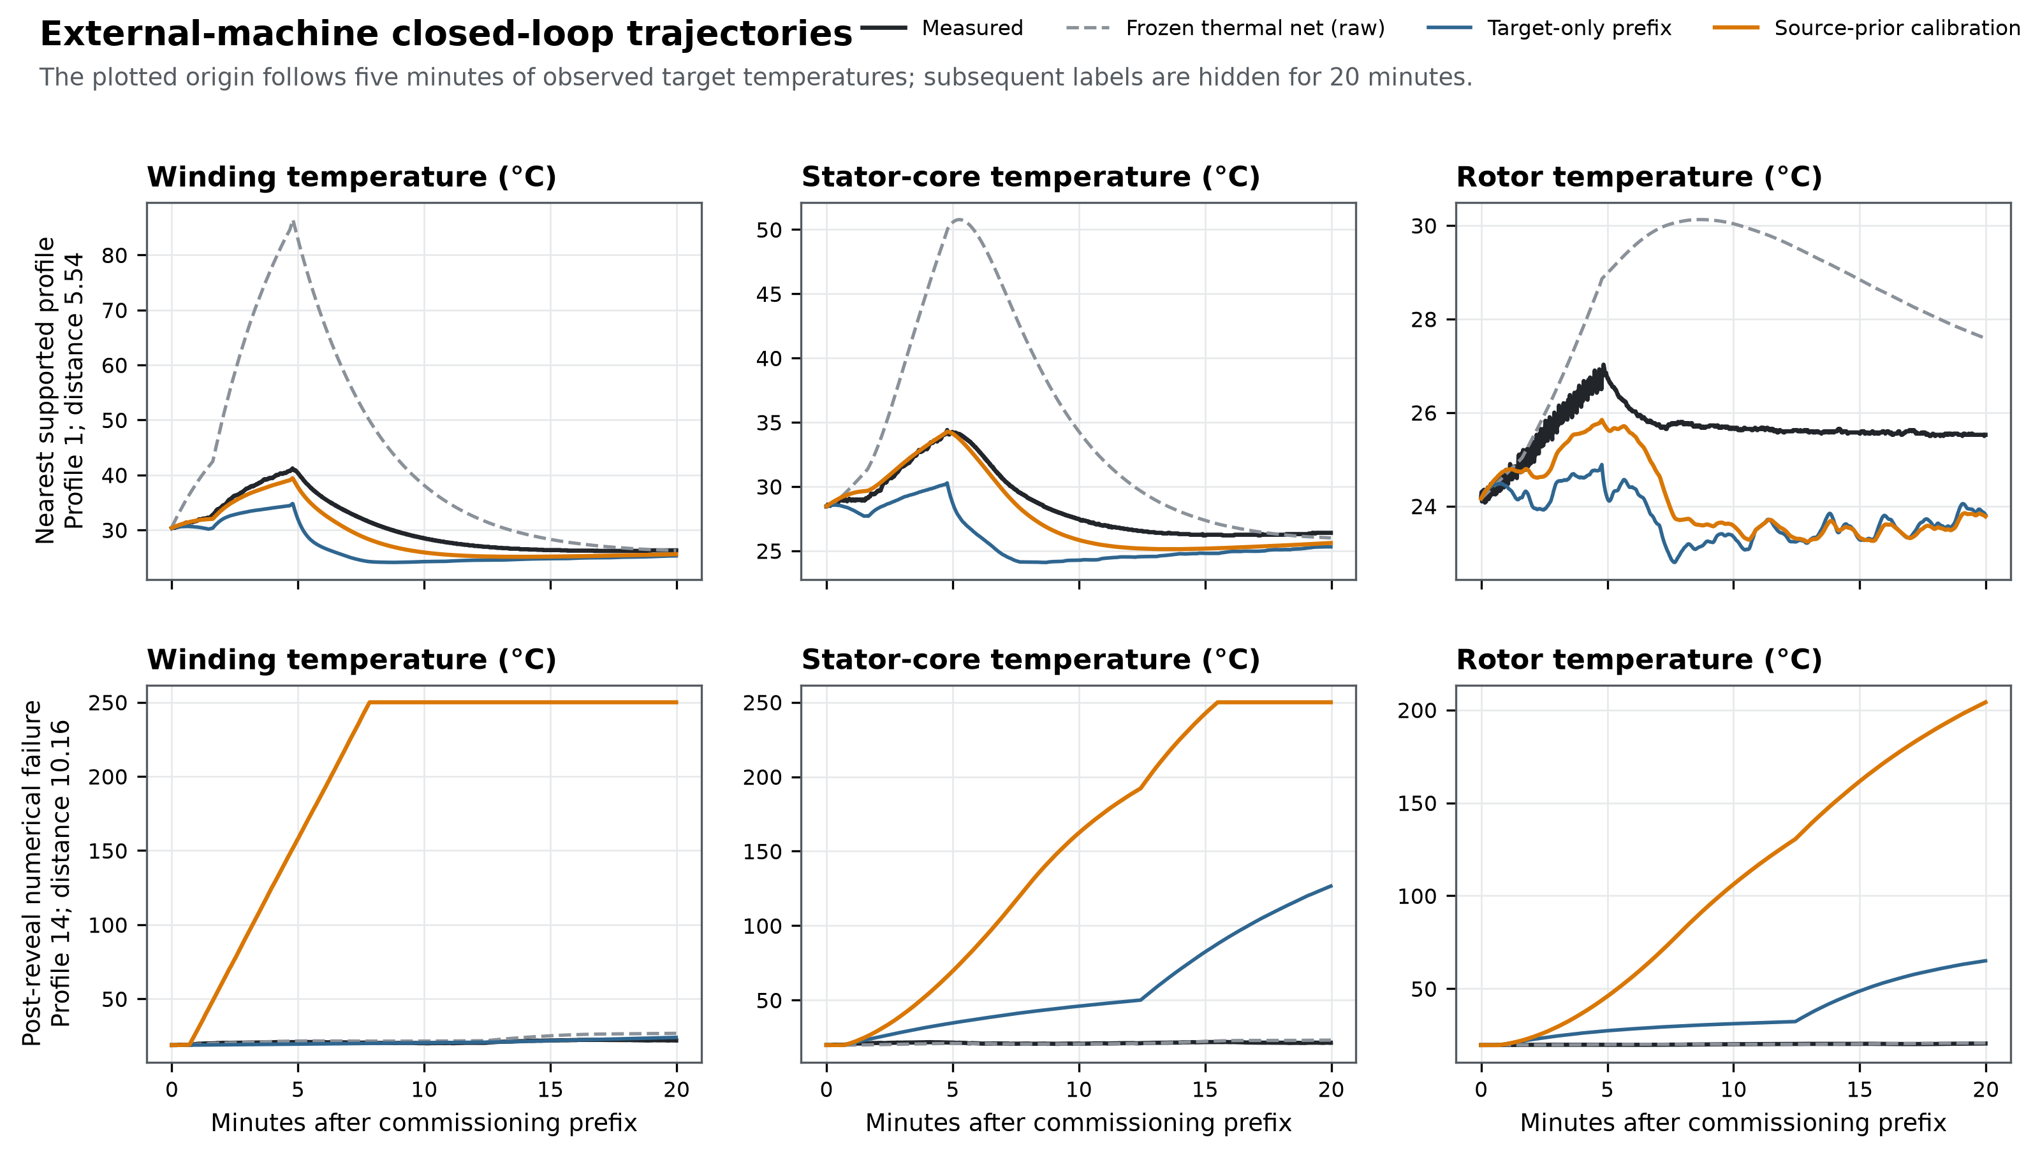

5. Discussion

5.1 What transported, what did not, and why the distinction matters
The study separates several claims that are often compressed into “generalization.” First, the raw thermal network generalized across source-machine profiles: 1.87 °C matched and 2.38 °C long-horizon RMSE are strong within-machine results. Second, those dynamics did not transport to the external machine: error increased by more than an order of magnitude. Third, normalized features reduced some magnitude mismatch but did not yield a reliable source model. Fourth, five-minute source-prior adaptation helped relative to that weak normalized comparator externally but was inferior to target-only fitting and persistence on the full external set. Fifth, the source-prior uncertainty band covered most profiles only by becoming extremely wide.
This decomposition prevents a common logical error. A positive relative improvement over one frozen baseline does not imply absolute usefulness. The external adaptation gate answered whether the source-prior update improved the normalized source model. It did. The operational comparison asked whether it was accurate, stable, and preferable to target-only or trivial controls. It was not. Retaining both statements makes the gate auditable rather than retroactively redefining success.
The raw model's failure is physically plausible. Effective couplings absorb motor geometry, thermal mass, cooling paths, sensor placement, and controller-dependent loss relationships. A 52 kW machine's absolute current, voltage, and heat-capacity scale should not be assumed transferable to a different IPMSM. Normalization removes magnitude but can also discard absolute information needed to identify heat generation. The source result-raw much better than normalized-shows that absolute scale carried real predictive signal within the first machine. Cross-machine invariance and within-machine fidelity are therefore competing design objectives, not guaranteed allies.

5.2 Why the source prior sometimes hurt
The source-prior estimator has only 299 target transitions at the primary budget and nine nonnegative coefficients per node. The quadratic penalty discourages parameter movement but does not impose closed-loop stability. A prefix may excite only a subset of heat pathways; parameters that fit local derivatives can still extrapolate badly when later current, speed, boundary temperature, or torque patterns change. Profile 14 demonstrates this failure mode. A smaller one-step residual is not sufficient for a stable 20-min recursive rollout.
The support result suggests a conditional use. In the six external prefixes close to source-train exogenous summaries, the source prior improved target-only RMSE by about 1.37 °C and remained within the guard. This could motivate a gated commissioning controller: use source-prior calibration only inside a validated support region; otherwise collect more target labels or fall back to a safer method. The current evidence cannot certify that policy because the threshold was tested on only one second machine and accepted fewer than half its profiles. It is a hypothesis for a prospective multi-motor study, not a deployed rule.

5.3 Implications for adaptive digital twins
Adaptive digital twins are often presented as continuously improving estimators. The present results add three safeguards. First, adaptation should be evaluated in the same closed-loop mode in which the state will be used; one-step accuracy can hide unstable recursion. Second, a source prior needs a negative-transfer detector or stable fallback, not only a regularization coefficient. Third, target-label budget is part of the algorithm. Fifteen minutes changed the conclusion: target-only fitting reached about 2.07 °C externally without guard activation, outperforming the source-prior version.
Temporary target-temperature access may be feasible during commissioning with instrumented test units, but not on every deployed motor. If no three-node prefix can be measured, the target-only results are not directly available. Future work should test partial-label commissioning, sparse surface sensors, offline fleet priors, and parameter constraints derived from thermal passivity.

5.4 Uncertainty must be judged by coverage and usefulness
Functional or trajectory conformal methods correctly emphasize simultaneous coverage rather than isolated time points. But a formal or empirical coverage target is only one axis of usefulness. The source-prior method's 106 °C mean half-width would span much of the physically permissible temperature range. Such a band cannot distinguish normal operation from a meaningful thermal limit. Reporting coverage without width could therefore rank the least informative method as the most trustworthy.
The external results also show why source-calibrated uncertainty cannot be assumed portable. The raw model's band was sharp on the source validation distribution yet covered only one external profile jointly. A future target deployment needs either target calibration profiles, explicit shift-aware weighting with validated overlap, or a conservative statement that the band is uncalibrated. The current support score is an abstention heuristic; it does not restore conformal validity.

5.5 Recommended evaluation checklist
For cross-motor thermal estimation, the following minimum reporting set follows from the evidence:
- split complete profiles, sessions, and physical machines before fitting;
- state exactly how many seconds of target temperature labels are used;
- evaluate recursive trajectories after labels are hidden;
- include target-only fitting and persistence, not only source-based baselines;
- report every numerical clip and non-finite state;
- declare support before external outcomes and retain rejected profiles in primary summaries;
- report trajectory-band width beside coverage; and
- distinguish condition-level uncertainty from fleet-level generalization.
These controls are inexpensive compared with developing a new architecture and materially change the conclusion that can be drawn from the same predictions.

6. Limitations
Only two physical machines are represented, one in each public dataset. The 14 and 16 test profiles are repeated operating conditions, not independent motor specimens. Consequently, no bootstrap interval or p-value supports a population-wide claim across PMSM fleets, power classes, or cooling designs.
The external shift is compound. Machine size, rotor/stator construction, cooling, controller, sensor placement, operating profiles, and acquisition conventions differ simultaneously. The study quantifies transport failure but cannot identify the causal contribution of each factor. Controlled experiments that vary one component at a time would be required.
The three-node bridge is imperfect. The source PM sensor and external rotor sensor are related but not identical; both stator-core and external winding nodes are constructed averages. dq quantities, speed, and torque follow the sources' documented names and units, but neither dataset provides a complete metrological uncertainty budget. The external duration discrepancy is disclosed rather than resolved by assumption.
Five- and fifteen-minute calibration assume temporary access to all three target temperatures. This is realistic for an instrumented commissioning experiment, not necessarily for volume deployment. The target-only advantage therefore establishes an information benchmark, not a sensor-free production solution.
The positive network is deliberately low-order. Its nonnegative coefficients do not guarantee global closed-loop stability, and the common state guard limits numerical consequences rather than repairing the model. More structured passivity or energy-balance constraints may improve safety.
Finally, the support threshold and trajectory bands were calibrated only on source profiles. Their external results are descriptive. The favorable supported subset contains six profiles from one machine, while the source-prior band's high coverage is operationally uninformative because it is very wide. Neither result should be converted into a formal deployment guarantee.

7. Conclusion
A low-order electrothermal network can be highly accurate on unseen profiles of its source PMSM and still fail severely on a second machine. In the frozen benchmark, direct raw-model transport degraded from 1.87 to 24.49 °C RMSE and its joint trajectory coverage fell to 1/16. Five-minute source-prior calibration improved a normalized source comparator externally but failed on the source test, was worse overall than target-only fitting and persistence, and became numerically unstable on one rejected external profile. The prior was useful only in a predeclared region that accepted 6/16 external profiles. High empirical coverage did not rescue the method because its average band half-width exceeded 106 °C.
For these two PMSMs, the practical conclusion is not that source knowledge is useless. It is that a source prior must earn deployment through support, closed-loop stability, target-only comparison, and informative uncertainty. When 15 minutes of labels were available, target-only fitting was the safer default. A prospective multi-motor study should now test support-gated source priors with explicit stability constraints and target-machine calibration; until then, within-machine accuracy should not be presented as evidence of cross-machine digital-twin readiness.

Data and code availability
The source dataset is available from Kaggle under DOI 10.34740/KAGGLE/DSV/2161054. The external data and published model code are available from the authors' Zirui24/lptn_informed_LSTM repository at the frozen commit reported above. The complete analysis code, immutable configuration, audit outputs, profile-level errors, predictions, figure generators, tests, and a file-hash manifest accompany this manuscript. Raw third-party data are not redistributed in the submission bundle; acquisition instructions and source licenses are included.

Ethics, competing interests, and funding
This study used public machine datasets and involved no human participants or animals. The authors declare no competing interests. Funding and author-contribution statements will be inserted before submission.

References
[1] Kirchgässner, W., Wallscheid, O., & Böcker, J. (2021). Estimating Electric Motor Temperatures With Deep Residual Machine Learning. IEEE Transactions on Power Electronics, 36(7), 7480-7488. https://doi.org/10.1109/TPEL.2020.3045596
[2] Kirchgässner, W., Wallscheid, O., & Böcker, J. (2022). Thermal Neural Networks: Lumped-Parameter Thermal Modeling With State-Space Machine Learning. Engineering Applications of Artificial Intelligence, 117, 105537. https://doi.org/10.1016/j.engappai.2022.105537
[3] Liu, Z., Kong, W., Fan, X., Li, Z., Peng, K., & Qu, R. (2024). Hybrid Thermal Modeling With LPTN-Informed Neural Network for Multinode Temperature Estimation in PMSM. IEEE Transactions on Power Electronics, 39(9), 10897-10909. https://doi.org/10.1109/TPEL.2024.3409388
[4] Son, S., Lee, H., Jeong, D., Sun, K. H., & Oh, K. Y. (2025). Digital Twin Model of a Permanent Magnet Synchronous Motor via a Multiphysics-Informed Deep Operator Network. Mechanical Systems and Signal Processing, 229, 112561. https://doi.org/10.1016/j.ymssp.2025.112561
[5] Zhu, Y., Liang, H., & Meng, L. (2026). Temperature Estimation and Hot-Spot Forecasting of PMSM Based on Physics-Informed Neural Network. Applied Thermal Engineering, 303, 132461. https://doi.org/10.1016/j.applthermaleng.2026.132461
[6] Zhang, X., Lang, W., Zhao, Y., & Gong, C. (2024). Transferable Neural Network Method Used for PMSM Permanent Magnet Temperature Estimation in Electrical Drive System. In 2024 Boao New Power System International Forum - Power System and New Energy Technology Innovation Forum (pp. 507-513). https://doi.org/10.1109/NPSIF64134.2024.10883597
[7] Shafieeroudbari, E., Iyer, L. V., & Kar, N. C. (2024). Real-Time Rotor Temperature Estimation in Permanent Magnet Synchronous Motor Using Incremental Deep Learning. In 2024 International Conference on Electrical Machines (pp. 1-6). https://doi.org/10.1109/ICEM60801.2024.10700124
[8] Gao, J., Luo, J., Yin, S., Gong, C., Wang, S., & Zhang, G. (2026). Adaptive Digital Twin Framework for PMSM Thermal Safety Monitoring: Integrating Bayesian Self-Calibration with Hierarchical Physics-Aware Network. Machines, 14(2), 138. https://doi.org/10.3390/machines14020138
[9] Wang, Z., Dai, Z., Póczos, B., & Carbonell, J. (2019). Characterizing and Avoiding Negative Transfer. In 2019 IEEE/CVF Conference on Computer Vision and Pattern Recognition (CVPR) (pp. 11285-11294). https://doi.org/10.1109/CVPR.2019.01155
[10] Kumar MP, P., Tu, Z. X., Chen, H. C., & Chen, K. C. (2024). Mitigating Negative Transfer Learning in Source Free-Unsupervised Domain Adaptation for Rotating Machinery Fault Diagnosis. IEEE Transactions on Instrumentation and Measurement, 73, 1-16. https://doi.org/10.1109/TIM.2024.3476610
[11] Hurlbert, S. H. (1984). Pseudoreplication and the Design of Ecological Field Experiments. Ecological Monographs, 54(2), 187-211. https://doi.org/10.2307/1942661
[12] Roberts, D. R., Bahn, V., Ciuti, S., Boyce, M. S., Elith, J., Guillera-Arroita, G., Hauenstein, S., Lahoz-Monfort, J. J., Schröder, B., Thuiller, W., Warton, D. I., Wintle, B. A., Hartig, F., & Dormann, C. F. (2017). Cross-Validation Strategies for Data with Temporal, Spatial, Hierarchical, or Phylogenetic Structure. Ecography, 40(8), 913-929. https://doi.org/10.1111/ecog.02881
[13] Lei, J., G'Sell, M., Rinaldo, A., Tibshirani, R. J., & Wasserman, L. (2018). Distribution-Free Predictive Inference for Regression. Journal of the American Statistical Association, 113(523), 1094-1111. https://doi.org/10.1080/01621459.2017.1307116
[14] Diquigiovanni, J., Fontana, M., & Vantini, S. (2022). Conformal Prediction Bands for Multivariate Functional Data. Journal of Multivariate Analysis, 189, 104879. https://doi.org/10.1016/j.jmva.2021.104879
[15] Tibshirani, R. J., Barber, R. F., Candès, E. J., & Ramdas, A. (2019). Conformal Prediction Under Covariate Shift. In Advances in Neural Information Processing Systems (Vol. 32). https://papers.neurips.cc/paper_files/paper/2019/hash/8fb21ee7a2207526da55a679f0332de2-Abstract.html
[16] Diquigiovanni, J., Fontana, M., & Vantini, S. (2025). The Importance of Being a Band: Finite-Sample Exact Distribution-Free Prediction Sets for Functional Data. Statistica Sinica, 35(2). https://doi.org/10.5705/ss.202022.0087
[17] El Mekkaoui, S., Ferreira, C. J., Guevara Gómez, J. C., Agrell, C., Vaughan, N. J., & Heggen, H. O. (2023). Neural Networks Based Conformal Prediction for Pipeline Structural Response. In Proceedings of the Twelfth Symposium on Conformal and Probabilistic Prediction with Applications (Vol. 204, pp. 134-146). https://proceedings.mlr.press/v204/el-mekkaoui23a.html
[18] Jaber, E., Blot, V., Brunel, N. J. B., Chabridon, V., Remy, E., Iooss, B., Lucor, D., Mougeot, M., & Leite, A. (2025). Conformal Approach to Gaussian Process Surrogate Evaluation with Marginal Coverage Guarantees. Journal of Machine Learning for Modeling and Computing, 6(3), 37-68. https://doi.org/10.1615/JMachLearnModelComput.2025054687
[19] Gray, A., Gopakumar, V., Rousseau, S., & Destercke, S. (2025). Guaranteed Prediction Sets for Functional Surrogate Models. In Proceedings of the Forty-First Conference on Uncertainty in Artificial Intelligence (Vol. 286, pp. 1569-1585). https://proceedings.mlr.press/v286/gray25a.html
[20] Gopakumar, V., Gray, A., Oskarsson, J., Zanisi, L., Giles, D., Kusner, M. J., Pamela, S., & Deisenroth, M. P. (2026). Uncertainty Quantification of Surrogate Models Using Conformal Prediction. Machine Learning: Science and Technology, 7(1), 015025. https://doi.org/10.1088/2632-2153/ae2e7b
[21] Kirchgässner, W., Wallscheid, O., & Böcker, J. (2021). Electric Motor Temperature [Data set]. Kaggle. https://doi.org/10.34740/KAGGLE/DSV/2161054

