When Healthy-Only Transfer Fails: A Leakage-Resistant Cross-Dataset Evaluation of PMSM Stator-Fault Detectors under Compound Speed, Load, and Topology Shift

Abstract
High within-dataset accuracy does not establish that a healthy-only stator-fault detector will transfer to a different permanent-magnet synchronous motor (PMSM). We evaluate eleven covariance and one-class detectors across two experimental datasets with motor/file separation, chronological target-health splits, 3 s alarm blocks, and no target-fault labels for fitting or thresholding. An exploratory study used three same-manufacturer 1.0, 1.5, and 3.0 kW PMSMs at fixed speed and load. A motor-balanced Log-Euclidean detector produced 0/42 later-time healthy alarms and 95.71% fault-block detection. A motor-balanced Isolation Forest produced 0/42 and 96.07%, with no resolved difference. We then froze the pipeline and healthy threshold before revealing 48 fault records from one independent dual-three-phase PMSM undergoing acceleration at eight loads. The frozen detector failed its empirical health gate (1/32 alarms; descriptive 95% Wilson upper bound 15.74% versus a 12% limit), detected 25.00% of fault blocks (95% turn-stratified record-bootstrap interval 21.09-29.43%), and attained AUROC 0.635. A target-only Minimum Covariance Determinant comparator instead produced 0/32 healthy alarms, 70.05% detection (65.36-75.26%), and AUROC 0.927. The frozen detector alarmed on none of the 48 records in the first three blocks but on all 48 in the final block; detection also fell from 56.25% at 0 N m to 12.50% at 35 N m. Conditional on this external motor, the results reveal a ranking reversal, acceleration-aligned alarm drift, and source-augmented variants that underperformed target-only counterparts. This audit-first protocol demonstrates why same-dataset scores and record-any alarms can overstate deployability under compound shift.
Keywords: permanent-magnet synchronous motor; stator-fault diagnosis; cross-dataset evaluation; healthy-only learning; negative transfer; leakage-resistant validation

1. Introduction
Interturn short circuits disturb the electrical symmetry of a PMSM and can progress to destructive winding and magnet damage. Current-based monitoring is attractive because three-phase currents are already measured by the drive and contain physically interpretable negative-sequence, harmonic, and current-vector signatures [1, 2, 3]. Recent learning systems also estimate fault severity from current sequences [4]. These methods usually assume, however, that training and deployment data originate from the same motor, operating condition, or calibrated measurement chain.
That assumption is fragile when a detector is moved to a motor of a different power rating. Rated current, controller response, sensor gain, and healthy signal covariance can all change even if the fault mechanism is related. The first classifier pilot in this study illustrates the operational consequence: a threshold fitted on two source motors labeled every later-time healthy block of the 1.0 and 1.5 kW targets as faulty. A high source-domain accuracy therefore does not establish a usable target alarm.
Domain adaptation and domain generalization have become major themes in rotating- machinery diagnosis [5, 6]. Most studies optimize target classification accuracy or domain-invariant representations. In a new motor, however, target fault labels may be unavailable while a short healthy commissioning trace is realistic. This deployment setting calls for a different question: can target health alone adapt the reference distribution and calibrate the alarm risk without exposing a target fault?
Cross-machine generalization is already an established and increasingly large-scale problem: prior work includes six machines, 43 bearings, and 20 conditions, while a unified benchmark spans eight public and two self-collected datasets [7, 8]. Transfer can also reduce target performance relative to a non-transfer reference [9, 10]. A credible evaluation must therefore include a target-only control rather than assuming that more source data are beneficial.
Conformal prediction supplies model-agnostic finite-sample calibration under exchangeability [11], and conformal methods have recently been used for open-set industrial fault diagnosis [12]. Ordinary exchangeability is not credible for densely sampled windows from a single motor record. Work on dependent conformal inference shows that time dependence requires additional assumptions or modified interpretation [13, 14]. Treating thousands of adjacent windows as independent calibration samples would consequently overstate the evidence.
This is not a hypothetical concern. Across two bearing datasets, changing from easier signal splits to run-, day-, and physical-part holdouts caused accuracy differences exceeding 40 percentage points in some pipelines [15]. More broadly, structured cross-validation is required when observations are temporally or hierarchically dependent [16], and splitting one acquisition into many windows does not create independent experimental replication [17].
This paper evaluates healthy-only detectors around that deployment constraint. Its contributions are:
1. an audit-first evaluation that separates physical motors and files, preserves chronological health regions, and never treats adjacent windows as independent experimental repeats; 2. a frozen, one-time external fault reveal in which features, eleven detectors, calibration scores, thresholds, and failure criteria were committed before any external fault value was opened; 3. direct evidence of a cross-dataset ranking reversal: near-ceiling same-family performance did not transfer under simultaneous topology, sampling-rate, speed, and load shift; 4. a diagnosis of negative transfer and operating-point confounding using target-only versus source-augmented comparators, ordered-block alarm drift, and record-level paired uncertainty; 5. an explicit evidence boundary: intervals are conditional on the recorded motors, block calibration is empirical under time dependence, and no post-reveal model is relabeled as the primary method.

2. Related work

2.1 PMSM stator-fault signatures and operating conditions
Motor current signature analysis detects winding asymmetry through sequence components, Park/Clarke current-vector geometry, and spectral changes. Negative-sequence current is particularly relevant to early interturn faults [2], while harmonic behavior can depend on winding configuration and the closed-loop drive [1]. This dependence motivates the use of ratios, normalized spectral features, and within-motor healthy references instead of raw amplitude alone. Order-tracked PMSM indicators have specifically been proposed for nonstationary speed and multiple loads [18], while physical-data dual models address rapidly varying speed in sparse-data PMSM diagnosis [19]. These studies motivate explicit operating-condition treatment rather than interpreting every frequency-dependent score change as a fault effect.
The present work does not attempt fault-phase localization or severity regression. Those are distinct supervised tasks and can require motor parameters, injected signals, or target fault examples. The observed nonmonotonic relation between the public dataset's nominal severity labels and the proposed anomaly score further prevents a valid severity claim.

2.2 Cross-machine diagnosis, negative transfer, and split design
Cross-domain machinery diagnosis commonly aligns source and target representations or learns domain-invariant features. Benchmark surveys include source aggregation, DANN, MMD, CORAL, mixup, meta-learning, and ensemble approaches [6]. Collaborative multimachine and multi-dataset benchmarks establish that neither cross-machine diagnosis nor domain generalization is itself novel [7, 8]. Recent machinery methods also attempt to mitigate negative transfer [10, 20].
The evaluation unit remains a separate problem. Signal-window holdout can share a physical part, acquisition day, or continuous trajectory between train and test and thereby measure interpolation rather than deployment [15]. This study instead treats the physical motor as the outer KAIST holdout, keeps external health roles in separate files/loads where possible, and reports paired fault effects at the record level. A source-supervised classifier is retained as a domain-shift diagnostic, while the principal task is a healthy-only target alarm.

2.3 Healthy-only detectors, SPD transfer, and calibrated alarms
One-class SVM, Isolation Forest, support-vector data description, and Minimum Covariance Determinant are established one-class or robust-description methods [21, 22, 23, 24]. Machinery studies have also fitted deep and classical one-class detectors from normal signals, although random normal-sample splits and fault-outcome-based hyperparameter selection can weaken a deployment interpretation [25]. These methods are consequently comparators here, not claimed innovations.
A covariance matrix captures interactions among current-shape, imbalance, harmonic, and spectral features. Direct Euclidean averaging preserves symmetry and positive definiteness but does not respect the intrinsic geometry of SPD matrices. The Log-Euclidean construction maps matrices through the matrix logarithm, averages them in a vector space, and maps the result back by the matrix exponential [26]. Here each motor contributes one covariance and therefore one equal vote, irrespective of window count.
The resulting Mahalanobis distance is only an anomaly score; it is not yet an alarm. Target healthy block scores are used to compute upper-tail conformal p-values. This calibration does not repair arbitrary temporal dependence. It instead provides an auditable empirical threshold whose calibration unit is a non-overlapping macroblock, with the dependence limitation reported explicitly.
Conformal anomaly alarms for heterogeneous industrial fleets also predate this study [27, 28], and limited-sample process monitoring can miss nominal false-alarm targets even with conformal thresholds [29]. The narrower gap examined here is the combination of a fault-blind frozen external reveal, record/entity-aware reporting, and same-algorithm target-only versus source-assisted controls. A targeted literature audit did not locate a rotating-machine study combining all three, but this absence statement is not a priority claim.

3. Dataset and leakage-resistant protocol

3.1 Dataset audit
The KAIST/Mendeley dataset contains vibration and three-phase current measurements from 1.0, 1.5, and 3.0 kW PMSMs at a fixed 3000 rpm and load setting [30, 31]. Each motor has interturn and intercoil faults at seven nominal nonzero severity levels. Current was sampled at 100 kHz.
The archive structure nominally contains one healthy record under each fault family. For every motor, those two healthy members have identical uncompressed size and CRC; an extracted pair was additionally identical by SHA-256. They are aliases rather than independent repeats. After deduplication, the current study contains three healthy and 42 fault records. Several fault TDMS files contain 121-149 s although the dataset description specifies 120 s. Every record is restricted to its first 120 s, producing equal record weight.
Each record is divided into 600 non-overlapping 0.2 s windows. Window features include phase RMS ratios, crest factor, kurtosis, Clarke-vector dispersion, sequence-current ratios, normalized harmonics, total harmonic distortion, sideband ratios, and spectral entropy. Absolute RMS, zero-sequence RMS, fundamental amplitude, and mean Clarke radius are excluded from the primary scale-free representation. The complete table contains 27,000 windows and no missing values.

3.2 Leave-one-motor-out separation
Three outer folds hold out each motor in turn. The other two motors are sources. Source fault labels can be used by supervised comparators, but the proposed detector estimates only healthy distributions. In every fold, the target motor contributes no fault label before evaluation.
Healthy feature autocorrelation exhibited an approximately 3 s nuisance cycle. Consequently, fifteen adjacent 0.2 s windows form one non-overlapping 3 s macroblock. The target healthy record has 40 blocks in chronological order:
- blocks 0-3: 12 s adaptation;
- block 4: guard;
- blocks 5-24: 60 s alarm calibration;
- block 25: guard;
- blocks 26-39: 42 s later-time healthy evaluation.
At an alarm level of 0.05, a conservative finite conformal threshold requires at least 19 calibration units. Thus, the 12 s adaptation trace cannot also be described as a 5% conformal calibration set: it supplies only four macroblocks. The protocol uses 20 separate calibration blocks. The motor holdout, chronological target-health split, and scoring flow are summarized in Fig. 1.
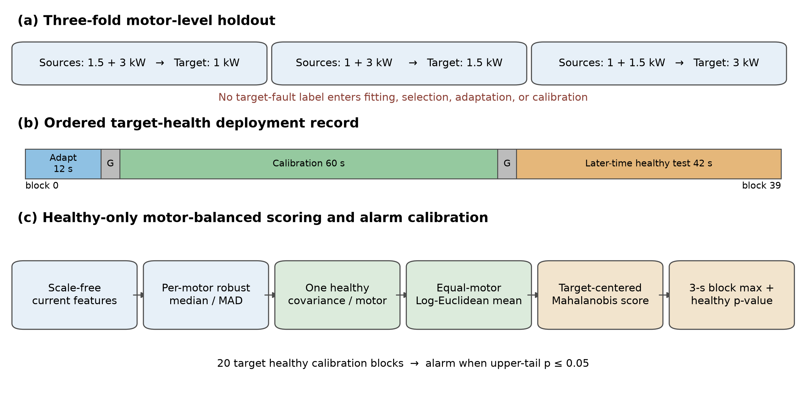
Fig. 1 Motor holdout, sequential target-health split, and method flow

4. Evaluated healthy-only detectors and alarm calibration
The frozen external protocol compared eleven detectors. Five covariance-score variants used target Ledoit-Wolf, target sample covariance, source-only covariance, arithmetic entity balancing, or Log-Euclidean entity balancing. Six one-class variants paired target-only or motor-balanced source-plus-target fitting with one-class SVM, Isolation Forest, or Minimum Covariance Determinant (MinCovDet). The Log-Euclidean variant below was designated and frozen as the primary detector before the external fault reveal; that designation is retained even though another comparator performed better after reveal.
Let xₘ,ᵢ in R^d be a scale-free feature vector from motor m. For each motor, allowed healthy reference samples define a coordinate-wise median cₘ and robust scale rₘ. The standardized vector is
$$x̃ₘ,ᵢ = (xₘ,ᵢ - cₘ) ./ rₘ$$
Only source healthy reference blocks and target adaptation blocks are allowed in these statistics. Let Sₘ be the sample covariance of the standardized healthy samples. Each covariance is regularized relative to its average marginal variance,
$$Sₘ⁽λ⁾ = Sₘ + λ [tr(Sₘ) / d] I$$
The motor-balanced Log-Euclidean covariance is
$$Σ_LE = exp[(1 / M) Σₘ₌₁ᴹ log Sₘ⁽λ⁾]$$
Two source motors and the target motor each contribute once. The ridge grid 10⁻⁴,10⁻³,10⁻²,10⁻¹ is evaluated only by treating each outer fold's source motors as nested pseudo-targets; all folds selected λ=10⁻².
After robust target centering, the window anomaly score is
$$s(x) = x̃ᵀ Σ_LE† x̃$$
For block b, A_b=maxᵢ ᵢₙ bs(xᵢ). Given n=20 target healthy calibration scores, the upper-tail p-value is
$$p_b = [1 + Σⱼ₌₁ⁿ 1(Aⱼ ≥ A_b)] / (n + 1)$$
The block raises an alarm when p_b≤0.05. Because calibration blocks are ordered parts of one health record, the p-value is interpreted empirically under a block-stationarity or weak-dependence approximation, not as distribution-free coverage under arbitrary temporal dependence.

5. Experiments

5.1 Exploratory same-family KAIST comparison
The implemented covariance comparators are target Ledoit-Wolf, regularized target sample covariance, source-only covariance, and arithmetic entity-balanced covariance. All share the same feature representation, target-health split, block maximum, and calibration rule. A supervised logistic classifier and gradient boosting model diagnose the initial source-to-target threshold shift.
Strong one-class comparators use either target adaptation health alone or a motor-balanced union of source and target health. They comprise a one-class SVM, Isolation Forest, and Minimum Covariance Determinant. Their hyperparameters were fixed without target-fault labels. Stochastic methods were additionally evaluated across five fixed seeds; the primary seed was frozen before external fault reveal.
Primary outcomes are the raw healthy false-alarm count, pooled Wilson interval, maximum per-motor empirical false-alarm rate, mean and worst-motor fault-block detection, and block AUROC. Paired method differences are computed for each of the 42 target fault records. A 10,000-replicate bootstrap resamples records within target motor and then averages the three motor means. Macroblocks and windows are not treated as independent experimental repetitions.
Target adaptation is varied over 3, 6, 12, and 24 s in two sensitivity designs. The fixed-horizon design holds calibration and test time constant; the sequential design moves calibration directly after each adaptation prefix. The original 12 s setting is retained irrespective of target-fault results.

5.2 Frozen independent-laboratory protocol and one-time reveal
The external target is a public dual-three-phase PMSM with winding taps, two measured three-phase current subsystems, and externally emulated interturn short circuits [32, 33]. Its eight healthy records are acceleration sweeps at 0-35 Nm, not steady 5000 rpm records. A health-only audit fixed the common analysis interval to [12, 36) s before any external fault file was downloaded. The 0 Nm record supplies four 3 s target-adaptation blocks; the independent 10, 20, and 30 Nm records supply 24 system-calibration blocks; and the 5, 15, 25, and 35 Nm records supply 32 held-out healthy blocks.
Each three-phase subsystem receives its own target robust alignment and target covariance. The three KAIST source motors and that target subsystem contribute one covariance each to a four-entity Log-Euclidean mean. Window maxima are first formed within each subsystem and then combined by a system maximum; the same system score is used for calibration. The 48 public fault records remained sealed until the protocol, feature parser, all comparator implementations, environment, healthy calibration scores, and thresholds were captured in hash-addressed commits. All 48 files were then downloaded from the official record, verified against a frozen filename/byte-count/MD5 manifest, and processed once over the unchanged [12, 36) s interval. The run yielded a complete 6 fault-turn counts by 8 loads grid (384 system blocks). The chronological reveal log and hash-addressed commits are retained as audit evidence.

5.3 Prospectively frozen secondary transient-set audit
A secondary stress test used a public 10 kHz dataset containing 12 records from one 200 W PMSM and nine from one 20 kW PMSM [34]. Every record transitions from prefault operation to an interturn short circuit under steady-state, load-transient, or speed-transient operation; there are no independent healthy-only records. Before loading any signal values, we froze the archive hash, full-record inclusion rule, parser contract, channel whitelist, onset rule, method set, thresholds, and outputs. Only measured alpha-beta current entered the 26-feature score; fault current located onset and electrical speed was retained for quality control only.
The primary endpoint used non-overlapping 0.2 s windows, a 0.2 s prefault guard, and the first 1 s after the frozen causal onset. Within each motor, one complete record was held out while the remaining records were assigned by hash to healthy-reference fitting or calibration. At least 19 calibration windows and at least 80% compatible records per motor were required. Parser incompatibility and failure of this motor-level gate were predeclared reportable outcomes: no record, time interval, or onset could be manually substituted after reveal. Because prefault segments and fault segments occur within the same records, this audit was designated a secondary transient stress test rather than a third independent health-cohort validation.

6. Results

6.1 Cross-capacity detection and empirical false-alarm risk
The proposed detector raised no alarm in 42 later-time target healthy blocks. Zero observed events does not imply zero population risk: the pooled 95% Wilson upper bound was 8.38%. Fault-block detection was 100.00%, 90.00%, and 97.14% when 1.0, 1.5, and 3.0 kW were targets, respectively. The fold mean was 95.71%, and the worst-motor result was 90.00%. Table 1 compares the five covariance-score variants under the common protocol.
Table 1 Exploratory KAIST covariance-score comparison under leave-one-motor-out evaluation
Method | Healthy FAR | Descriptive Wilson upper | Mean detection | Worst motor | Mean AUROC
Target Ledoit-Wolf | 1/42 | 12.32% | 90.30% | 82.14% | 0.9969
Target sample covariance | 0/42 | 8.38% | 93.87% | 86.79% | 0.9983
Source-only covariance | 0/42 | 8.38% | 89.11% | 70.18% | 0.9968
Arithmetic entity balance | 0/42 | 8.38% | 95.48% | 87.86% | 0.9989
Log-Euclidean entity balance | 0/42 | 8.38% | 95.71% | 90.00% | 0.9993

Per-motor detection and descriptive healthy false-alarm intervals are shown in Fig. 2.
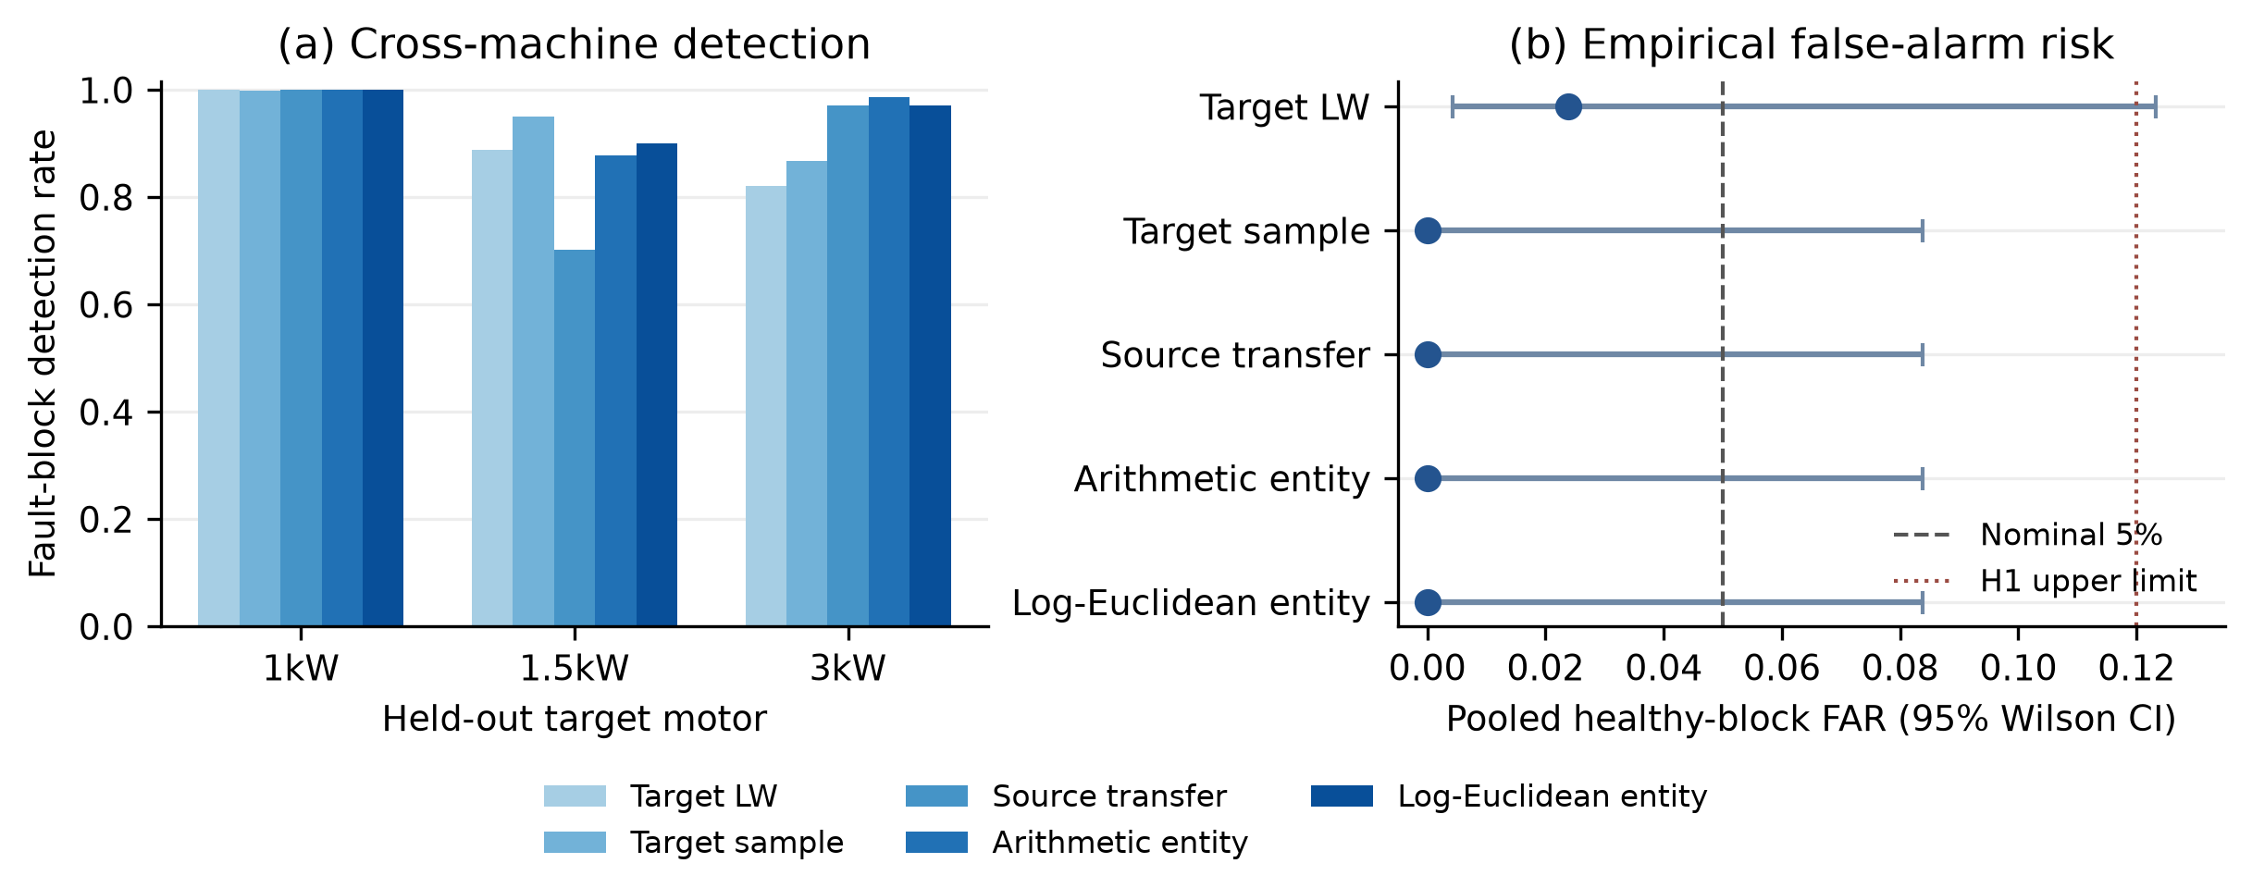
Fig. 2 Per-motor detection and healthy false-alarm intervals

6.2 Paired fault-record comparison
The proposed method exceeded source-only covariance by 6.61 percentage points (95% bootstrap CI [1.79, 12.32]) and target Ledoit-Wolf by 5.42 points ([0.59, 11.19]). The interval crossed zero against target sample covariance (+1.85 points, [-2.14, 6.01]) and arithmetic entity balancing (+0.24 points, [-1.37, 2.32]). The pilot therefore supports the value of target-health covariance transfer over pure source transfer, but it does not establish that Log-Euclidean averaging is uniformly better than simpler entity averaging. The record-level paired differences are shown in Fig. 3.
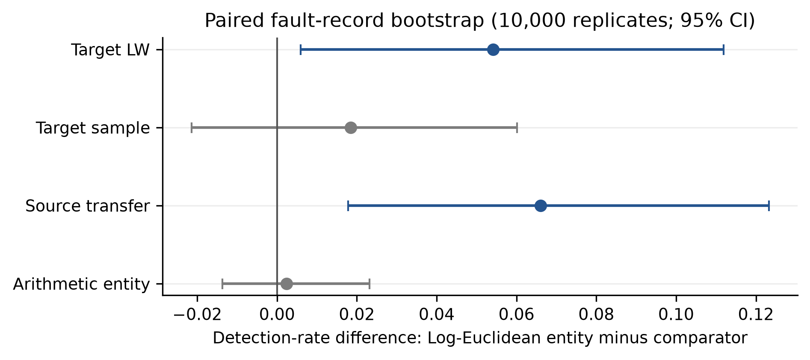
Fig. 3 Record-level paired detection differences

6.3 Strong one-class baselines
The strongest baseline with zero observed healthy alarms was the motor-balanced Isolation Forest, with 96.07% record-macro detection and 90.71% worst-motor detection. The proposed method reached 95.71% and 90.00%, respectively. Their paired record difference was -0.36 percentage points (95% CI [-3.93, 3.45]), providing no evidence that either detector was more accurate. Target-only Isolation Forest attained the highest detection rate, 97.56%, but raised 1/42 healthy alarms and therefore missed the prespecified empirical false-alarm gate. The proposed method exceeded target one-class SVM (+6.01 points, [1.07, 11.90]), target Minimum Covariance Determinant (+5.89 points, [0.95, 11.67]), and motor-balanced Minimum Covariance Determinant (+3.39 points, [0.30, 6.85]). Table 2 reports the one-class comparison under the same health gate.
Table 2 Exploratory KAIST one-class baselines under the common healthy-data protocol
One-class method | Healthy FAR | Mean detection | Worst motor
Target one-class SVM | 0/42 | 89.70% | 82.68%
Motor-balanced one-class SVM | 0/42 | 91.25% | 82.86%
Target Isolation Forest | 1/42 | 97.56% | 95.36%
Motor-balanced Isolation Forest | 0/42 | 96.07% | 90.71%
Target Minimum Covariance Determinant | 1/42 | 89.82% | 84.11%
Motor-balanced Minimum Covariance Determinant | 1/42 | 92.32% | 87.32%
Proposed Log-Euclidean detector | 0/42 | 95.71% | 90.00%

The result supports a competitive deterministic and interpretable covariance detector, not a claim of universal state-of-the-art performance. Across five seeds, the motor-balanced Isolation Forest varied from 96.01% to 96.85% detection and from zero to two healthy alarms, illustrating that a single favorable seed is insufficient for an alarm-risk claim. Paired record differences against these baselines appear in Fig. 4.
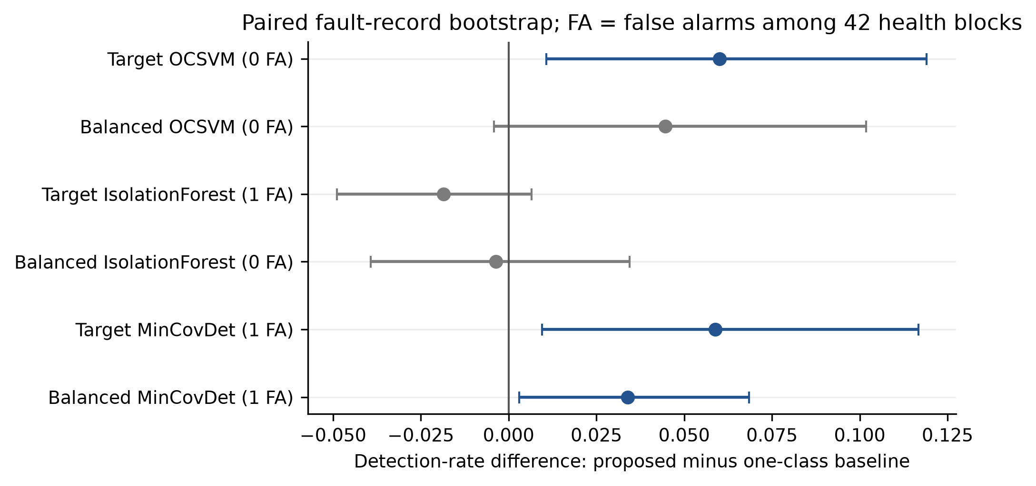
Fig. 4 Paired record differences against strong one-class baselines

6.4 Adaptation budget
With common calibration and evaluation periods, 3, 6, 12, and 24 s adaptation produced 94.64%, 96.90%, 96.25%, and 94.94% mean detection. All budgets had 0/30 healthy test false alarms. Sequential deployment gave the same nonmonotonic pattern. The apparent 6 s maximum cannot be selected after inspecting target faults; 12 s remains the frozen primary choice. If these short durations were instead used for conformal calibration, their minimum attainable p-values would be 0.50, 0.333, 0.20, and 0.111, all above 0.05. The adaptation-budget results and calibration feasibility boundary are shown in Fig. 5.
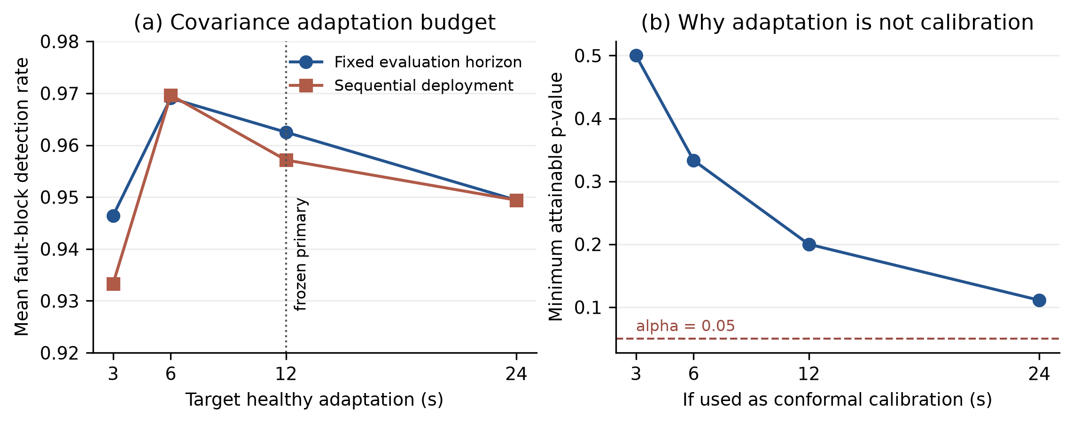
Fig. 5 Adaptation-budget sensitivity and calibration feasibility

6.5 Block-length and aggregation sensitivity
The 3 s maximum exactly reproduced the primary outputs. With the same 60 s calibration horizon, 1 s and 2 s maxima reduced mean detection to 93.61% and 93.73%, respectively. A 3 s 90th-percentile aggregation increased mean detection to 97.32% but introduced 1/42 healthy false alarms; its descriptive Wilson upper bound was 12.32%, above the predeclared 12% gate. It therefore does not replace the health-ACF-selected primary setting. Five- and six-second blocks supply only 12 and 10 calibration units and were skipped because they cannot resolve an alarm level of 0.05. Block-length and aggregation sensitivity are summarized in Fig. 6.
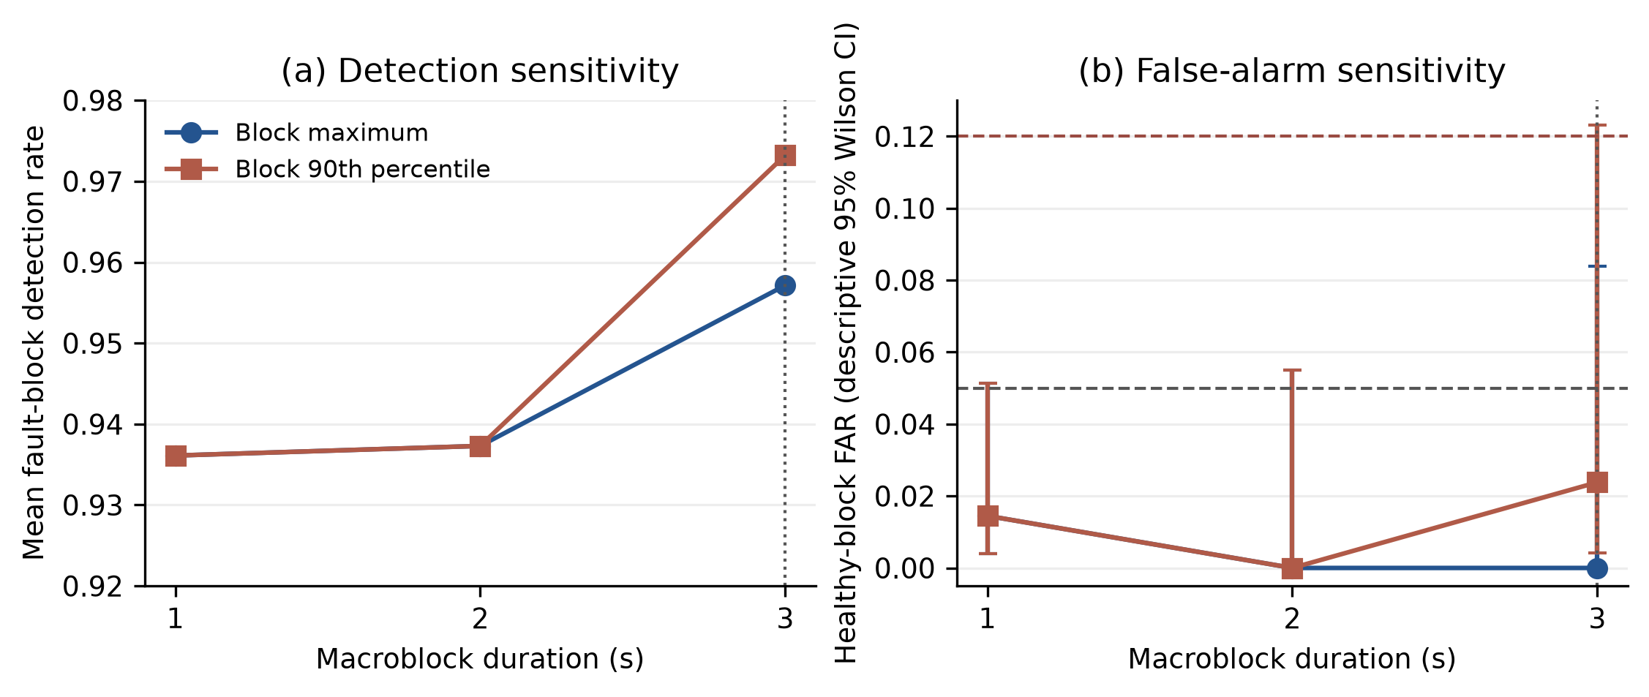
Fig. 6 Block-length and aggregation sensitivity

6.6 Negative findings
Every covariance method detected 100% of blocks in the lowest two labeled severities, so the original exploratory pilot hypothesis had an uninformative ceiling. Detection was also not monotone in severity. Three of six motor-fault-family Spearman correlations between mean anomaly score and nominal severity were negative, including both families for the 1.0 kW motor. Reliable threshold detection on this dataset consequently does not imply valid severity estimation. The nonmonotonic severity patterns are displayed in Fig. 7.
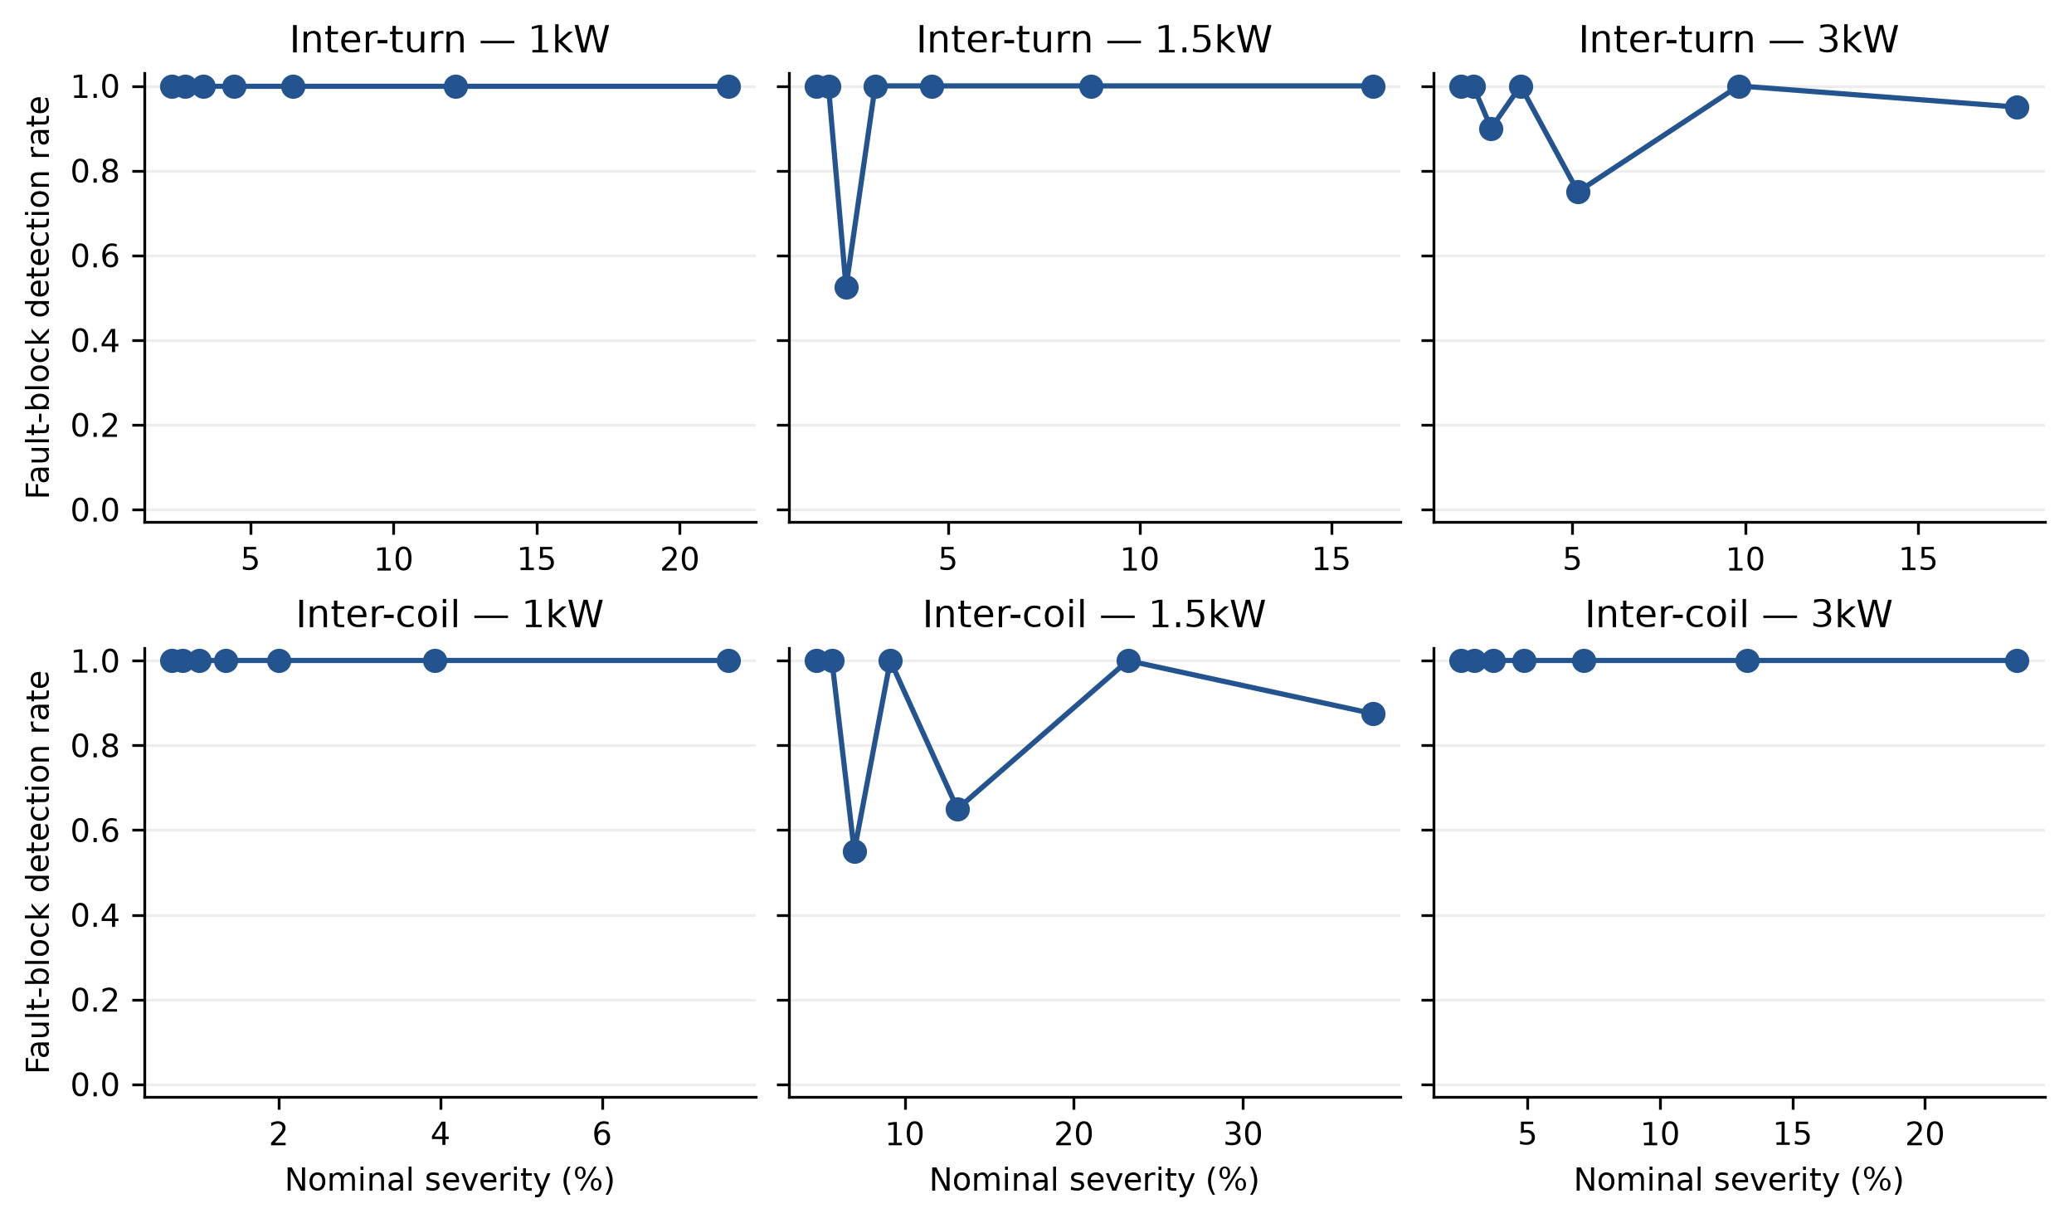
Fig. 7 Nonmonotonic detection across nominal severity

6.7 Frozen external validation and ranking reversal
After the complete pipeline and health thresholds were frozen, all 48 external fault files passed the predeclared filename, variable, sample-count, timebase, finite-value, and interval checks. No file or block was excluded. The frozen Log-Euclidean detector retained the one healthy alarm observed at the locked health stage. Its point FAR was 1/32 = 3.125% and its maximum load-specific FAR was 1/8 = 12.5%, but the descriptive pooled 95% Wilson upper bound was 15.74%. It therefore failed the predeclared H1 criterion of at most 12% upper-bound risk. This failure means that the available evidence was insufficient to pass the gate; it does not prove that the population FAR exceeds 5%.
The fault result reversed the exploratory KAIST ranking. The frozen detector identified 25.00% of the 384 ordered fault blocks (turn-stratified record-bootstrap 95% interval, 21.09-29.43%) and attained pooled block AUROC 0.6354. Target-only MinCovDet, which had been implemented before reveal, produced 0/32 healthy alarms, 70.05% detection (65.36-75.26%), and AUROC 0.9268. The paired improvement of target MinCovDet over the frozen detector was 45.05 percentage points (40.63-49.48%). Target-only MinCovDet is reported as the observed comparator leader, not retroactively redesignated as the primary method.
In a post-reveal analysis applying Holm adjustment across the ten listed candidate-versus-primary contrasts, the target-MinCovDet comparison retained an adjusted p=0.001. The 95% interval above is an unadjusted percentile interval; Holm correction applies only to the p-values. This adjustment covers only that listed conditional comparison family and does not turn the one external motor into a population sample.
This ranking was more stable than the exact MinCovDet operating point. In a post-reveal robustness analysis using five previously fixed seeds, target-only MinCovDet remained above the other stochastic methods but ranged from 65.36% to 77.08% detection and from 0 to 2 healthy alarms; only three of five seeds passed H1. Its primary-seed outcome must therefore not be presented as a seed-invariant performance guarantee. Table 3 gives the complete frozen external method comparison.
Table 3 Frozen external method comparison on one dual-three-phase PMSM
External method | Healthy alarms | Fault-block detection | Block AUROC | H1
Target MinCovDet | 0/32 | 70.05% | 0.9268 | pass
Target Isolation Forest | 3/32 | 59.90% | 0.8670 | fail
Target sample covariance | 1/32 | 55.99% | 0.8757 | fail
Motor-balanced Isolation Forest | 2/32 | 50.52% | 0.8245 | fail
Target Ledoit-Wolf | 1/32 | 36.72% | 0.7675 | fail
Motor-balanced MinCovDet | 1/32 | 30.21% | 0.7013 | fail
Arithmetic entity covariance | 1/32 | 27.34% | 0.6972 | fail
Frozen Log-Euclidean detector | 1/32 | 25.00% | 0.6354 | fail
Target one-class SVM | 1/32 | 12.76% | 0.7209 | fail
Motor-balanced one-class SVM | 1/32 | 12.76% | 0.6876 | fail
Source-only covariance | 1/32 | 12.76% | 0.5747 | fail

Figure 8 jointly shows fault detection, healthy alarms, and the predeclared H1 decision.
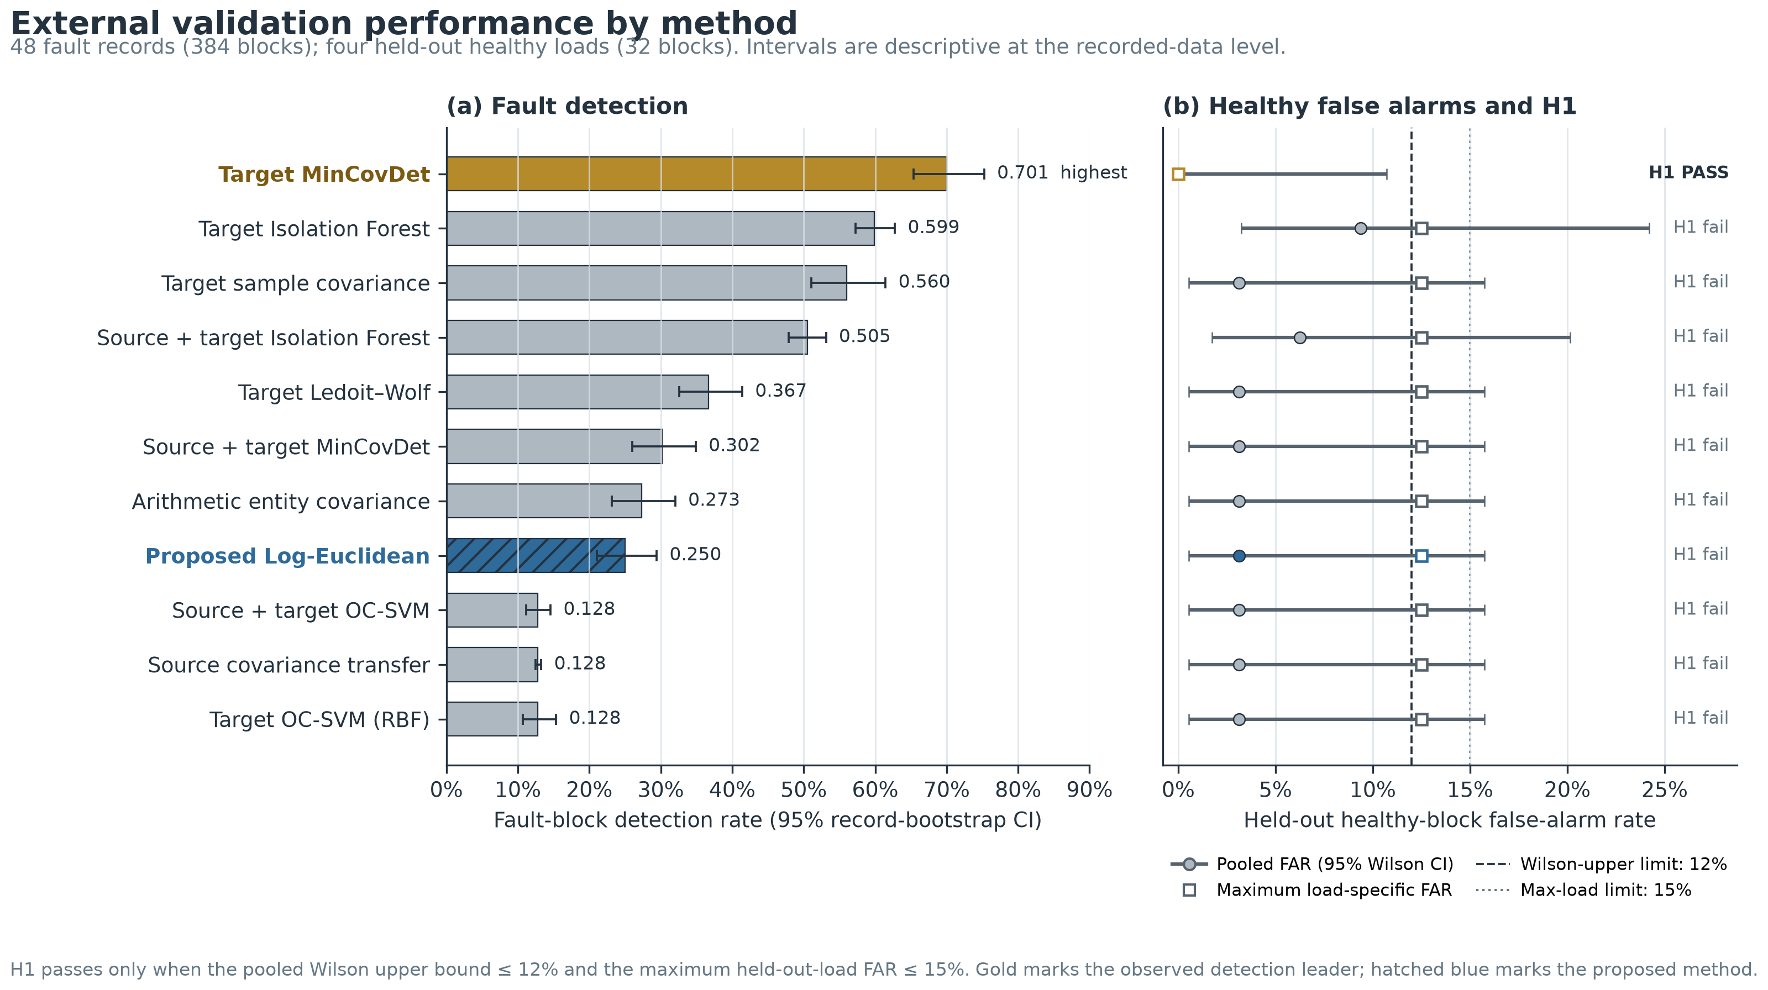
Fig. 8 External fault detection, healthy false alarms, and the predeclared H1 decision

6.8 Operating-point drift and negative transfer
The frozen detector did not alarm on any of the 48 fault records in analysis blocks 0-2, but alarmed on every record in block 7. Its only held-out healthy alarm also occurred in block 7. Over the same ordered blocks, approximate median speed rose from 218 to 2,214 rpm. The fault and healthy score trajectories therefore moved in the same direction as the operating point, making the apparent 48/48 record-any detection misleading: each record could be counted as detected by a late, speed-entangled alarm.
At the first four blocks, block detection was 2.60% and only 10.42% of records had any alarm. By the first seven blocks these values were 14.29% and 52.08%; only inclusion of the eighth block raised them to 25.00% and 100%. The median first alarm was block 6, corresponding to an approximate 1,643 rpm proxy taken from the matching healthy load record. In contrast, target MinCovDet detected 54.69% of the first four blocks and had a median first alarm at block 1 (approximately 318 rpm).
The pooled Spearman association between block position and frozen score was 0.836 for held-out health and 0.821 for faults. Yet the equal-weight mean of eight block-position-specific AUROCs was 0.805, compared with the pooled AUROC of 0.635. This post-reveal diagnostic suggests that fault-ranking information remained after matching acceleration position, while the transported unconditional score and fixed threshold were overwhelmed by operating-point drift. The threshold-normalized score and alarm trajectories are shown in Fig. 9.
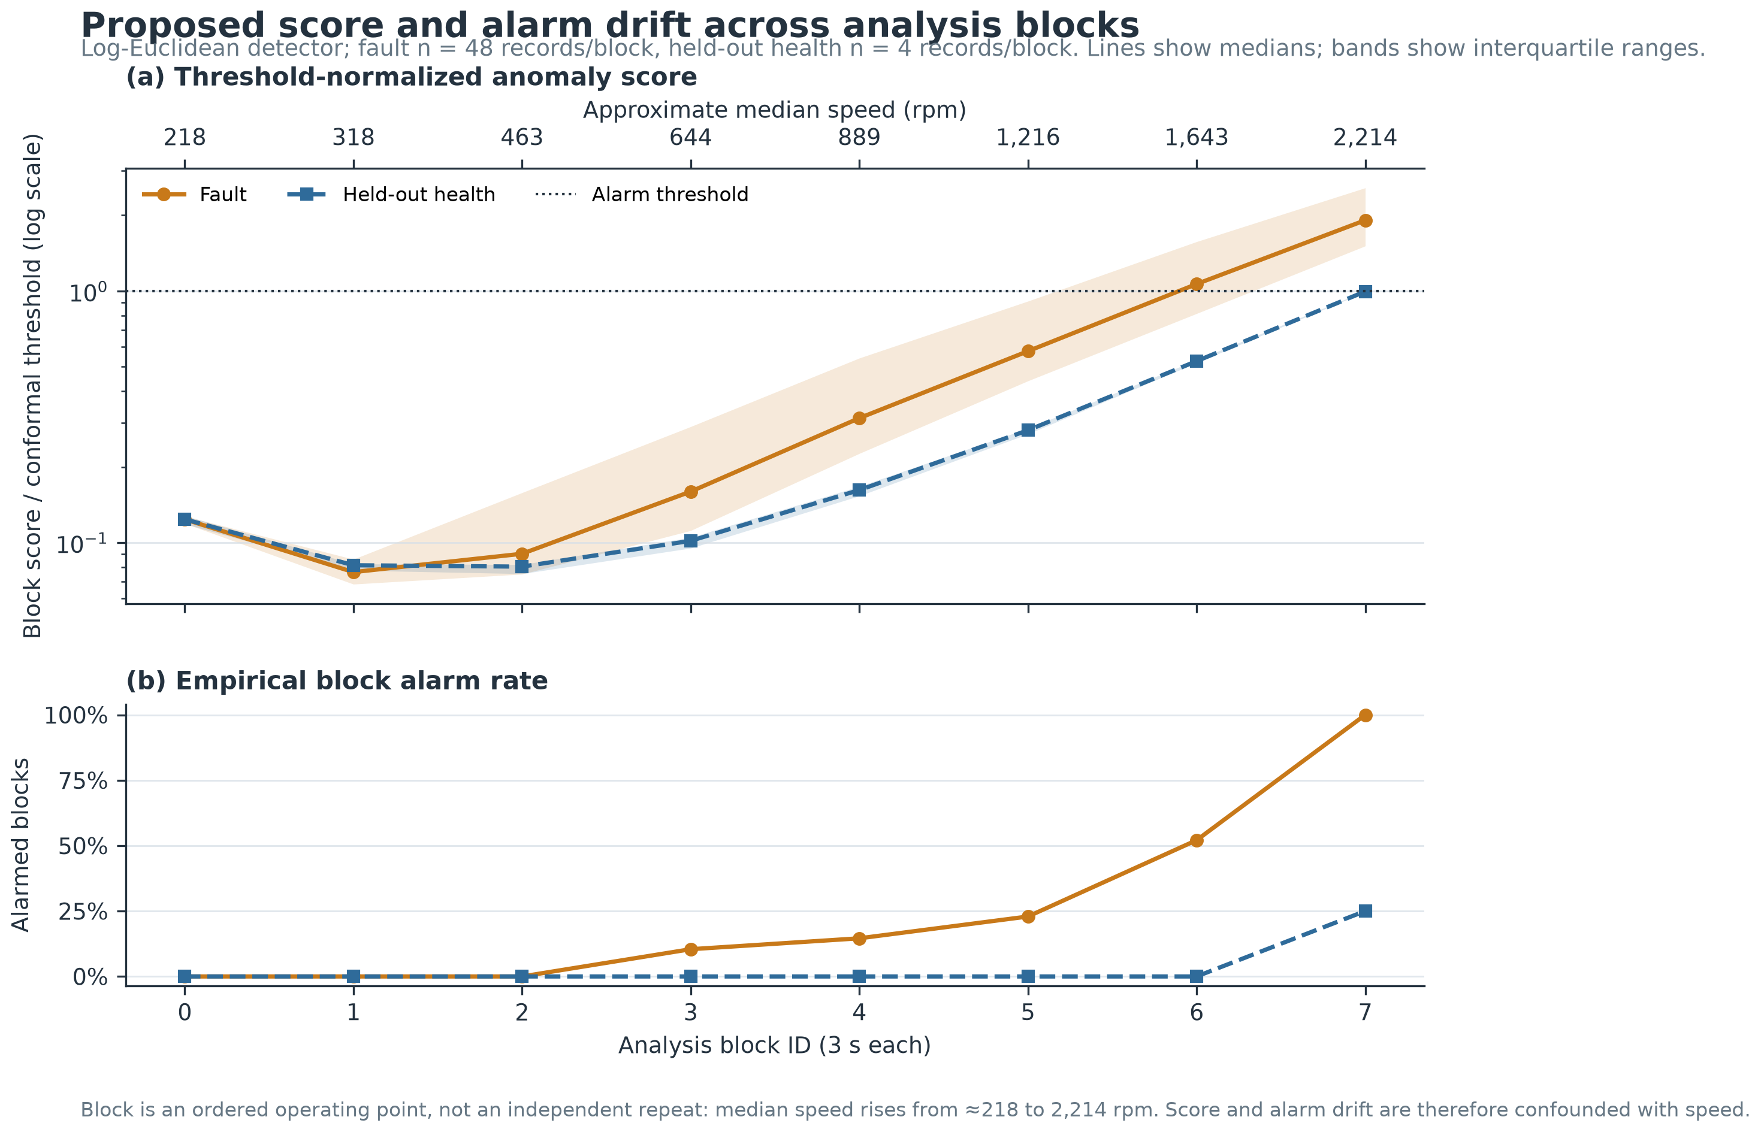
Fig. 9 Threshold-normalized score and alarm drift over the acceleration trajectory
The failure was also load dependent. Frozen-detector block detection fell from 56.25% at 0 N m to 12.50% at 35 N m. Across fault-turn counts, detection ranged only from 15.63% to 32.81% and did not increase monotonically. The full 6 by 8 condition grid shows that many high-load records triggered in only one of eight ordered blocks. The complete fault-turn-by-load alarm grid is shown in Fig. 10.
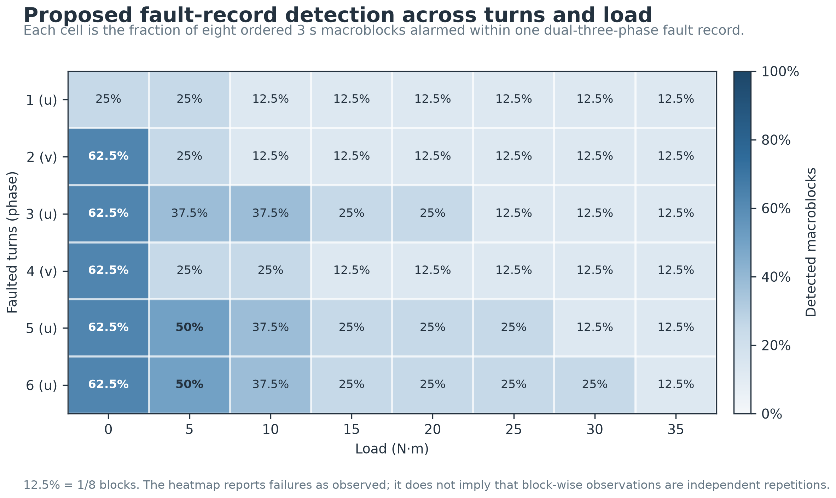
Fig. 10 Frozen-detector block detection over fault turns and load
Source data were not uniformly harmful: the frozen target-adapted Log-Euclidean configuration exceeded pure source covariance by 12.24 points (paired interval 8.33-16.41%), although those configurations also differ in covariance aggregation and regularization. Within the same MinCovDet estimator family, the source-augmented variant underperformed the target-only variant, 30.21% versus 70.05%; the paired target-only minus motor-balanced difference was 39.84 points (35.42-44.27%). On this motor under the frozen protocol, that same-estimator contrast is evidence of conditional negative transfer from source augmentation.

6.9 Post-reveal feature and geometry diagnosis
An exploratory, analysis-only audit reconstructed the frozen Log-Euclidean precision matrices from hash-locked inputs. It reproduced all 448 frozen block scores to a maximum absolute error of 3.64×10⁻¹². For a symmetric precision matrix P, the winning window's Mahalanobis score was allocated as cⱼ=xⱼ(Px)ⱼ, which splits each cross-term equally and satisfies Σⱼ cⱼ=xᵀ Px. No detector was refit and no threshold was changed. Reported contribution percentages are means of block-normalized absolute shares from the winning window under this chosen decomposition; they are not unique model feature weights.
Electrical fundamental frequency was almost nondiscriminative after matching health and fault at the same load and block position (direction-free single-feature AUROC 0.504; matched Hedges' g approximately zero), yet the chosen decomposition allocated it 18.07% of absolute fault-score contribution and 38.54% of held-out healthy contribution. In block 7 those shares rose to 39.63% and 89.31%, respectively. Conversely, the maximum and mean third-harmonic ratios each had single-feature AUROC above 0.925 and matched standardized effects near 1.0, but together received less than 0.6% of the frozen fault-score contribution. Phase-A RMS ratio combined high discrimination (AUROC 0.815) with 21.62% contribution, while sequence unbalance produced AUROC 0.771 and 6.99% contribution. At the feature-family level, absolute fault contribution was 49.79% current shape, 24.91% sequence imbalance, 18.07% speed proxy, 6.53% harmonics/sidebands, and 0.70% entropy.
This mismatch supports a specific failure interpretation: under the chosen symmetric decomposition, observed scores allocated substantial contribution to an operating-point direction with almost no matched fault contrast, while allocating little contribution to some fault-sensitive harmonic directions. It is not a causal feature-selection result. The same healthy load/block/subsystem is reused across six fault-turn conditions and every record comes from one motor, so these effect sizes are descriptive and post-reveal only. Figure 11 contrasts single-feature discrimination with the frozen-score contribution allocation.
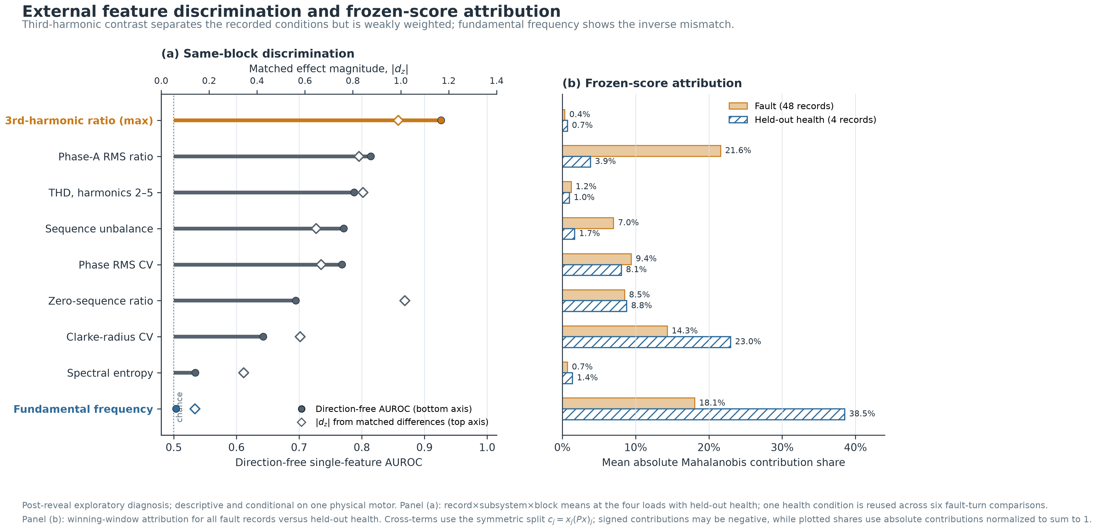
Fig. 11 Post-reveal single-feature discrimination versus frozen-score contribution

6.10 Sampling-rate sensitivity
To examine whether the 100 kHz KAIST versus 10 kHz external sampling mismatch could explain the failure under this pipeline, every KAIST current record was antialias-filtered and resampled to 10 kHz with polyphase resampling before applying the unchanged 0.2 s windows, feature schema, 3 s blocks, ridge, calibration, and external protocol. This analysis was specified after reveal and is diagnostic rather than confirmatory.
The 10 kHz KAIST arm remained usable internally: exploratory LOMO detection decreased from 95.71% to 91.96% and AUROC from 0.9993 to 0.9947. Replacing only the source arm in the frozen external run did not recover transfer. Log-Euclidean external detection changed from 25.00% to 24.74%, AUROC from 0.6354 to 0.6331, and healthy alarms remained 1/32. Forty-seven of 48 fault records were unchanged and one worsened; none improved. Target-only MinCovDet was, by construction, unchanged at 70.05%, so its lead over the transfer detector increased from 45.05 to 45.31 points. The sampling-rate mismatch may affect individual features, but this controlled sensitivity does not support it as the primary explanation for the observed negative transfer.

6.11 Secondary transient-set compatibility and null sensitivity
The frozen primary parser attempted all 21 official records and accepted none. The MATLAB timeseries objects contained empty explicit time arrays even though uniform 10 kHz timing was encoded in their metadata, whereas the frozen parser required an explicit monotonic time vector. Consequently, the primary run produced no features, scores, or detector comparison; this is a prospective compatibility failure, not a fault-detection result.
An opt-in post-reveal structural repair reconstructed time only from the stored start, increment, and length metadata without changing signals, features, or onset rules. It made 12/12 records from the 200 W motor and 4/9 from the 20 kW motor compatible. The other five 20 kW onsets overlapped the frozen 0.5 s baseline, so that motor failed the 80% gate (44.44%) and was not selectively reanalyzed. A descriptive leave-one-record-out sensitivity on the single 200 W motor then produced 0/60 alarms in the primary first-second fault windows for every one of 12 detectors, and 0/120 across the full 2 s post-onset horizon. Held-out prefault alarms ranged from 7/176 to 13/176. Proposed produced 8/176 (4.55%) with mean record AUROC 0.541; Target MinCovDet produced 9/176 (5.11%) with AUROC 0.564. With no standalone healthy sessions, zero thresholded detection, and only one analyzed motor, this post-reveal result neither confirms generalization nor identifies positive or negative transfer. Full compatibility, method, and hash tables are reported in Online Resource 1, Section S9.

7. Discussion
The central result is the external ranking reversal, not the near-ceiling KAIST AUROC. Within one manufacturer, topology, speed, and load, both the frozen Log-Euclidean detector and a motor-balanced Isolation Forest appeared highly effective. Under a simultaneous change in winding topology, measurement rate, load, and speed trajectory, the same frozen score lost detection and failed the predeclared empirical health gate. This is the deployment gap that random-window or same-family holdout cannot measure.
The ordered-block analysis changes the interpretation of the raw external outcomes. All 48 fault records alarmed in block 7, while some had already alarmed in earlier blocks; the final block's operating point also drove the healthy score upward. Record-any detection would therefore report 100% while hiding poor early-trajectory coverage and a late healthy false alarm. Pooled AUPRC similarly adds limited operational information unless interpreted against the 384/416 = 92.3% fault-block prevalence, which gives an all-positive ranking a baseline near 0.923. The appropriate evidence is the joint display of chronological block detection, held-out health alarms, per-condition coverage, and record-level paired differences.
Conditional negative transfer on this motor is not equivalent to saying that source knowledge has no value. The target-adapted Log-Euclidean configuration outperformed pure-source covariance, while source-augmented MinCovDet underperformed its target-only counterpart under the same estimator family. A plausible mechanism is a mismatch between an unconditional healthy reference and the external acceleration trajectory: speed-sensitive spectral and covariance directions move both healthy and faulty scores together. The frozen-geometry audit supports this interpretation: fundamental frequency received large score contribution despite chance-level matched discrimination, while a third-harmonic contrast was highly discriminative but weakly weighted. Antialiasing the KAIST source to the same 10 kHz rate did not rescue transfer, ruling against a simple sampling-rate-only explanation under this pipeline. A block-conditioned analysis can still retain fault-ranking information, which motivates operating-condition-aware healthy residuals, but any such detector is post-reveal development on this dataset and requires a new untouched confirmation.
The calibration design also sets a practical boundary. A short target trace can estimate a coordinate system, but a nominal 5% conformal p-value needs at least 19 calibration units. In this study those units are ordered blocks from a few continuous records, not independent sessions; the resulting Wilson intervals and p-values are descriptive under a stationarity/mixing interpretation. They are not machine-level safety guarantees.
The secondary transient audit adds a different failure mode: a validation can fail before model comparison if file-time semantics or available prefault baselines do not meet the frozen contract. Reconstructing documented implicit time made analysis possible, but it did not restore confirmatory status. The 200 W null sensitivity is consistent with cross-record healthy heterogeneity overwhelming the short post-onset change under these thresholds; because this interpretation followed reveal, it is a design diagnostic rather than evidence for a revised detector.
Six limitations dominate the claims. First, each KAIST motor has only one unique healthy record, so its calibration and later-time evaluation are not independent sessions. Second, all KAIST machines share manufacturer and fixed operating condition. Third, the KAIST target faults were inspected during development and are exploratory. Fourth, the external 48-record grid comes from one physical dual-three-phase motor; record bootstrap quantifies variability across its recorded conditions, not across a population of motors. Fifth, the external shift is compound, so this experiment cannot causally separate topology, sampling rate, controller, speed, and load effects. Sixth, the secondary transient dataset has no independent healthy records; its frozen parser failed, only four of nine 20 kW records passed the repaired baseline gate, and the reported 200 W sensitivity is post-reveal and conditional on one motor.
The next method study should use only healthy data to condition scores on electrical frequency and load, include a target-only MinCovDet primary comparator, harmonize sampling-rate sensitivity, and freeze early-trajectory detection and FAR criteria before evaluation on another unseen motor or independent laboratory. Multiple genuinely independent healthy sessions, documented time semantics, and adequate prefault duration are required before session-level risk can be estimated.

8. Conclusion
This study demonstrates why healthy-only PMSM fault detection must be evaluated across physical files, motors, operating trajectories, and laboratories rather than adjacent windows. A detector with 95.71% exploratory same-family detection fell to 25.00% after a frozen external reveal, failed its health-risk gate, and was exceeded by a target-only robust covariance comparator at 70.05%. The failure was structured: alarms drifted across ordered blocks in alignment with the acceleration trajectory, detection weakened with load, and source-augmented variants underperformed target-only counterparts on this motor. The contribution is therefore not a claim of a universally superior detector, but a reproducible account of ranking reversal and conditional negative transfer that preserves the frozen primary failure. A prospectively logged secondary audit likewise did not supply confirmatory evidence: its primary parser was incompatible with the stored time representation, and all methods missed the first second in the repaired single-motor sensitivity. Reliable deployment requires operating-condition-aware target-health modeling, independent healthy sessions, and a new untouched confirmation; the present evidence does not establish unrestricted machine generalization, severity estimation, prognosis, or a safety guarantee.

Data and code availability
The KAIST source dataset is available from Mendeley Data; the independent dual-three-phase PMSM dataset and the secondary 200 W/20 kW transient dataset are available from Zenodo. All three are under CC BY 4.0 [31, 32, 34]. The project contains resumable checksummed downloads, archive and MAT audits, duplicate removal, feature extraction, motor/file-level evaluation, paired bootstrap, sensitivity analyses, automated tests, and figure generation. Raw data remain excluded from version control; the reveal manifests, protocols, selected derived results, and audit metadata are retained for exact reconstruction. Detailed partitions, thresholds, comparator results, post-reveal diagnostics, sampling-rate controls, transient-set compatibility outcomes, and file hashes are provided in Online Resource 1. The anonymized code, automated tests, protocols, and selected derived outputs needed to rerun the reported analyses are provided in Online Resource 2.

Statements and declarations

Competing interests
The authors declare no financial or non-financial competing interests.

Ethics approval and consent to participate
Not applicable. This study reanalyzes public experimental machine-current datasets and does not involve human participants, animals, or personal data.

Funding
Funding information is supplied on the separate title page and withheld from this file for double-blind review.

Author contributions
The author-contribution statement is supplied on the separate title page and withheld from this file for double-blind review.

Generative AI assistance
An LLM-based coding assistant was used under human direction for implementation support, automated consistency checks, and manuscript drafting and editing. All reported computations were executed on the cited datasets and checked against frozen outputs and automated tests. The human authors remain responsible for reviewing and approving the submitted version.

References
[1] Zafarani, M., Bostanci, E., Qi, Y., Goktas, T., & Akin, B. (2018). Interturn Short-Circuit Faults in Permanent Magnet Synchronous Machines: An Extended Review and Comprehensive Analysis. IEEE Journal of Emerging and Selected Topics in Power Electronics, 6(4), 2173-2191. https://doi.org/10.1109/JESTPE.2018.2811538
[2] Jeong, H., Moon, S., & Kim, S. W. (2017). An Early Stage Interturn Fault Diagnosis of PMSMs by Using Negative-Sequence Components. IEEE Transactions on Industrial Electronics, 64(7), 5701-5708. https://doi.org/10.1109/TIE.2017.2677355
[3] Li, D., Zhu, M., Zhao, Y., & Lin, S. (2024). Detection and Location of Inter-Turn Short-Circuit in a PMSM Based on Square of Negative Sequence Current Vector Modulus. IEICE Electronics Express, 21(22), 20240550. https://doi.org/10.1587/elex.21.20240550
[4] Lee, H., Jeong, H., Koo, G., Ban, J., & Kim, S. W. (2021). Attention Recurrent Neural Network-Based Severity Estimation Method for Interturn Short-Circuit Fault in Permanent Magnet Synchronous Machines. IEEE Transactions on Industrial Electronics, 68(4), 3445-3453. https://doi.org/10.1109/TIE.2020.2978690
[5] Li, X., Zhang, W., Ma, H., Luo, Z., & Li, X. (2020). Domain Generalization in Rotating Machinery Fault Diagnostics Using Deep Neural Networks. Neurocomputing, 403, 409-420. https://doi.org/10.1016/j.neucom.2020.05.014
[6] Xiao, Y., Shao, H., Yan, S., Wang, J., Peng, Y., & Liu, B. (2025). Domain Generalization for Rotating Machinery Fault Diagnosis: A Survey. Advanced Engineering Informatics, 64, 103063. https://doi.org/10.1016/j.aei.2024.103063
[7] Li, J., Wang, Y., Zi, Y., Zhang, H., & Li, C. (2023). Causal Consistency Network: A Collaborative Multimachine Generalization Method for Bearing Fault Diagnosis. IEEE Transactions on Industrial Informatics, 19(4), 5915-5924. https://doi.org/10.1109/TII.2022.3174711
[8] Zhao, C., Zio, E., & Shen, W. (2024). Domain Generalization for Cross-Domain Fault Diagnosis: An Application-Oriented Perspective and a Benchmark Study. Reliability Engineering & System Safety, 245, 109964. https://doi.org/10.1016/j.ress.2024.109964
[9] Wang, Z., Dai, Z., Póczos, B., & Carbonell, J. (2019). Characterizing and Avoiding Negative Transfer. In 2019 IEEE/CVF Conference on Computer Vision and Pattern Recognition (CVPR) (pp. 11285-11294). https://doi.org/10.1109/CVPR.2019.01155
[10] Kumar MP, P., Tu, Z. X., Chen, H. C., & Chen, K. C. (2024). Mitigating Negative Transfer Learning in Source Free-Unsupervised Domain Adaptation for Rotating Machinery Fault Diagnosis. IEEE Transactions on Instrumentation and Measurement, 73, 1-16. https://doi.org/10.1109/TIM.2024.3476610
[11] Angelopoulos, A. N., & Bates, S. (2023). Conformal Prediction: A Gentle Introduction. Foundations and Trends in Machine Learning, 16(4), 494-591. https://doi.org/10.1561/2200000101
[12] Heddoub, A., Homri, L., & Siadat, A. (2026). Class-Conditional Conformal Prediction with Discriminant-Analysis Backbones for Reliable Open-Set Fault Diagnosis in Safety-Critical Industrial Systems. Journal of Process Control, 161, 103701. https://doi.org/10.1016/j.jprocont.2026.103701
[13] Chernozhukov, V., Wüthrich, K., & Zhu, Y. (2018). Exact and Robust Conformal Inference Methods for Predictive Machine Learning with Dependent Data. In Proceedings of the 31st Conference on Learning Theory (Vol. 75, pp. 732-749). https://proceedings.mlr.press/v75/chernozhukov18a.html
[14] Barber, R. F., & Pananjady, A. (2026). Predictive Inference for Time Series: Why Is Split Conformal Effective Despite Temporal Dependence?. In Proceedings of the 37th International Conference on Algorithmic Learning Theory (Vol. 313, pp. 1-24). https://proceedings.mlr.press/v313/barber26a.html
[15] Wheat, L., von Mohrenschildt, M. V., Habibi, S., & Al-Ani, D. (2024). Impact of Data Leakage in Vibration Signals Used for Bearing Fault Diagnosis. IEEE Access, 12, 169879-169895. https://doi.org/10.1109/ACCESS.2024.3497716
[16] Roberts, D. R., Bahn, V., Ciuti, S., Boyce, M. S., Elith, J., Guillera-Arroita, G., Hauenstein, S., Lahoz-Monfort, J. J., Schröder, B., Thuiller, W., Warton, D. I., Wintle, B. A., Hartig, F., & Dormann, C. F. (2017). Cross-Validation Strategies for Data with Temporal, Spatial, Hierarchical, or Phylogenetic Structure. Ecography, 40(8), 913-929. https://doi.org/10.1111/ecog.02881
[17] Hurlbert, S. H. (1984). Pseudoreplication and the Design of Ecological Field Experiments. Ecological Monographs, 54(2), 187-211. https://doi.org/10.2307/1942661
[18] Urresty, J. C., Riba, J. R., & Romeral, L. (2013). Diagnosis of Interturn Faults in PMSMs Operating Under Nonstationary Conditions by Applying Order Tracking Filtering. IEEE Transactions on Power Electronics, 28(1), 507-515. https://doi.org/10.1109/TPEL.2012.2198077
[19] Li, M., Geng, Y., Wang, W., Tu, M., & Wu, X. (2024). Permanent Magnet Synchronous Motor Inter-Turn Short Circuit Diagnosis Based on Physical-Data Dual Model Under Oil-Drilling Environment. Engineering Applications of Artificial Intelligence, 132, 107938. https://doi.org/10.1016/j.engappai.2024.107938
[20] Liu, X., Liu, F., Geng, X., Fan, L., Jiang, M., & Zhang, F. (2025). Frequency Domain Guided Latent Diffusion Model for Domain Generalization in Cross-Machine Fault Diagnosis. Measurement, 249, 116989. https://doi.org/10.1016/j.measurement.2025.116989
[21] Schölkopf, B., Platt, J. C., Shawe-Taylor, J., Smola, A. J., & Williamson, R. C. (2001). Estimating the Support of a High-Dimensional Distribution. Neural Computation, 13(7), 1443-1471. https://doi.org/10.1162/089976601750264965
[22] Liu, F. T., Ting, K. M., & Zhou, Z. H. (2008). Isolation Forest. In 2008 Eighth IEEE International Conference on Data Mining (pp. 413-422). https://doi.org/10.1109/ICDM.2008.17
[23] Tax, D. M. J., & Duin, R. P. W. (2004). Support Vector Data Description. Machine Learning, 54(1), 45-66. https://doi.org/10.1023/B:MACH.0000008084.60811.49
[24] Rousseeuw, P. J., & Van Driessen, K. (1999). A Fast Algorithm for the Minimum Covariance Determinant Estimator. Technometrics, 41(3), 212-223. https://doi.org/10.1080/00401706.1999.10485670
[25] Yoon, D., & Yu, J. (2024). Machinery Fault Signal Detection with Deep One-Class Classification. Applied Sciences, 14(1), 221. https://doi.org/10.3390/app14010221
[26] Arsigny, V., Fillard, P., Pennec, X., & Ayache, N. (2006). Log-Euclidean Metrics for Fast and Simple Calculus on Diffusion Tensors. Magnetic Resonance in Medicine, 56(2), 411-421. https://doi.org/10.1002/mrm.20965
[27] Farouq, S., Byttner, S., Bouguelia, M. R., & Gadd, H. (2021). Mondrian Conformal Anomaly Detection for Fault Sequence Identification in Heterogeneous Fleets. Neurocomputing, 462, 591-606. https://doi.org/10.1016/j.neucom.2021.08.016
[28] Farouq, S., Byttner, S., Bouguelia, M. R., & Gadd, H. (2022). A Conformal Anomaly Detection Based Industrial Fleet Monitoring Framework: A Case Study in District Heating. Expert Systems with Applications, 201, 116864. https://doi.org/10.1016/j.eswa.2022.116864
[29] Diallo, A. R., Homri, L., & Dantan, J. Y. (2025). Reducing False Alarms in Fault Detection: A Comparative Analysis Between Conformal Prediction and Classical Methods Applied to PCA and Autoencoders. Journal of Process Control, 152, 103495. https://doi.org/10.1016/j.jprocont.2025.103495
[30] Jung, W., Yun, S. H., Lim, Y. S., Cheong, S., & Park, Y. H. (2023). Vibration and Current Dataset of Three-Phase Permanent Magnet Synchronous Motors with Stator Faults. Data in Brief, 47, 108952. https://doi.org/10.1016/j.dib.2023.108952
[31] Jung, W., Yun, S., Lim, Y. S., Cheong, S., & Park, Y. H. (2022). Vibration and Current Dataset of Three-Phase Permanent Magnet Synchronous Motors with Stator Faults (Version 5) [Data set]. Mendeley Data. https://doi.org/10.17632/rgn5brrgrn.5
[32] Kozovsky, M. (2024). Measurement of Interturn Short-Circuits Emulation on Dual Three-Phase PMS Motor [Data set]. Zenodo. https://doi.org/10.5281/zenodo.13889418
[33] Kozovský, M., Buchta, L., & Blaha, P. (2022). Interturn Short Circuit Modelling in Dual Three-Phase PMSM. In IECON 2022 - 48th Annual Conference of the IEEE Industrial Electronics Society (pp. 1-6). https://doi.org/10.1109/IECON49645.2022.9968364
[34] Zezula, L., Kozovsky, M., & Blaha, P. (2024). Diagnostics of Interturn Short Circuits in PMSMs With Online Fault Indicators Estimation - Dataset [Data set]. Zenodo. https://doi.org/10.5281/zenodo.15631383

