  - Project Documentation - GIC Fund Data Analysis
Name of Preparer: Periyasamy Tamilarasi
Date: November 18, 2025
Project Goal: Establish a data pipeline to ingest fund data and market reference data and execute two key financial reconciliation and performance analyses.
This solution uses Python with the MS SQL Express database for database management and pandas for data manipulation and CSV generation, addressing all parts of the request.
Contents
1. Data Ingestion and Database Setup (PowerShell & SQL) 1
2. Analysis and Reporting (Python & SQL) 2
2.1. Best Performing Fund Analysis 2
2.2. Price Reconciliation Analysis 2
3. Gaps/Dependencies for a Production Version 3
3.1 Data Dependencies and Validation 3
3.2. Scalability and Technology Stack 3
3.3. Reporting and Deployment 4
4. Annexure 4

1. Data Ingestion and Database Setup (PowerShell & SQL)
This phase focused on creating the central database (GIC) and safely loading all data sources using the PowerShell ingestion script.
Task | Tool/Script | Outcome
Database Creation | master-reference-sql.sql | Created the GIC database and all required tables.
 | fund_positions_table_script.sql | Created table.
Data Ingestion | For all the tables in this script file, followed the steps below:  - Created CSV file  - Bulk Insert data  Due to insert limitation issue. | Successfully loaded all data from source files into relevant data tables.  Resolved insert only 1000 records at a time.
 | Ingest-FundData.ps1 | Successfully loaded all data from the source files into the SQL Server instance (DESKTOP-LE91ITE\SQLEXPRESS).  Python code to read investors’ files from file explorer and input Investor name and EOD from file name.
Data Cleaning | Embedded in DDL/Scripts | Addressed initial data type inconsistencies and ensured all price and position data was correctly imported into the SQL tables.

2. Analysis and Reporting (Python & SQL)
Two primary analyses were executed using Python scripts that leveraged the powerful pandas and SQL alchemy libraries for efficient interaction with the SQL database.

2.1. Best Performing Fund Analysis
This script calculated the total market value and overall return for each fund and identified the top performer.
- Script: best_performing_fund_analysis.py & SQL script to double check result.
- Outcome: Successfully generated the best_performing_fund_analysis.csv file, which ranks funds based on their performance metrics.

2.2. Price Reconciliation Analysis
This script compared the price reported by the fund against the market reference data to identify pricing differences. This query was highly optimized to handle complex data type issues and performance bottlenecks.
- Script: price_reconciliation_analysis.py & SQL script to double check result.
- Outcome: Successfully generated the price_reconciliation_analysis.csv file, containing a list of all positions with the calculated Price_Difference and the Price_Source_Flag (e.g., 'Exact Match', 'Last Available Price Used', or 'No Reference Price Found').
- Key Technical Resolution: The final query incorporated set-based optimization (LEFT JOIN and ROW_NUMBER) to resolve performance hang issues and ensure compatibility with older SQL Server versions and problematic legacy data types (TEXT).

Gaps/Dependencies for a Production Version
While the code provides the required logic, a production-grade system would require addressing the following gaps and dependencies:

3.1 Data Dependencies and Validation
- Missing external-funds data file: The primary dependency is the actual format and structure of the external-funds CSV file. The current solution relies on a mock structure.
- Instrument Mapping: In a production system, a single instrument identifier (e.g., Instrument_ID) is often insufficient. A robust system would require a cross-reference table to map different identifiers (ISIN, SEDOL, TICKER/SYMBOL) to a single internal ID to reliably join fund positions to reference prices.
- Data Quality Checks (Validation):
  - Referential Integrity: Ensure all Instrument_IDs in the fund reports exist in the bond_reference or equity_reference tables.
  - Price Sanity: Implement checks for extreme price , flagging them as potential data errors instead of merely reporting them as a "Break."
  - Date Alignment: The current price reconciliation assumes the closest prior date is acceptable. Production may require an explicit cut-off policy.

3.2. Scalability and Technology Stack
- Database Choice: An in-memory SQLite database (:memory:) is suitable for small-scale analysis and testing, but for a production environment with an N number of funds, a more robust, concurrent, and scalable database is required, such as PostgreSQL or MS SQL Server.
- Ingestion Pipeline: Instead of a simple Python script, ingestion would be part of a scheduled workflow (e.g., using Apache Airflow or a cloud-native scheduler) that fetches files from a secure location (e.g., SFTP, S3 bucket), validates them, and then loads them into the warehouse.
- Concurrency: The price reconciliation logic relies on subqueries for finding the latest price. While functional in SQLite, a large dataset would benefit from a dedicated time-series database or a more optimized SQL approach like Lateral Joins (PostgreSQL/SQL Server) for better performance.

3.3. Reporting and Deployment
- Reporting Platform: Generating raw CSVs is acceptable for analysis, but production reporting would typically use tools like Tableau, Power BI, or a custom web dashboard to visualize performance, trend breaks, and send automated alerts.
- Code Deployment: The Python script would be containerized (e.g., using Docker) and deployed to a cloud platform (e.g., AWS, GCP, Azure) to run reliably and on a scheduled basis (e.g., monthly).

Annexure
  - DB Screenshot

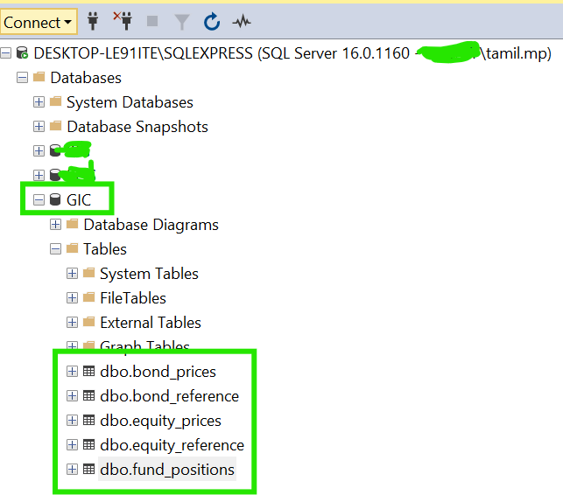

  - DB Count Screenshot
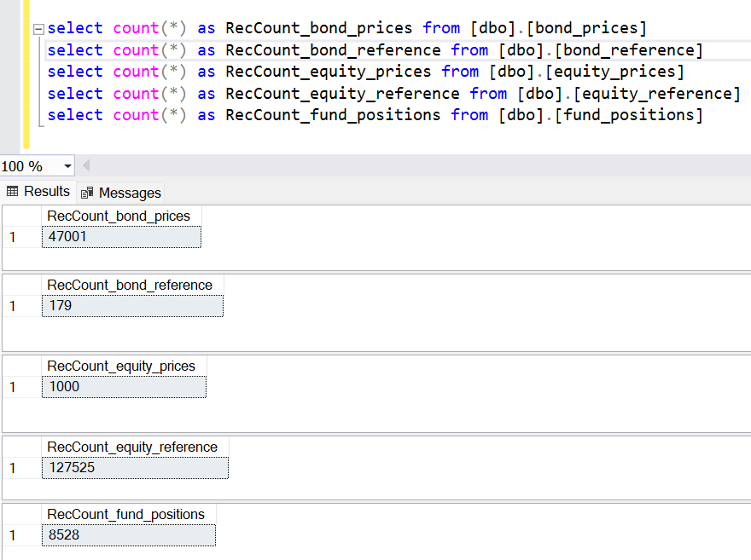
Thank you

