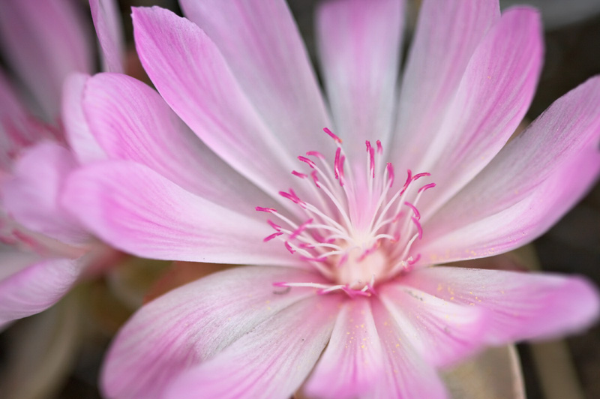

Laurie Kiguchi Educational Consulting

Advising for College and Careers

Lewisia rediviva

