深度人脸识别调研 | 文件类型：调研文档
深度人脸识别调研 | 文件编号：
深度人脸识别调研 | 面向的部门： 研发中心
深度人脸识别调研 | 保密等级：高
深度人脸识别调研 | 作者： 刘凯
深度人脸识别调研 | 日期：2018-08-21
深度人脸识别调研 | 版本：1.0V

深度人脸识别调研



目录
1. 深度人脸识别简介 3
2. 特征提取和匹配 4
2.1 网络结构 4
2.3 Loss函数 4
2.3 人脸匹配 5
3. 人脸处理 5
附录A：Loss函数 7
附录B：距离计算 11

1. 深度人脸识别简介
一个人脸识别系统主要包含3个模块：人脸检测(Face Detection)、人脸对齐(Face Alignment)和人脸识别(Face Recognition)，如图1所示。前两个模块不在本文讨论之列，本文主要对人脸识别算法进行初步的调研。人脸识别算法的发展大致可以分成三个阶段，第一个阶段通过降维将人脸投影到低维空间，如EigenFace[2]，FisherFace[3]等算法。第二个阶段主要采用人工特征+分类器的方法，如HOG[4]，LBP[5]，Gabor[6]等。第三个阶段则主要基于深度学习理论，如DeepFace[7]，FaceID[8]-[10]，FaceNet[11]等。本文主要是对深度人脸识别(Deep Face Recognition)算法的相关模块的算法进行调研。

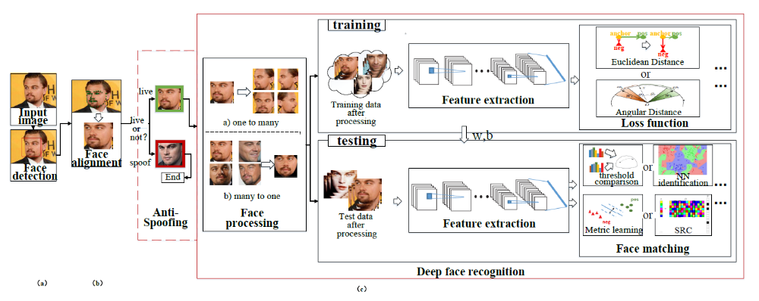
图1：人脸识别框图

深度人脸识别大致可以分为如下几个模块：1) 人脸处理(Face processing)，主要是对人脸变化进行处理，如伪装(pose)、光照(illumination)、表情(expression)和遮挡(occlusion)等。大致可以分成两类，‘one to many’ 和‘many to one’，参考文献[1]的表I。2) 特征提取，主要包括网络结构(Network Architecture)和误差函数(Loss function)两块。参考文献[1]的表II和表III。3) 人脸匹配(Face Matching)，包括人脸验证(Face Verification)和人脸ID(Face Identification)。

2. 特征提取和匹配

2.1 网络结构
现有的深度人脸识别算法使用的网络大都是经典的神经网络，如AlexNet[12], VGGNet[13], GoogleNet[14], ResNet[15]和SENet[16]等，对应的深度人脸识别算法包括Deepface[7], VGGface[17], FaceNet[11], Sephereface[18]和VGGface2[19]等，如图2所示：
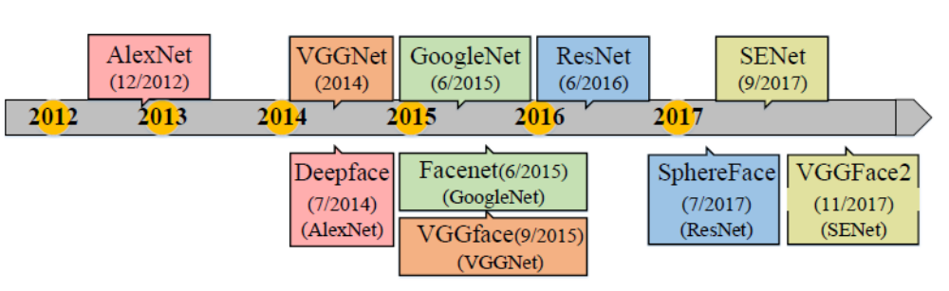
图2：网络结构和深度人脸识别算法

此外，一些特殊的网络结构也能应用到人脸识别上，如MFM(Max Feature Map)[20], B-CNN(Bilinear CNN)[21], c-CNN(Conditional CNN)[22]等。

2.3 Loss函数
Loss函数是深度人脸识别中很重要的部分，大致可以分成三类：基于欧氏距离的loss，基于角度/余弦边界的loss(Angular/cosine margin based loss)和基于Softmax及其变化的loss。基于欧式距离的loss主要包括contrastive loss[8]-[10], triplet loss[11][23][24]和center loss[25]-[28]等。基于角度/余弦边界的loss将特征映射到角度域，以区分不同的特征，如A-Softmax[30], L-Softmax[31], Arcface[29], AM-Softmax [33]等。Softmax loss除了传统的表达式，也有许多变化和扩展，如vMF loss(von Mises Fisher)[36], L2 softmax[34], COCO loss[35]等。Loss函数的发展演进参考图3。

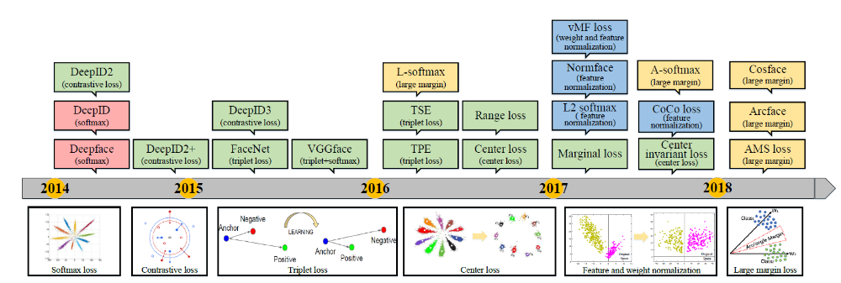
图3： loss函数的演进

2.3 人脸匹配
在测试阶段的特征比对通常使用cosine distance或L2 distance来测量两个特征的距离，然后用阈值比较和最近邻法来完成人脸的验证和识别(verification and identification)。更多人脸验证和识别算法参考[37]-[42]。

3. 人脸处理
人脸处理可以大致分成两类：many-to-one normalization和one-to-many augmentation。前者是从多幅图片中生成正面的图片，消除各种人脸变化的影响，供后续的对齐和比对，算法主要分成三类：SAE[59]-[61]，CNN[62]-[65]和GAN[66]-[68]。而后者则是从少量的图片出发，生成多组不同的图片，主要分成四类：data augmentation[43]-[45], 3D Model[46]-[51], CNN Model[52]-[53]和GAN Model[54]-[58]。参考图4。

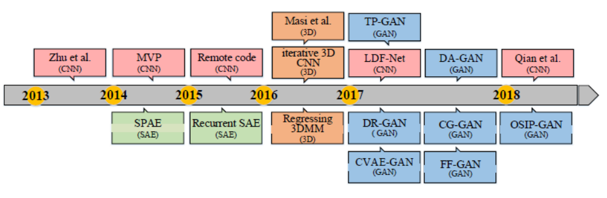
图4：人脸处理算法的演进
深度人脸识别思维导图：
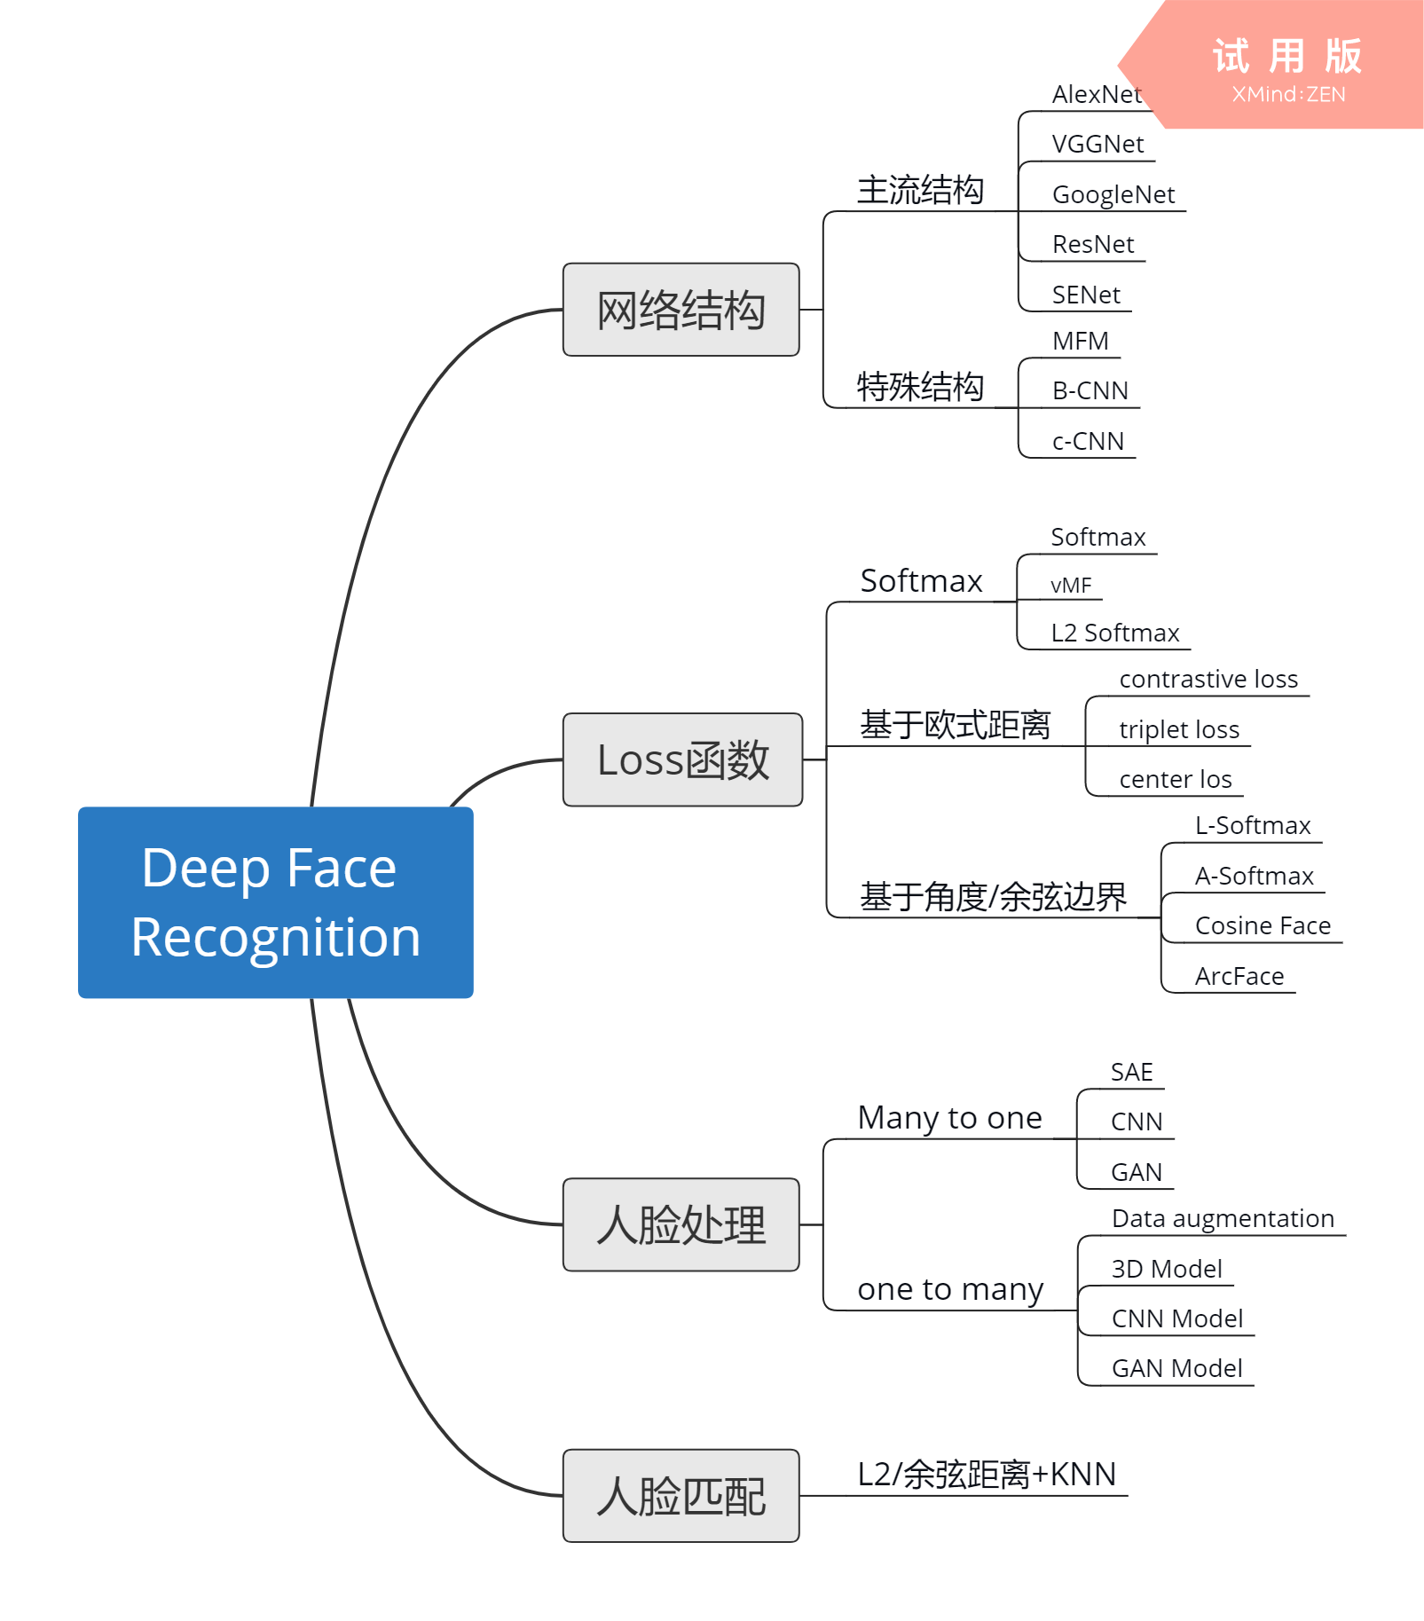

附录A：Loss函数
对于分类问题来说，Loss函数只要能separable就可以了，但对于FR问题，Loss函数不仅要separable，还要discriminative，即不同类在特征空间的距离越大越好。传统的Softmax loss只能满足separable，但discriminative的性能较差。因此需要新的loss函数来提高discriminative特性。Loss函数的本质是在分类的判别式上增加一个边界(margin)m，使得不同类在特征空间上的“距离”至少为m，从而增加discriminative特性，这里的“距离”可能并不一定是常规意义下的欧几里得距离。本附录简单列举几种常见的Loss函数。

Softmax loss
传统的Softmax loss[7]为：
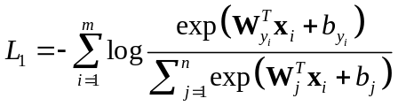
其中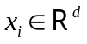为第个深度特征，属于第类，d为特征的维度。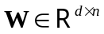为最后一个全连接层的权重，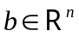为偏置。和分别为mini-batch数和分类个数。分类效果如图A1所示：
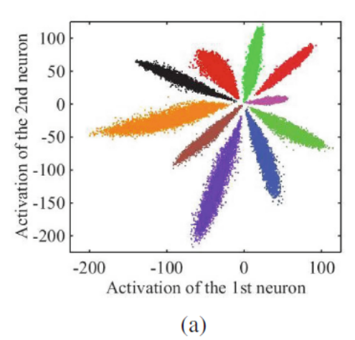
图A1：Softmax loss分类

Contrastive loss
Contrastive loss[9]旨在减小同类样本的距离，增加不同样本的距离。
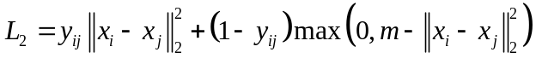
其中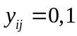分别表示特征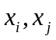不属于/属于同一类。其中m为margin，表示不同的类之间的距离。

Triplet loss
Triplet loss[11]旨在最小化锚点(Anchor)和正样本的距离，最大化与负样本的距离，loss函数为：
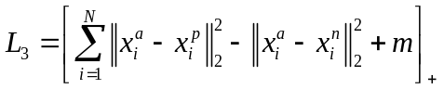
其中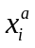，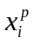和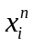分别为锚点的特征、正样本的特征和负样本的特征，同样m表示margin。
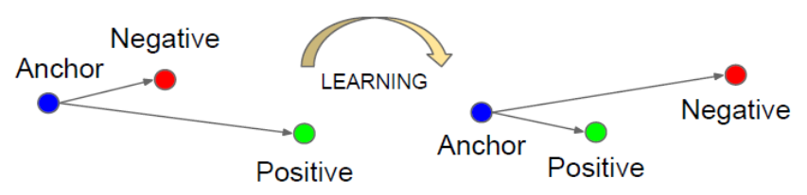
图A2：Triplet loss示意图

Center loss
Center loss[25]旨在减小同一类的距离，其loss函数为：
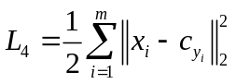
其中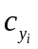为类的中心，也是需要迭代优化的参数，其思想类似于K-means算法，对于非同类的点不会影响的值，只有同类的点才会改变的值。文献[25]是将center loss和Softmax loss合并的：
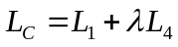
其中为权衡两者的参数，其效果如图A3所示：

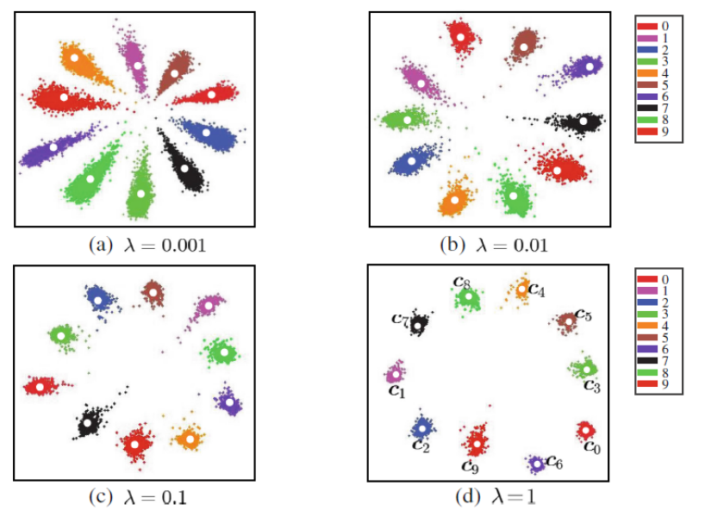
图A3：Center loss + Softmax loss

L-Softmax
L-Softmax[31]是从softmax loss上转化而来，但L-Softmax更关注的是角度域上特征之间的距离。在中，因为有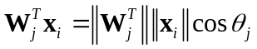，为了增加不同类之间的距离，将决策边界m加入到角度中(称为Multiplicative Angular Margin)，即当：
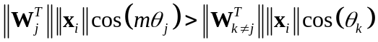
时，将判定为类，其中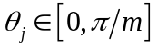。因此L-Softmax loss为：
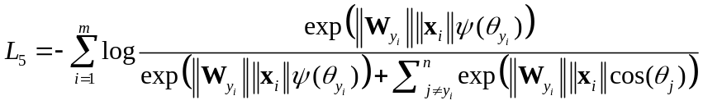
其中，
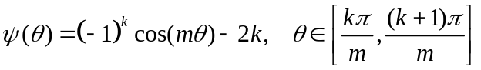
且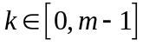为一个正整数。L-Softmax的效果如图A4：

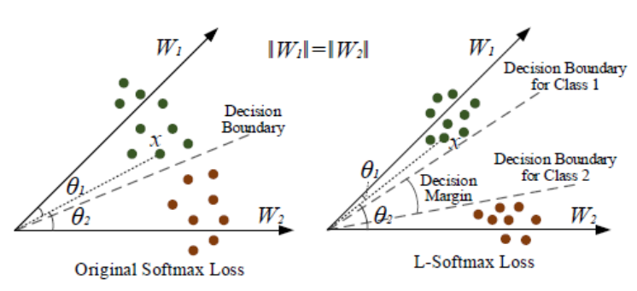
图A4：L-Softmax
A-Softmax
A-Softmax[30]是将L-Softmax中的权重进行归一化(Weights Normalization)，即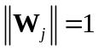，得到：
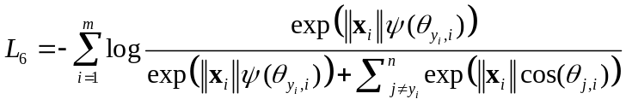

AM-Softmax
AM-Softmax[30]相比于A-Softmax又进一步将特征矢量归一化(Feature Normalization)，并且将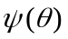替换为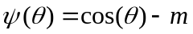(Additive Cosine Margin)，得到：
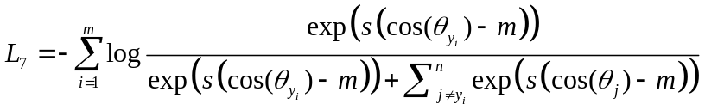
AM-Softmax的示例如图A5所示：
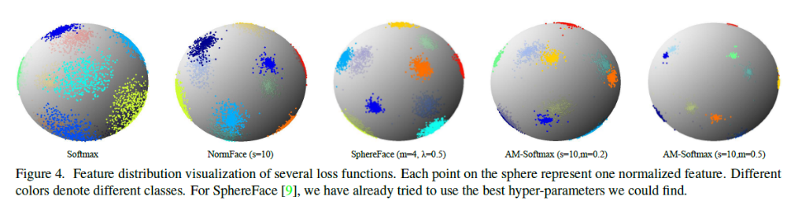
图A5：AM-Softmax示例图，其中第三个SphereFace就是上面提到的A-Softmax

ArcFace
与AM-Softmax不同，ArcFace是将边界m加到余弦里面，称为(Additive Angular Margin)，即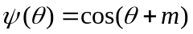，得到：
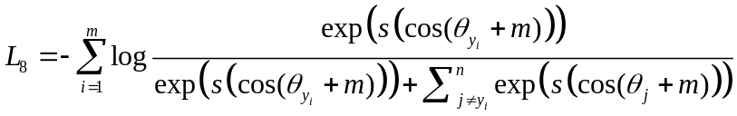
ArcFace示意图：
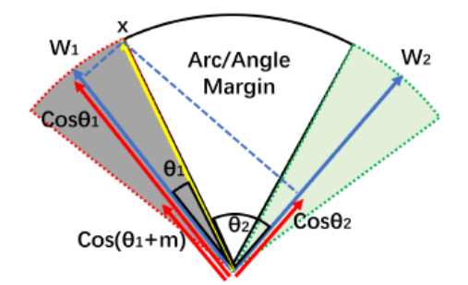
图A6：Argface是示意图

附录B：距离计算
在FR的人脸比对中，往往要计算不同特征的距离，因此本附录总结了一些常见的距离度量(不限于机器学习领域)。

欧几里得距离
欧式距离是最常用的距离，设有两个维度为矢量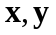，则两者的欧式距离为：
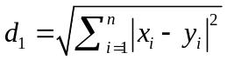

Manhattan距离
Manhattan距离的表达式为：
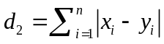
欧式距离和Manhattan距离的关系可以从图B1看出：
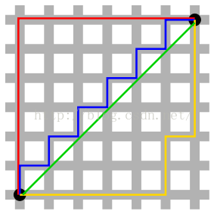
图B1：欧式距离为绿线，其他三根为Manhattan距离

切比雪夫距离(Chebyshev Distance)
切比雪夫距离可以看成是无穷范数的距离，其表达式为：
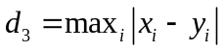

Minkowski 距离
Minkowski距离是一类距离的表达式：
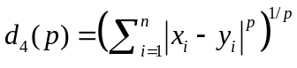
可以看到Minkowski距离的定义跟范数的定义很像，且当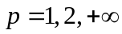时，Minkowski距离分别等于Manhattan距离，欧式距离和切比雪夫距离。

马氏距离(Mahalanobis Distance)
马氏距离的表达式为：
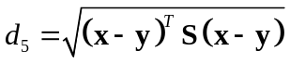
其中，为协方差矩阵：
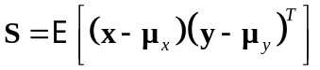

余弦距离
余弦距离表示两个矢量的夹角，但会损失模长的信息，表达式为：
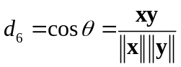

参考文献
- Mei Wang, Weihong Deng. Deep Face Recognition: A Survey [OL]. arXiv: 1804.06655, 2018.
- Matthew Turk, Alex Pentland. Eigenfaces for recognition. Journal of Cognitive Neuroscience, 1991.
- Peter N Belhumeur J P Hespanha David Kriegman. Eigenfaces vs. Fisherfaces: recognition using class specific linear projection. IEEE Transactions on Pattern Analysis and Machine Intelligence, 1997.
- N. Dalal and B. Triggs. Histograms of oriented gradients for human detection. In Computer Vision and Pattern Recognition (CVPR), 2005.
- T. Ahonen, A. Hadid, and M. Pietikainen. Face description with local binary patterns: Application to face recognition. IEEE Trans. Pattern Anal. Machine Intell., 28(12):2037–2041, 2006.
- C. Liu and H. Wechsler. Gabor feature based classification using the enhanced fisher linear discriminant model for face recognition. Image processing, IEEE Transactions on, 11(4):467–476, 2002.
- Y. Taigman, M. Yang, M. Ranzato, and L. Wolf. Deepface: Closing the gap to human- level performance in face verification. In CVPR, pages 1701–1708, 2014.
- W.-S. T. WST. Deeply learned face representations are sparse, selective, and robust. perception, 31:411–438, 2008.
- Y. Sun, Y. Chen, X. Wang, and X. Tang. Deep learning face representation by joint identification-verification. In NIPS, pages 1988– 1996, 2014.
- Y. Sun, D. Liang, X. Wang, and X. Tang. Deepid3: Face recognition with very deep neural networks. arXiv:1502.00873, 2015.
- F. Schroff, D. Kalenichenko, and J. Philbin. Facenet: A unified embedding for face recognition and clustering. In CVPR, pages 815– 823, 2015.
- A. Krizhevsky, I. Sutskever, and G. E. Hinton. Imagenet classification with deep convolutional neural networks. In NIPS, pages 1097–1105, 2012.
- K. Simonyan and A. Zisserman. Very deep convolutional networks for large-scale image recognition. arXiv:1409.1556, 2014.
- C. Szegedy, W. Liu, Y. Jia, et al. Going deeper with convolutions. Cvpr, 2015.
- K. He, X. Zhang, S. Ren, and J. Sun. Deep residual learning for image recognition. In CVPR, pages 770–778, 2016.
- J. Hu, L. Shen, and G. Sun. Squeeze-and-excitation networks. arXiv: 1709.01507, 2017.
- O. M. Parkhi, A. Vedaldi, A. Zisserman, et al. Deep face recognition. In BMVC, 2015.
- W. Liu, Y. Wen, Z. Yu, M. Li, B. Raj, and L. Song. Sphereface: Deep hypersphere embedding for face recognition. In CVPR, volume 1, 2017.
- Q. Cao, L. Shen, W. Xie, O. M. Parkhi, and A. Zisserman. Vggface2: A dataset for recognising faces across pose and age. arXiv:1710.08092, 2017.
- Wu, R. He, and Z. Sun. A lightened cnn for deep face representation. In CVPR, 2015.
- A. R. Chowdhury, T.-Y. Lin, S. Maji, and E. Learned-Miller. One-to-many face recognition with bilinear cnns. In WACV, pages 1–9. IEEE, 2016.
- C. Xiong, X. Zhao, D. Tang, K. Jayashree, S. Yan, and T.-K. Kim. Conditional convolutional neural network for modality-aware face recognition. In ICCV, IEEE, 2015.
- J. Liu, Y. Deng, T. Bai, Z. Wei, and C. Huang. Targeting ultimate accuracy: Face recognition via deep embedding. arXiv:1506.07310, 2015.
- C. Ding and D. Tao. Robust face recognition via multimodal deep face representation. IEEE Transactions on Multimedia, 17(11):2049–2058, 2015.
- Y. Wen, K. Zhang, Z. Li, and Y. Qiao. A discriminative feature learning approach for deep face recognition. In ECCV, pages 499–515. Springer, 2016.
- Y. Wu, H. Liu, J. Li, and Y. Fu. Deep face recognition with center invariant loss. In Proceedings of the on Thematic Workshops of ACM Multimedia 2017, pages 408–414. ACM, 2017.
- X. Zhang, Z. Fang, Y. Wen, Z. Li, and Y. Qiao. Range loss for deep face recognition with long-tail. arXiv:1611.08976, 2016.
- J. Deng, Y. Zhou, and S. Zafeiriou. Marginal loss for deep face recognition. In CVPR Workshops, volume 4, 2017.
- J. Deng, J. Guo, and S. Zafeiriou. Arcface: Additive angular margin loss for deep face recognition. arXiv:1801.07698, 2018.
- W. Liu, Y. Wen, Z. Yu, M. Li, B. Raj, and L. Song. Sphereface: Deep hypersphere embedding for face recognition. In CVPR, volume 1, 2017.
- W. Liu, Y. Wen, Z. Yu, and M. Yang. Large-margin softmax loss for convolutional neural networks. In ICML, pages 507–516, 2016.
- W. Liu, Y.-M. Zhang, X. Li, Z. Yu, B. Dai, T. Zhao, and L. Song. Deep hyperspherical learning. In NIPS, pages 3953–3963, 2017.
- F. Wang, W. Liu, H. Liu, and J. Cheng. Additive margin softmax for face verification. arXiv:1801.05599, 2018.
- R. Ranjan, C. D. Castillo, and R. Chellappa. L2-constrained softmax loss for discriminative face verification. arXiv:1703.09507, 2017.
- Y. Liu, H. Li, and X. Wang. Rethinking feature discrimination and polymerization for large-scale recognition. arXiv:1710.00870, 2017.
- M. Hasnat, J. Bohn´e, J. Milgram, S. Gentric, L. Chen, et al. von mises-fisher mixture model-based deep learning: Application to face verification. arXiv:1706.04264, 2017.
- Y. Cheng, J. Zhao, Z. Wang, Y. Xu, K. Jayashree, S. Shen, and J. Feng. Know you at one glance: A compact vector representation for low-shot learning. In CVPR, 2017.
- N. Crosswhite, J. Byrne, C. Stauffer, O. Parkhi, Q. Cao, and A. Zisserman. Template adaptation for face verification and identification. In FG 2017, pages 1–8, 2017.
- S. Guo, S. Chen, and Y. Li. Face recognition based on convolutional neural network and support vector machine. In IEEE International Conference on Information and Automation, pages 1787–1792, 2017.
- L. Xiong, J. Karlekar, J. Zhao, J. Feng, S. Pranata, and S. Shen. A good practice towards top performance of face recognition: Transferred deep feature fusion. arXiv:1704.00438, 2017.
- L. Z. Zhengming Ding, Yandong Guo and Y. Fu. One-shot face recognition via generative learning. In FG, pages 1–7. IEEE, 2018.
- W. D. H. S. Zimeng Luo, Jiani Hu. Deep unsupervised domain adaptation for face recognition. In FG, pages 453–457. IEEE, 2018.
- Y. Sun, X. Wang, and X. Tang. Sparsifying neural network connections for face recognition. In CVPR, pages 4856–4864, 2016.
- C. Ding and D. Tao. Robust face recognition via multimodal deep face representation. IEEE Transactions on Multimedia, 17(11):2049–2058, 2015.
- J. Liu, Y. Deng, T. Bai, Z. Wei, and C. Huang. Targeting ultimate accuracy: Face recognition via deep embedding. arXiv:1506.07310, 2015.
- T. Y. J. H. Zhanfu An, Weihong Deng. Deep transfer network with 3d morphable models for face recognition. In FG, pages 416–422. IEEE, 2018.
- A. T. Tran, T. Hassner, I. Masi, and G. Medioni. Regressing robust and discriminative 3d morphable models with a very deep neural network. In CVPR, pages 1493–1502. IEEE, 2017.
- E. Richardson, M. Sela, and R. Kimmel. 3d face reconstruction by learning from synthetic data. In 3DV, pages 460–469. IEEE, 2016.
- I. Masi, T. Hassner, A. T. Tran, and G. Medioni. Rapid synthesis of massive face sets for improved face recognition. In FG 2017, pages 604–611. IEEE, 2017.
- I. Masi, A. T. Tr?n, T. Hassner, J. T. Leksut, and G. Medioni. Do we really need to collect millions of faces for effective face recognition? In ECCV, pages 579–596. Springer, 2016.
- P. Dou, S. K. Shah, and I. A. Kakadiaris. End-to-end 3d face reconstruction with deep neural networks. In CVPR, volume 5, 2017.
- J. H. Yichen Qian, Weihong Deng. Task specific networks for identity and face variation. In FG, pages 271–277. IEEE, 2018.
- J. Yim, H. Jung, B. Yoo, C. Choi, D. Park, and J. Kim. Rotating your face using multi-task deep neural network. In CVPR, pages 676–684, 2015.
- J. Bao, D. Chen, F. Wen, H. Li, and G. Hua. Cvae-gan: finegrained image generation through asymmetric training. arXiv:1703.10155, 2017.
- J. Bao, D. Chen, F. Wen, H. Li, and G. Hua. Towards open-set identity preserving face synthesis. In CVPR, pages 6713–6722, 2018.
- W. D. Weilong Chai and H. Shen. Cross-generating gan for facial identity preserving. In FG, pages 130–134. IEEE, 2018.
- J. Zhao, L. Xiong, P. K. Jayashree, J. Li, F. Zhao, Z. Wang, P. S. Pranata, P. S. Shen, S. Yan, and J. Feng. Dual-agent gans for photorealistic and identity preserving profile face synthesis. In NIPS, pages 65–75, 2017.
- J. Y. X. W. X. T. Yujun Shen, Ping Luo. Faceid-gan: Learning a symmetry three-player gan for identity-preserving face synthesis. In CVPR, pages 416–422. IEEE, 2018.
- Y. Zhang, M. Shao, E. K. Wong, and Y. Fu. Random faces guided sparse many-to-one encoder for pose-invariant face recognition. In ICCV, pages 2416–2423. IEEE, 2013.
- J. Yang, S. E. Reed, M.-H. Yang, and H. Lee. Weakly-supervised disentangling with recurrent transformations for 3d view synthesis. In NIPS, pages 1099–1107, 2015.
- M. Kan, S. Shan, H. Chang, and X. Chen. Stacked progressive autoencoders (spae) for face recognition across poses. In CVPR, pages 1883–1890, 2014.
- L. Hu, M. Kan, S. Shan, X. Song, and X. Chen. Ldf-net: Learning a displacement field network for face recognition across pose. In FG 2017, pages 9–16. IEEE, 2017.
- J. Yim, H. Jung, B. Yoo, C. Choi, D. Park, and J. Kim. Rotating your face using multi-task deep neural network. In CVPR, pages 676–684, 2015.
- Z. Zhu, P. Luo, X. Wang, and X. Tang. Deep learning identitypreserving face space. In ICCV, pages 113–120. IEEE, 2013.
- Z. Zhu, P. Luo, X. Wang, and X. Tang. Recover canonical-view faces in the wild with deep neural networks. arXiv:1404.3543, 2014.
- X. Yin, X. Yu, K. Sohn, X. Liu, and M. Chandraker. Towards largepose face frontalization in the wild. arXiv:1704.06244, 2017.
- L. Tran, X. Yin, and X. Liu. Disentangled representation learning gan for pose-invariant face recognition. In CVPR, volume 3, page 7, 2017.
- R. Huang, S. Zhang, T. Li, R. He, et al. Beyond face rotation: Global and local perception gan for photorealistic and identity preserving frontal view synthesis. arXiv:1704.04086, 2017.

